|  |  |
| --- | --- |
| ***Roll No*** | ***22SW040 --> Section 01*** |
| ***Name*** | ***Farooque Sajjad*** |
| ***Subject*** | ***CN Practical (lab_04)*** |
| ***Teacher*** | ***Ma’am Aisha*** |

***Determining Bits to Borrow***

*To find out how many bits to borrow from the host portion, we need to ensure we can create at least 4 subnets. The formula to determine the number of subnets based on borrowed bits is:*

*{Number of Subnets} = 2^n*

*Where (n) is the number of bits borrowed.*

*To create 4 subnets: we have formula --> [2^n]*

*- If (n = 2): (2^2 = 4) (sufficient)*

*- If (n = 1) :( 2^1 = 2) (not sufficient)*

*Thus, we need to borrow* ***2 bits****.*

***Calculation for Host Bits***

*The original Class C subnet mask is 255.255.255.0 (or /24), meaning we have 8 bits available in the fourth octet for hosts.*

*If we borrow 2 bits from the host portion:*

*[{Bits left for hosts} = 8 - 2 = 6]*

*Using the remaining 6 bits for hosts allows us to calculate the number of usable hosts per subnet:*

*[ {Usable Hosts} = 2^6 - 2 = 64 - 2 = 62]*

*This meets the requirement of at least 25 hosts per subnet.*

*Subnetting Information*

*Now, let's fill in the information in the required table format:*

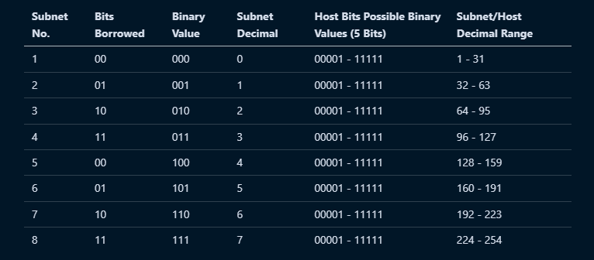

***Answers to the Questions***

***1. Which octet(s) represent the network portion of a Class C IP address?***

*The first three octets (197.15.22) represent the network portion.*

***2. Which octet(s) represent the host portion of a Class C IP address?***

*The fourth octet (0) represents the host portion.*

***3. What is the binary equivalent of the Class C network address in the scenario?***

* *197 in binary: 11000101*
* *15 in binary: 00001111*
* *22 in binary: 00010110*
* *0 in binary: 00000000*
* *Finally, 197.15.22.0--> in binary is --> 11000101.00001111.00010110.00000000*

***4. How many high-order bits were borrowed from the host bits in the fourth octet?***

*2 bits were borrowed.*

***5. What subnet mask must be used? Show the subnet mask in decimal and binary.***

* *Subnet Mask in Decimal: 255.255.255.192*
* *Subnet Mask in Binary: 11111111.11111111.11111111.11000000*

***6. What is the maximum number of subnets that can be created with this subnet mask?***

*Maximum number of subnets: 4 --> b/c (2 bits borrowed: (2^2 = 4)) --> acc to formula (2^n)*

***7. What is the maximum number of usable subnets that can be created with this mask?***

*Usable subnets: 4 --> (all subnets created are usable except the all-zero subnet).*

***8. How many bits were left in the fourth octet for host IDs?***

*6 bits were left for host IDs.*

***9. How many hosts per subnet can be defined with this subnet mask?***

*62 usable hosts per subnet (64 - 2 for network and broadcast acc to (2^n -2 formula)).*

***10. What is the maximum number of hosts that can be defined for all subnets with this scenario?***

*Maximum hosts across all subnets: (62 times 4 = 248) b/c there are 4 subnets*

***11. Is 197.15.22.63 a valid host IP address with this scenario?***

*No, it is not valid because it falls into the broadcast range of the first subnet (197.15.22.0 to 197.15.22.63).*

***12. Why or why not?***

*- It falls into the broadcast address range (197.15.22.63), which cannot be assigned to a host.*

***13. Is 197.15.22.160 a valid host IP address with this scenario?***

*Yes, it is valid because it falls within the range of the subnet (160 to 191) created by the subnetting.*

***14. Why or why not?***

*197.15.22.160 is within the valid range for the fourth subnet, making it assignable to a host.*