|  |  |
| --- | --- |
| ***Roll No*** | ***22SW040 🡪 Section_01*** |
| ***Name*** | ***Farooque Sajjad*** |
| ***Subject*** | ***CN Practical (LAB_5)*** |
| ***Teacher*** | ***Ma’am Aisha*** |

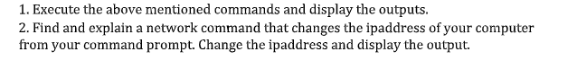

***TASK_01***

***Executing the Command Mentioned in the Handout***

1. ***ipconfig***

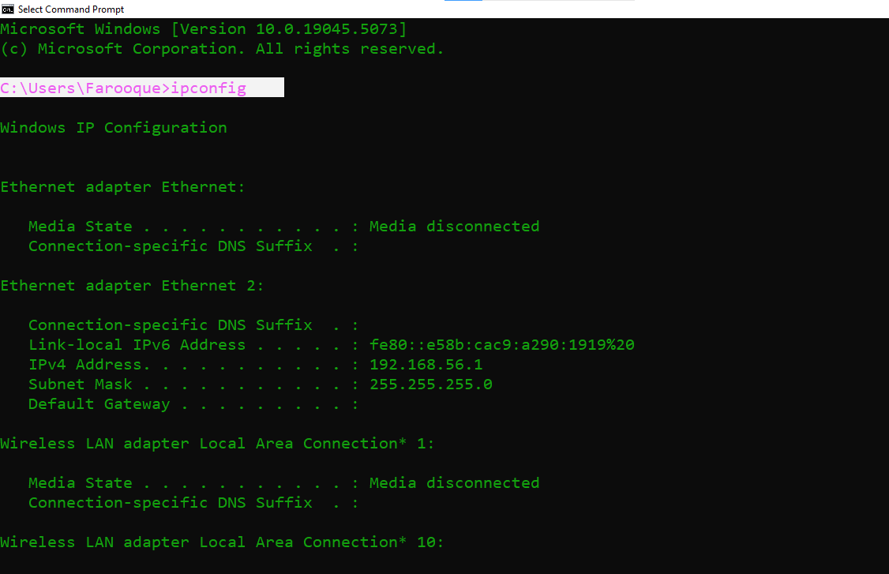

1. ***ipconfig/displaydns***

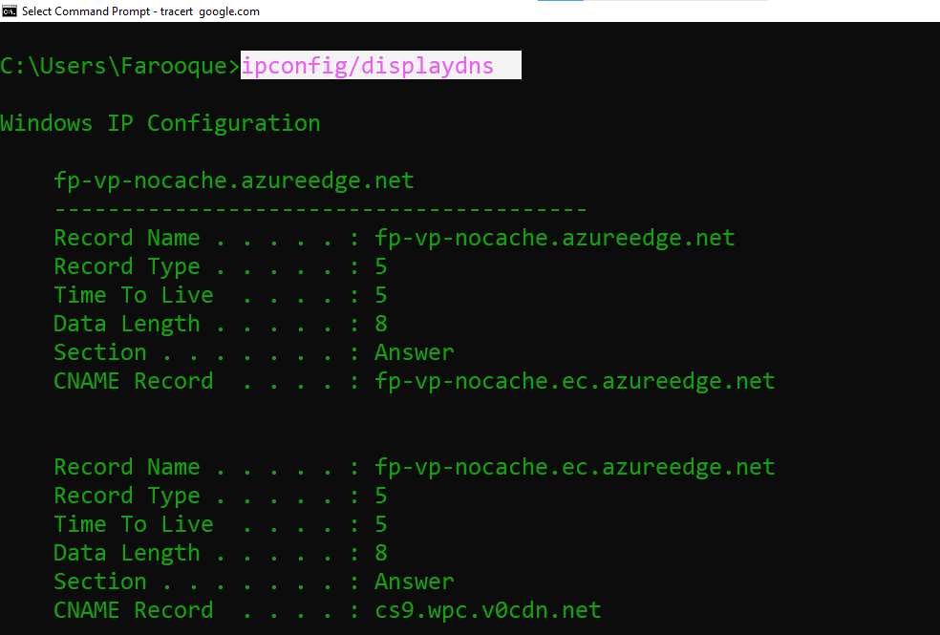

1. ***ping***

1. ***tracert***

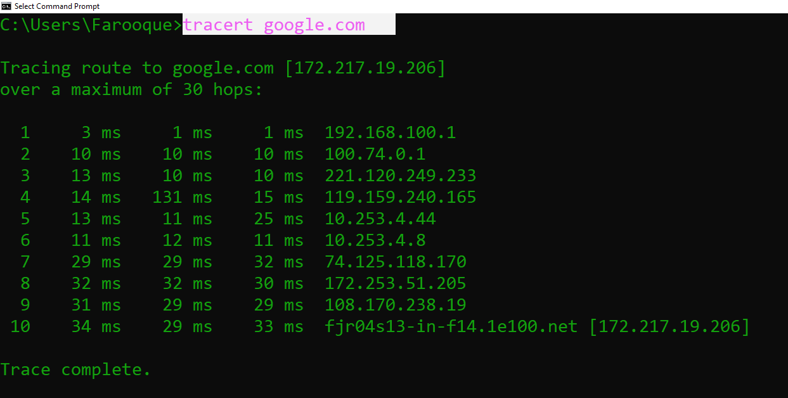

1. ***net view***

1. ***arp -a***

***TASK_02***

***CHANGING THE IP ADDRESS TO THE CONNECTED WIFI OF MY HOME***

***IPV4 address before changing***

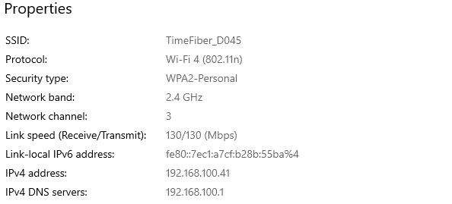

***Running the command to change the IP address***

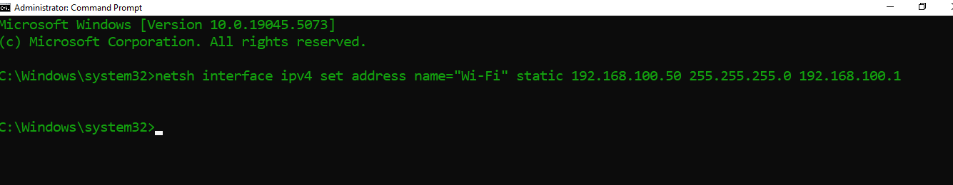

***IPV4 address has been changed***

