|  |  |
| --- | --- |
| ***Roll No*** | ***22SW040 🡪 Section_01*** |
| ***Name*** | ***Farooque Sajjad*** |
| ***Subject*** | ***CN Practical (LAB_6)*** |
| ***Teacher*** | ***Ma’am Aisha*** |

***Class Exercise Mentioned in the handout answering the given question***

***1. Why have we assigned an IP address of which class and how many host IP addresses it has?***

*The IP address assigned (“192.168.1.254”) is of Class C. Class C allows for a maximum of 254 usable host IP addresses (from 192.168.1.1 to 192.168.1.254) due to the subnet mask “255.255.255.0”, which provides 256 total addresses but subtracts 2 for the network and broadcast addresses.*

***2. Why have the hosts been assigned the default gateway addresses?***

*The hosts have been assigned default gateway addresses to enable communication with devices outside their local subnet. The default gateway serves as the route for packets destined for other networks, allowing the hosts to access the router for forwarding to other networks.*

***Task_01***

***Connecting 3 pcs using crossover cable***

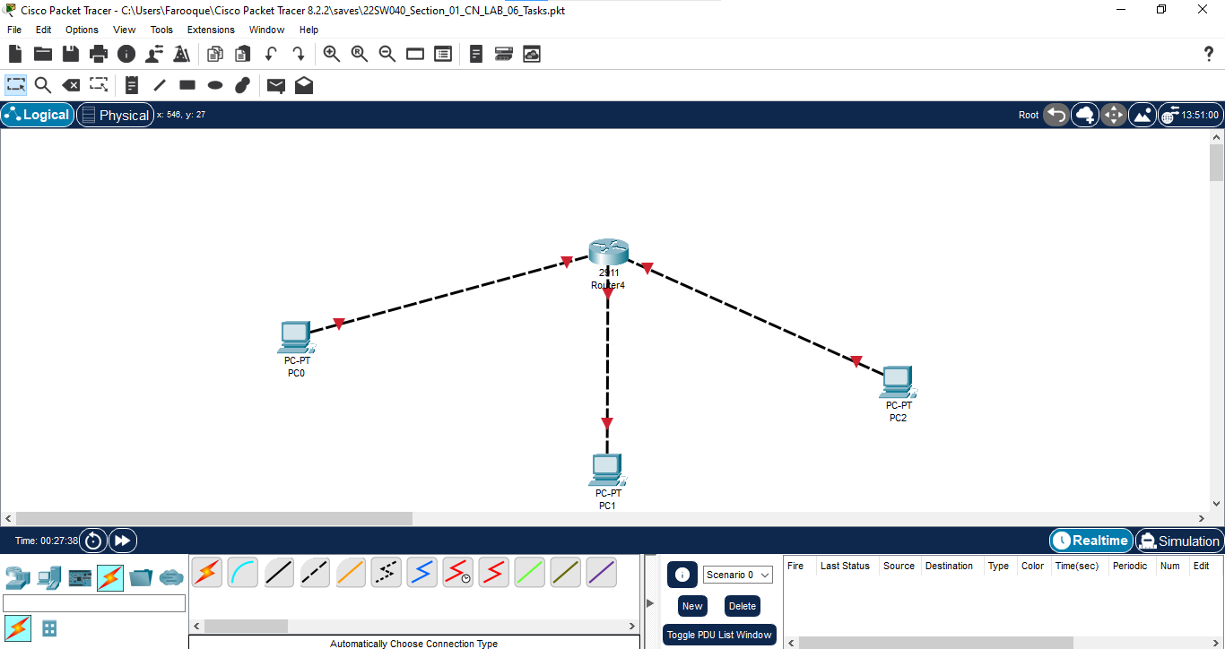

***Task_02***

***Configuring connected pcs***

***Doing interface up for GigabitEthernet0/0***

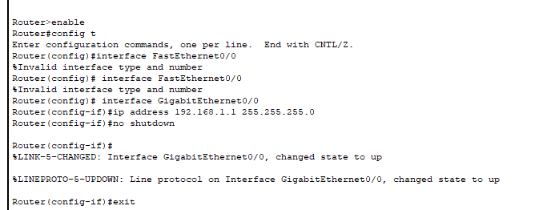

***Doing interface up for GigabitEthernet0/1***

***Doing interface up for GigabitEthernet0/2***

***Now all the interfaces have been up connecting becomes green***

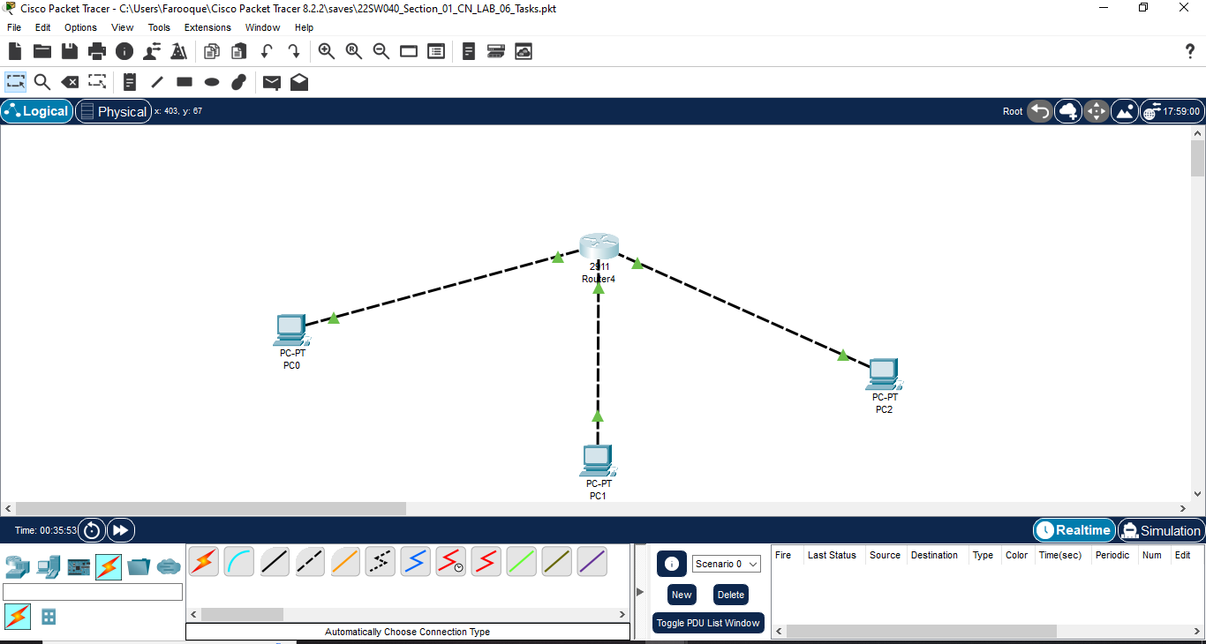

***Assigning the IP address, subnet mask, and default gateway to PC0***

***Assigning the IP address, subnet mask, and default gateway to PC1***

***Assigning the IP address, subnet mask, and default gateway to PC1***

***Has Successfully run the ping command from PC0 to PC1 and PC2***

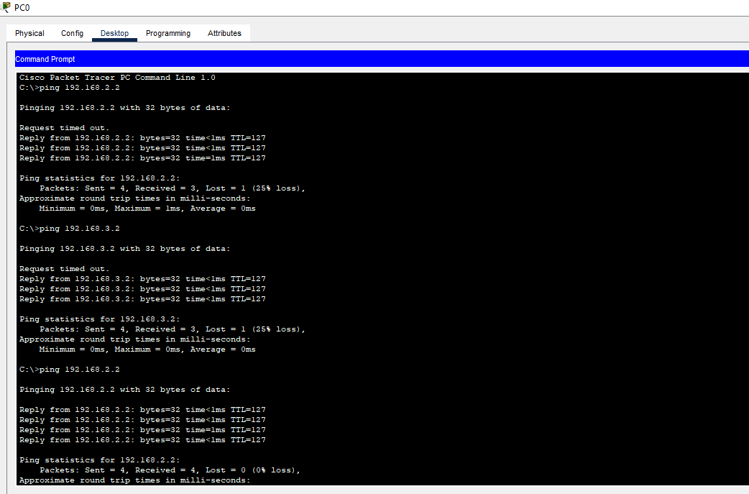

***Has Successfully run the ping command from PC1 to PC0 and PC2***

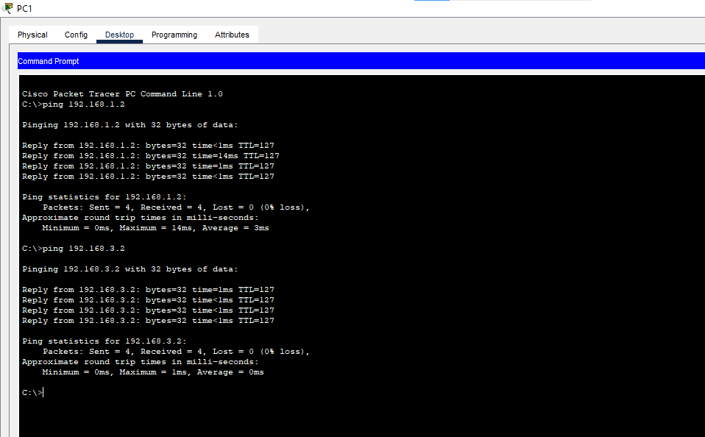

***Has Successfully run the ping command from PC2 to PC1 and PC0***

