|  |  |
| --- | --- |
| ***Roll No*** | ***22SW040 🡪 Section_01*** |
| ***Name*** | ***Farooque Sajjad*** |
| ***Subject*** | ***CN Practical (LAB_7)*** |
| ***Teacher*** | ***Ma’am Aisha*** |

***ANSWERING THE QUESTIONS MENTIONED IN THE HANDOUT***

***Why is the interface serial0 changed to down?***

*The serial interface “serial0” initially goes down due to a lack of a “clock rate” on the DTE side of the connection. Only the DCE side of a serial connection can set the clock rate, which synchronizes communication across the link.*

***Why the hosts have been assigned the same network IP addresses?***

*The hosts are on different subnets, each connected to a different router. They use the same network prefix “192.168.x.0”, where “x” is different for each subnet, but they cannot communicate without routing because they are distinct subnets.*

***Are all the necessary interfaces up?***

*Yes, all necessary interfaces are up, as confirmed by “show ip int brief” output showing each interface with “up” status. (see the screenshots below)*

***Can a host on subnet 172.16.0.0 see a host on network 192.168.3.0?***

*No, because routing between these subnets has not yet been configured. To allow communication, static routes must be added to the routing tables.*

***Why are there three static routes needed on Router1 and Router3?***

*Each router needs to reach three different subnets that are not directly connected. Router1 requires routes to reach “192.168.2.0”, “192.168.3.0”, and “172.16.0.0”, while Router3 requires routes to reach “192.168.0.0”, “192.168.1.0”, and “192.168.2.0”. Static routes enable traffic to pass between these networks through Router2.*

***List the routes listed in the routing table?***

*Router1: Direct routes to “192.168.0.0”, “192.168.1.0”; Static routes to “192.168.2.0”, “172.16.0.0”, “192.168.3.0”*

*Router2: Direct routes to “192.168.0.0”, “172.16.0.0”, “192.168.2.0”; Static routes to “192.168.1.0”, “192.168.3.0”*

*Router3: Direct routes to “172.16.0.0”, “192.168.3.0”; Static routes to “192.168.2.0”, “192.168.0.0”, “192.168.1.0”*

***What is the administrative distance?***

*The default administrative distance for static routes is 1.*

***TASK***

***First drag and drop 3 routers and pcs***

***Then adding NM-1E and WIC-IT to each of the router***

***Now connecting routers and pcs***

***Assigning the IP addresses to the connected pcs***

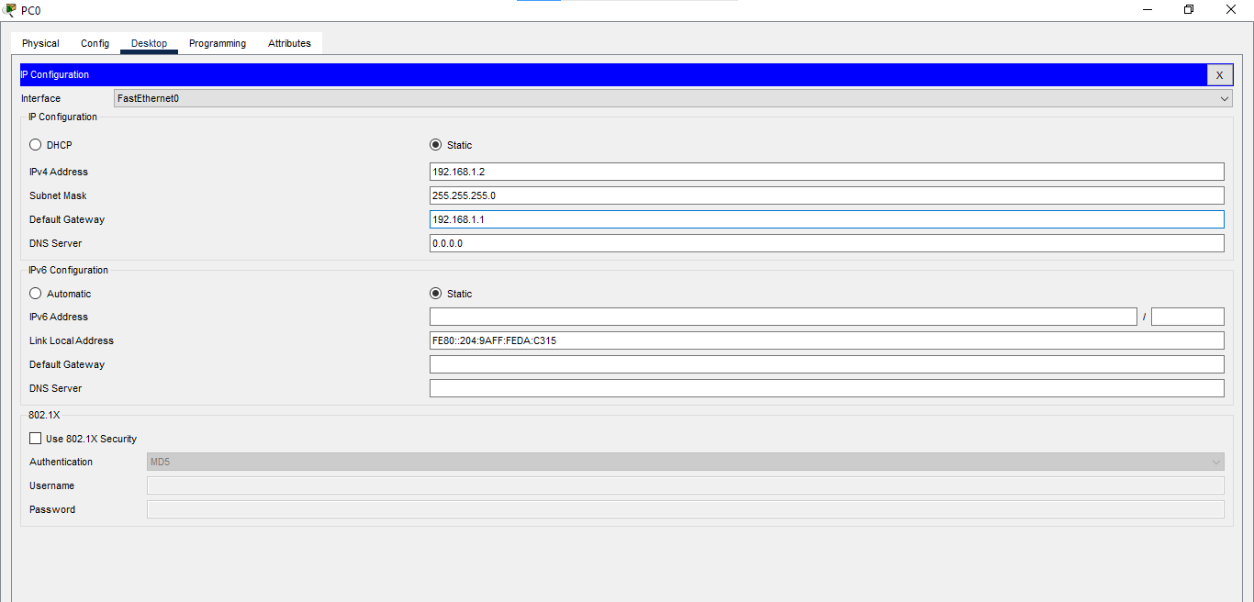

***Now configuring the Serial and Fast Ethernet Interfaces for all the Routers***

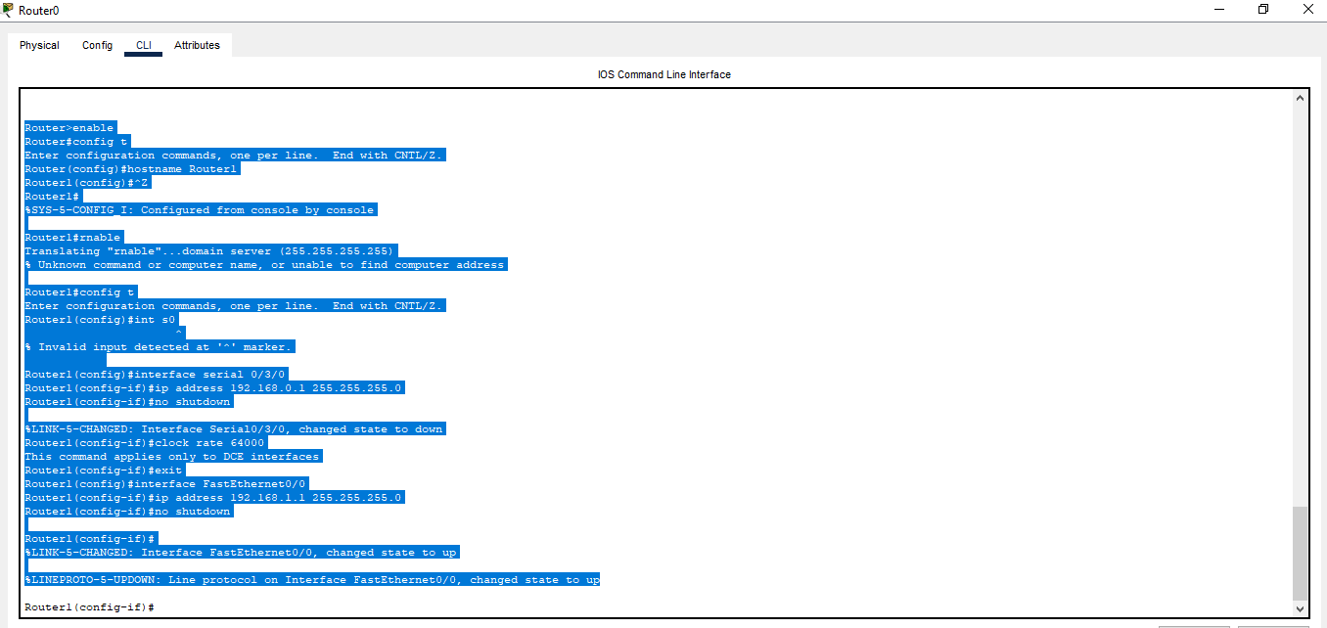

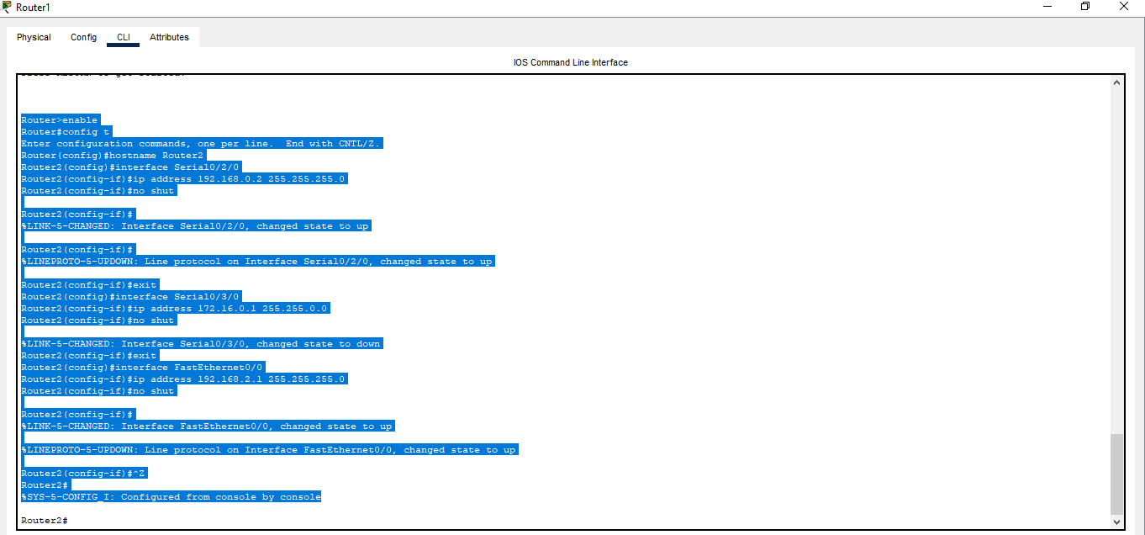

***All the connection becomes green (all interfaces are up)***

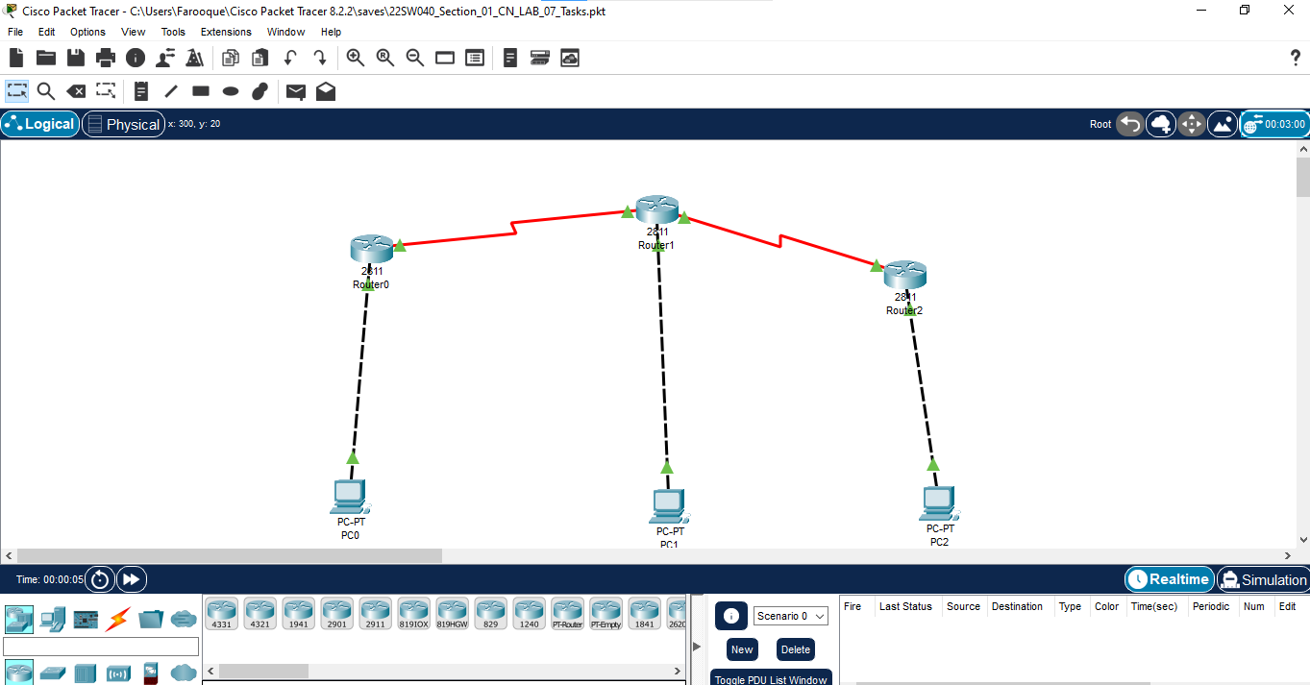

***Running the command (sh ip int brief) on all the Routers***

***Now Running the command (sh ip route) on all the Routers***

***Now Doing Static Routing between all the connected Routers***

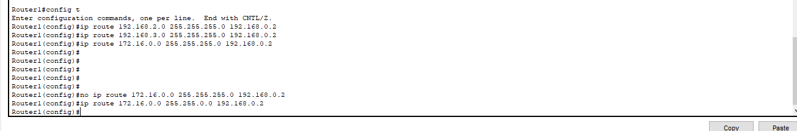

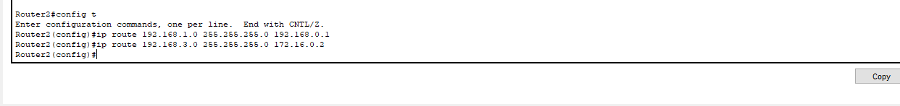

***Again, Running the Command (s hip route) to reflect the static routing***

***Now Running the ping command from PC0, PC1, and PC2 for all the connections***



