|  |  |
| --- | --- |
| ***Roll No*** | ***22SW040 🡪 Section_01*** |
| ***Name*** | ***Farooque Sajjad*** |
| ***Subject*** | ***CN Practical (LAB_8)*** |
| ***Teacher*** | ***Ma’am Aisha*** |

***ANSWERING THE QUESTIONS MENTIONED IN THE HANDOUT***

***1. How many interfaces are up on Router1? Mention their names:***

*Interfaces Up: Two interfaces are up on Router1.*

*Names: Serial0/3/0 and Ethernet0/0*

***2. Are all the necessary interfaces up?***

*Yes, both Serial0 and Ethernet0 interfaces are up on both Router1 and Router2.*

***3. What networks are displayed?***

*For Router1:*

*“192.168.1.0/24” (connected via Ethernet0/0)*

*“192.168.0.0/24” (connected via Serial0/3/0)*

*For Router2:*

*“192.168.0.0/24” (connected via Serial03/0)*

*“192.168.2.0/24” (connected via Ethernet0/0)*

***4. What interface is directly connected?***

*Router1: Serial0 (192.168.0.0/24), Ethernet0 (192.168.1.0/24)*

*Router2: Serial0 (192.168.0.0/24), Ethernet0 (192.168.2.0/24)*

***5. What does 0.0.0.0 signify here?***

*The address “0.0.0.0” represents the default route, or "gateway of last resort." It is used to direct traffic to any destination not specified in the routing table.*

***6. List the routes listed in the routing table.***

*Router1 Routing Table:*

*Connected route “192.168.1.0/24” via Ethernet0*

*Connected route “192.168.0.0/24” via Serial0*

*Static default route “0.0.0.0/0” via 192.168.0.2*

*Router2 Routing Table:*

*Connected route “192.168.0.0/24” via Serial0*

*Connected route “192.168.2.0/24” via Ethernet0*

*Static default route “0.0.0.0/0” via 192.168.0.1*

***7. What is the administrative distance?***

*The administrative distance for static routes is 1.*

***TASK***

***First drag and drop 2 routers and pcs***

***Then adding NM-1E and WIC-IT to each of the router***

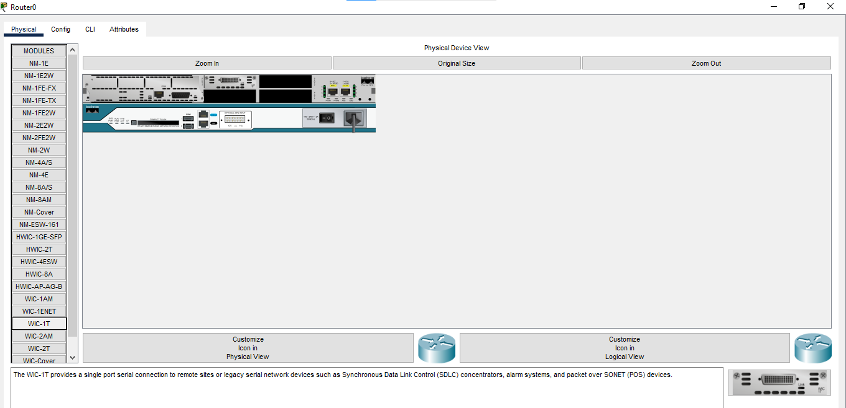

***Now connecting routers and pcs***

***Assigning the IP addresses to the connected pcs***

***Now configuring the Serial and Fast Ethernet Interfaces for both the Routers***

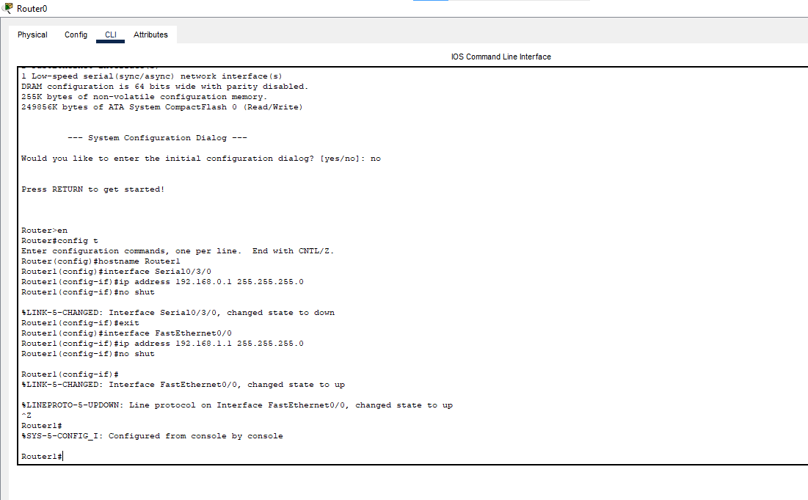

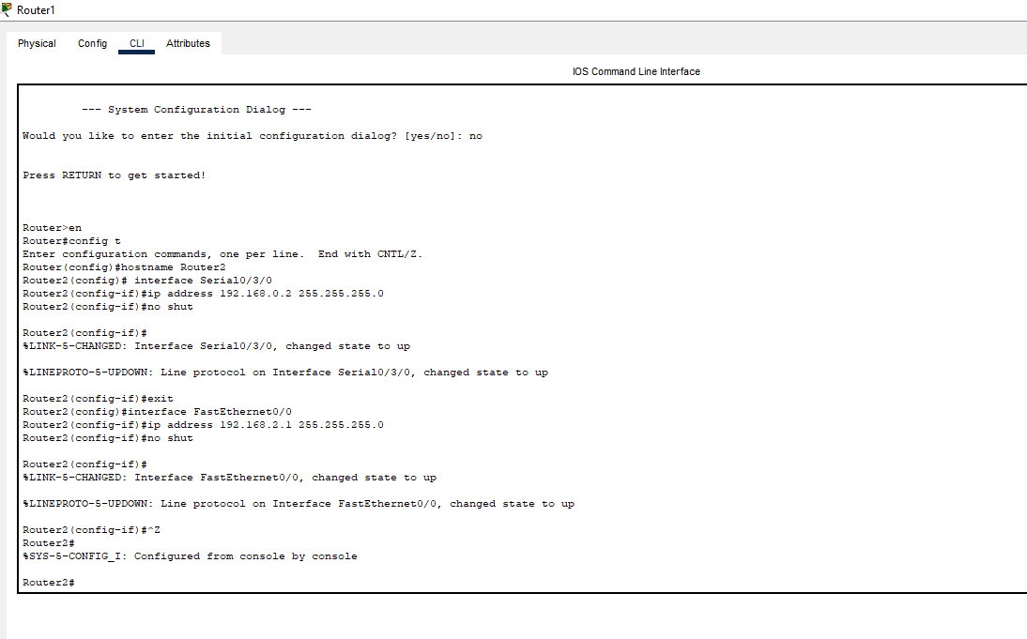

***All the connection becomes green (all interfaces are up)***

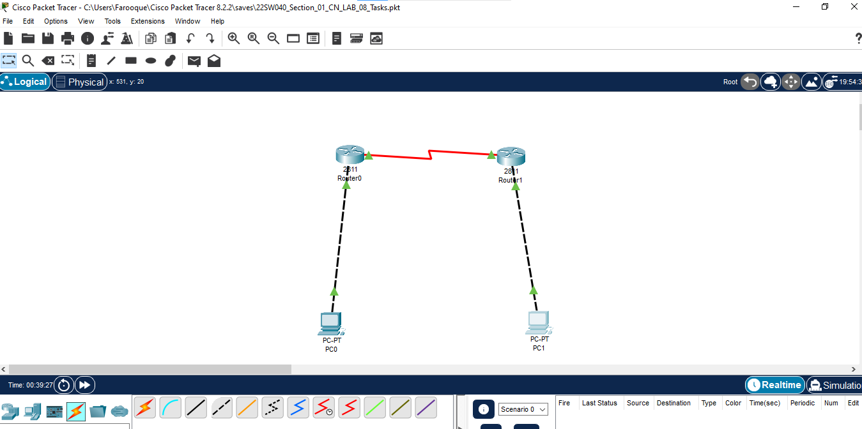

***Running the command (sh ip route) on both the Routers***

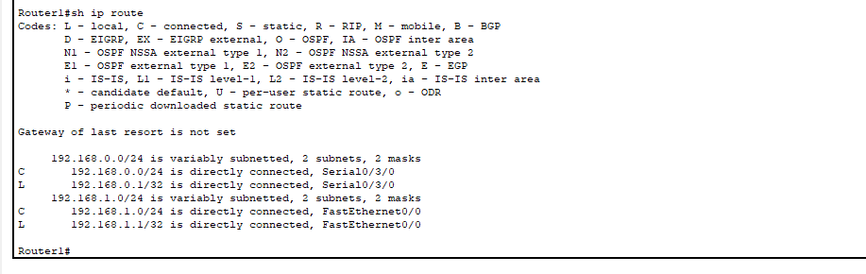

***Now Doing Default Routing between both the connected Routers***

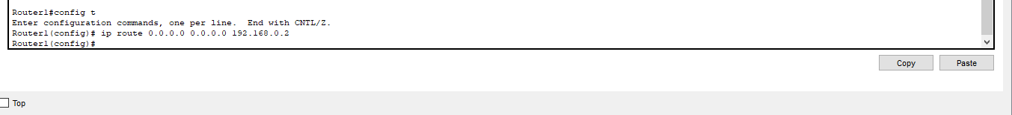

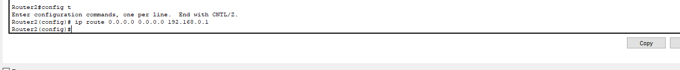

***Again, Running the Command (s hip route) to reflect the Dynamic routing***

***Now Running the ping command from PC0 and PC1 for all the connections***

