|  |  |
| --- | --- |
| ***Roll No*** | ***22SW040 🡪 Section_01*** |
| ***Name*** | ***Farooque Sajjad*** |
| ***Subject*** | ***CN Practical (LAB_9)*** |
| ***Teacher*** | ***Ma’am Aisha*** |

***ANSWERING THE QUESTIONS MENTIONED IN THE HANDOUT***

***Note: There is mistake in the IP address of the Serial connection of R2 the correct IP address of Serial connection should be (192.168.10.2) not (192.168.12.2)***

***Question). How would you assign a Class A IP address to interface Serial0 on Router1?***

*To assign a Class A IP address (e.g., 10.0.0.1) to the Serial0 interface on Router1, you would enter:*

*Router1(config)int s0*

*Router1(configif)ip address 10.0.0.1 255.0.0.0*

*Router1(configif)no shut*

***Question). Are all the necessary interfaces up?***

*Yes, all the necessary interfaces are up. (see the screen shots below)*

***Question). What are the entries in the Router1 routing table?***

*The routing table for Router1 includes:*

*192.168.5.0/24 (directly connected to Ethernet0)*

*192.168.10.0/24 (directly connected to Serial0)*

*(also, you can verify by seeing the screenshots below)*

***Question). What are the entries in the Router2 routing table?***

*The routing table for Router2 includes:*

*192.168.6.0/24 (directly connected to Ethernet0)*

*192.168.10.0/24 (directly connected to Serial0) (updated one)*

***Question). List the routes listed in the routing table.***

*After configuring RIP, the updated routing tables are as follows:*

*Router1 routing table:*

*192.168.5.0/24 directly connected, Ethernet0*

*192.168.10.0/24 directly connected, Serial0*

*192.168.6.0/24 RIP learned route via 192.168.10.2 (updated one) on Serial0*

*Router2 routing table:*

*192.168.6.0/24 directly connected, Ethernet0*

*192.168.12.0/24 directly connected, Serial0*

*192.168.5.0/24 RIP learned route via 192.168.10.3 on Serial0*

***What is the administrative distance?***

*The administrative distance for RIP is 120. This value is shown in the routing table next to the RIP learned routes (e.g., [“120/1]”).*

***TASK***

***First drag and drop 2 routers and pcs***

***Then adding NM1E and WICIT to each of the router***

***Now connecting routers and pcs***

***Assigning the IP addresses to the connected pcs***

***Now configuring the Serial and Fast Ethernet Interfaces for both the Routers***

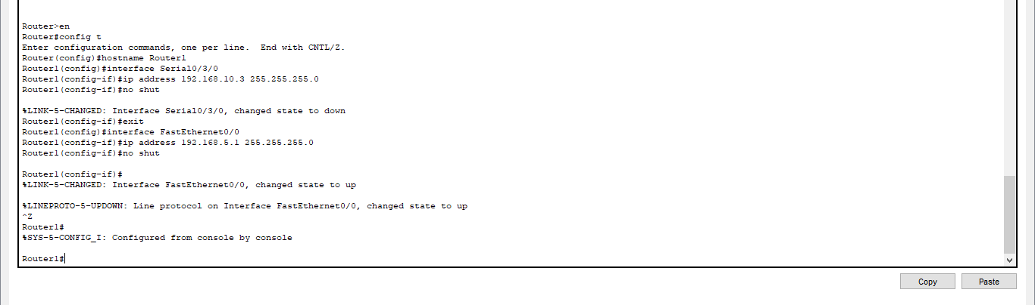

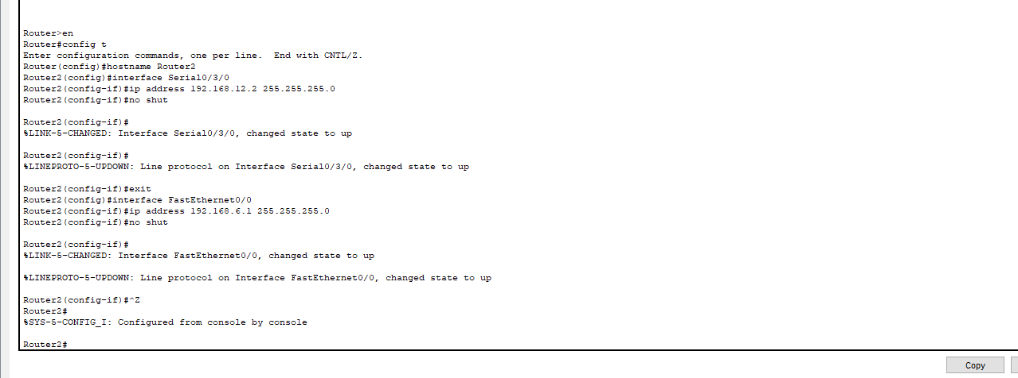

***All the connection becomes green (all interfaces are up)***

***Running the command (sh ip route) on both the Routers***

***Now Doing RIP Routing between both the connected Routers***

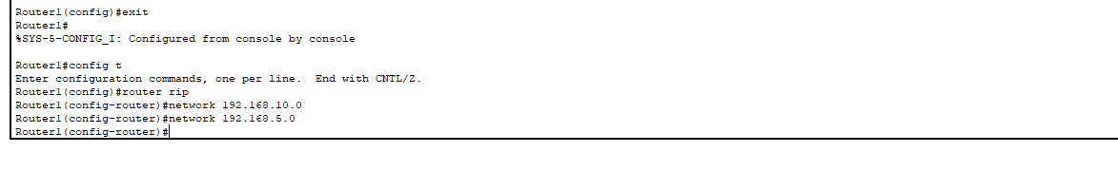

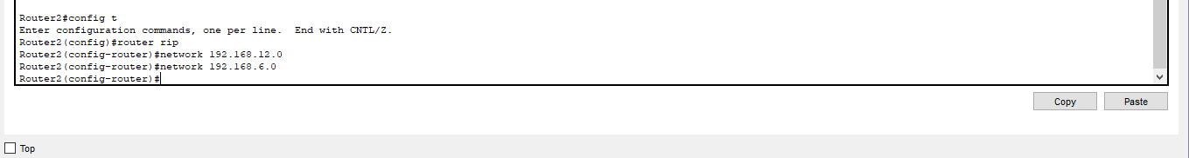

***Again, Running the Command (s hip route) to reflect the RIP routing***

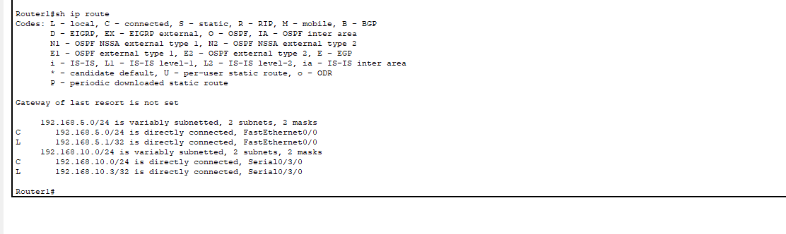

***Updated serial interface ip address and RIP routing for R2***

***Now Running the ping command from PC0 and PC1 for all the connections***



