|  |  |
| --- | --- |
| ***Roll No*** | ***22SW040 🡪 Section_01*** |
| ***Name*** | ***Farooque Sajjad*** |
| ***Subject*** | ***CN Practical (LAB_10)*** |
| ***Teacher*** | ***Ma’am Aisha*** |

***ANSWERING THE QUESTIONS MENTIONED IN THE HANDOUT***

***Why is the interface Serial0 changed state to down?***

*The interface Serial0 changes state to "down" because it does not detect a signal from the other end of the serial link. This could be due to either the cable being disconnected, a misconfiguration, or the interface on the other connected router being down.*

***Are all the necessary interfaces up?***

*Yes, all the necessary interfaces are up seeing the screenshots below*

***What networks are displayed on Router3?***

*Router3 displays the following networks:*

*172.16.0.0 (directly connected to Serial0)*

*192.168.3.0 (directly connected to Ethernet0)*

*192.168.0.0, 192.168.2.0, and 192.168.1.0 (learned via RIP)*

***Which network is directly connected to the Ethernet port?***

*The 192.168.3.0 network is directly connected to Router3’s Ethernet0 interface.*

***Why are there three network entries on Router2?***

*Router2 has three network entries because it has interfaces on three different subnets:*

*192.168.0.0 (connected to Serial0)*

*172.16.0.0 (connected to Serial1)*

*192.168.2.0 (connected to Ethernet0)*

*These networks are included in the RIP configuration to advertise them to other routers.*

***List the shortest listed route in the routing table of R2.***

*The shortest listed route in Router2’s routing table would be the directly connected networks with a metric of 0, such as 192.168.0.0, 172.16.0.0, and 192.168.2.0.*

***What is the administrative distance, and which protocol is used?***

*The administrative distance for RIP is 120, and the routing protocol used here is RIP (Routing Information Protocol).*

***TASK***

***First drag and drop 3 routers and pcs***

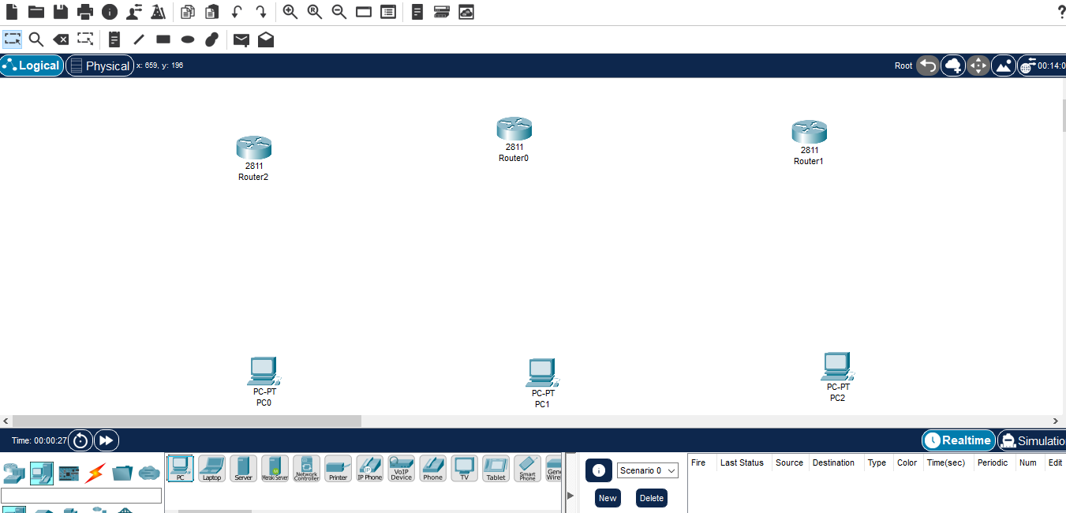

***Then adding NM-1E and WIC-IT to each of the router***

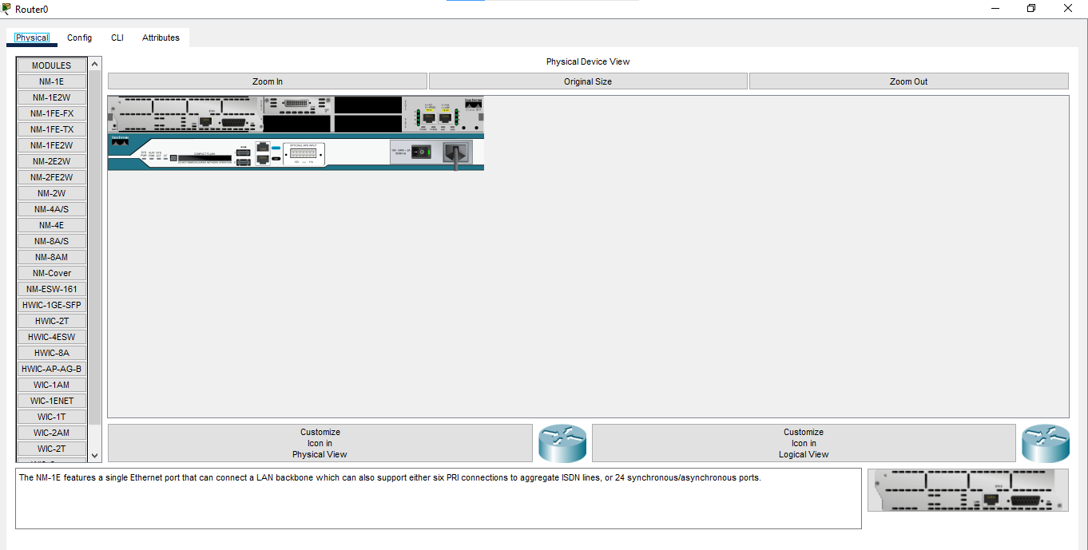

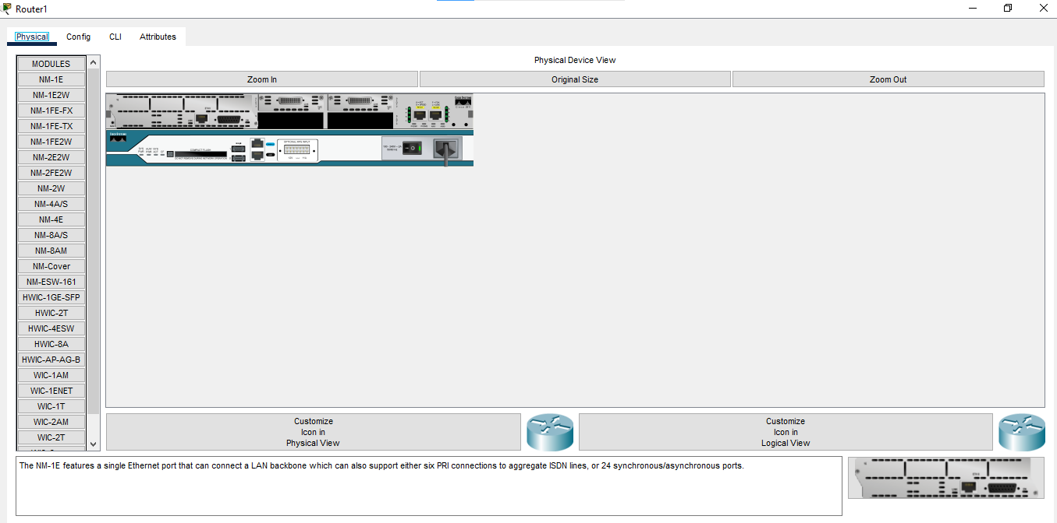

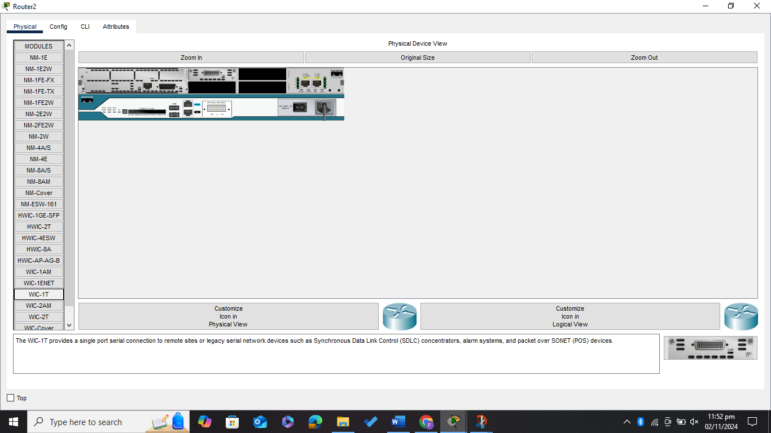

***Now connecting routers and pcs***

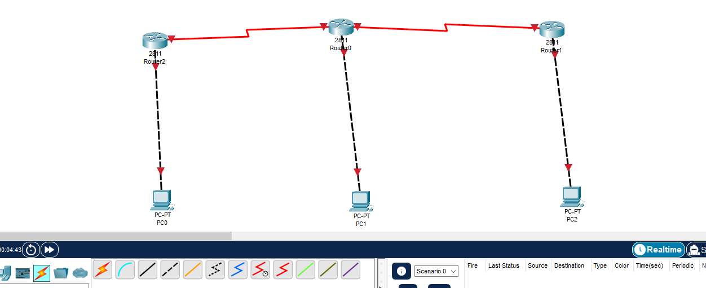

***Assigning the IP addresses to the connected pcs***

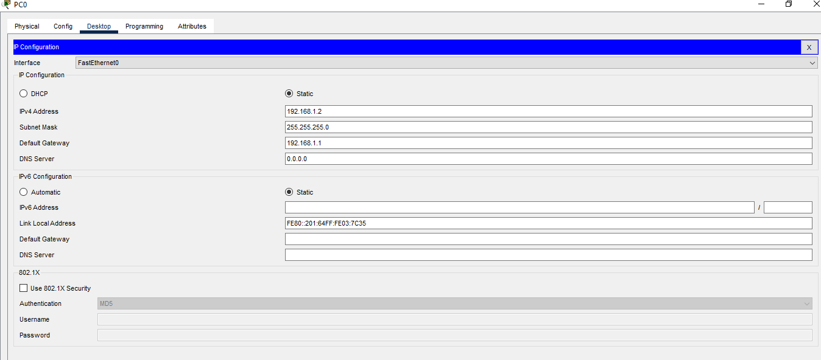

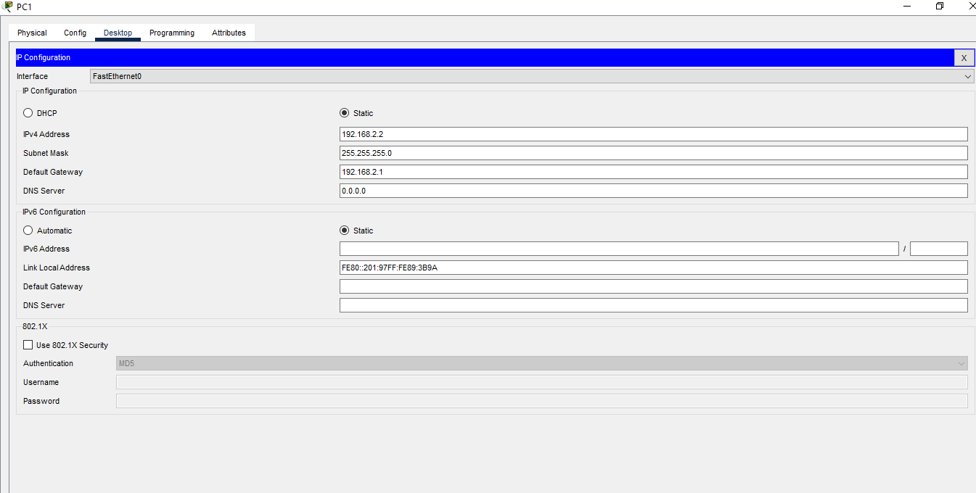

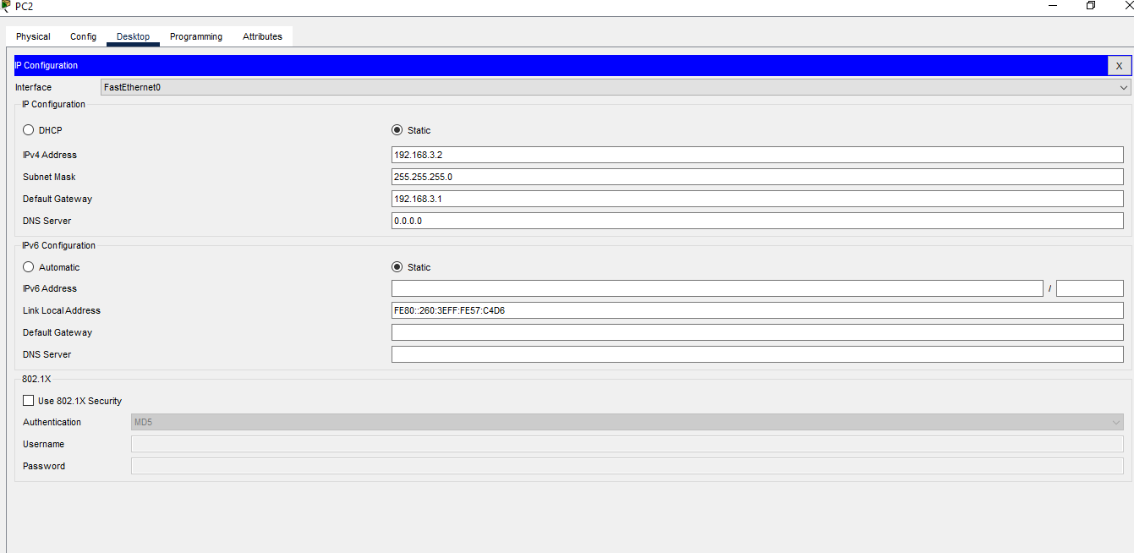

***Now configuring the Serial and Fast Ethernet Interfaces for all the Routers***

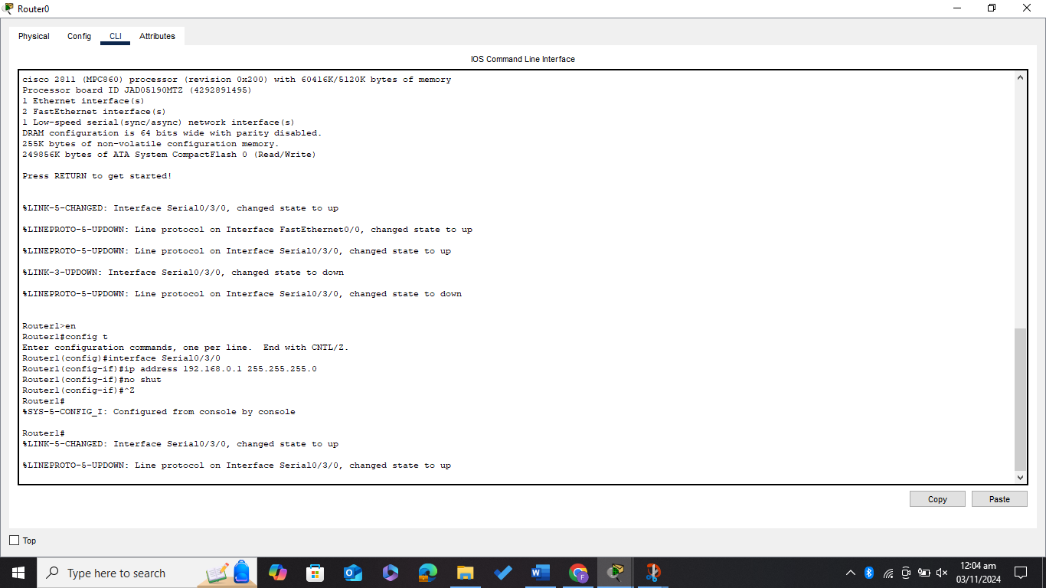

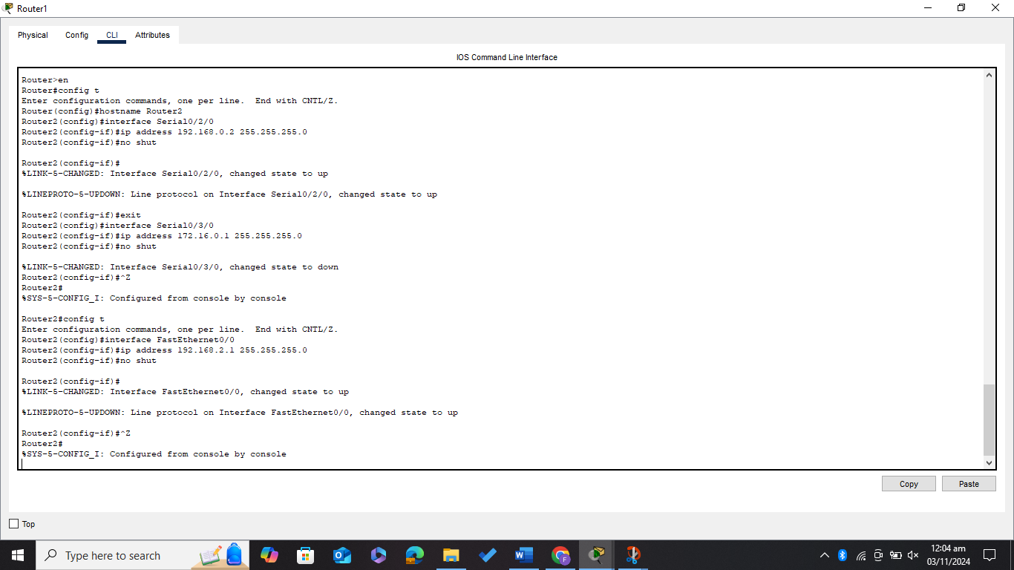

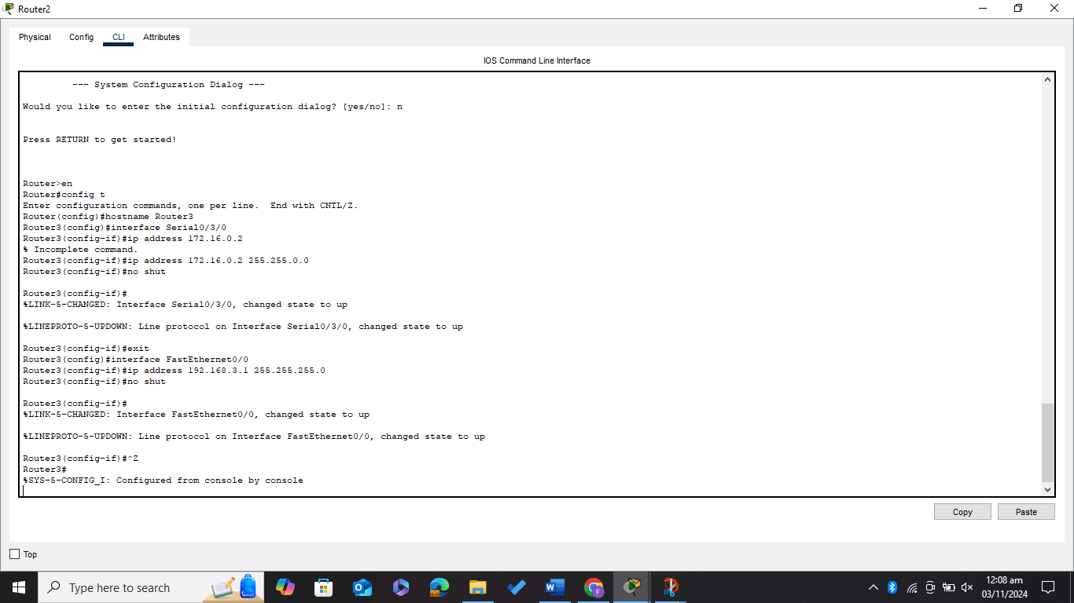

***All the connection becomes green (all interfaces are up)***

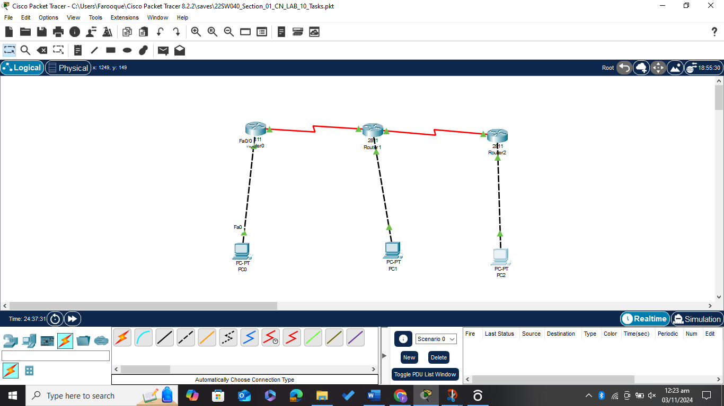

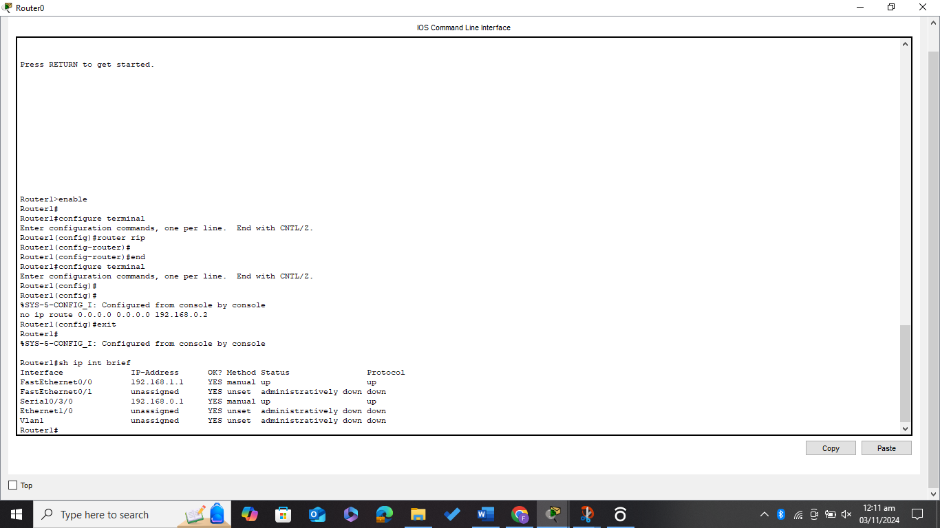

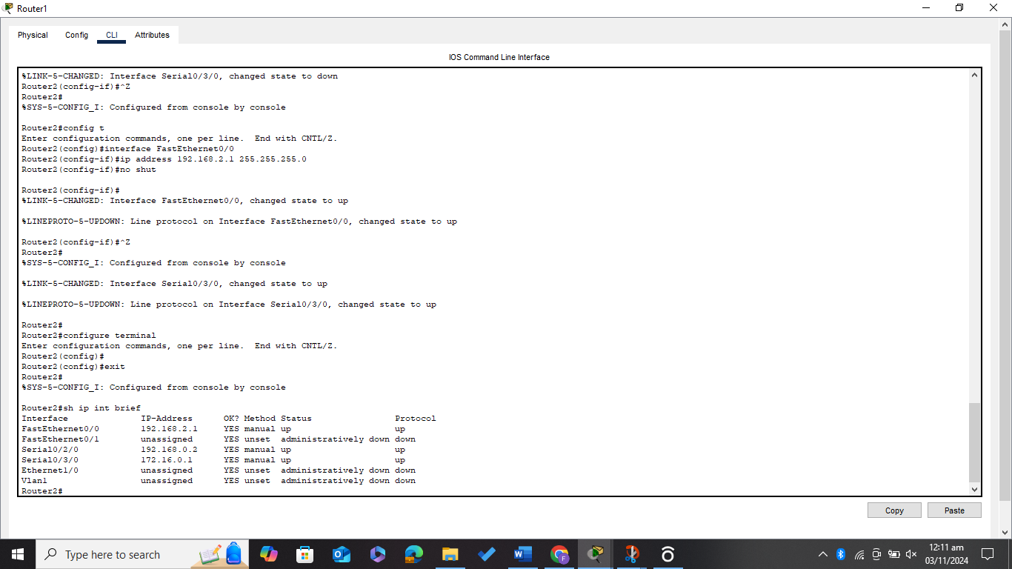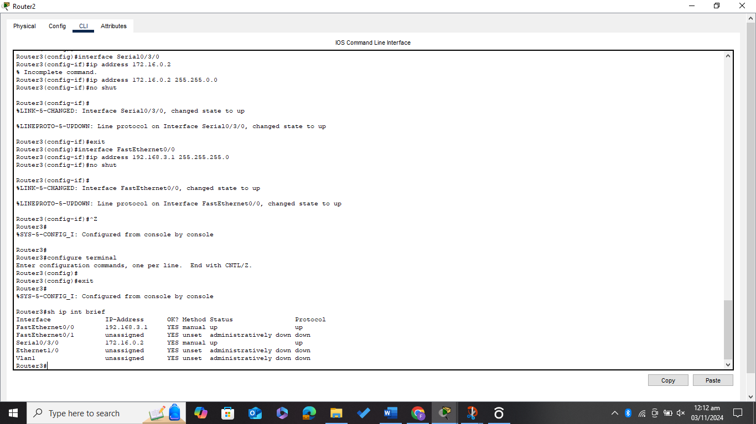

***Running the command (sh ip route and s hip int brief) on both the Routers***

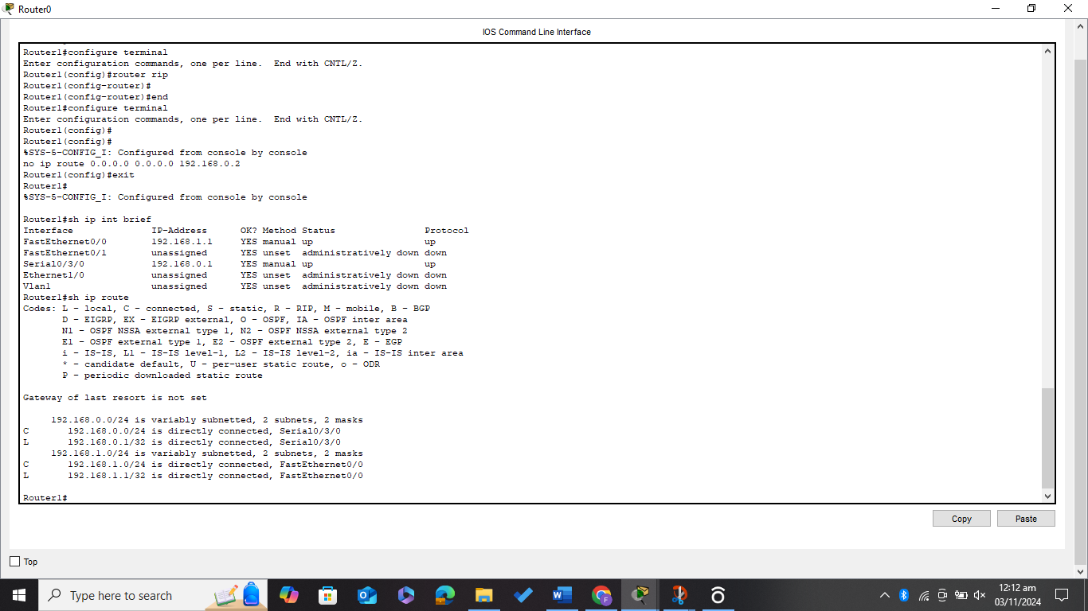

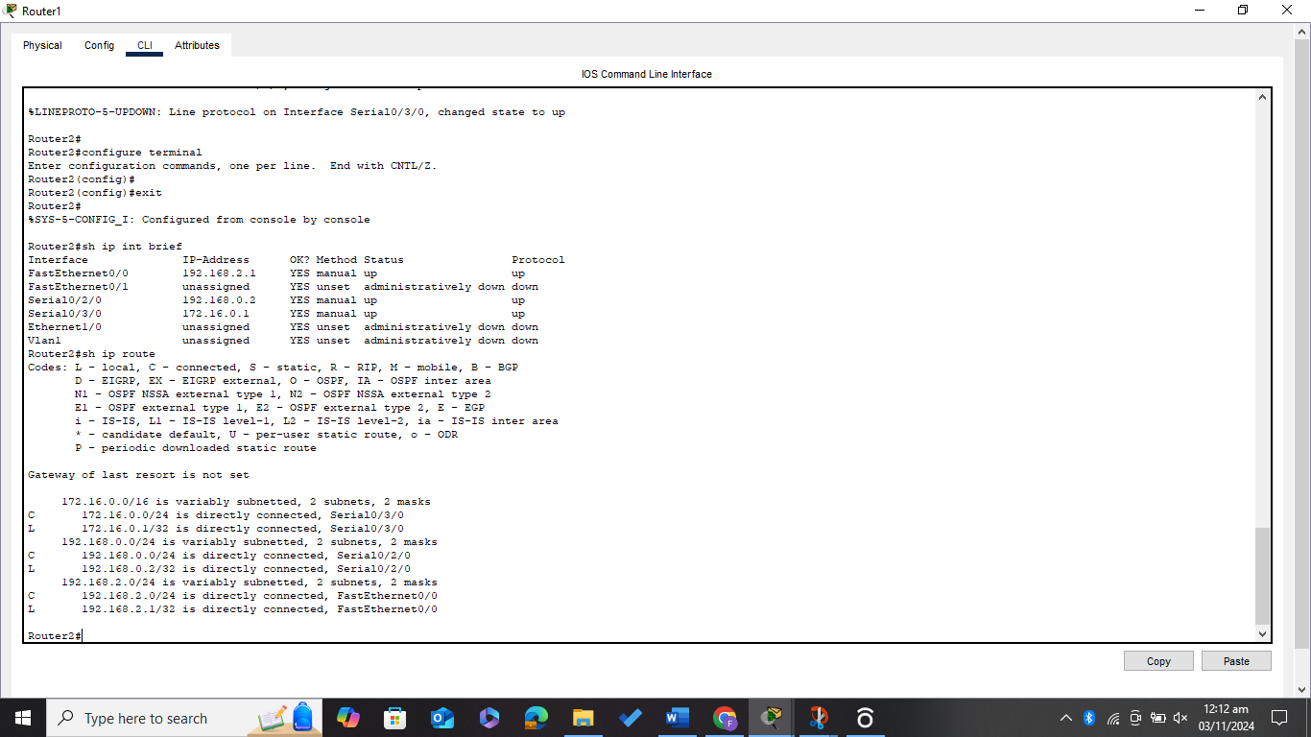

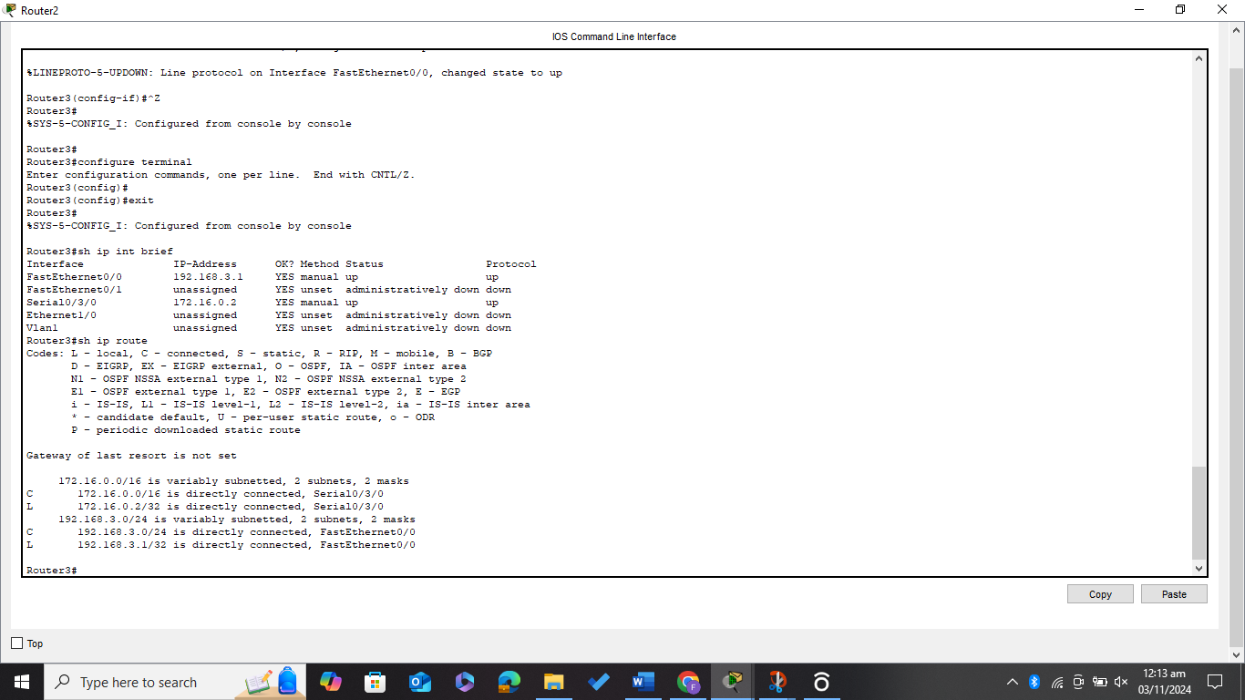

***Now Doing RIP Routing between all the connected Routers***

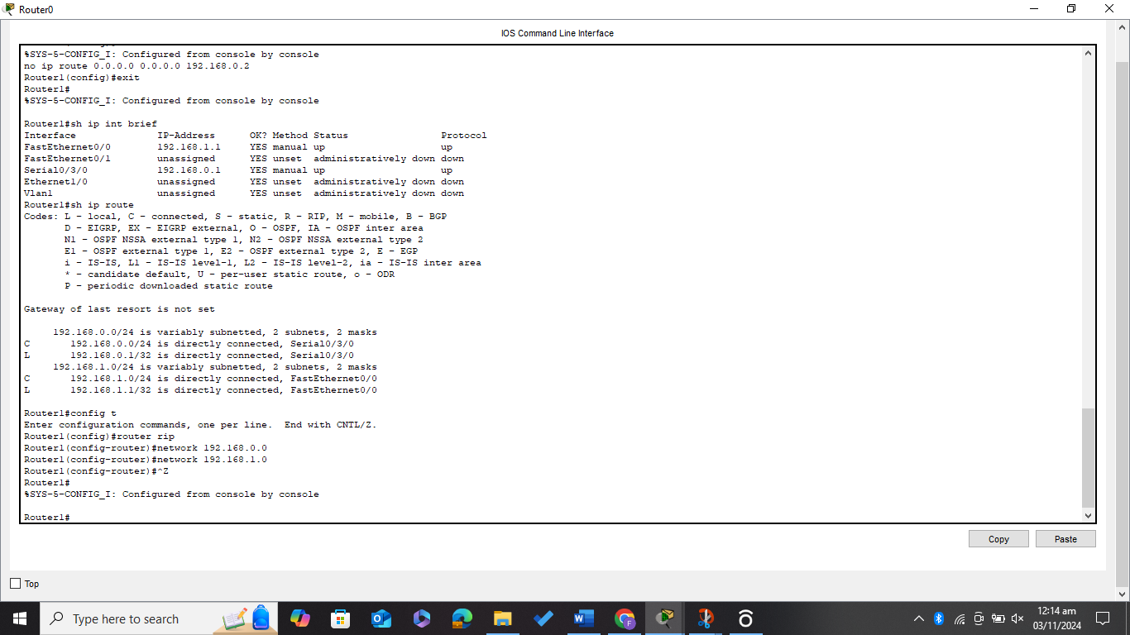

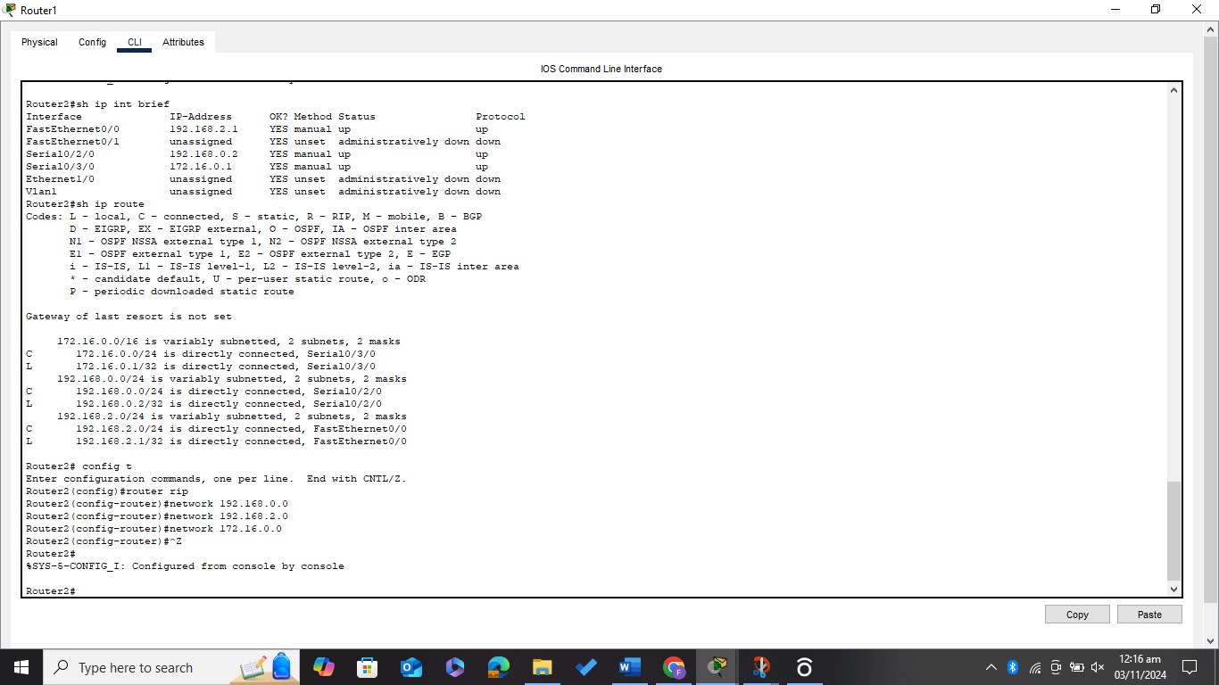

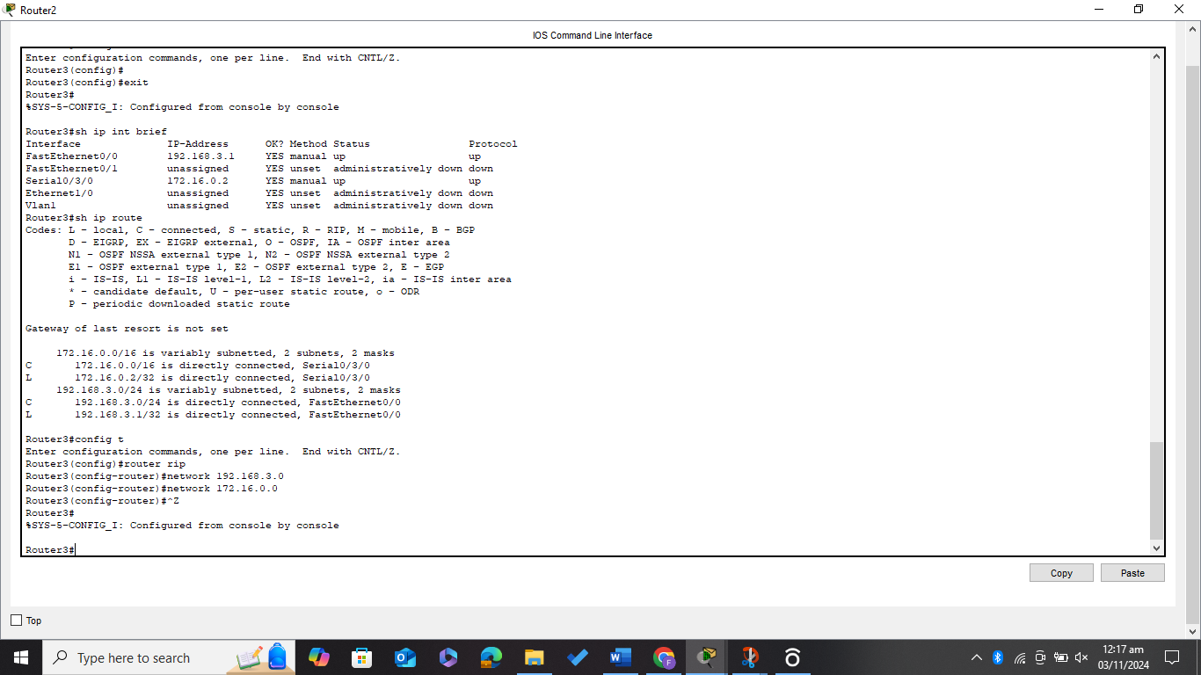

***Again, Running the Command (s hip route) to reflect the Dynamic routing***

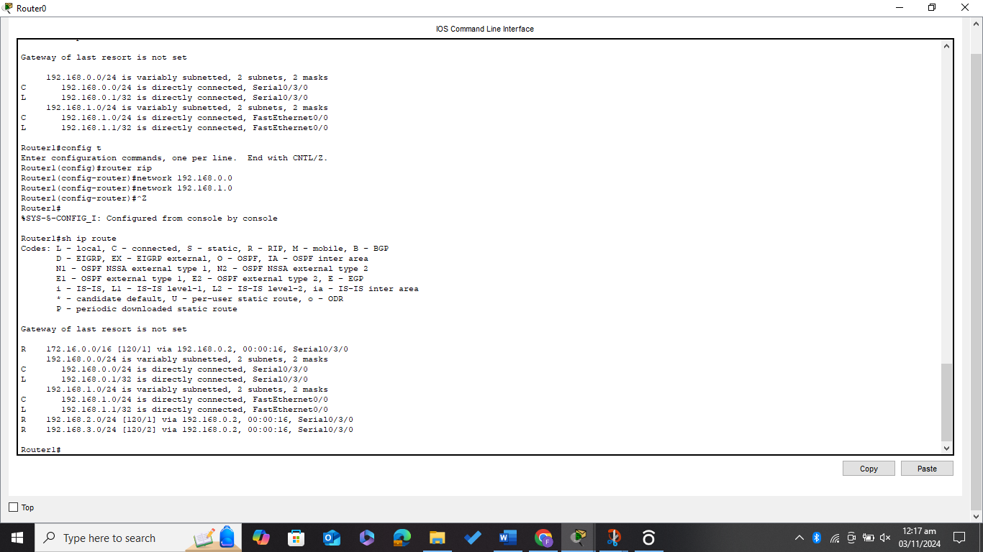

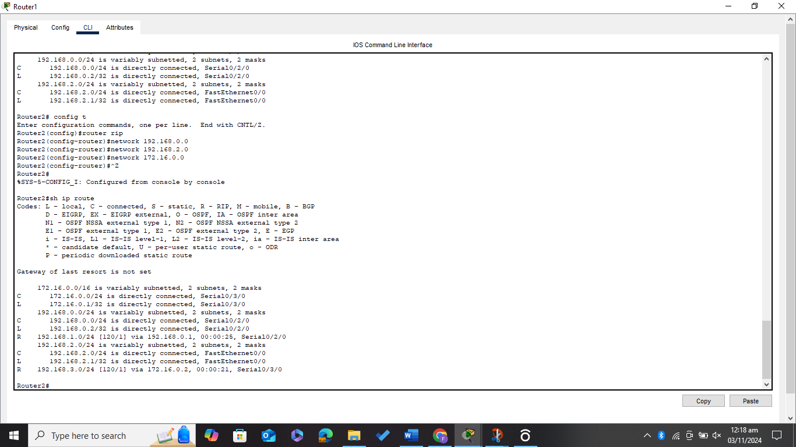

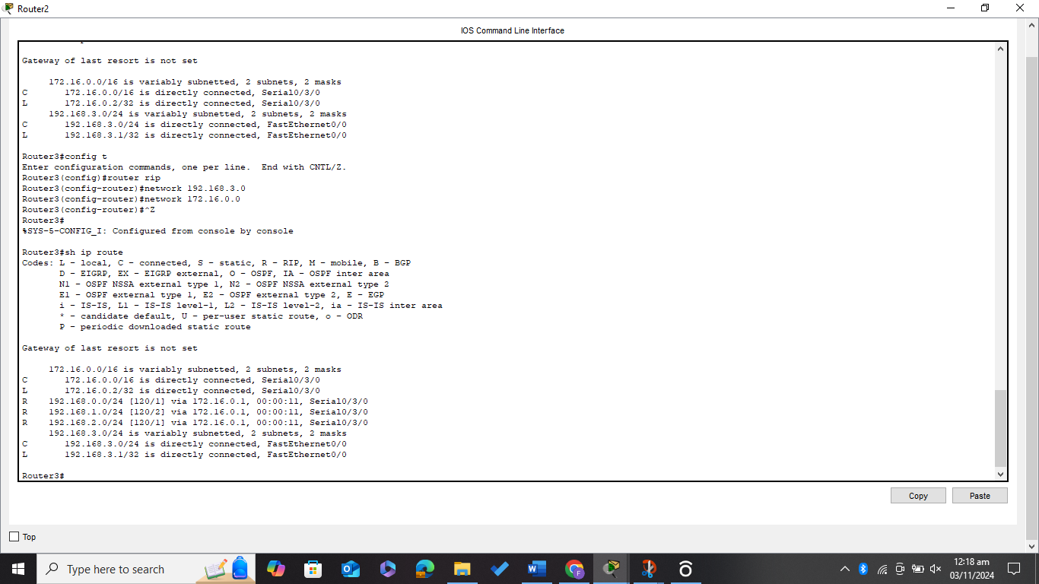

***Now Running the ping command from PC0, PC1, and PC2 for all the connections***

