|  |  |
| --- | --- |
| ***Roll No*** | ***22SW040 🡪 Section_01*** |
| ***Name*** | ***Farooque Sajjad*** |
| ***Subject*** | ***CN Practical (LAB_11)*** |
| ***Teacher*** | ***Ma’am Aisha*** |

***ANSWERING THE QUESTIONS MENTIONED IN THE HANDOUT***

***Q1(a):* *Check the interfaces on both routers with the commands show ip interface brief or show interface.***

***See the screenshots below***

***Q1(b): If an interface gets down, will it retain the IP address or not?***

*When an interface goes down, it will retain its IP address configuration. The interface status will change to "down," but the IP address configuration remains in place. This allows the interface to resume operation with the same IP address once it comes back online.*

***Q2: Why do routers reflect network addresses only?***

*Routers reflect network addresses only because routing tables are designed to store routes to networks or subnets, not individual host addresses. By reflecting network addresses, routers can route packets to the appropriate network, where further routing or switching will determine the specific host destination. This method is more efficient and reduces the size of routing tables.*

***Q3: What does "/65" represent in the routing table?***

*In the OSPF routing table, the value “/65” represents the OSPF metric or cost associated with reaching a specific network. OSPF uses a cost value to determine the best route to a destination, and lower costs are preferred. The metric of 65 here shows the cumulative cost from the router to the destination network, accounting for the link costs along the route.*

***Q4: List the remote routes listed in the routing table of Router2.***

*In Router2’s routing table, the remote routes learned via OSPF include:*

*“192.168.1.0/24” via “192.168.0.1”*

*“192.168.3.0/24” via “172.16.0.2”*

*These routes are identified with an “O” prefix in the routing table, indicating they were learned via OSPF.*

***TASK***

***First drag and drop 3 routers and pcs***

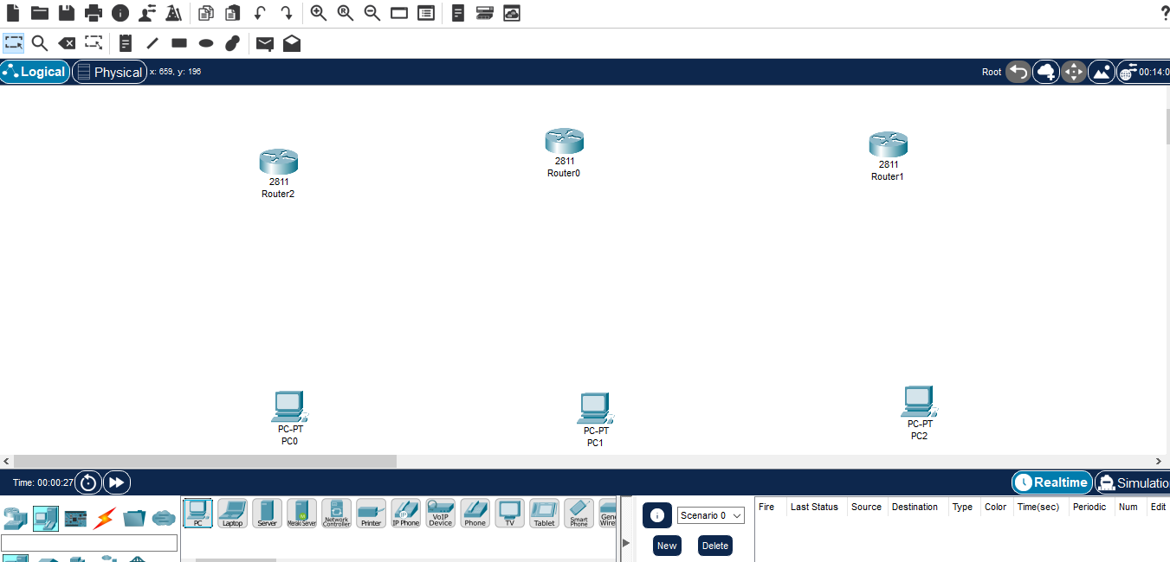

***Then adding NM1E and WICIT to each of the router***

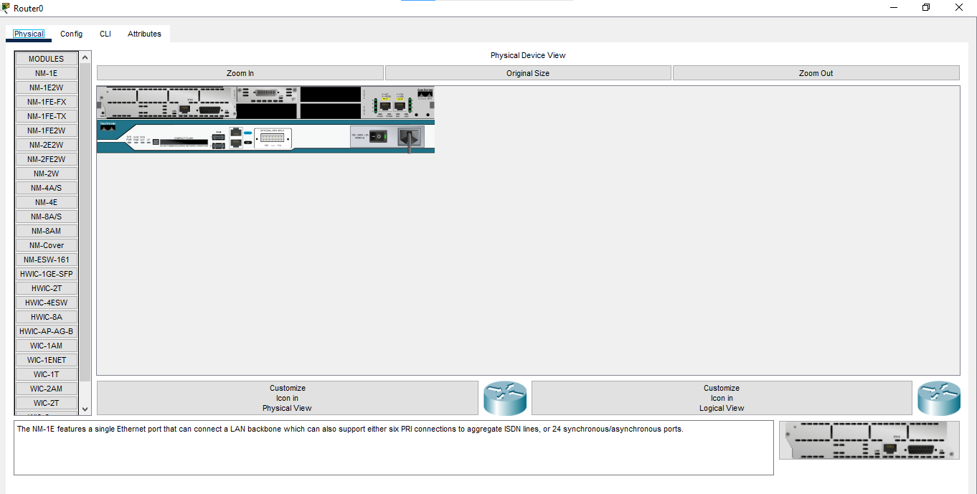

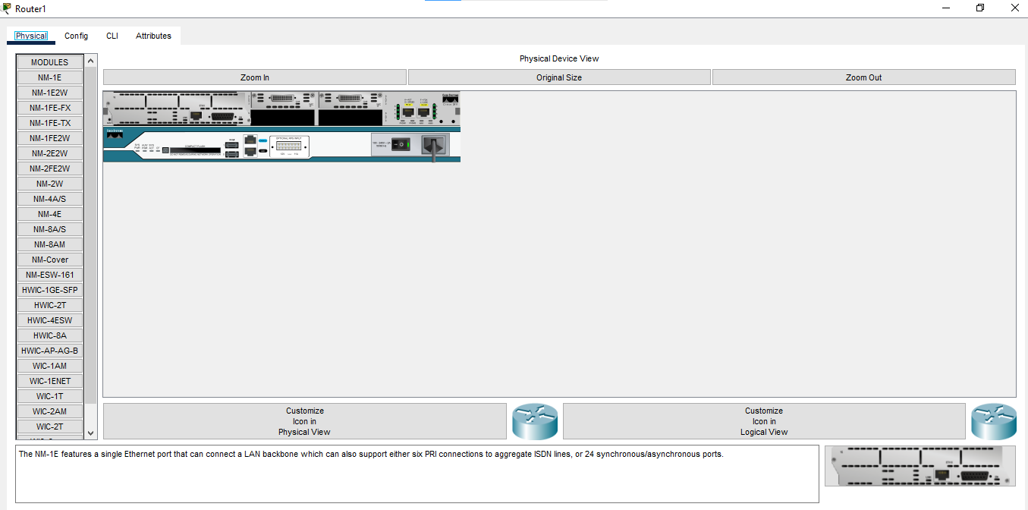

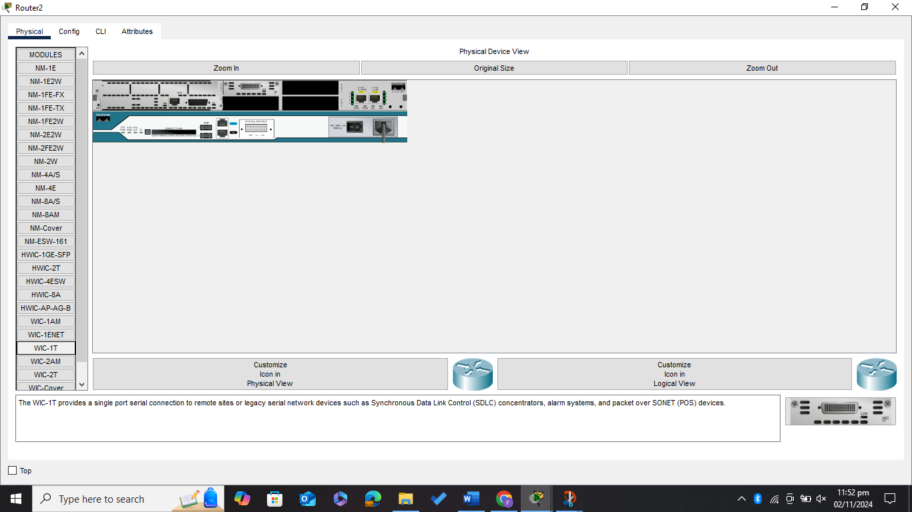

***Now connecting routers and pcs***

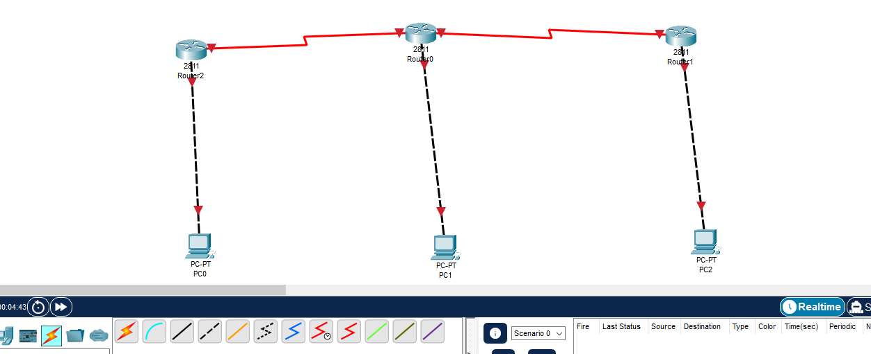

***Assigning the IP addresses to the connected pcs***

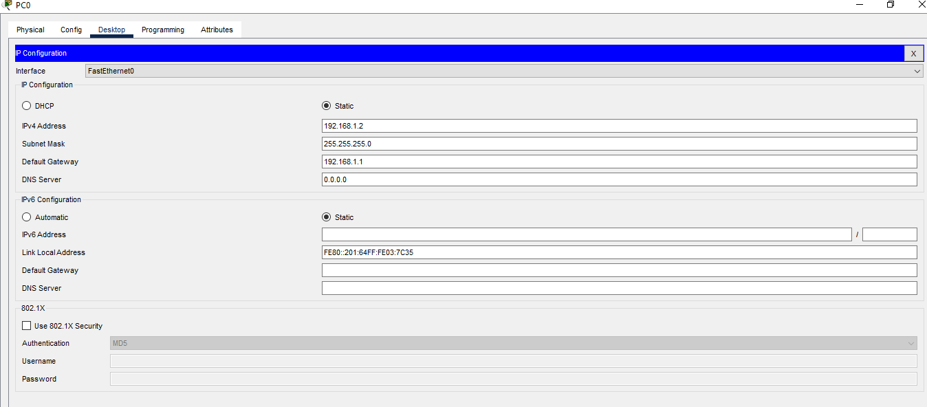

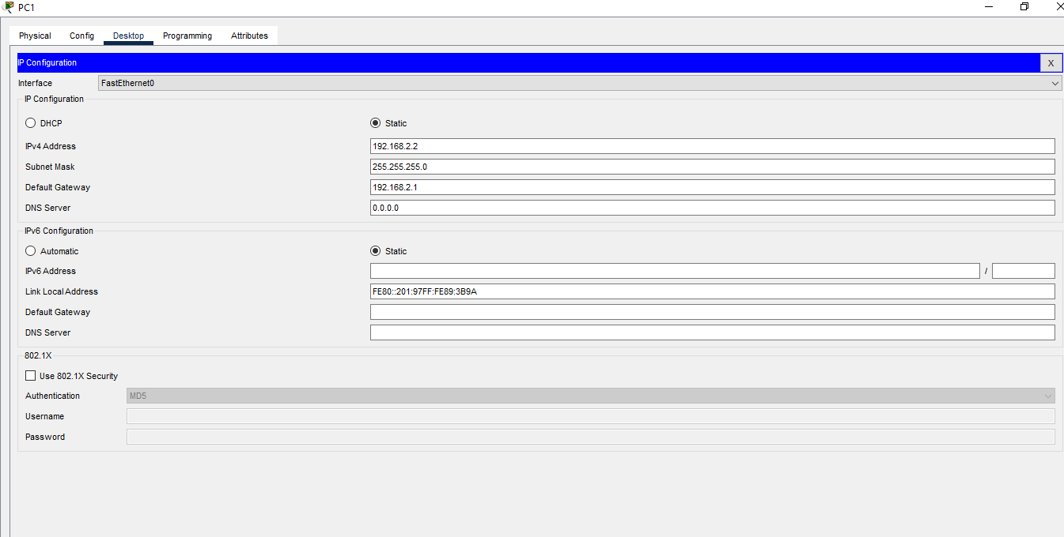

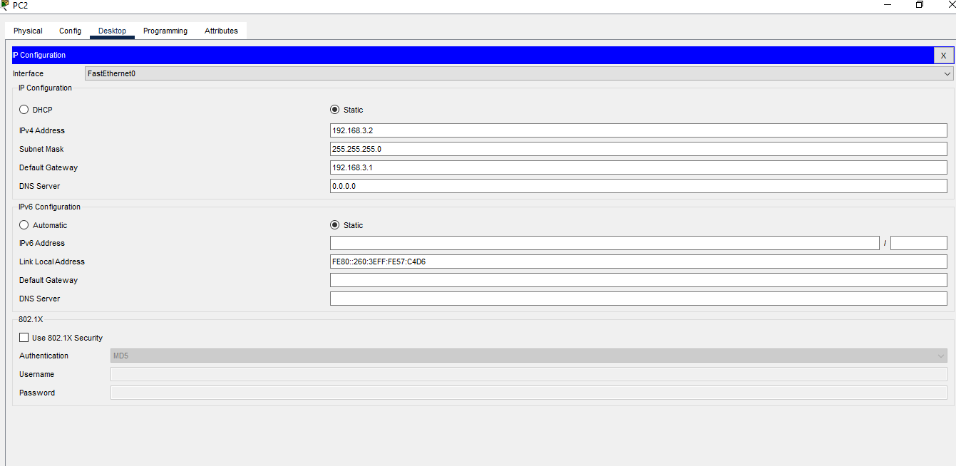

***Now configuring the Serial and Fast Ethernet Interfaces for all the Routers***

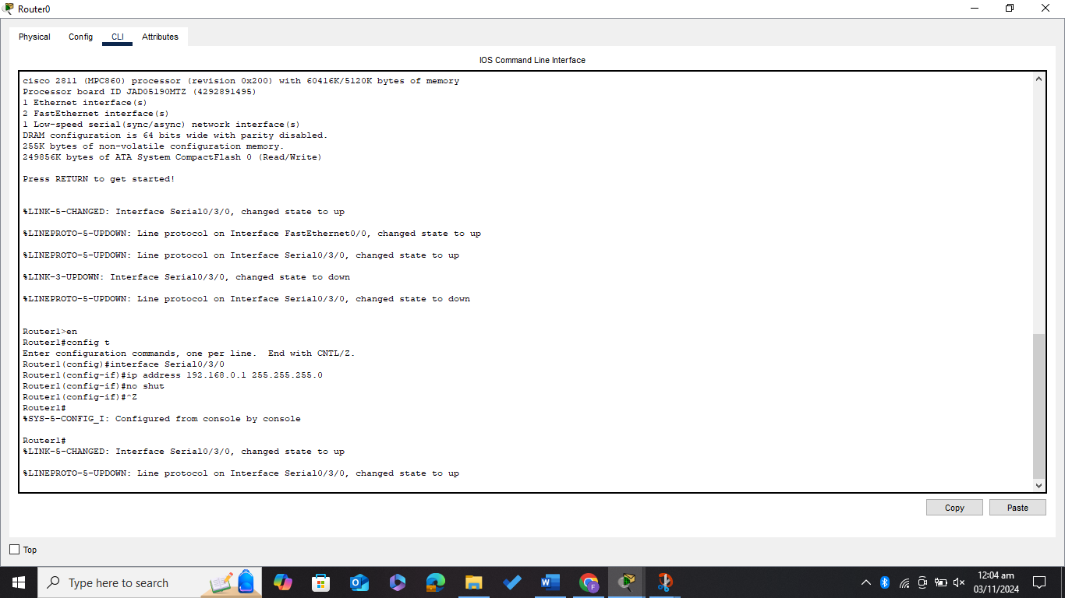

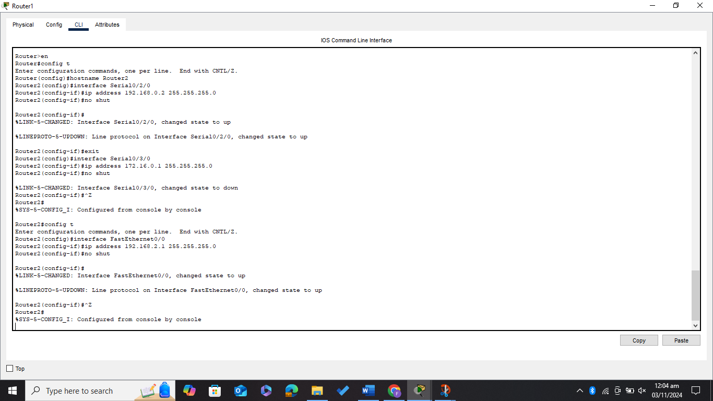

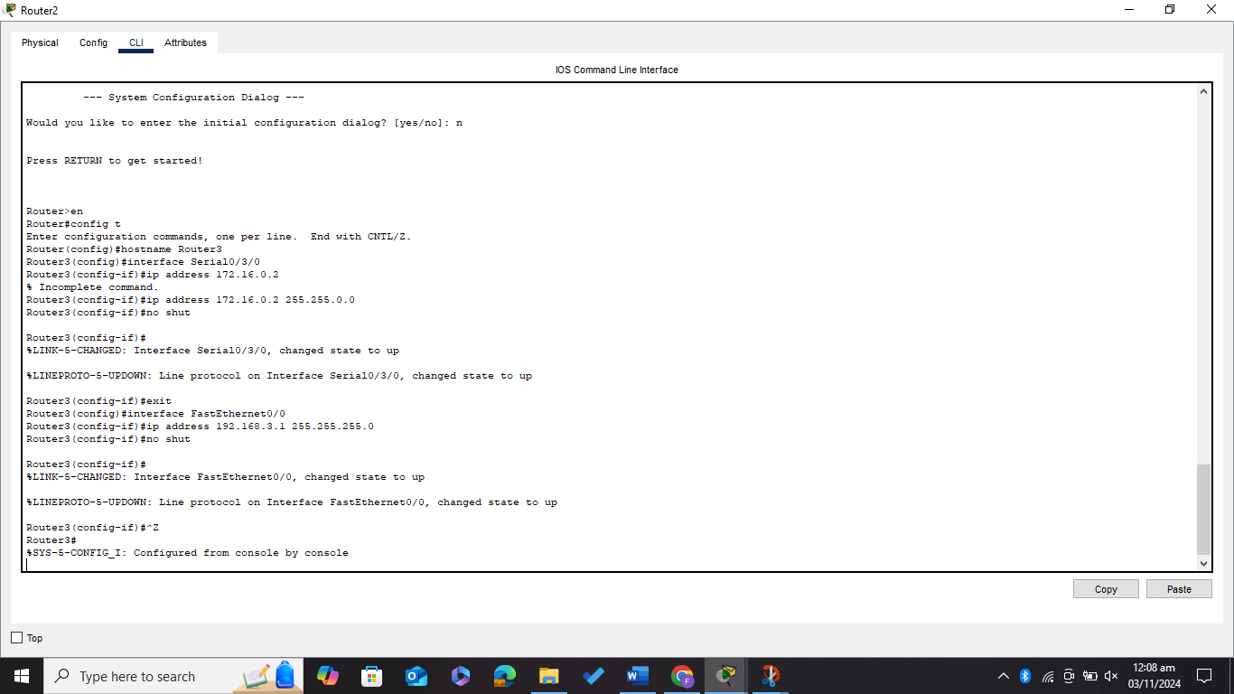

***All the connection becomes green (all interfaces are up)***

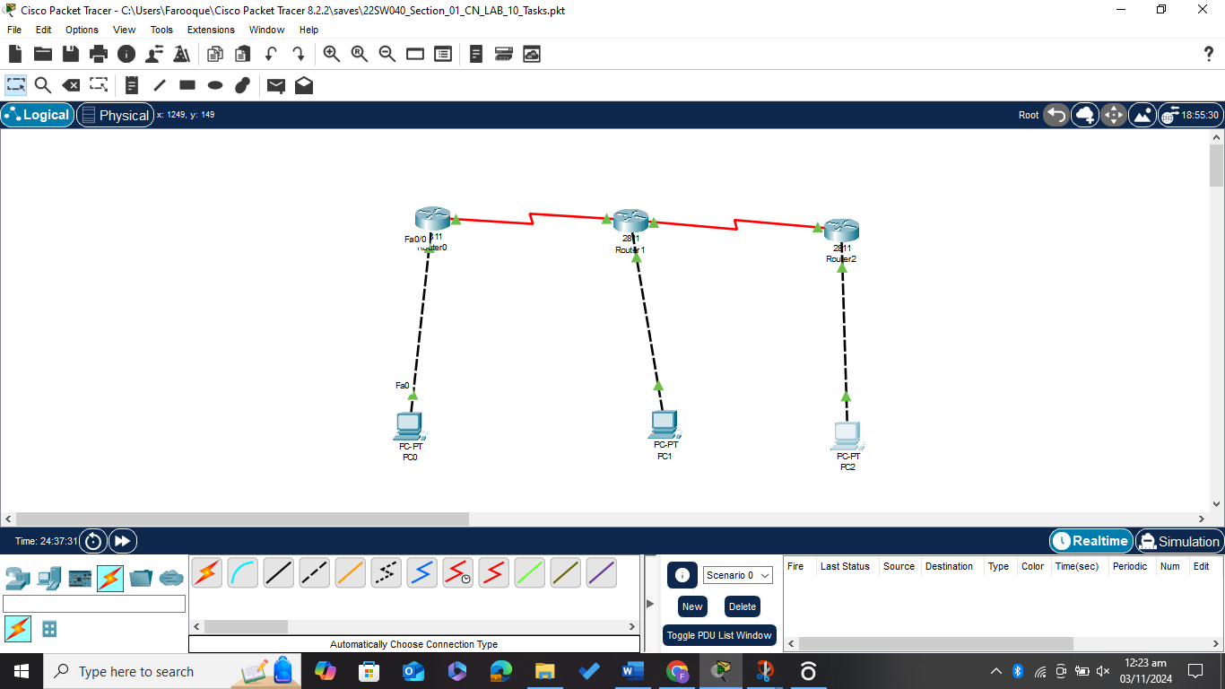

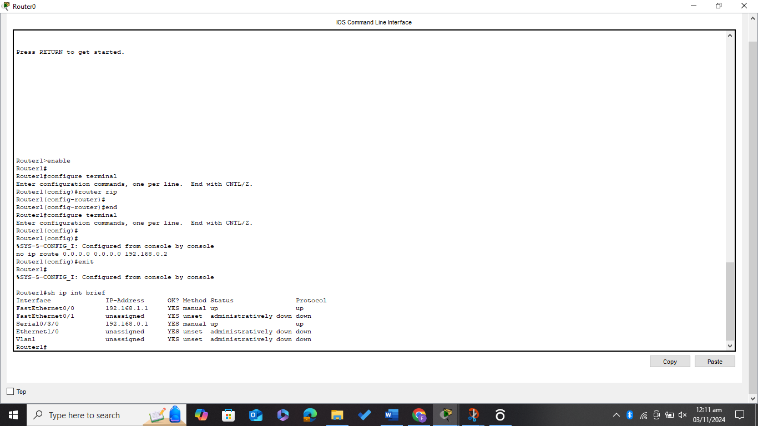

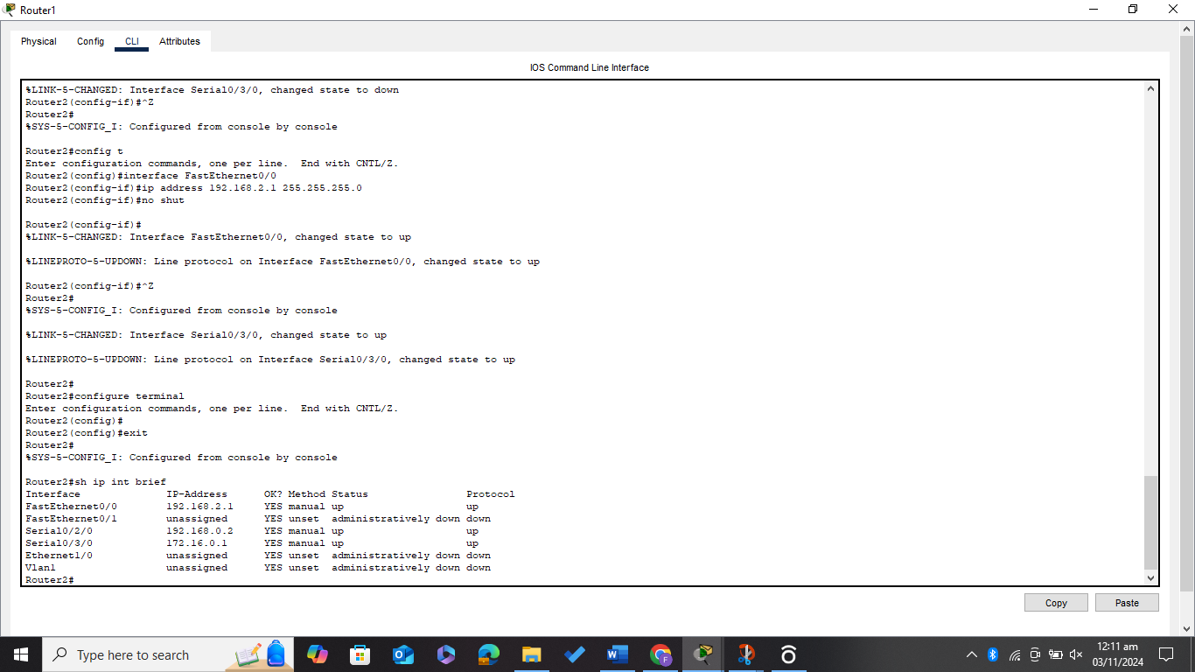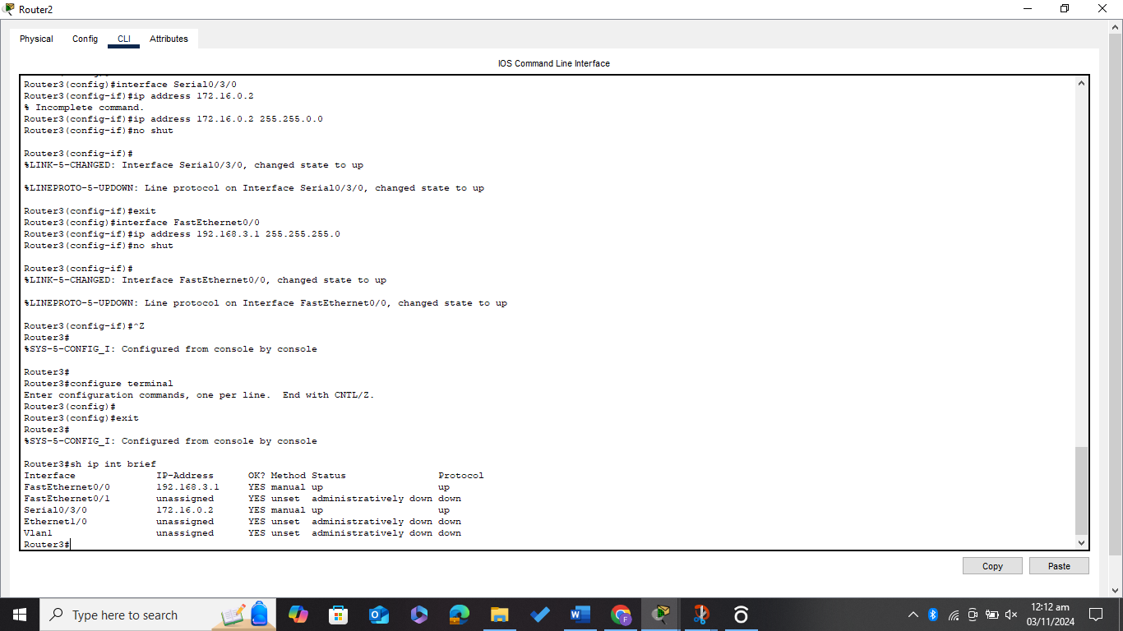

***Running the command (sh ip route and s hip int brief) on all the Routers***

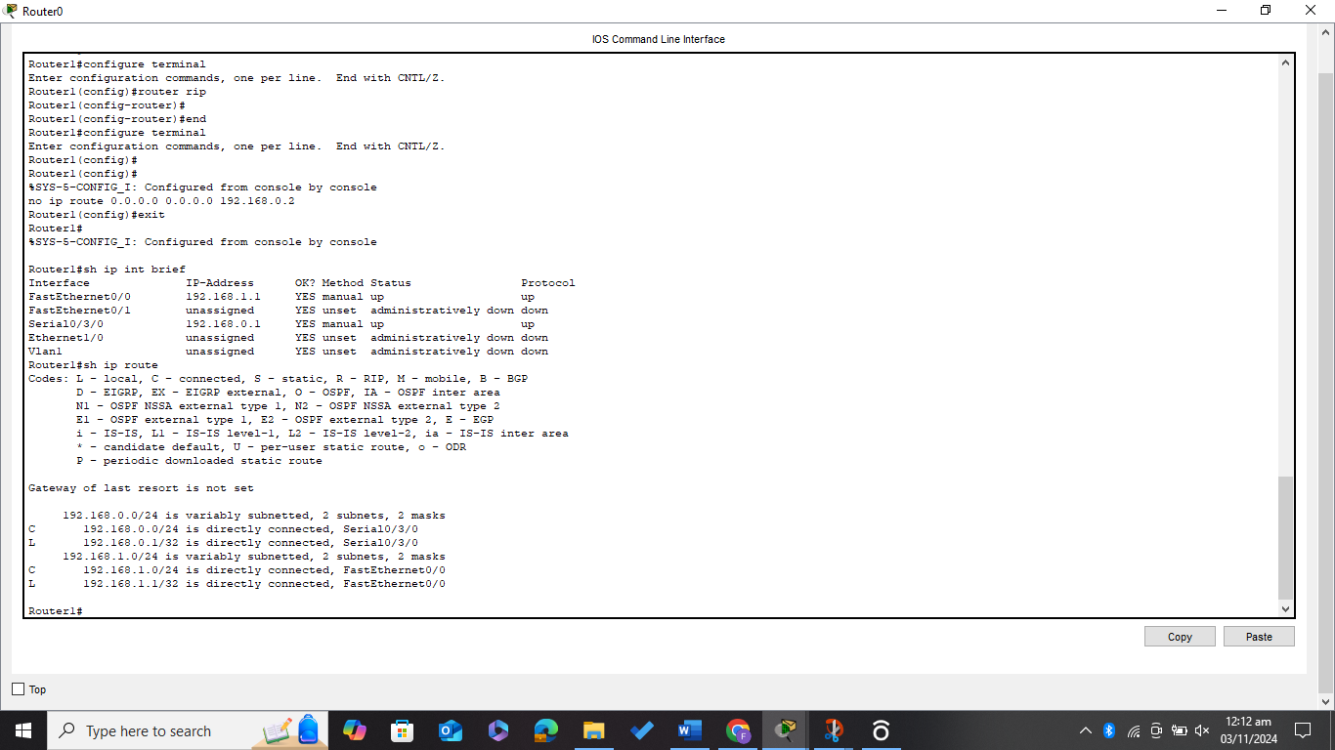

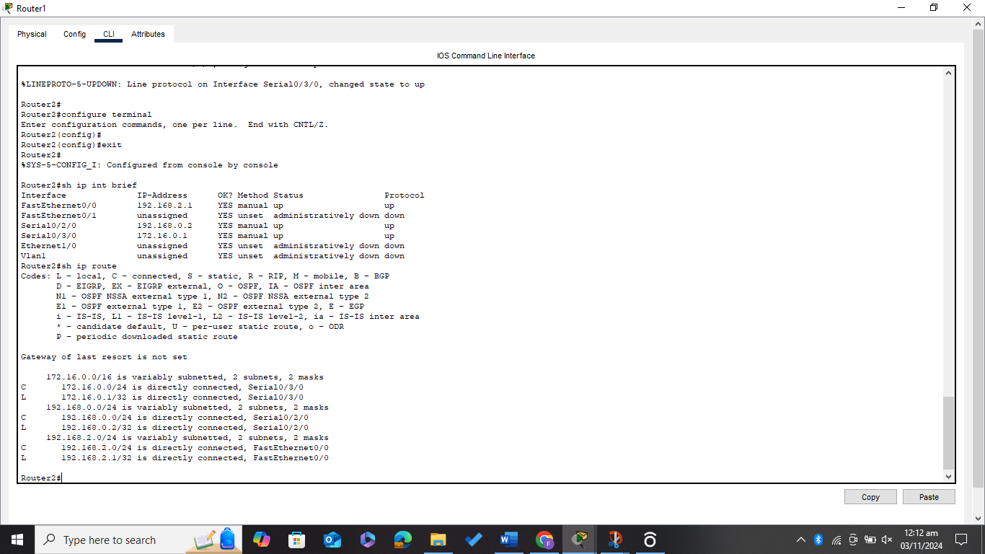

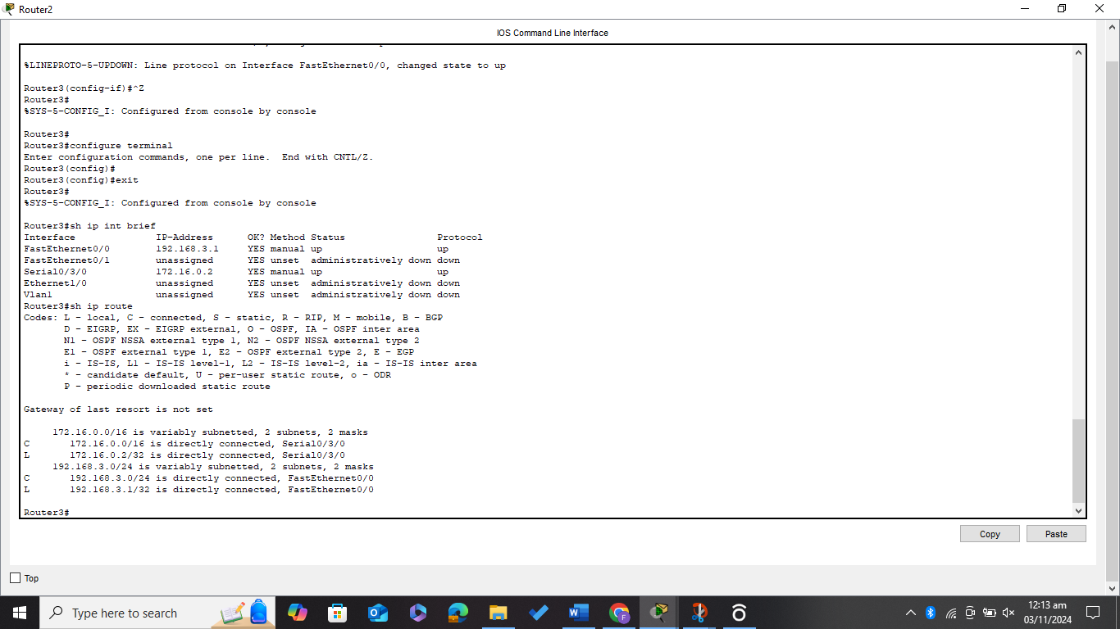

***Now Doing OSPF routing between all the connected Routers***

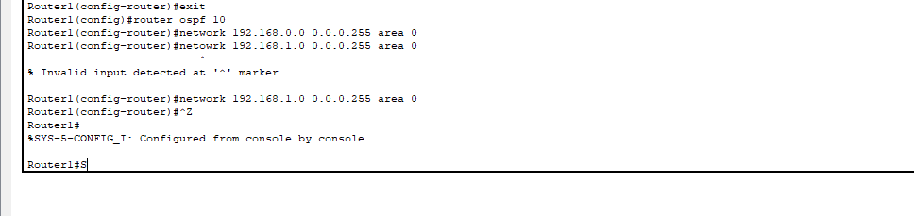

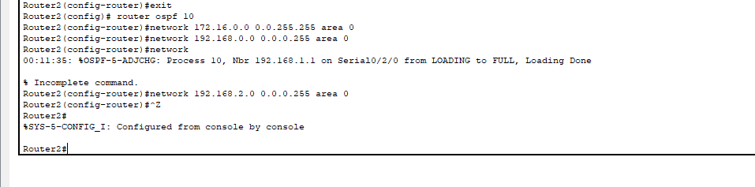

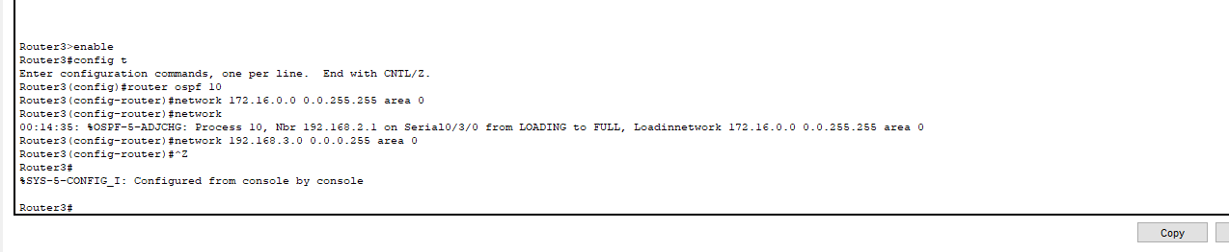

***Again, Running the Command (s hip route) to reflect the OSPF routing***

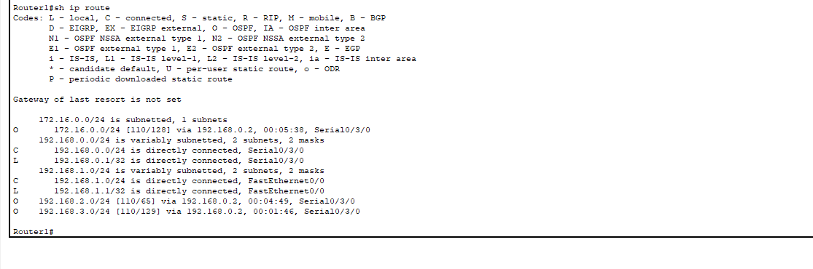

***Now Running the ping command from PC0, PC1, and PC2 for all the connections***



