|  |  |
| --- | --- |
| ***Roll No*** | ***22SW040 🡪 Section_01*** |
| ***Name*** | ***Farooque Sajjad*** |
| ***Subject*** | ***CN Practical (LAB_12)*** |
| ***Teacher*** | ***Ma’am Aisha*** |

***ANSWERING THE QUESTIONS MENTIONED IN THE HANDOUT***

***Q 1 (a). Check the interfaces on both routers with the commands show ip interface brief or show interface.***

*Yes, see the screenshots below all this have been done.*

***Q 1 (b. Can an interface configured with an IP address be in a down state?***

*Yes, an interface can be in a down state even if it is configured with an IP address. This can happen if the interface is administratively down (shut down manually by an administrator) or if there are physical or linklayer issues, such as a disconnected cable or an inactive line protocol.*

***Q 2. What are the major network entries in the Router 2 routing table?***

*In Router 2's routing table, the major network entries are:*

*192.168.0.0/24: This is directly connected to the Serial0 interface.*

*172.16.0.0/16: This is directly connected to the Serial1 interface.*

*192.168.2.0/24: This is directly connected to the Ethernet0 interface.*

*192.168.1.0/24: This is learned via EIGRP, reachable through the Serial0 interface at 192.168.0.1.*

*192.168.3.0/24: This is also learned via EIGRP, reachable through the Serial1 interface at 172.16.0.2.*

***Q 3. What does “eigrp 20” mean?***

*“`eigrp 20” refers to the Autonomous System (AS) number assigned to the EIGRP process. All routers that are part of the same EIGRP network and need to share routing information with each other must be configured with the same AS number. In this case, "20" is the chosen AS number for this network setup.*

***Q 4. What does “[90/1628160]” mean?***

*A: The notation “[90/1628160]” in the EIGRP routing table entry represents the following:*

*90: This is the administrative distance of EIGRP for internal routes. It is a measure of the trustworthiness of the route, with lower values being more preferred.*

*1628160: This is the composite metric, calculated based on EIGRP’s metric formula, which takes into account factors like bandwidth, delay, reliability, and load. The lower the metric, the more preferable the route.*

***Q 5. List the summary route for networks 192.168.0.0/26, 192.168.1.0/29, and 192.168.2.0/30.***

*To create a summary route that encompasses these networks, we need to identify the common bits across the addresses:*

*192.168.0.0/26 covers IP range from 192.168.0.0 to 192.168.0.63.*

*192.168.1.0/29 covers IP range from 192.168.1.0 to 192.168.1.7.*

*192.168.2.0/30 covers IP range from 192.168.2.0 to 192.168.2.3.*

*The smallest subnet that encompasses these ranges is 192.168.0.0/22, which covers the IP range 192.168.0.0 to 192.168.3.255.*

*Thus, the summary route is:*

*192.168.0.0/22*

***TASK***

***First drag and drop 3 routers and pcs***

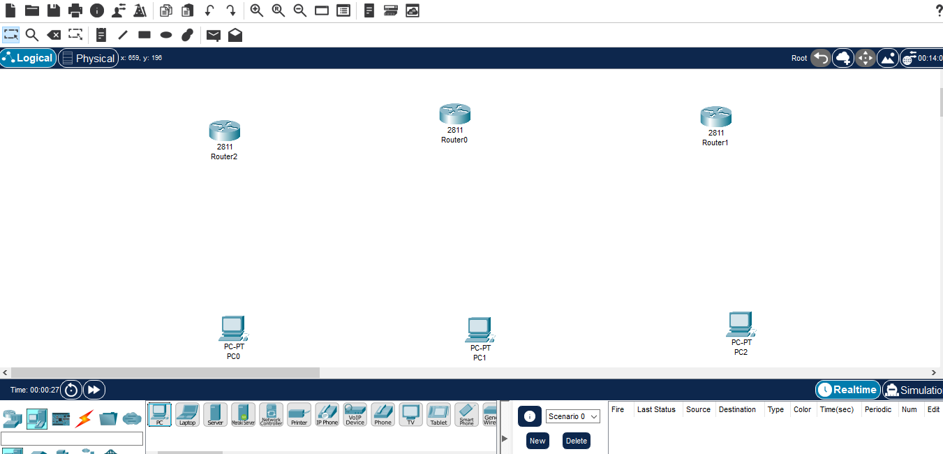

***Then adding NM1E and WICIT to each of the router***

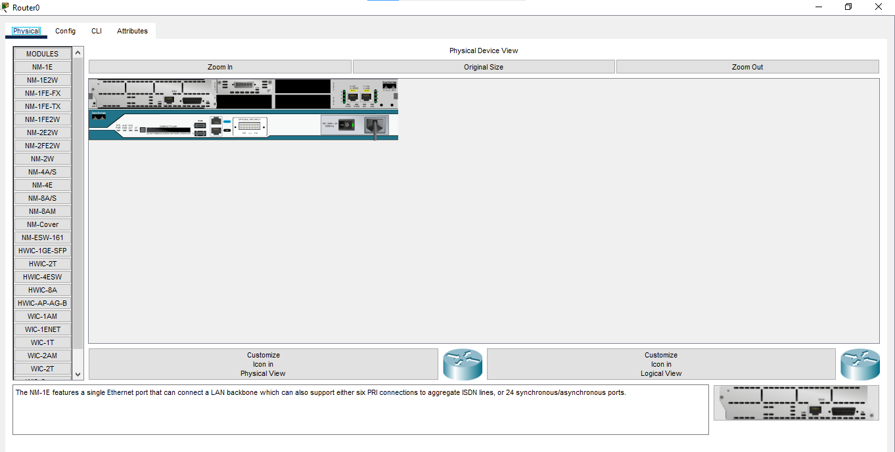

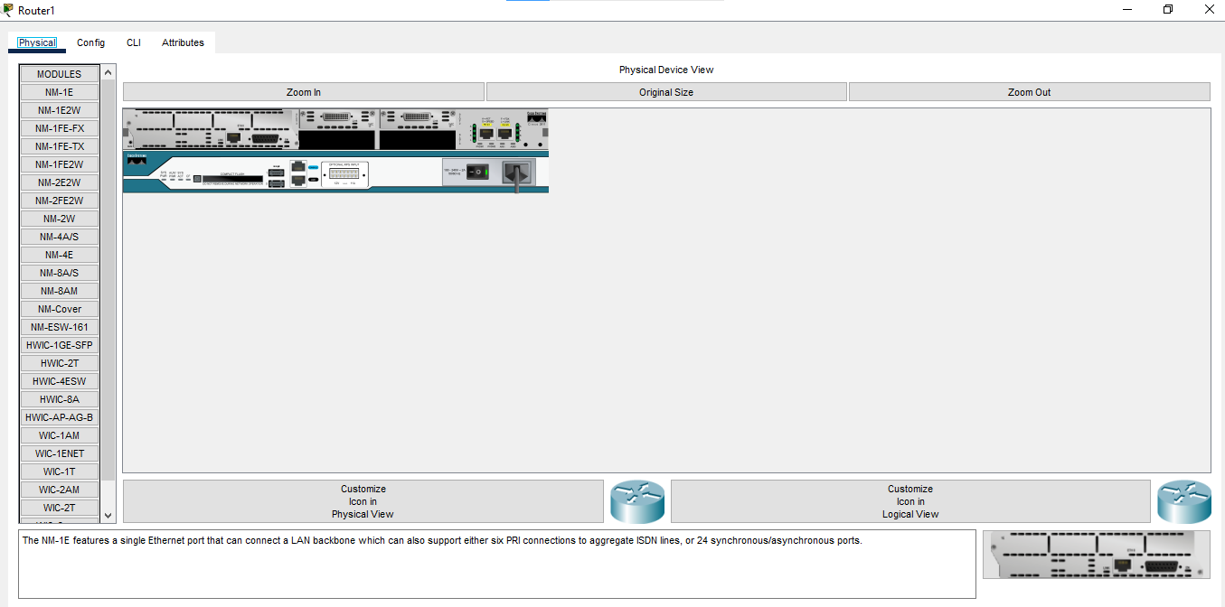

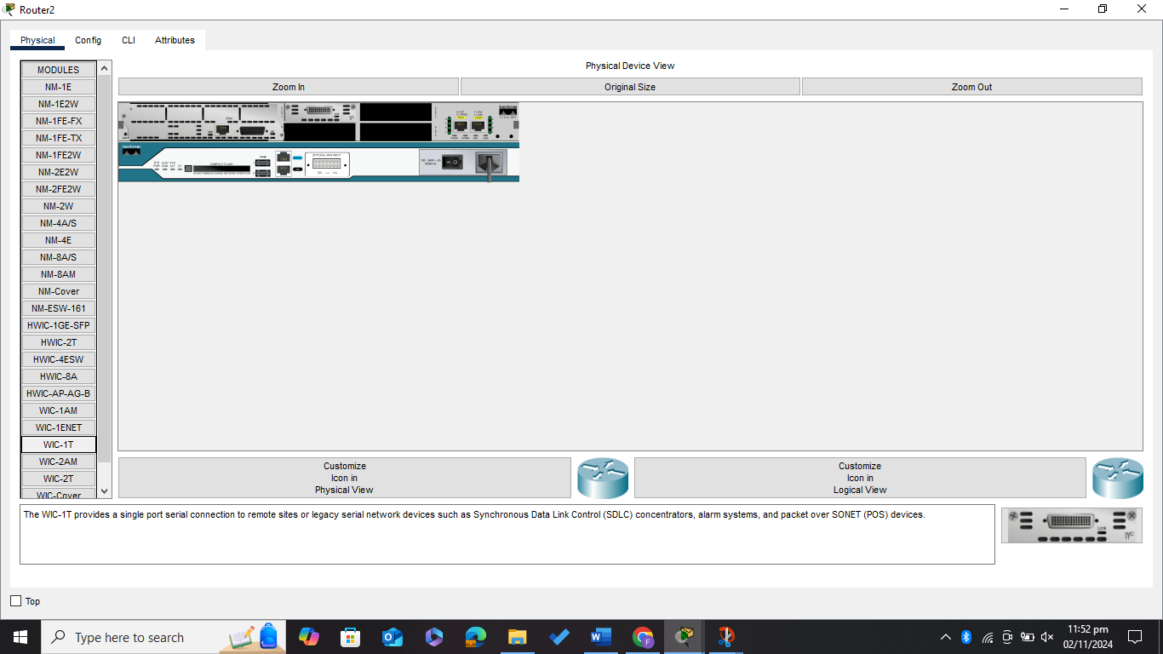

***Now connecting routers and pcs***

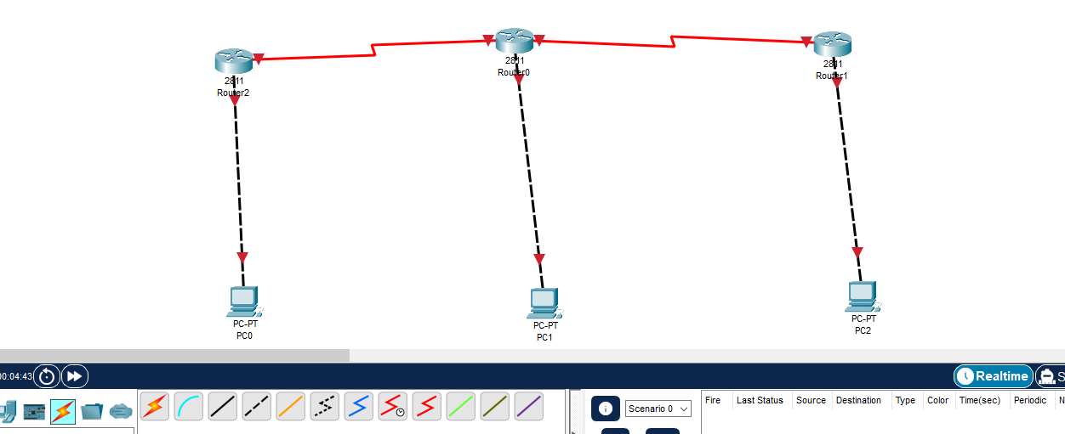

***Assigning the IP addresses to the connected pcs***

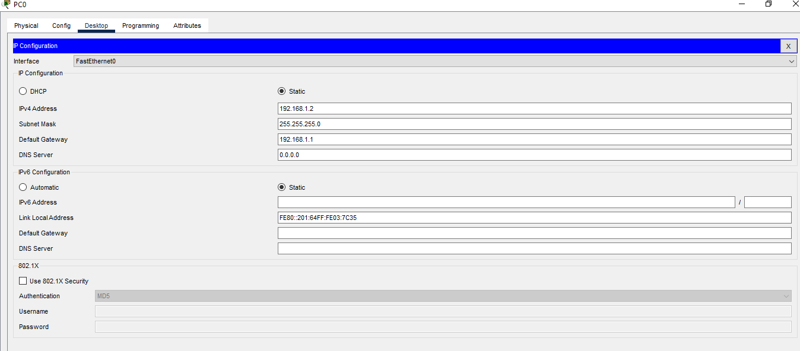

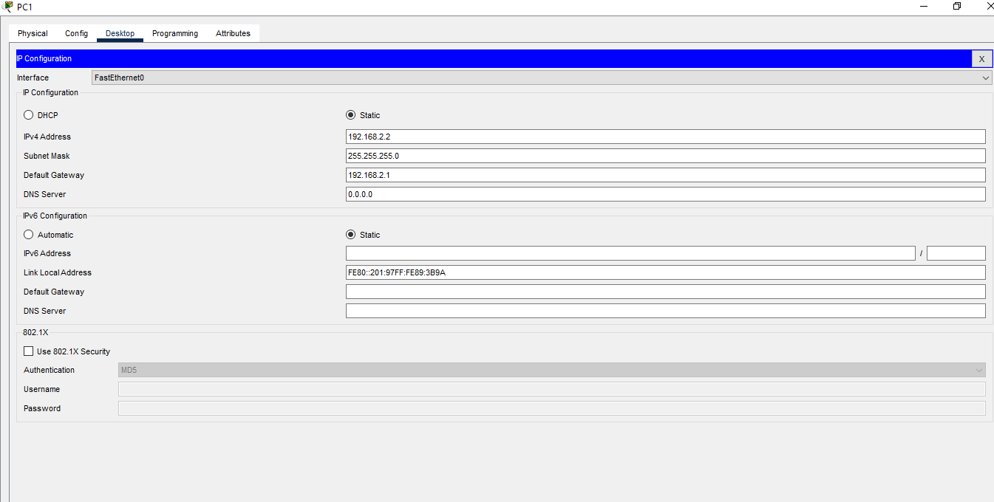

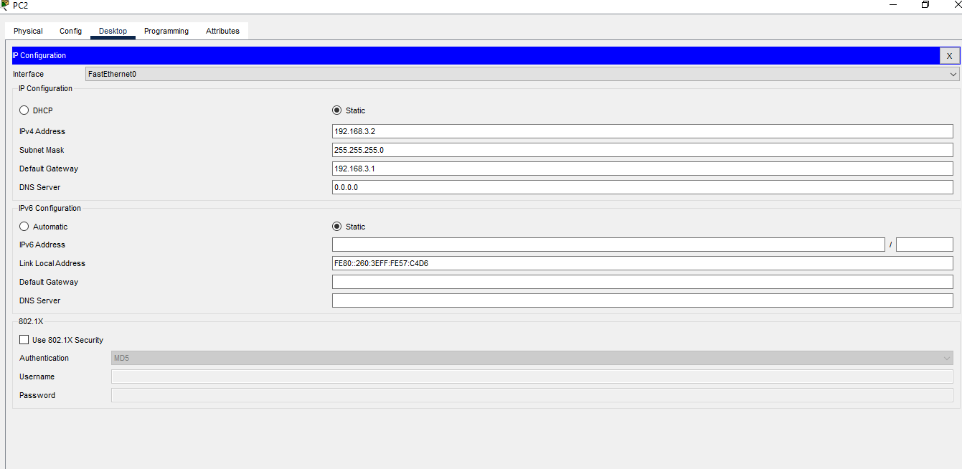

***Now configuring the Serial and Fast Ethernet Interfaces for all the Routers***

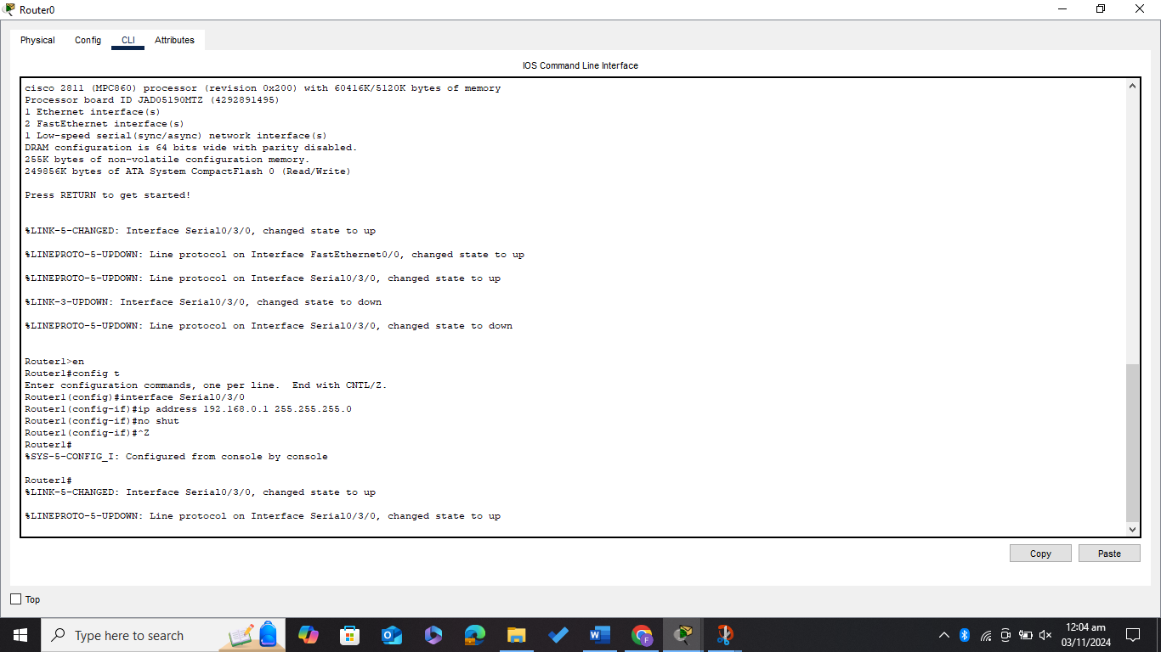

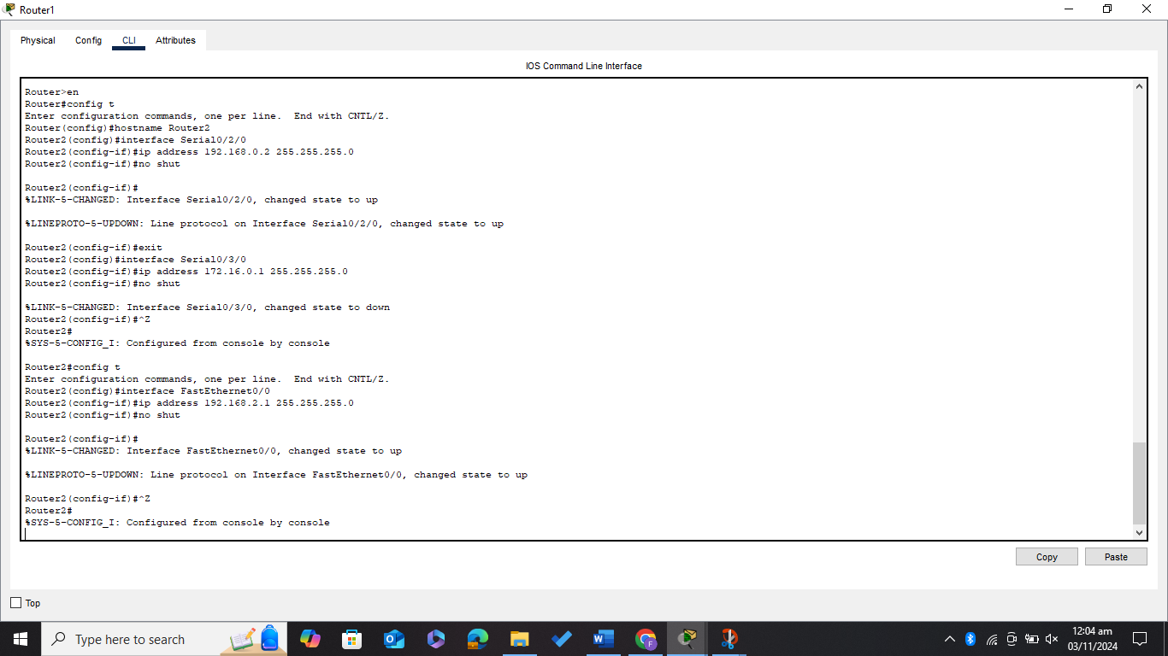

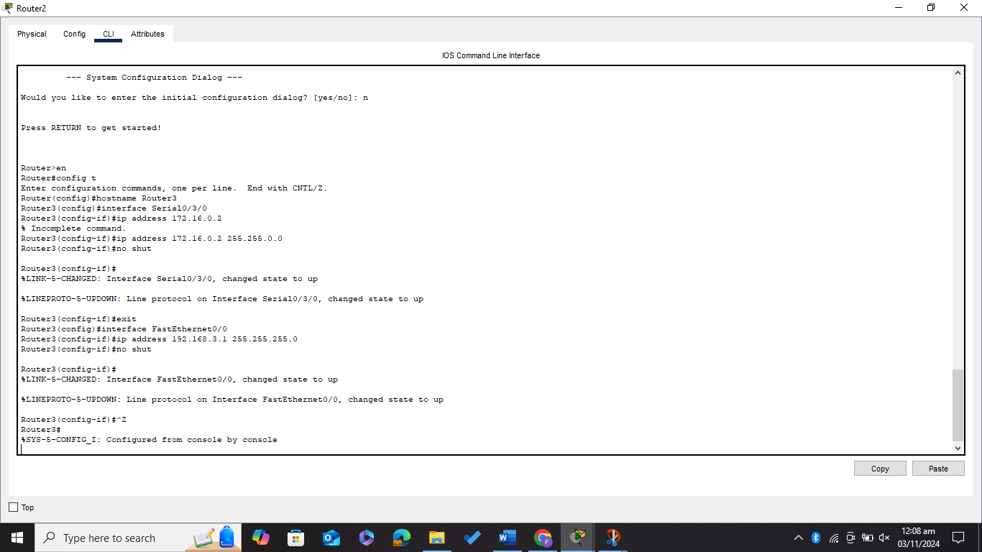

***All the connection becomes green (all interfaces are up)***

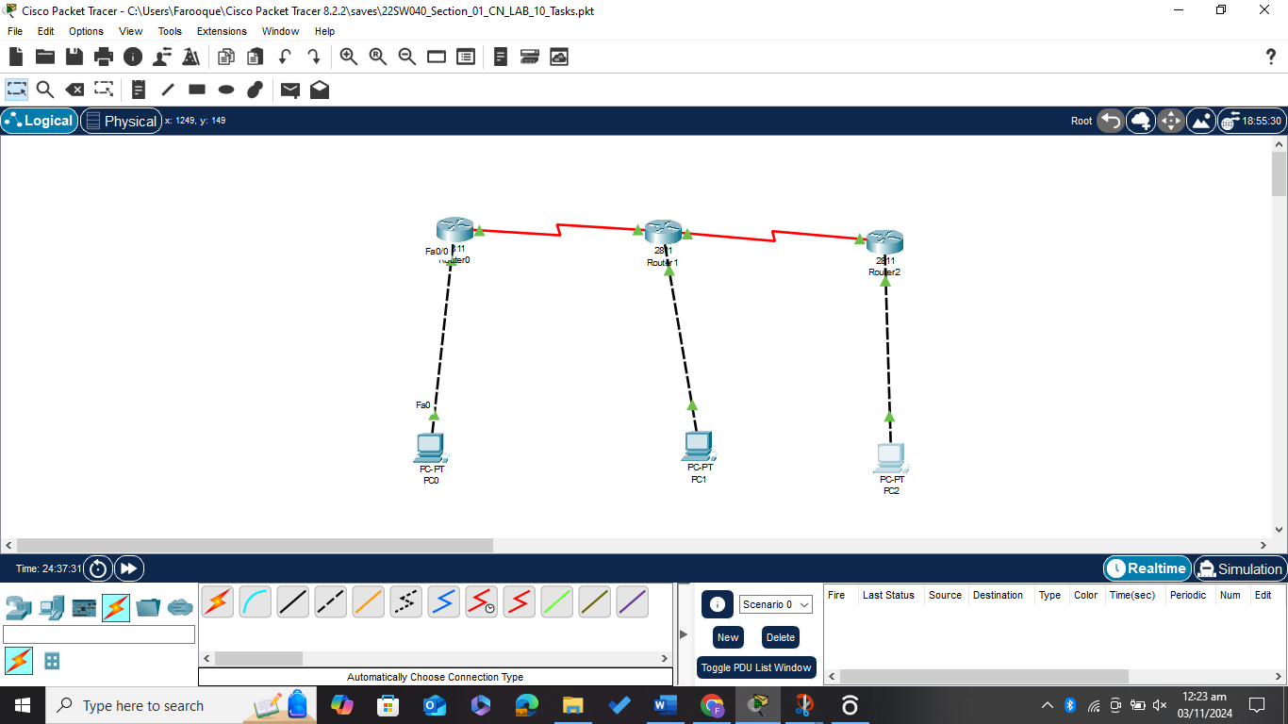

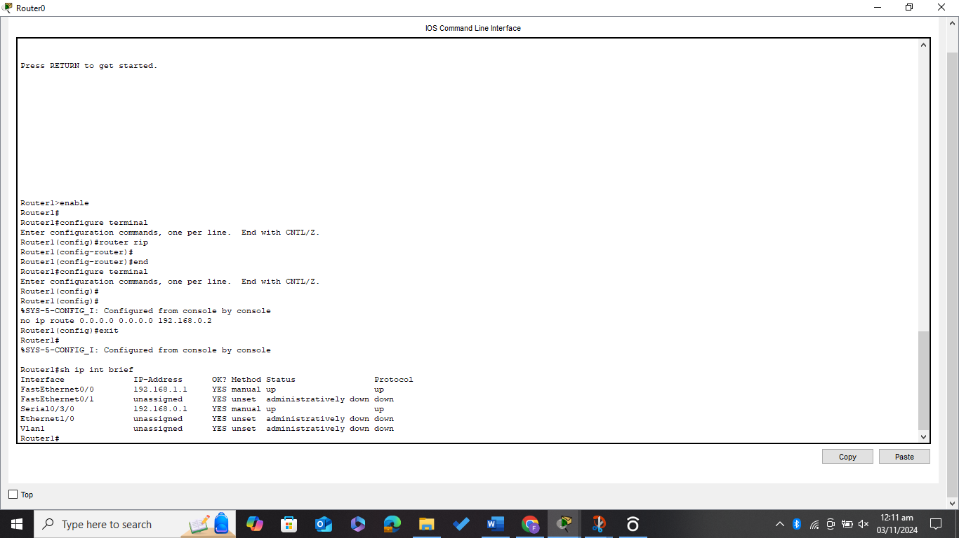

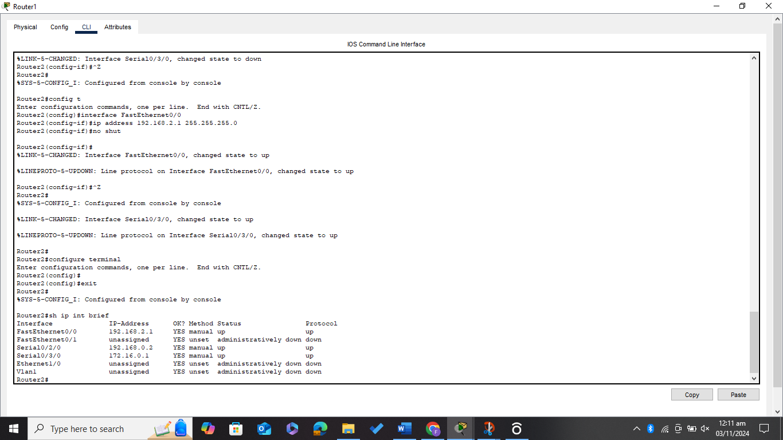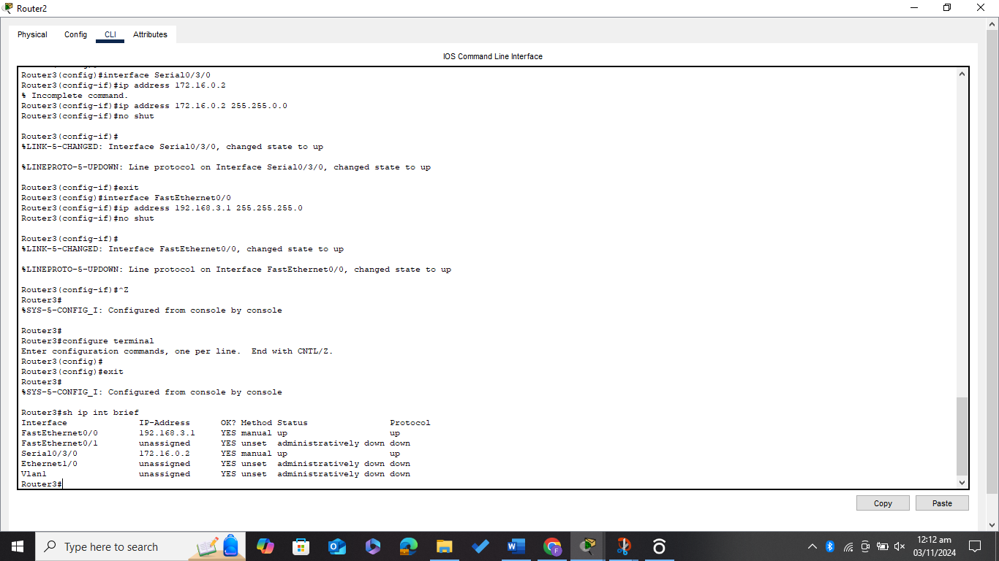

***Running the command (sh ip route and s hip int brief) on all the Routers***

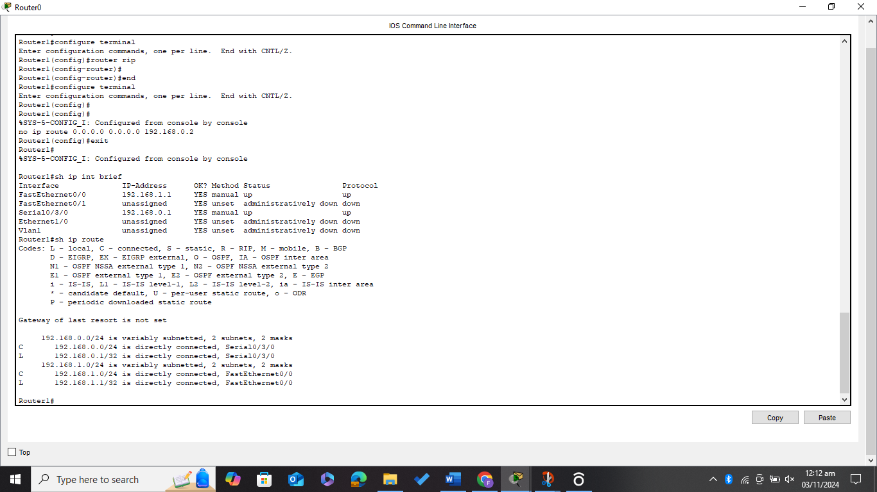

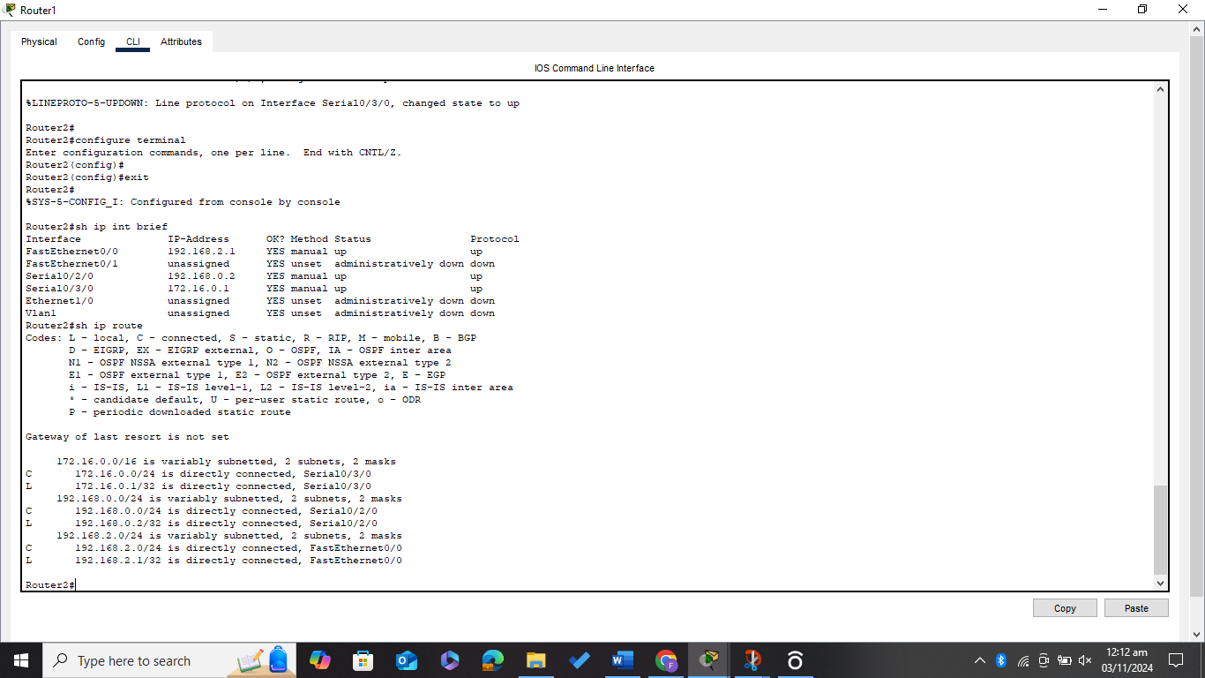

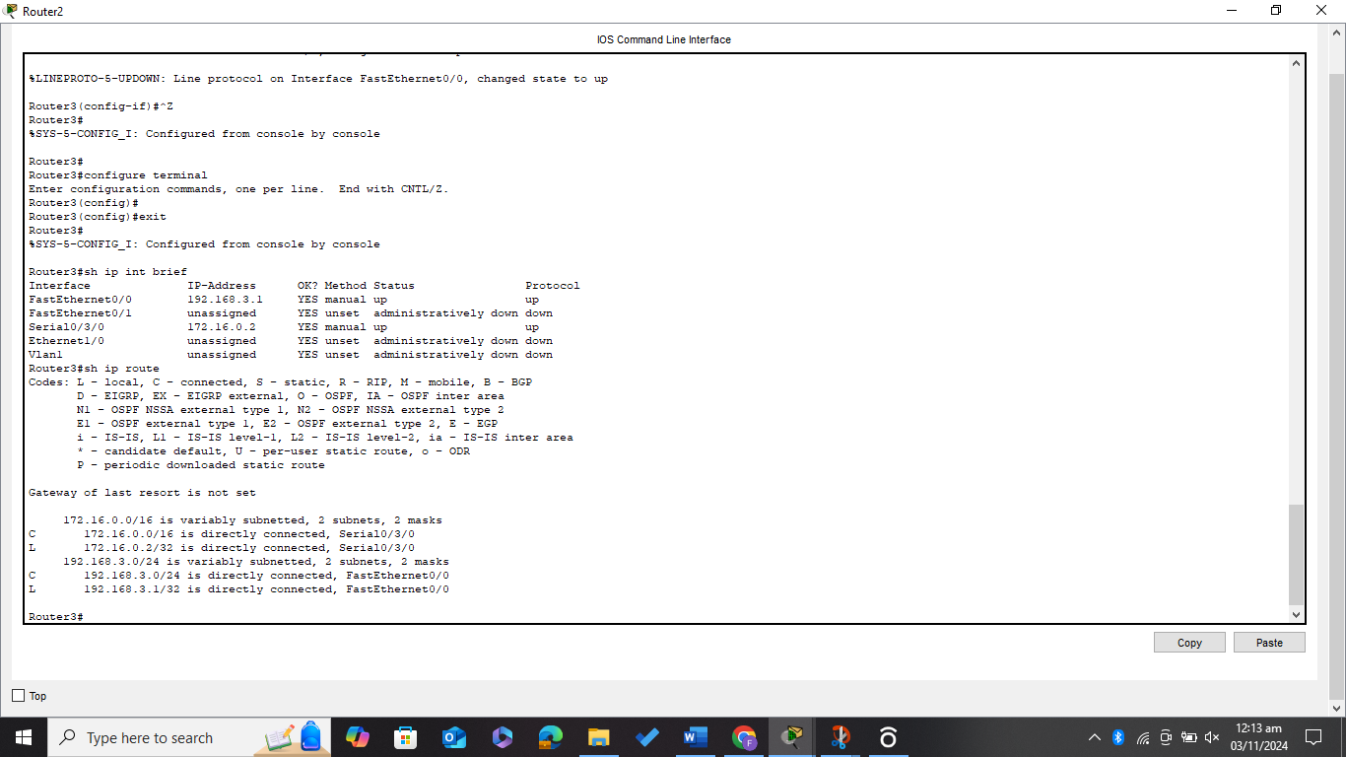

***Now Doing EIGRP routing between all the connected Routers***

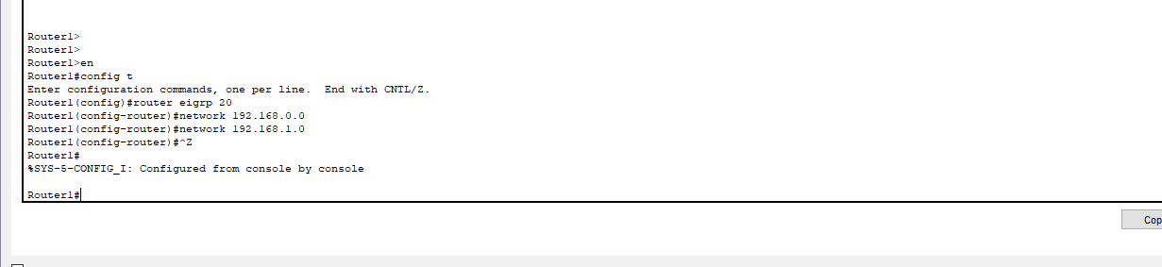

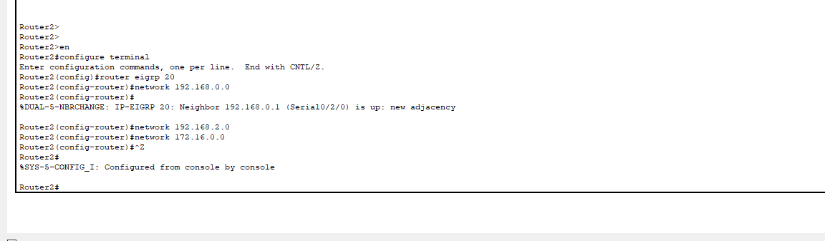

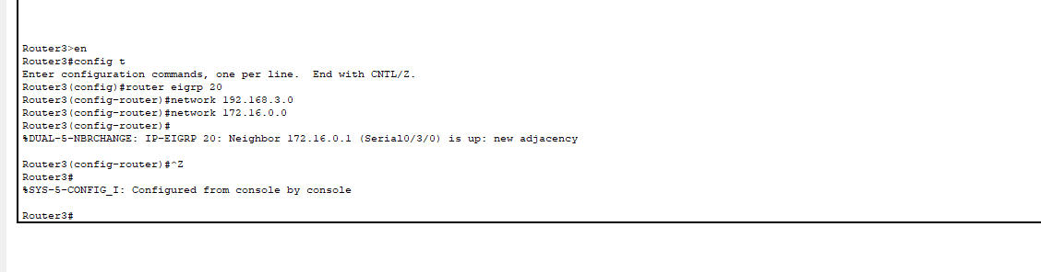

***Again, Running the Command (sh ip route) to reflect the EIGRP routing***

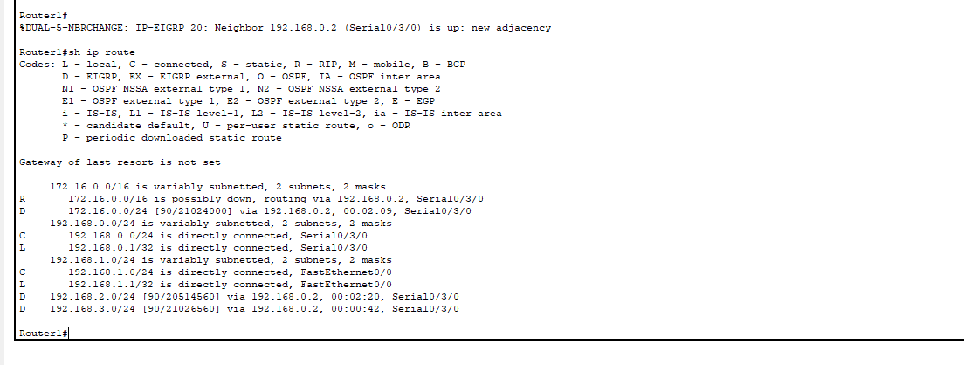

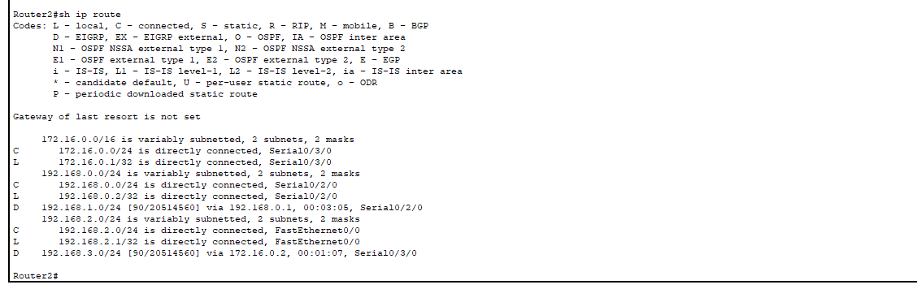

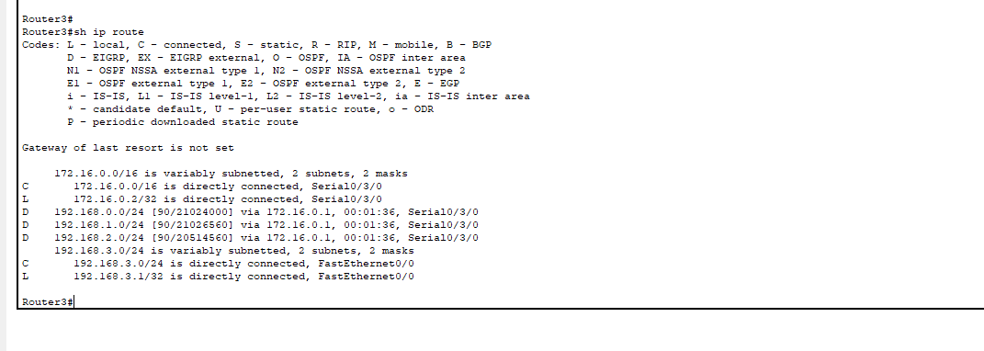

***Now Running the ping command from PC0, PC1, and PC2 for all the connections***

