**DBS LAB NO : 02 TASKS**

**22SWO4O --> SECTION : O1**

**Task NO : 1 --> Convert UNF to 1NF ?**

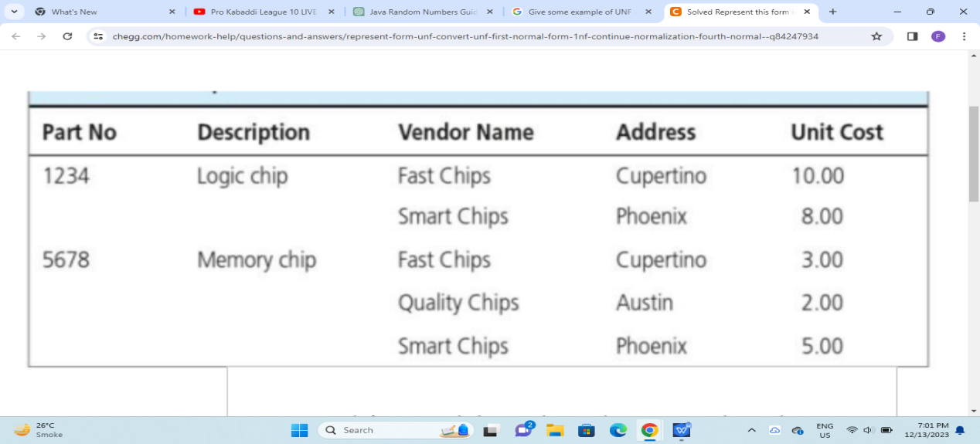

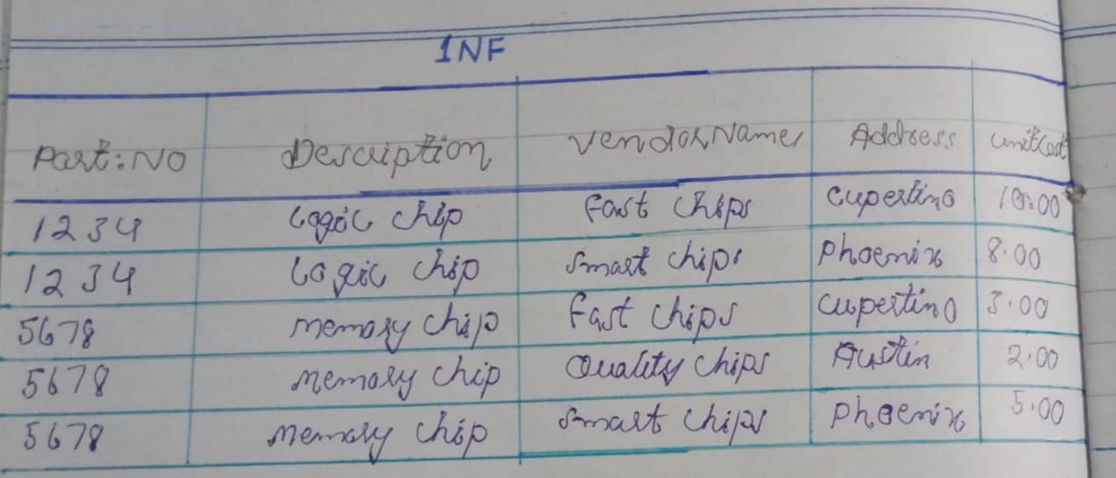

**Task No : 03 --> Consider any example of which clearly depict insertion, deletion and updation anomaly?**

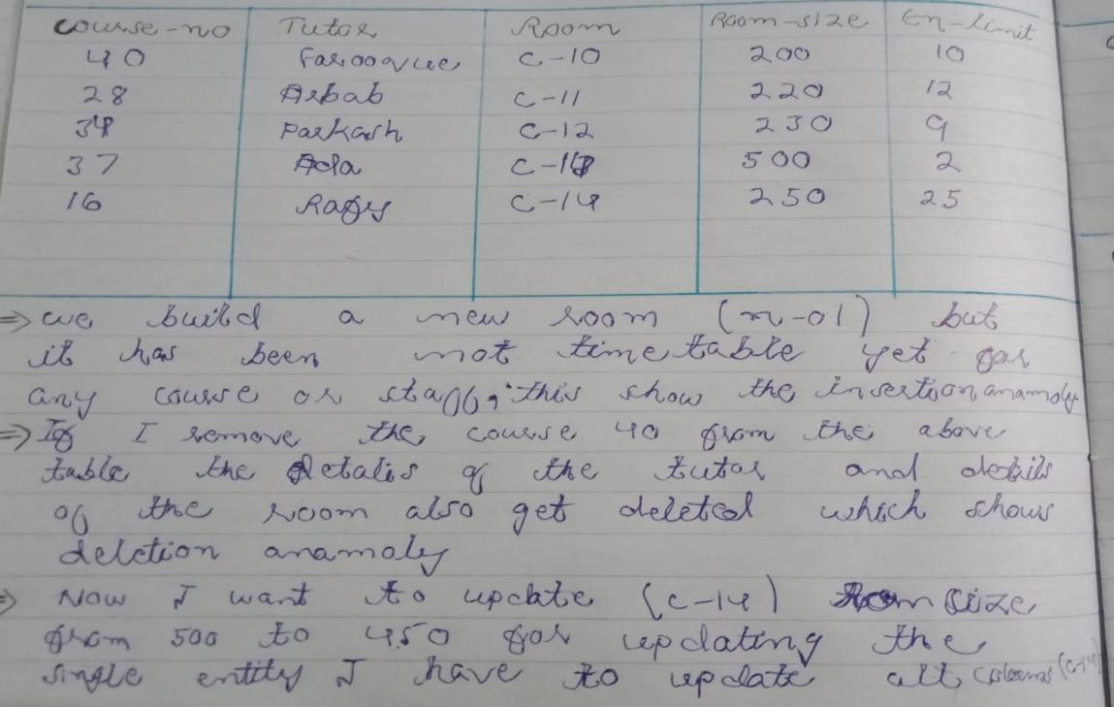

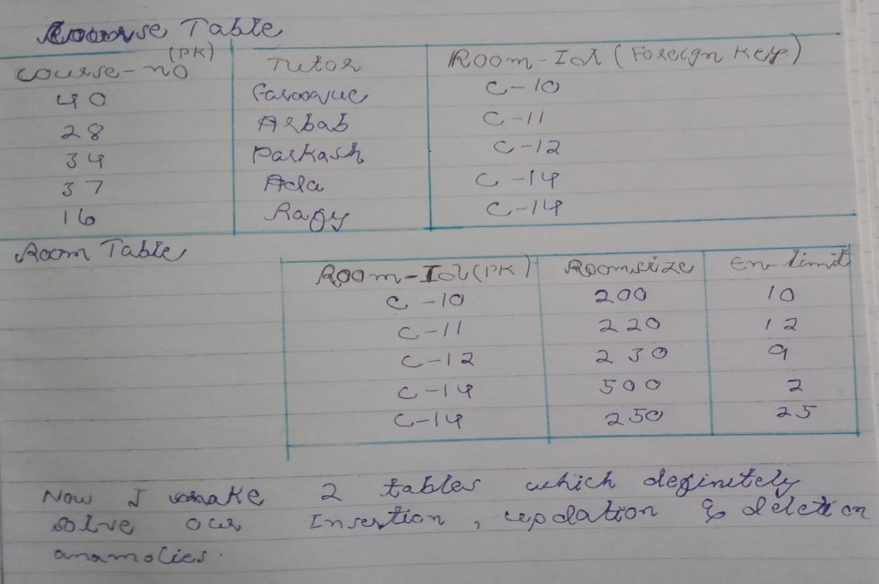

**Task No : 02 --> Quote any 2 examples of Functional Dependencies ?**

## Examples of Functional Dependencies

**1. Order Details Table of Shama Online Store**

Consider a table storing order details. It might have columns like OrderID, ProductID, Quantity, and Price. In this case, the following functional dependency exists:

* **OrderID -> ProductID**

This means that for any given OrderID, there will be only one unique ProductID. In other words, you can determine the specific product ordered by knowing the order ID, but not vice versa.

**2. MUET Course Registration System**

Imagine a table storing student course registrations. It might contain columns like StudentID, CourseID, Semester, and GPA . In this scenario, the following functional dependency holds:

* **(StudentID, Semester) -> CourseID**

This signifies that a student can only enroll in a particular course once per semester. Knowing both the StudentID and Semester uniquely determines the CourseID they registered for.