**DBS 2nd Sessional Test (Sec 1)**

* Import the given database from the myssqlsampledatabase.sql file using the import database option in phpMyAdmin or in mysqlworkbench.
* The imported database would have the following structure:



Solve the queries given below:

* Display the employees who work in the offices located in Paris.

Result query and output screenshot:

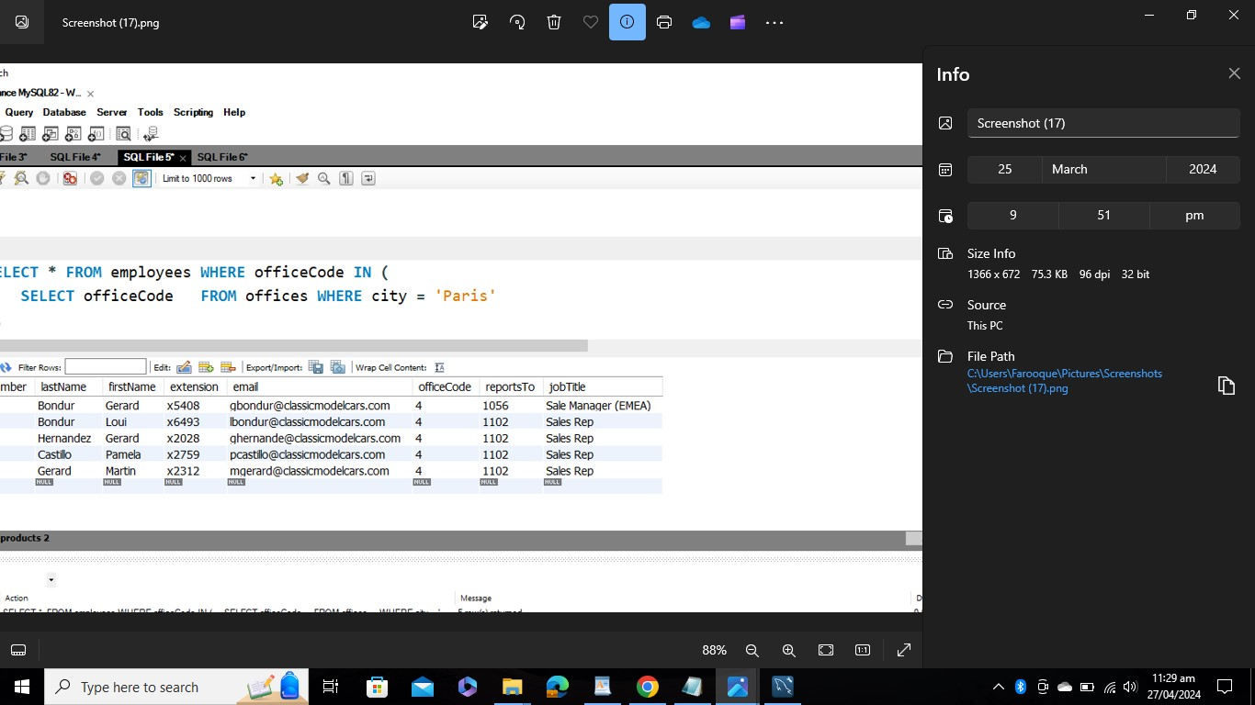

Expected Output:



* Display the product names, product lines and the total sales of the products for each of the product lines with total sales greater than 20000. Order the results in ascending order of the total sales.

Result query and output screenshot:



Expected Output:



* Display the product code, product name and buy prices of products whose product codes contain the string _20 and the buy price is in the range of 40 to 100.

Result Query and output screenshot:



Expected Output:

