|  |  |
| --- | --- |
| **Student Name** | **Farooque Sajjad** |
| **Roll Number** | **22SW040** |
| **Section #** | **01** |
| **Lab #** | **02** |

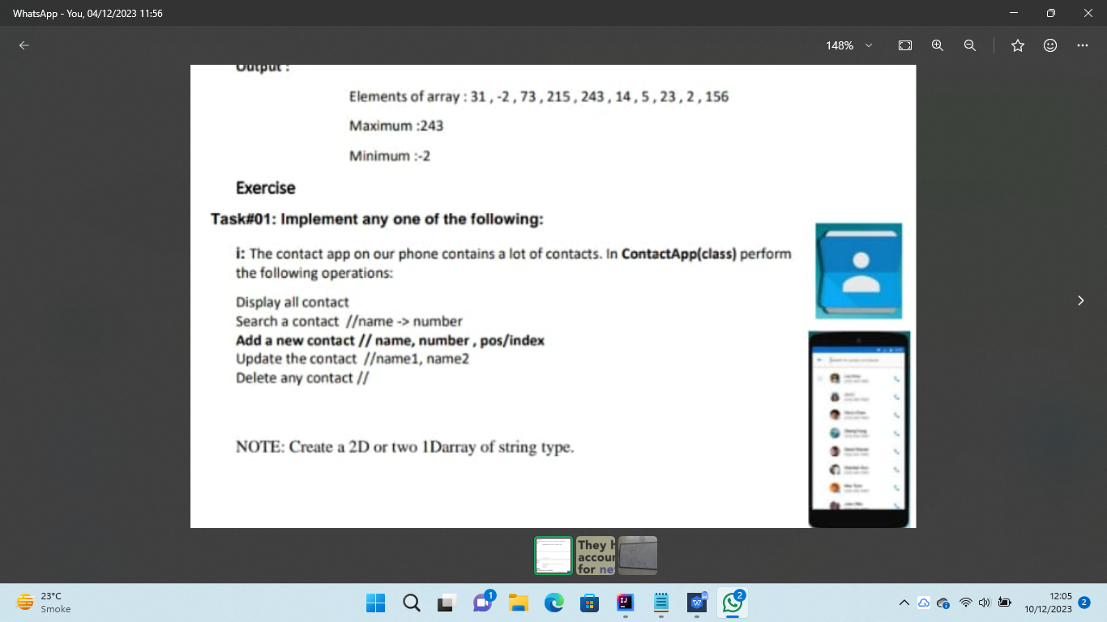

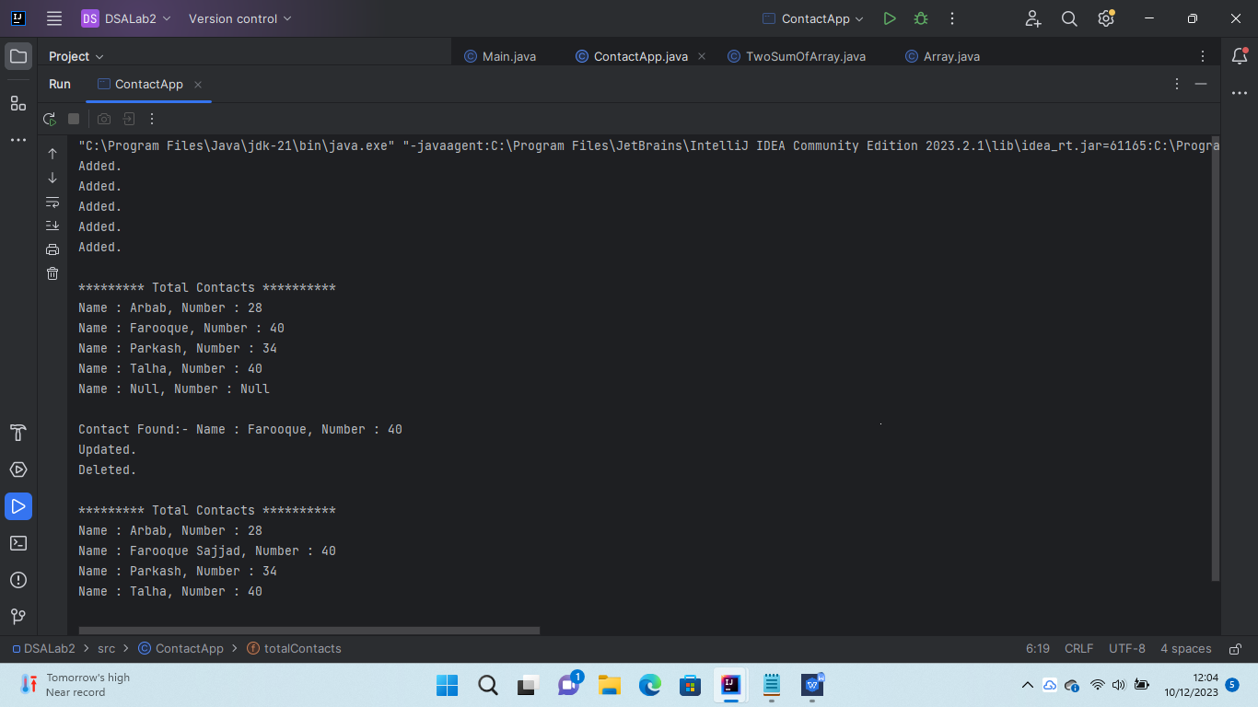

**Two Sum Problem on LeetCode**

