|  |  |
| --- | --- |
| **Student Name** | **Farooque Sajjad** |
| **Roll Number** | **22SW040** |
| **Section #** | **01** |
| **Lab #** | **03** |

**Task#01 : Implement Linear Search in java.**

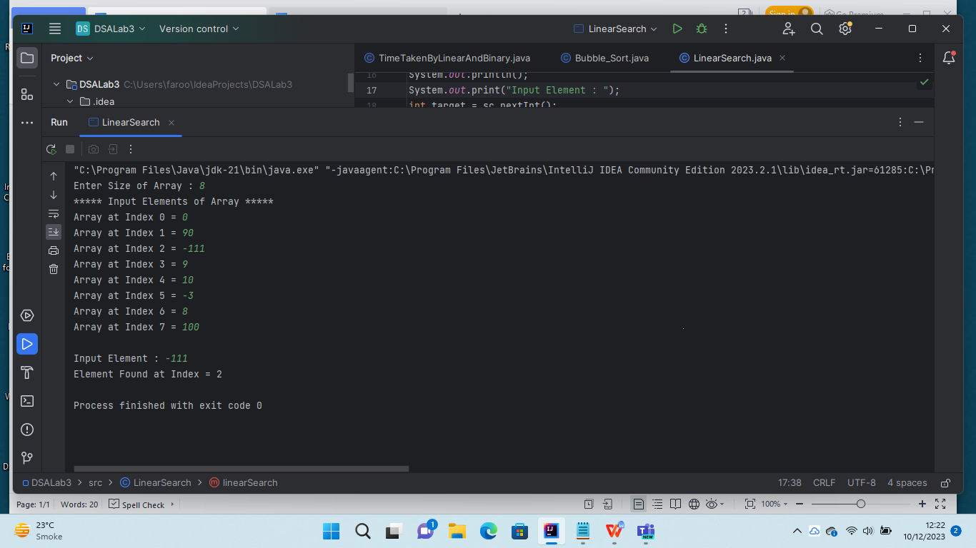

**Task#02 : Implement Binary Search in java.**

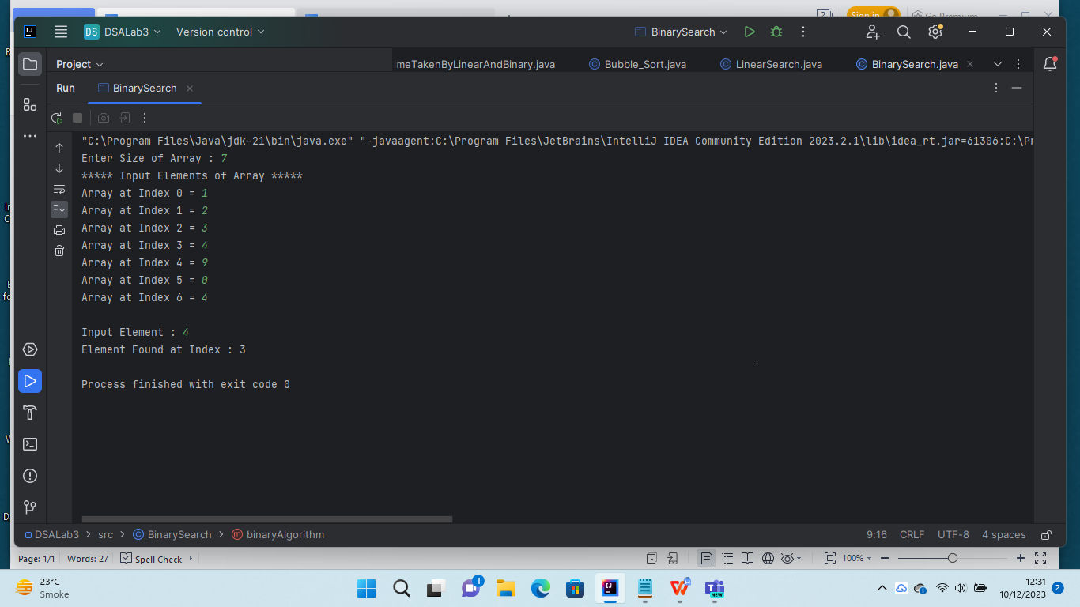

**Task#03 : Implement Bubble sort in java**

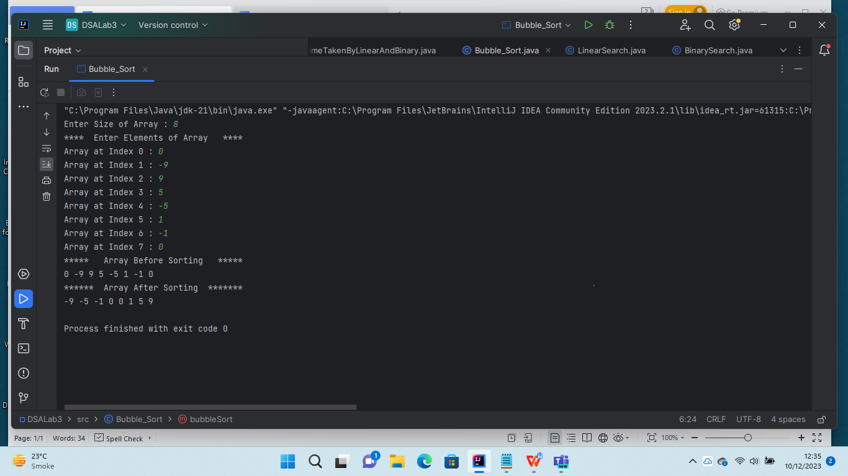

**Task#04 : Display the Time different taken by each (linear and binary search) method.**

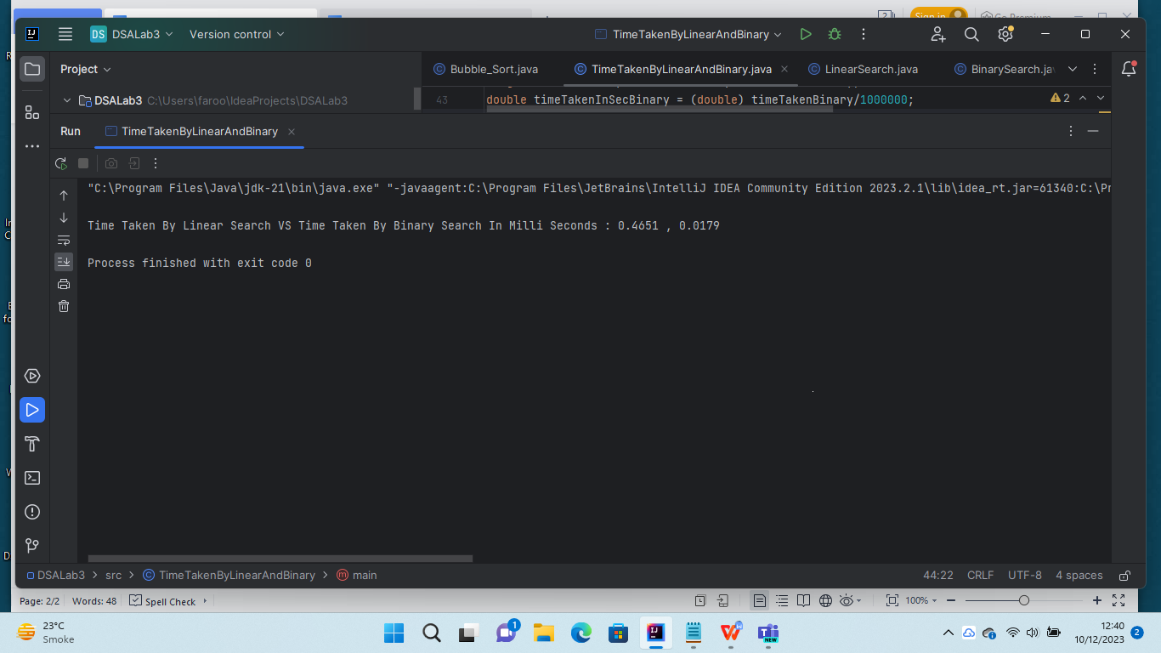

**Task#05 : Explain why the one method took less time as compared to other.**

Because in the case of linear search, it systematically checks every element, making it time-consuming, especially for larger arrays, since it examines each element sequentially and waste our time and memory.

On the other hand, binary search, with its unique time complexity, quickly eliminates half of the remaining

elements in each step, making it much more efficient, especially for larger sorted arrays and reduce the time for traversing the array.