

***COMPLEX ENGINEERING PROBLEM OF DWH***

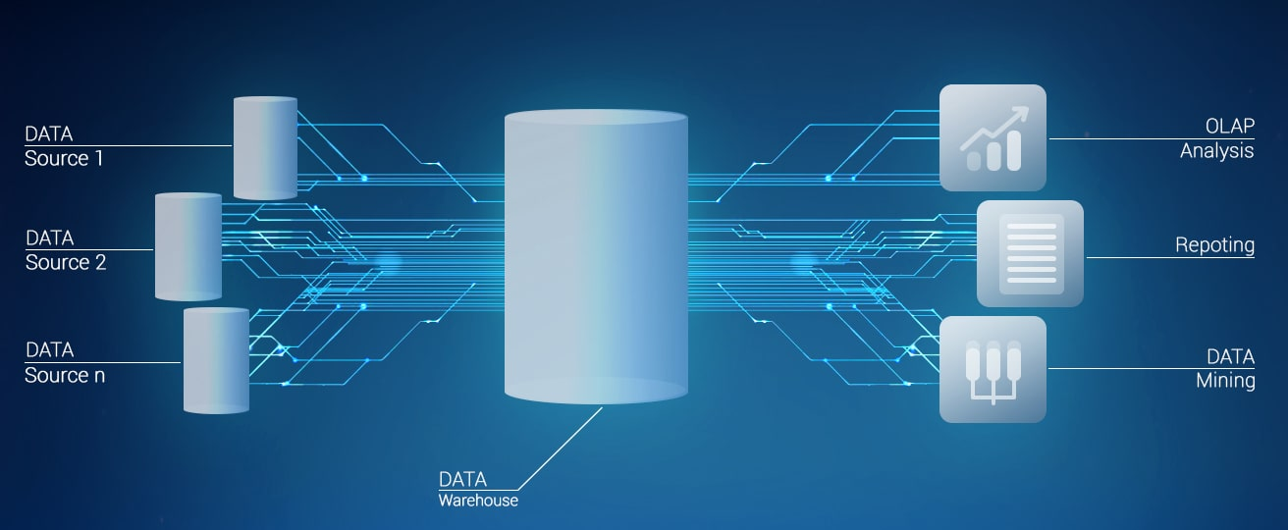

* ***ROLL NO: 22SW040***
* ***SECTION: 01***
* ***NAME: FAROOQUE SAJJAD***
* ***SUBMITTED TO: SIR SHERAM***

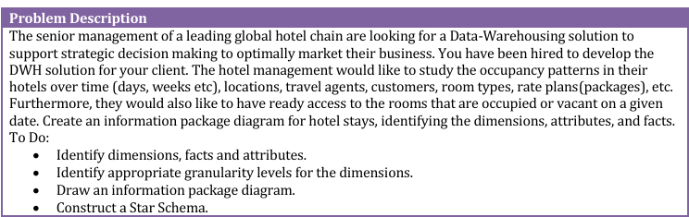



***Solution Approach***

* ***Identifying dimensions, facts and attributes***
* ***Identifying Granularity level for dimensions***
* ***Drawing Information Package Diagram (Using Lucid Chart)***
* ***Constructing a Star Schema (Using Lucid Chart)***

***Identification of Dimensions, Facts, and Attributes***

***Facts***

***1. Occupancy Rate***

***Formula***

Occupancy Rate = {Number of Rooms Booked/Total Rooms Available} 100

***Definition***

The percentage of available rooms that are occupied during a specific time (e.g., daily, weekly, or monthly).

***Business Relevance***

* Indicates how effectively the hotel utilizes its room inventory.
* High occupancy shows peak demand; low occupancy may signal opportunities for targeted marketing or discounts.

***Data Considerations***

* ***Granularity:*** Measure occupancy at daily, weekly, or monthly levels.
* ***Segmentation:*** Analyze by room type, location, or customer segment (e.g., loyalty to members vs. new customers).
* ***Comparison:*** Look at averages and peak values to observe fluctuations and benchmark against industry standards.

***2. Revenue (Total Amount Earned per Stay)***

***Definition***

Total revenue from a guest's stay, including room charges and any additional services (e.g., food, drinks, amenities).

***Business Relevance***

* Helps understand the hotel's income structure and segment profitability.
* Identifies high-value customers and informs marketing and pricing adjustments.

***Data Considerations***

* ***Breakdown by Components:*** Separate revenue by categories (room, food & drinks, spa) for deeper insights.
* Associated Dimensions: Link revenue to rate plans, room type, and booking channel.
* ***Average Revenue Per Room (RevPAR):*** Combines revenue with occupancy rates to provide a comprehensive view of performance.

***3. Number of Guests/Persons (Total Guests per Stay)***

***Definition***

Count of all individuals staying in a room, including primary guests and additional people.

***Business Relevance***

* + Assists in assessing demand for room configurations (e.g., family rooms vs. singles).
  + Informs marketing based on family vs. solo traveler patterns.

***Data Considerations***

* + ***Demographic Segmentation:*** Track adults vs. children to inform family-oriented services.
  + ***Group Bookings:*** Identify peak occupancy patterns from group or bulk reservations.
  + ***Seasonal Trends:*** Examine guest counts seasonally to identify demand patterns linked to events and holidays.

***4. Room Status (Occupied or Free)***

***Definition***

Indicator of whether each room is currently occupied or vacant.

***Business Relevance***

* + Supports operational management of room assignments, cleaning schedules, and new arrivals.
  + Real-time status helps improve room turnover and optimize occupancy.

***Data Considerations***

* + ***Timestamp of Last Status Change:*** Track last check-in/check-out times for better planning.
  + ***Expected Check-Out Time:*** Predict check-outs to enhance room turnover scheduling.
  + ***Room Status History:*** Analyze historical room statuses to identify frequently unoccupied or high-demand rooms.

***5. Length of Stay***

***Definition***

The number of days a guest stays.

***Business Relevance***

Helps understand guest preferences for short vs. long stays, which can inform room availability, pricing strategies, and targeted marketing (e.g., offering discounts for extended stays).

***Data Considerations***

* + ***Average Length of Stay:*** Use this to track trends and set baseline expectations.
  + ***Stay Distribution:*** Analyze short, medium, and long stays for segment-specific offers.

***6. Booking Lead Time***

***Definition***

The number of days between booking and check-in.

***Business Relevance***

Identifies booking patterns, which can help with pricing adjustments (e.g., higher rates for last-minute bookings) and inventory planning.

***- Data Considerations:***

* + ***Segmentation by Lead Time:*** Track early vs. last-minute bookings for targeted offers and demand forecasting.
  + ***Seasonal Analysis:*** Identify peak times when lead times shorten or lengthen.

***7. Room Revenue (Per Stay)***

***Definition***

Total revenue generated from room charges alone, per stay.

***Business Relevance***

Offers insights into the core income generated by room bookings, essential for monitoring the profitability of each room type and pricing model.

***Data Considerations***

* + ***Room Type Segmentation:*** Break down revenue by room type (e.g., suites vs. standard rooms).
  + ***Trends in Room Revenue per Stay:*** Track revenue patterns over time to optimize pricing for various seasons and guest segments.

***Dimensions***

1. **Time**
2. **Location**
3. **Customer**
4. **Room Type**
5. **Travel Agent**
6. **Rate Plan**
7. **Stay Details**
8. **Room Status**
9. **Revenue Components**

***1. Time Dimension***

***Definition***

Represents the time-based aspects of hotel data, such as booking dates, stay dates, and analysis periods.

***Business Relevance***

Understanding time-based data supports seasonal analysis, trend identification, and strategic decision-making around pricing, staffing, and promotions.

***2. Location Dimension***

***Definition***

Identifies the geographical location of each hotel property.

***Business Relevance***

Enables performance comparison across locations and helps in understanding location-specific demand and trends.

***3. Customer Dimension***

***Definition***

Details of customer-specific information related to demographics and loyalty.

***Business Relevance***

Supports segmentation, personalized marketing, and loyalty analysis, helping to identify high-value customers and tailor services to different demographic groups.

***4. Room Type Dimension***

***Definition***

Details of the type and specific features of each room.

***Business Relevance***

Essential for managing room inventory, pricing strategies, and forecasting demand for different room categories.

***5. Travel Agent Dimension***

***Definition***

It contains data about travel agents and their impact on bookings.

***Business Relevance***

Useful for analyzing third-party booking patterns and evaluating travel agent performance.

***6. Rate Plan Dimension***

***Definition***

Represents different rate plans and packages offered to guests.

***Business Relevance***

Important for understanding revenue generation through different rate plans and for developing targeted promotions.

***7. Stay Details Dimension***

***Definition***

Information related to the specifics of each guest’s stay, including length and booking lead time.

***Business Relevance***

Provides insights into guest booking patterns, average stay lengths, and helps in demand forecasting and pricing adjustments.

***8. Room Status Dimension***

***Definition***

Tracks whether rooms are currently occupied or vacant.

***Business Relevance***

Supports operational efficiency by enabling real-time monitoring of room availability and turnover.

***9. Revenue Components Dimension***

***Definition***

Break down revenue data into the room and additional services.

***Business Relevance***

Enables detailed revenue analysis, helping to identify key revenue drivers and optimize pricing strategies.

***Attributes***

***Time***

* Day
* Week
* Month
* Quarter
* Year

***Location***

* Hotel Name
* City
* Country
* Region

***Customer***

* Customer ID
* Name
* Gender
* Age
* Loyalty Program Level
* Contact Info

***Room Type***

* Room Type (e.g., Suite, Standard, Deluxe)
* Room Number
* Room Features

***Travel Agent***

* Travel Agent ID
* Name
* Contact Info

***Rate Plan***

* Plan ID
* Package Name
* Price per Night

***Stay Details***

* Length of Stay (number of days)
* Booking Lead Time (days between booking and check-in)
* Number of Guests (including primary and additional guests)

***Room Status***

* Room Status (Occupied/Free)
* Last Status Change Timestamp
* Expected Check-Out Time

***Revenue Components***

* Room Revenue (Per Stay)
* Additional Services Revenue (e.g., Food & Beverage, Spa)
* Total Revenue Per Stay
* Average Revenue Per Room (RevPAR)

***Time Attributes***

* + ***Day:*** Represents daily data for detailed reporting.
  + ***Week:*** Summarizes weekly data for weekly performance analysis.
  + ***Month:*** Used for monthly trend identification and performance analysis.
  + ***Quarter:*** Groups data for quarters for seasonal performance assessment.
  + ***Year:*** Used for annual comparisons and long-term trend analysis.

***Location Attributes***

* + ***Hotel Name:*** The unique name or identifier for each hotel property.
  + ***City:*** Identifies the city where the hotel is located.
  + ***Country:*** The country in which the hotel operates.
  + ***Region:*** A broader geographic categorization, useful for regional trend analysis.

***Customer Attributes***

* + ***Customer ID:*** A unique identifier for each guest.
  + ***Name:*** The guest's full name for personalization and record-keeping.
  + ***Gender:*** Used for demographic analysis and targeted marketing.
  + ***Age:*** Supports age-based segmentation and targeted offers.
  + ***Loyalty Program Level:*** Indicates the customer’s loyalty tier, which can influence room rates, perks, and marketing offers.
  + ***Contact Info:*** Contact details (e.g., email, phone number) for communication and marketing outreach.

***Room Type Attributes***

* + ***Room Type:*** The category of the room (e.g., Suite, Standard, Deluxe), essential for pricing and inventory management.
  + ***Room Number:*** Unique room identifier within the hotel, used for assigning bookings.
  + ***Room Features:*** Describes amenities and features (e.g., sea view, king bed), helping match guest preferences to available rooms.

***Travel Agent Attributes***

* + ***Travel Agent ID:*** Unique identifier for each travel agent or booking platform.
  + ***Name:*** Name of the travel agent or agency.
  + ***Contact Info:*** Contact details, useful for communication and relationship management.

***Rate Plan Attributes***

* + ***Plan ID:*** Unique identifier for each rate plan.
  + ***Package Name:*** Name of the rate plan or package (e.g., Bed & Breakfast).
  + ***Price per Night:*** The cost associated with the rate plan per night, important for revenue calculations and comparisons.

***Stay Details Attributes***

* + ***Length of Stay:*** The total number of days a guest stays, used for analyzing guest stay patterns.
  + ***Booking Lead Time:*** Days between booking date and check-in date, useful for understanding booking behavior and planning.
  + ***Number of Guests:*** Total number of individuals in each booking, used for assessing demand for room configurations.

***Room Status Attributes***

* + ***Room Status:*** Indicates whether a room is occupied or vacant.
  + ***Last Status Change Timestamp:*** Records the last check-in or check-out time for operational planning.
  + ***Expected Check-Out Time:*** Helps forecast room availability and plan for room turnover.

***Revenue Components Attributes***

* + ***Room Revenue:*** Revenue from room charges per stay, a core metric for hotel profitability.
  + ***Additional Services Revenue:*** Revenue from non-room services (e.g., food & drink, spa), helping to understand supplementary income.
  + ***Total Revenue Per Stay:*** The combined revenue from room and additional services, used for calculating overall guest spending.
  + ***Average Revenue Per Room (RevPAR):*** Average revenue per available room, a key performance indicator in the hospitality industry.

***Granularity Levels for Dimensions***

* ***Time:*** Daily (specific booking and stay dates)
* ***Location:*** Hotel-Level (each hotel is treated as its own entity)
* ***Customer:*** Customer-Level (each customer has unique attributes)
* ***Room Type:*** Room-Level (each room within the hotel is uniquely identifiable)
* ***Travel Agent****:* Travel Agent-Level (each agent has its own ID and attributes)
* ***Rate Plan****:* Rate Plan-Level (each package or plan is treated as a distinct product)
* ***Stay Details****:* Booking-Level (details for each individual booking)
* ***Room Status****:* Room-Level (status of each room)
* ***Revenue Components***: Transaction-Level (revenue data for each transaction)