|  |  |
| --- | --- |
| ***ROLLNO*** | ***22SW040*** |
| ***NAME*** | ***FAROOQUE SAJJAD*** |
| ***SECTION*** | ***ONE*** |
| ***SUBJECT*** | ***INFORMATION SECURITY*** |

***ASSIGNMENT: - DOING ENCRYTION AND DECRYPTION OF PLAIN TEXT BY USING ONLINE TOOLS FOR DIFFERNET ALGORITHMS.***

1. **ONE TIME PAD CIPHER**

https://www.boxentriq.com/

***2) RAIL FENCE CIPHER***

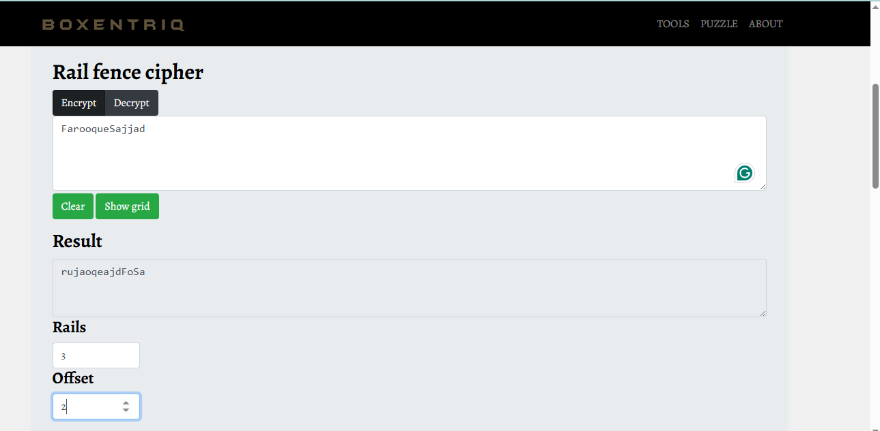

https://www.boxentriq.com/

1. ***CEASER CIPHER***

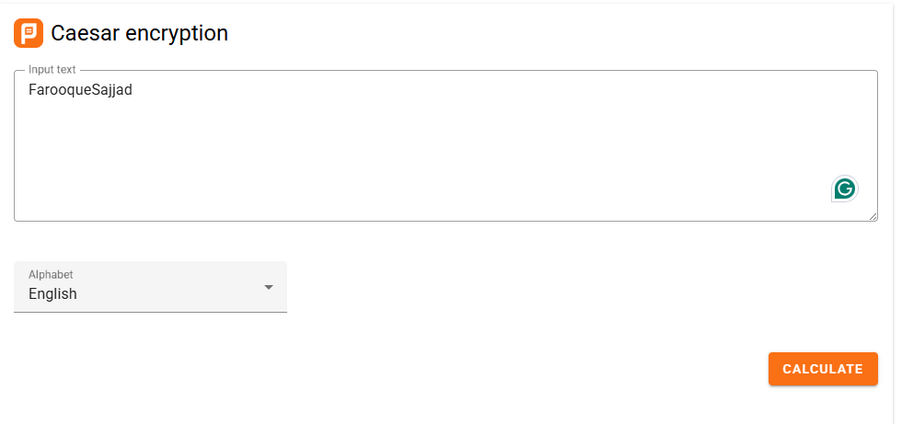

https://planetcalc.com/1434/

1. ***PLAYFAIR CIPHER***

https://planetcalc.com/1434/

1. ***TRANSPOSITION CIPHER***

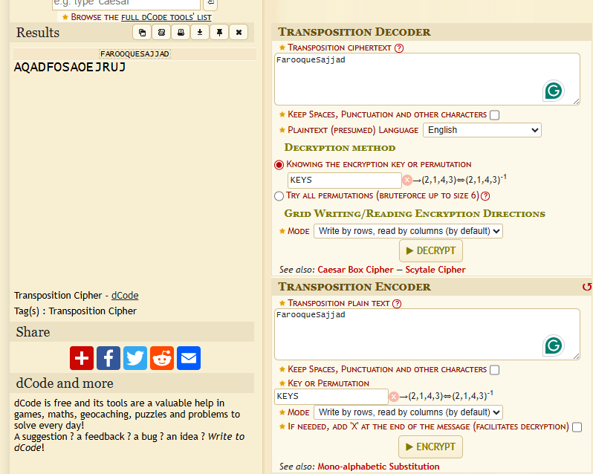

https://www.dcode.fr/transposition-cipher

1. **VIGENERE CIPHER**

<https://cryptii.com/pipes/vigenere-cipher>