|  |  |
| --- | --- |
| **Roll NO** | **22SW040--> Section 1** |
| **Name** | **Farooque Sajjad** |
| **Lab** | **OS(lab# 3)** |
| **Teacher** | **Sir Zulfiqar** |

**LAB TASKS SOLUTIONS**

**Lab Tasks Solutions**

NOTE : If you need code (bat files) you can get these files by clicking the link of my OS lab repo.

<https://github.com/Farooquekk/Operating-System-Lab-Tasks/tree/main/22SW040_Section_01_OS_lab_03>

1. Create a batch script that opens your 5 favorite websites at once.

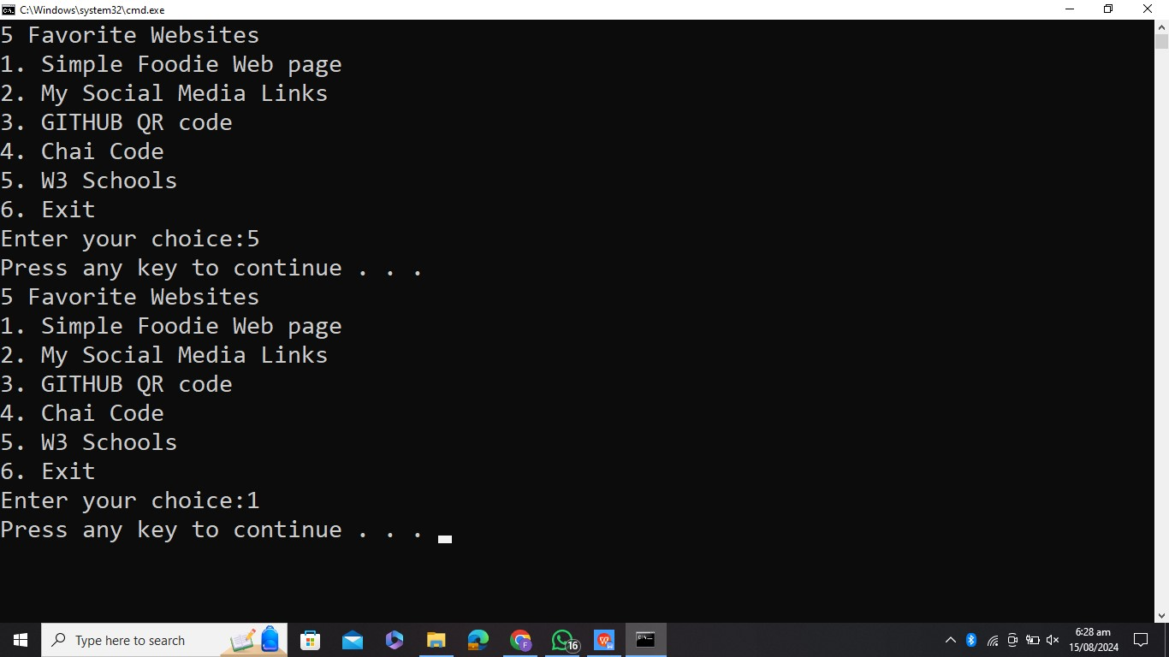



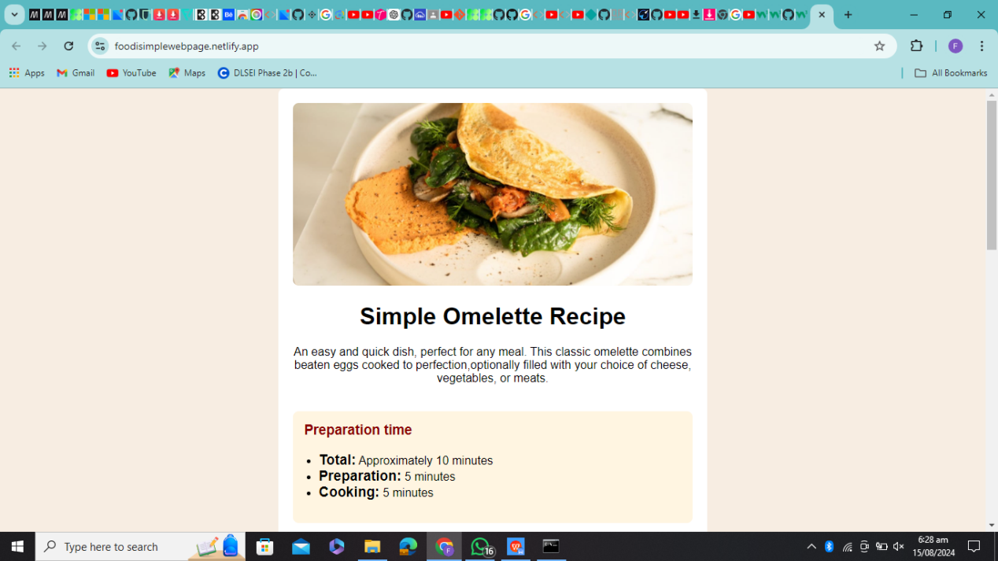

1. Create a batch script that organizes your files in a directory based on their extensions.

For Example: Puts all .txt files in .txt folder, all .png files in .png folder

**Note: The directory to organize should be given by user at runtime (+1 Mark)**

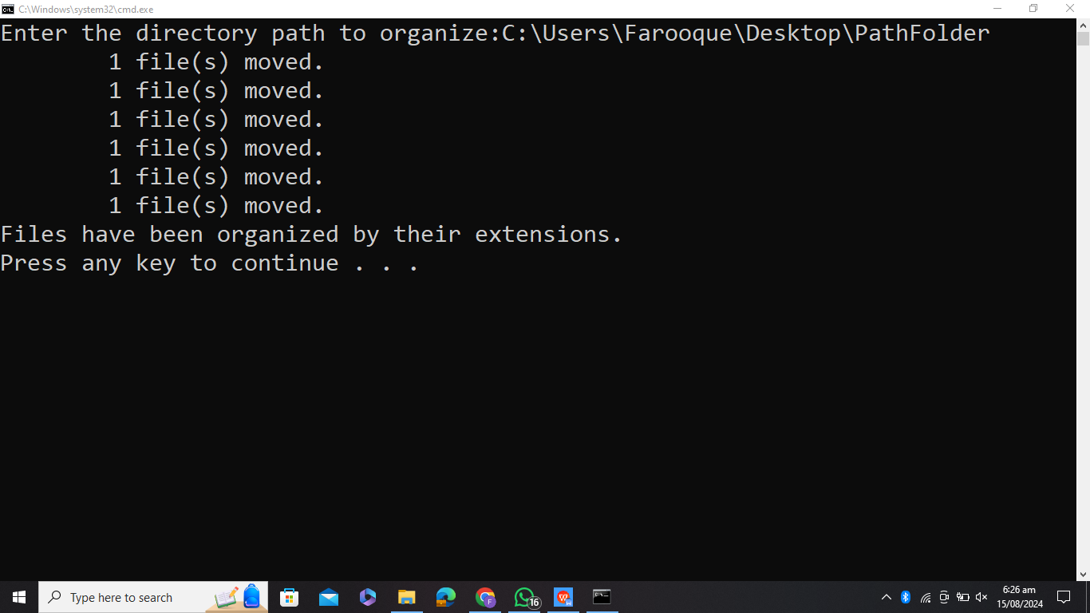

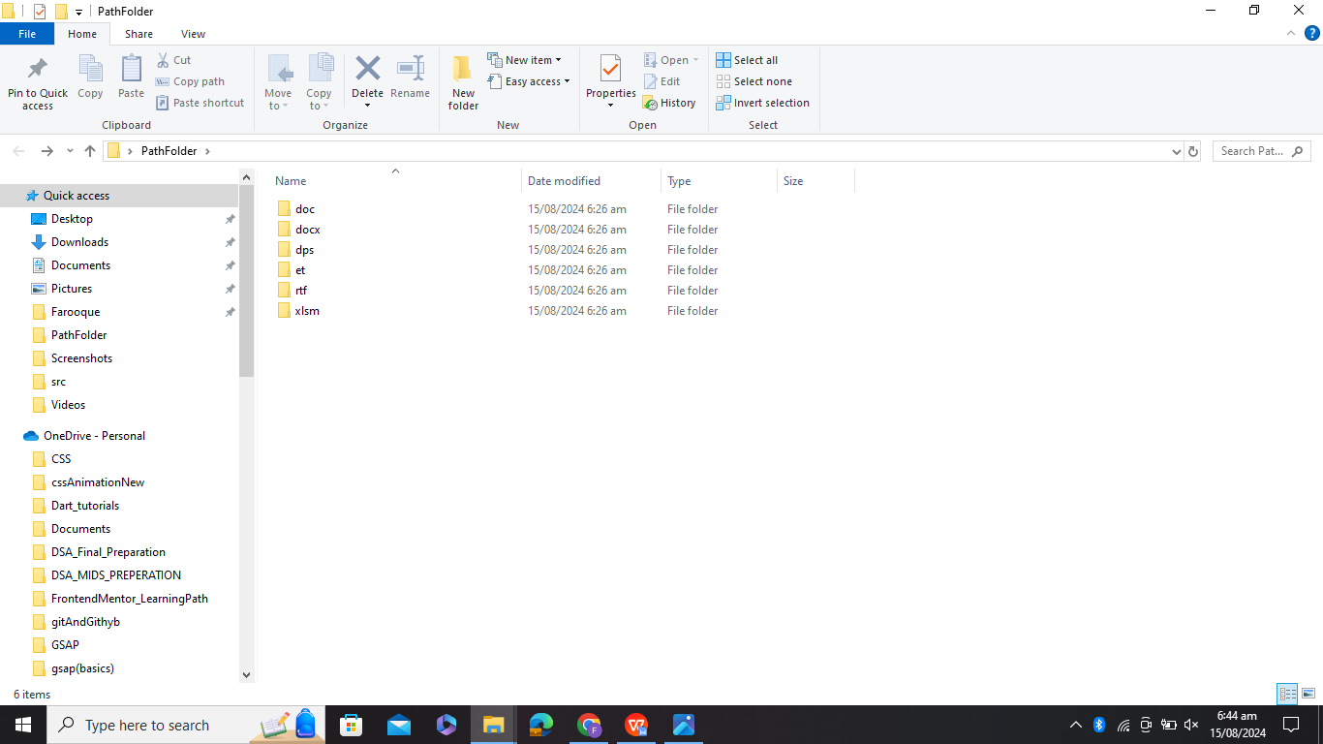

1. Create a batch script that work as a simple calculator.

