|  |  |
| --- | --- |
| *Roll No* | *22SW040 🡪 Section_01* |
| *Name* | *Farooque Sajjad* |
| *Subject* | *SCD(LAB)* |
| *LAB* | *7* |

***Introduction***

Software testing is an essential phase in the software development lifecycle, ensuring that applications function correctly and securely. This lab assignment focuses on testing various functionalities of a web application, including login authentication, character limit validation, SQL injection prevention, and file upload validation. Through both positive and negative test cases, we aim to assess the application's robustness and ability to handle expected and unexpected inputs.

***Objective***

The objective of this lab assignment is to evaluate the application's behaviour under different scenarios by conducting systematic testing. By identifying and addressing potential vulnerabilities, we can ensure data integrity, security, and user experience. The test cases included in this assignment cover authentication mechanisms, input validation, security against SQL injection attacks, and file upload restrictions.

***Scope***

This lab assignment focuses on four primary test cases:

1. **Username in Login Form** – Verifying correct and incorrect login credentials.
2. **Character Limit in Text Fields** – Ensuring input fields accept or restrict character lengths appropriately.
3. **SQL Injection in Search Bar** – Checking for security vulnerabilities against malicious database queries.
4. **File Upload Validation** – Testing the system’s ability to accept valid files and reject unauthorized formats.

By executing these test cases, we aim to analyse the web application’s resilience to errors and security threats while improving its overall performance and reliability.

***First***

|  |  |  |  |  |  |
| --- | --- | --- | --- | --- | --- |
| ***Test Case 01: Username in Login Form*** | | | | | |
| ***Positive Test Case*** | | | | | |
| ***Test ID*** | ***Test Scenario*** | ***Test Steps*** | ***Expected Result*** | ***Actual Result*** | ***Status*** |
| *TC_001* | *Entering a valid username and password* | Navigate to the login page  Enter a valid username and password. | *User Should be successfully logged in.* | *User successfully logged in. (Approved)* | *Pass* |

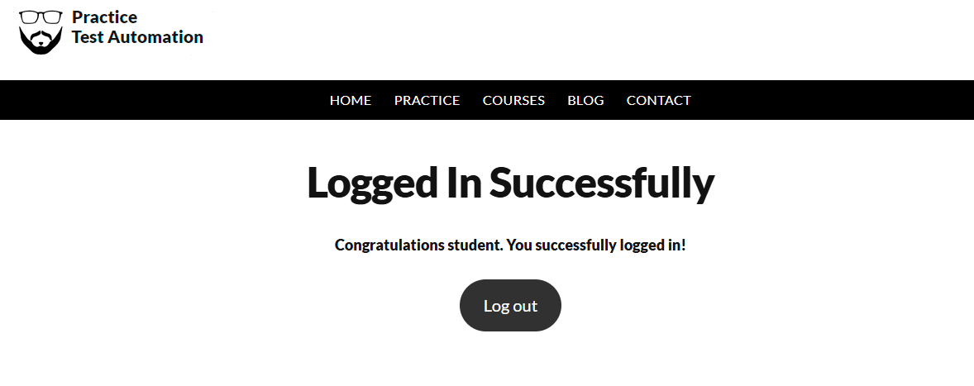

|  |  |  |  |  |  |
| --- | --- | --- | --- | --- | --- |
| ***Test Case 01: Username in Login Form*** | | | | | |
| ***Negative Test Case*** | | | | | |
| ***Test ID*** | ***Test Scenario*** | ***Test Steps*** | ***Expected Result*** | ***Actual Result*** | ***Status*** |
| *TC_002* | *Entering a valid username and password* | Navigate to the login page  Enter a valid username and password. | *Should show error or invalid username and password prompt.* | *Showing Error (Invalid Password and username).* | *Pass* |

***Second***

|  |  |  |  |  |  |
| --- | --- | --- | --- | --- | --- |
| ***Test Case 02: Character Limit in Text Field*** | | | | | |
| ***Positive Test Case*** | | | | | |
| ***Test ID*** | ***Test Scenario*** | ***Test Steps*** | ***Expected Result*** | ***Actual Result*** | ***Status*** |
| *TC_003* | Entering a valid name within the character limit. | Navigating to the website.  Entering a name within the allowed character. | The Website should accept the input. | *Yes, the website is accepting the input.* | *Pass* |

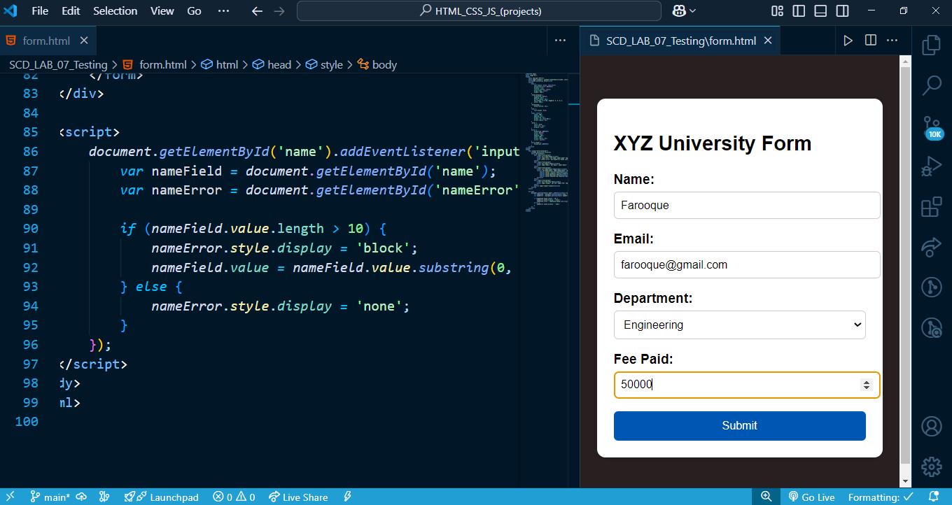

|  |  |  |  |  |  |
| --- | --- | --- | --- | --- | --- |
| ***Test Case 02: Character Limit in Text Field*** | | | | | |
| ***Negative Test Case*** | | | | | |
| ***Test ID*** | ***Test Scenario*** | ***Test Steps*** | ***Expected Result*** | ***Actual Result*** | ***Status*** |
| *TC_004* | Entering a valid name within the character limit. | Navigating to the website.  Entering a name within the allowed character. | The Website should not accept the input. | *Yes, the website is not accepting the input.* | *Pass* |

***Third***

|  |  |  |  |  |  |
| --- | --- | --- | --- | --- | --- |
| ***Test Case 03: SQL Injection in Search Bar*** | | | | | |
| ***Positive Test Case*** | | | | | |
| ***Test ID*** | ***Test Scenario*** | ***Test Steps*** | ***Expected Result*** | ***Actual Result*** | ***Status*** |
| *TC_005* | Entering a normal search query | Navigate to the search bar.  Enter a valid search term. | The system should return relevant search results. | Yes, the system is returning relevant search results. | *Pass* |

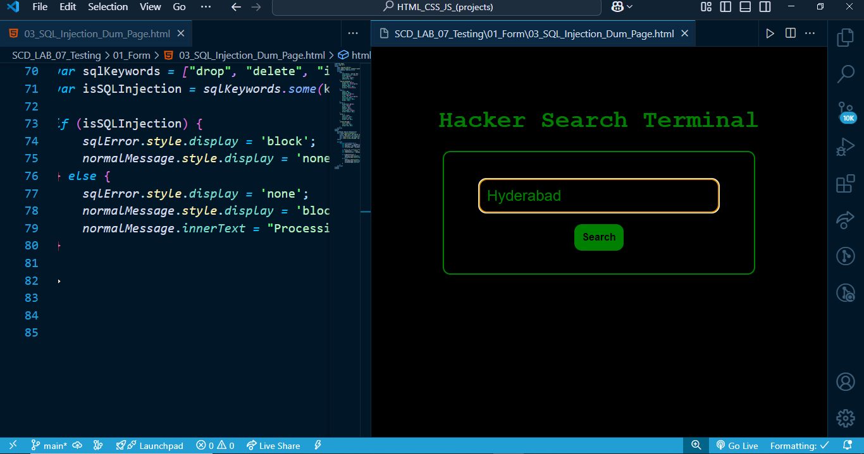

|  |  |  |  |  |  |
| --- | --- | --- | --- | --- | --- |
| ***Test Case 03: SQL Injection in Search Bar*** | | | | | |
| ***Negative Test Case*** | | | | | |
| ***Test ID*** | ***Test Scenario*** | ***Test Steps*** | ***Expected Result*** | ***Actual Result*** | ***Status*** |
| *TC_006* | Injecting SQL Commands. | Navigating to the search function. Enter a SQL query like drop, truncate etc. | The system should handle the input safely and display an error message instead of executing the SQL command. | Yes, the system is displaying error. | *Pass* |

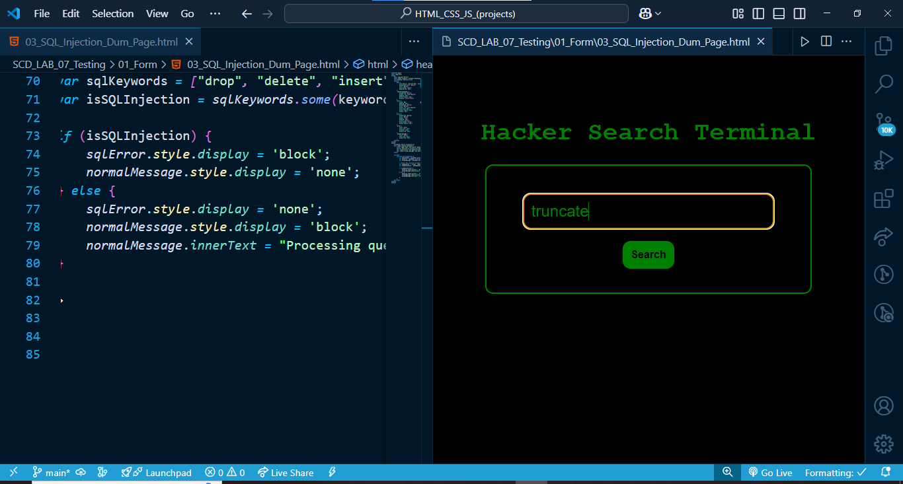

***Fourth***

|  |  |  |  |  |  |
| --- | --- | --- | --- | --- | --- |
| ***Test Case 04: File Upload Validation*** | | | | | |
| ***Positive Test Case*** | | | | | |
| ***Test ID*** | ***Test Scenario*** | ***Test Steps*** | ***Expected Result*** | ***Actual Result*** | ***Status*** |
| *TC_007* | *Uploading a Valid file.* | Navigating to the section and uploading the file. | The system should accept the file and upload it successfully. | *Yes, System is accepting it.* | *Pass* |

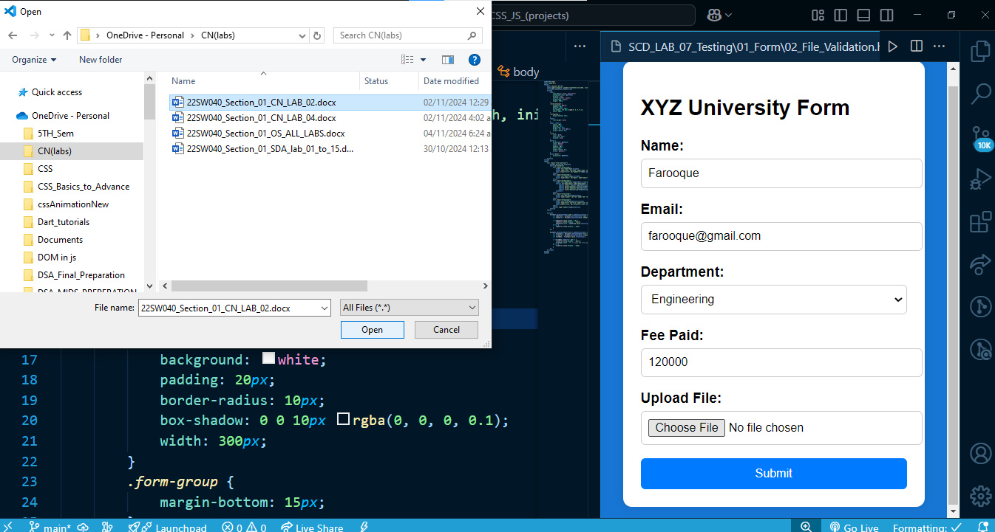

|  |  |  |  |  |  |
| --- | --- | --- | --- | --- | --- |
| ***Test Case 04: File Upload Validation*** | | | | | |
| ***Negative Test Case*** | | | | | |
| ***Test ID*** | ***Test Scenario*** | ***Test Steps*** | ***Expected Result*** | ***Actual Result*** | ***Status*** |
| *TC_008* | *Uploading an invalid file.* | Navigating to the section and uploading the file. | The system should reject the file and display an error message like "Invalid file format." etc | *Yes, System is showing error.* | *Pass* |



