|  |  |
| --- | --- |
| ***RollNo*** | ***22SW040 🡪 Section_01*** |
| ***Subject*** | ***SCD (lab)*** |
| ***LAB*** | ***09 (Azure DevOps Server, git, and Visual Studio)*** |
| ***Teacher*** | ***Ma’am Hina*** |

* ***After installing the MS DevOps Server Configuring Environment.***

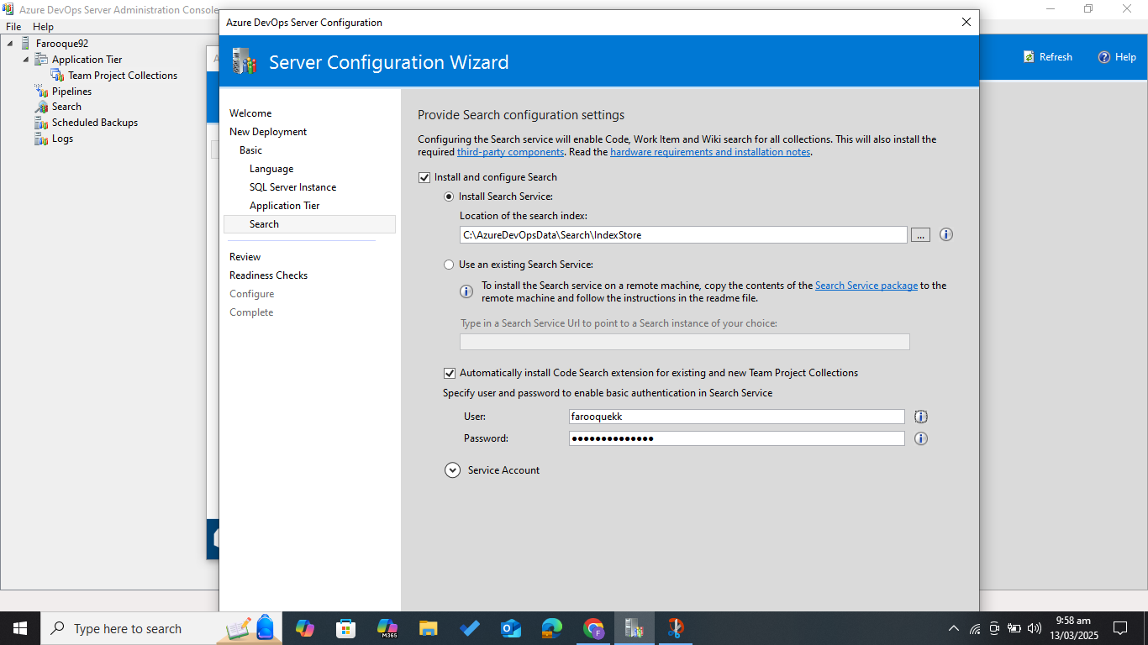

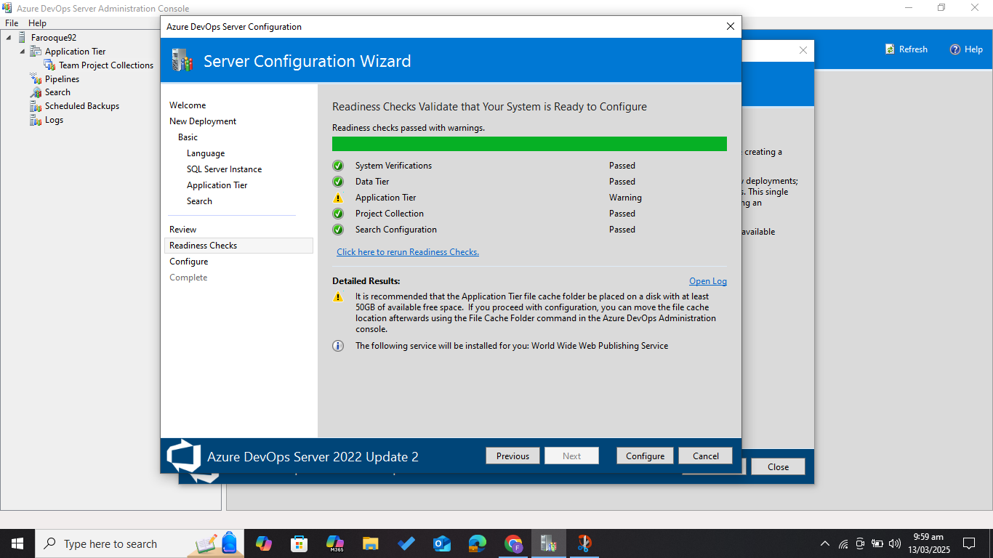

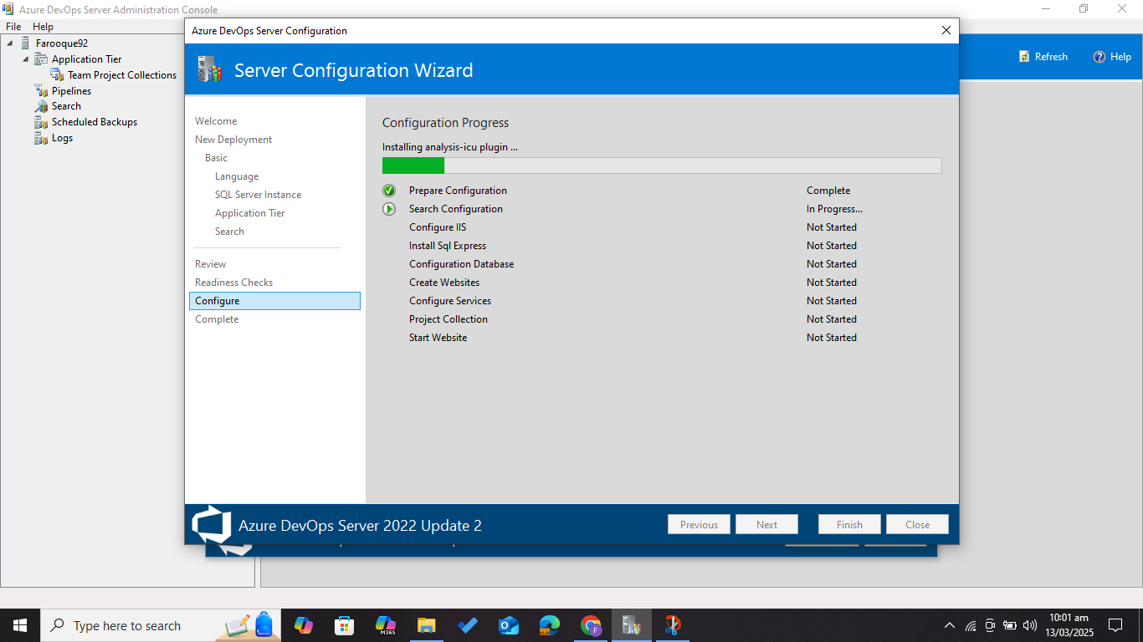

* ***Yes, the server is successfully configured and all required dependencies have been installed.***

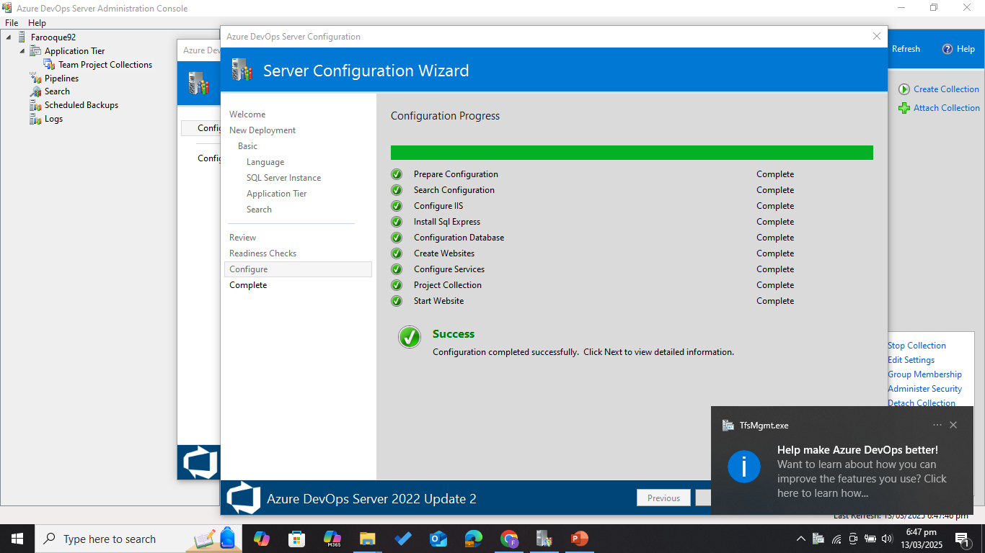

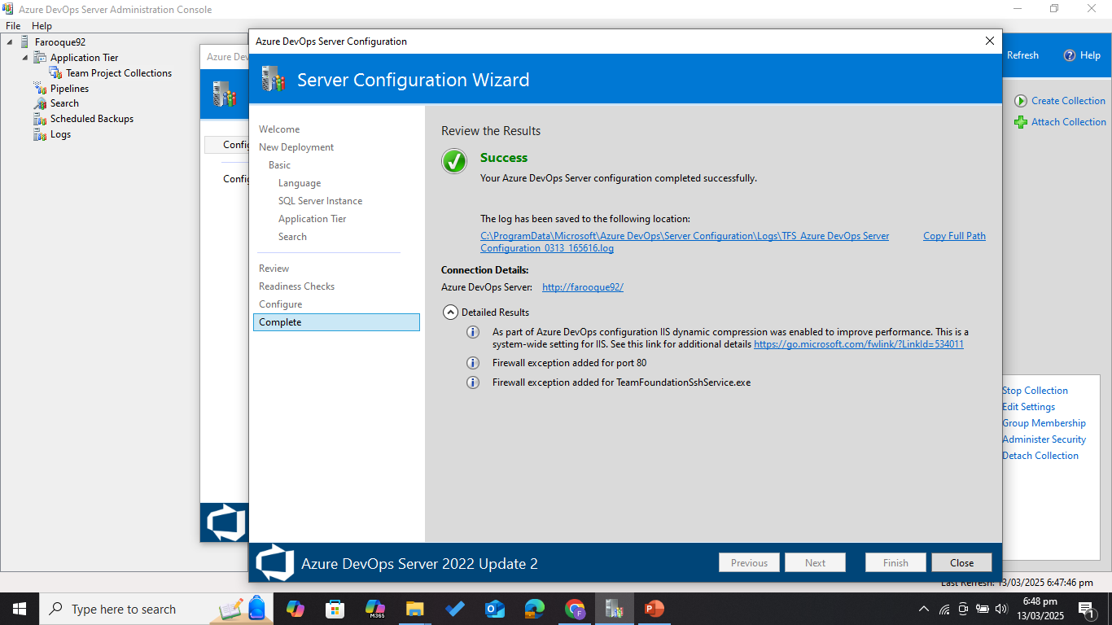

* ***Successfully logged in to MS Azure DevOps.***

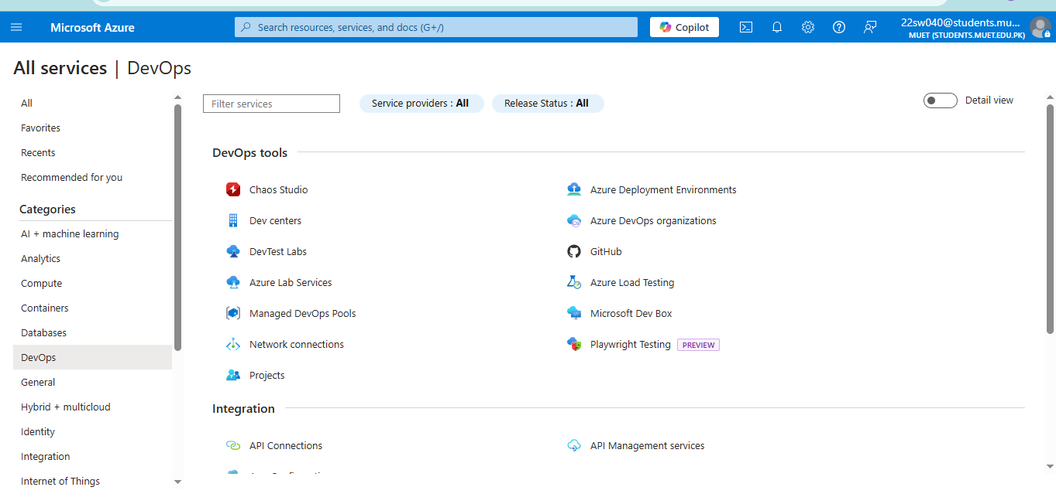

* ***After the sever I have installed git (version control) .***

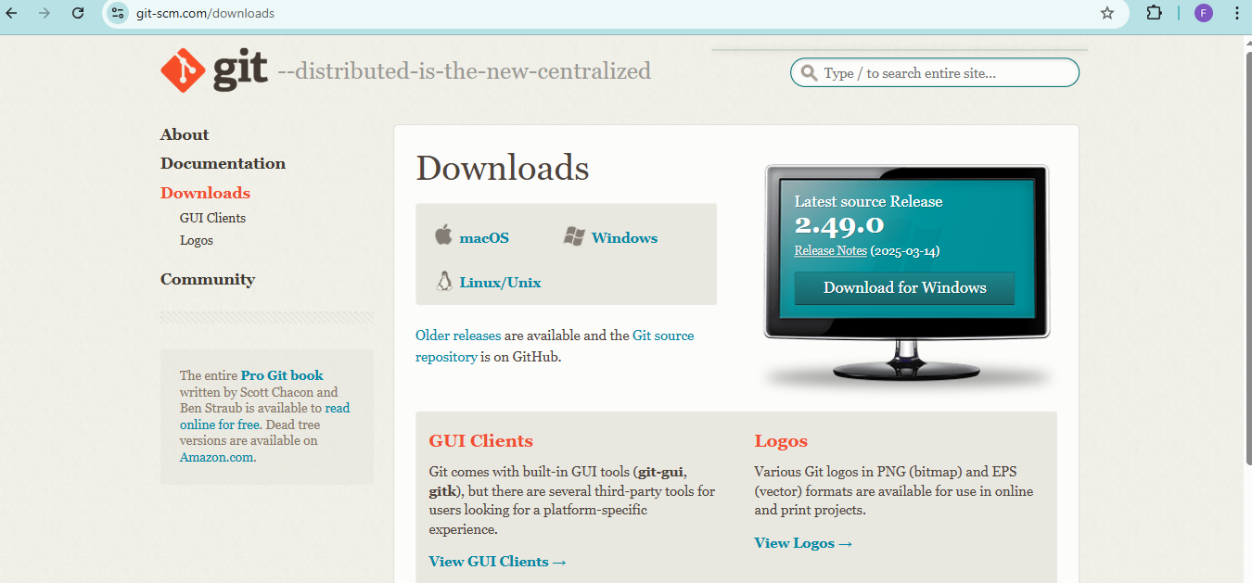

* ***Yes, git is successfully installed on my pc see the SS of git version.***

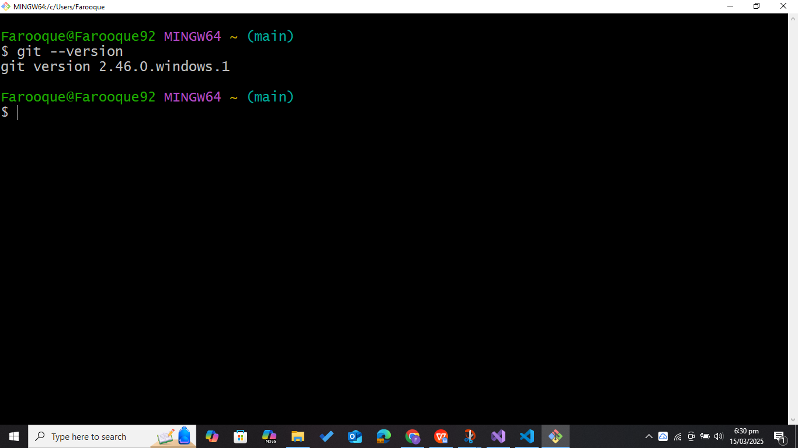

* ***Yes, it is showing connection dev. Azure websites see the SS below.***

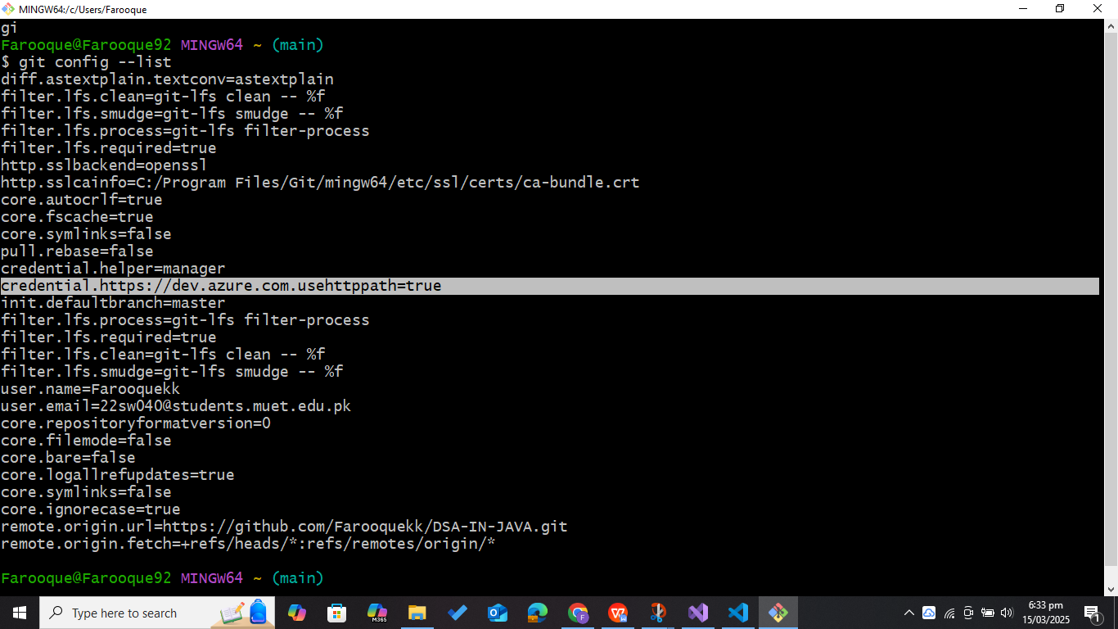

* ***Now Creating a project name (MyWebsite_01) into my default collection in Azure DevOps.***

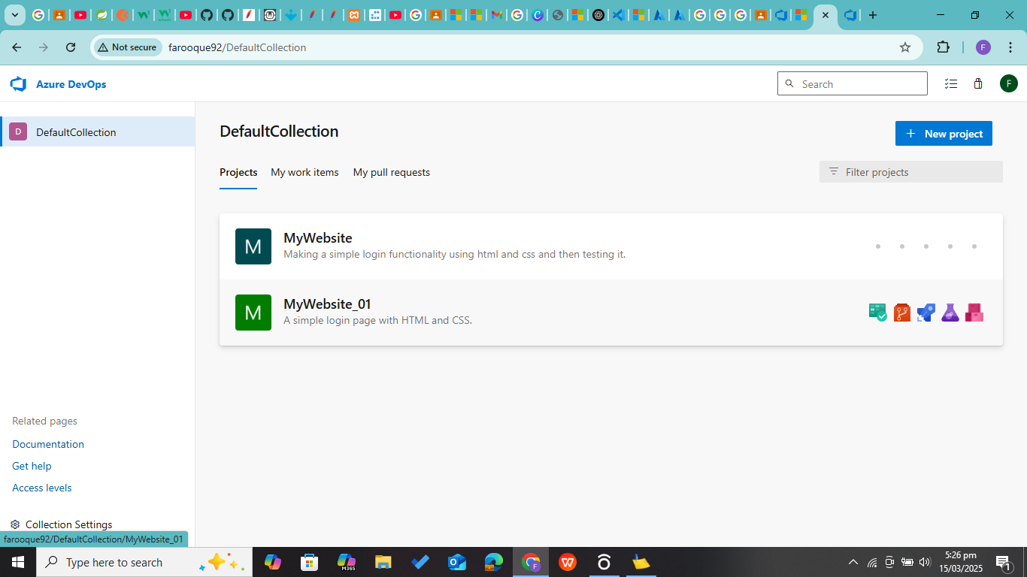

* ***Now I am selecting Work Items from the side bar menu.***

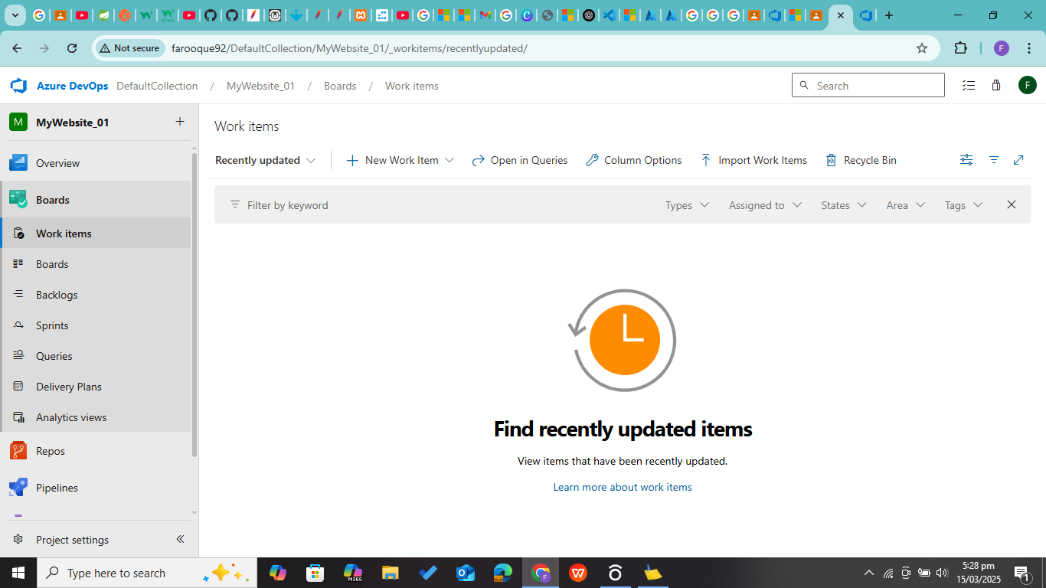

* ***Now creating a test case giving it a name .***

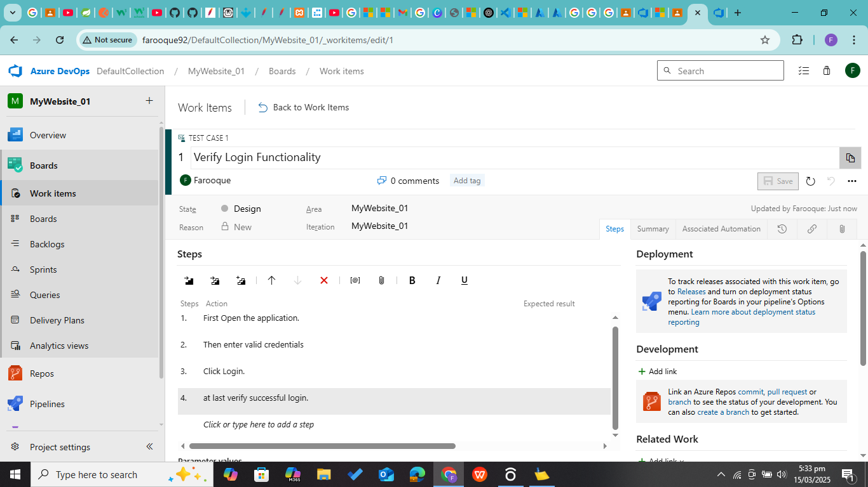

* ***Now adding steps (actions) and its expected result for that test case.***

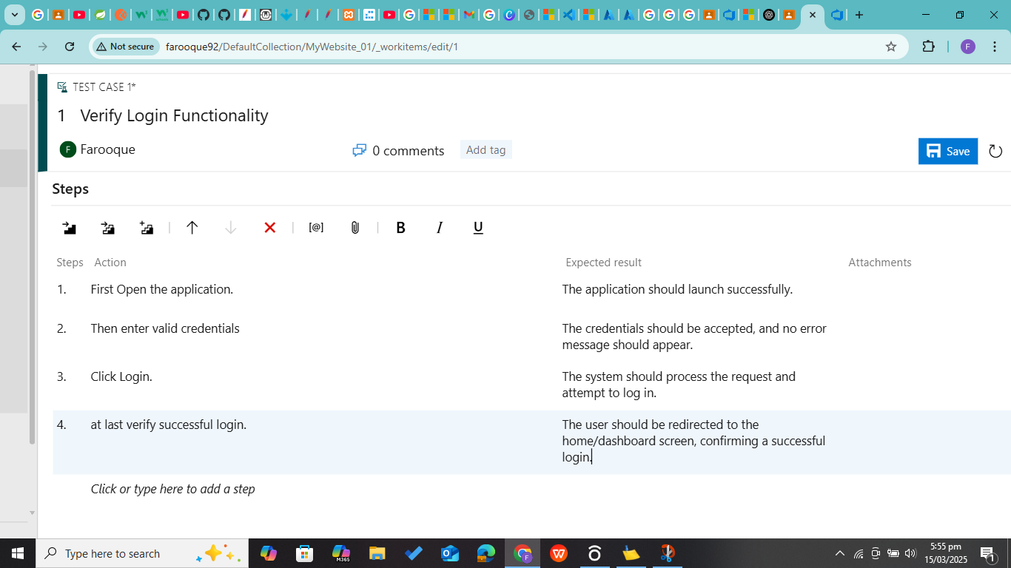

* ***Yes, the test case is successfully created and saved.***
* ***Now Connecting our azure devops server to visual studio.***

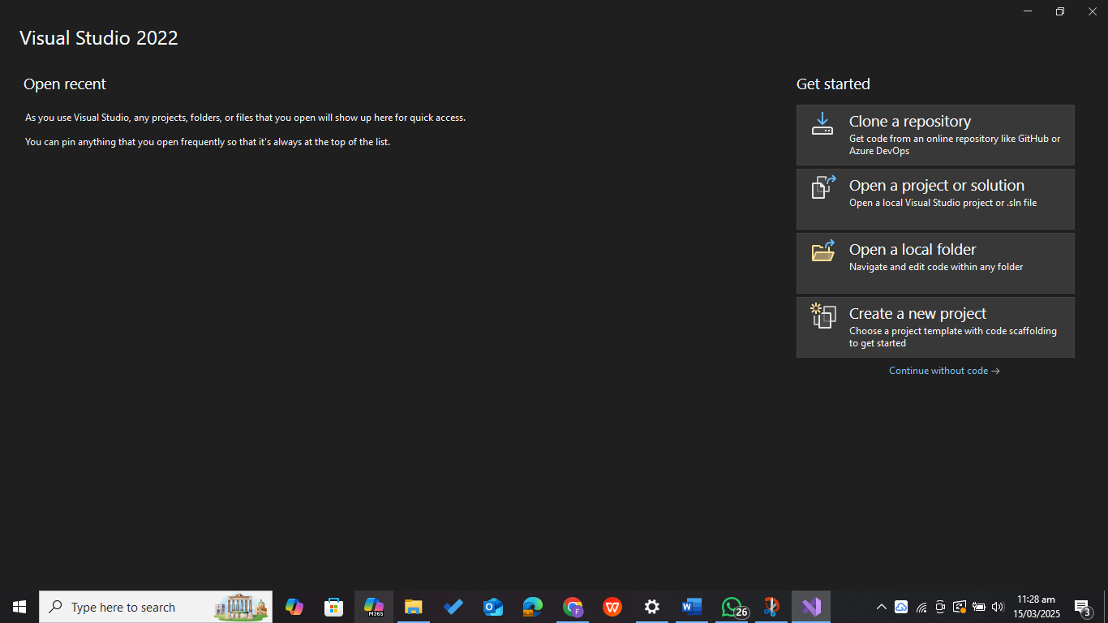

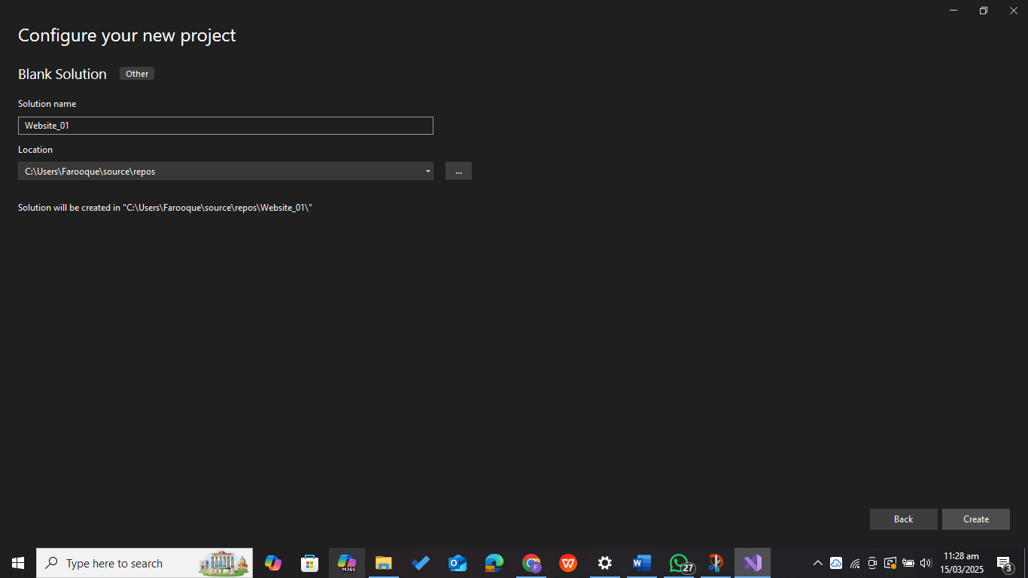

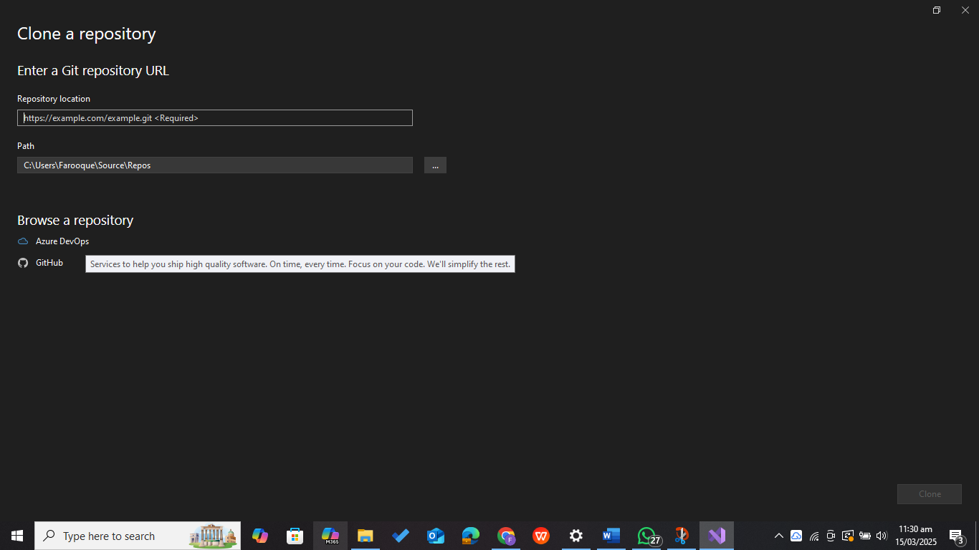

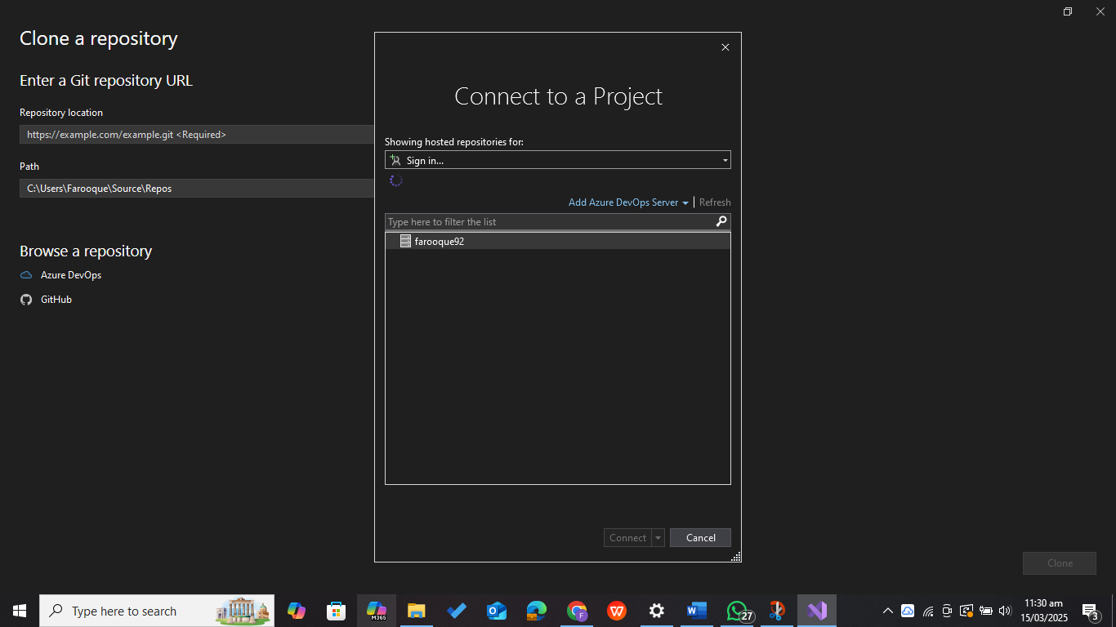

* ***Yes, successfully connected.***
* ***Now Creating Project (My Website) and make simple website with login functionality and then creating a login test case using YAML.***
* ***See the Project Structure below.***

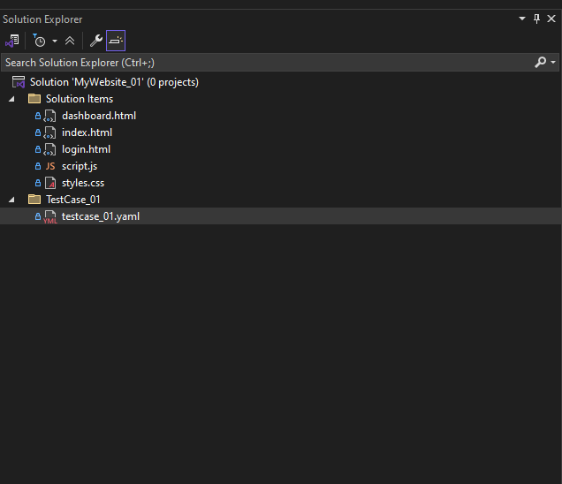

* ***Created a simple website for applying the test case.***

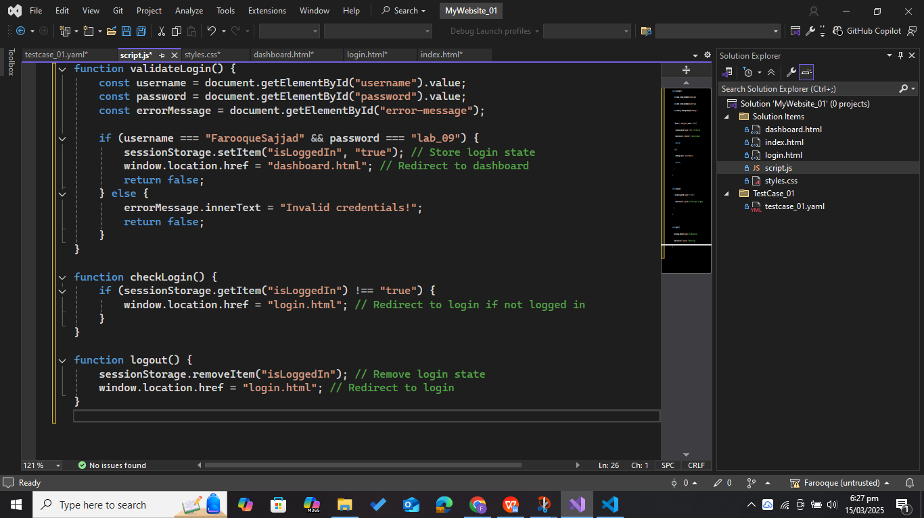

* ***Created a test case in YAML in visual studio.***

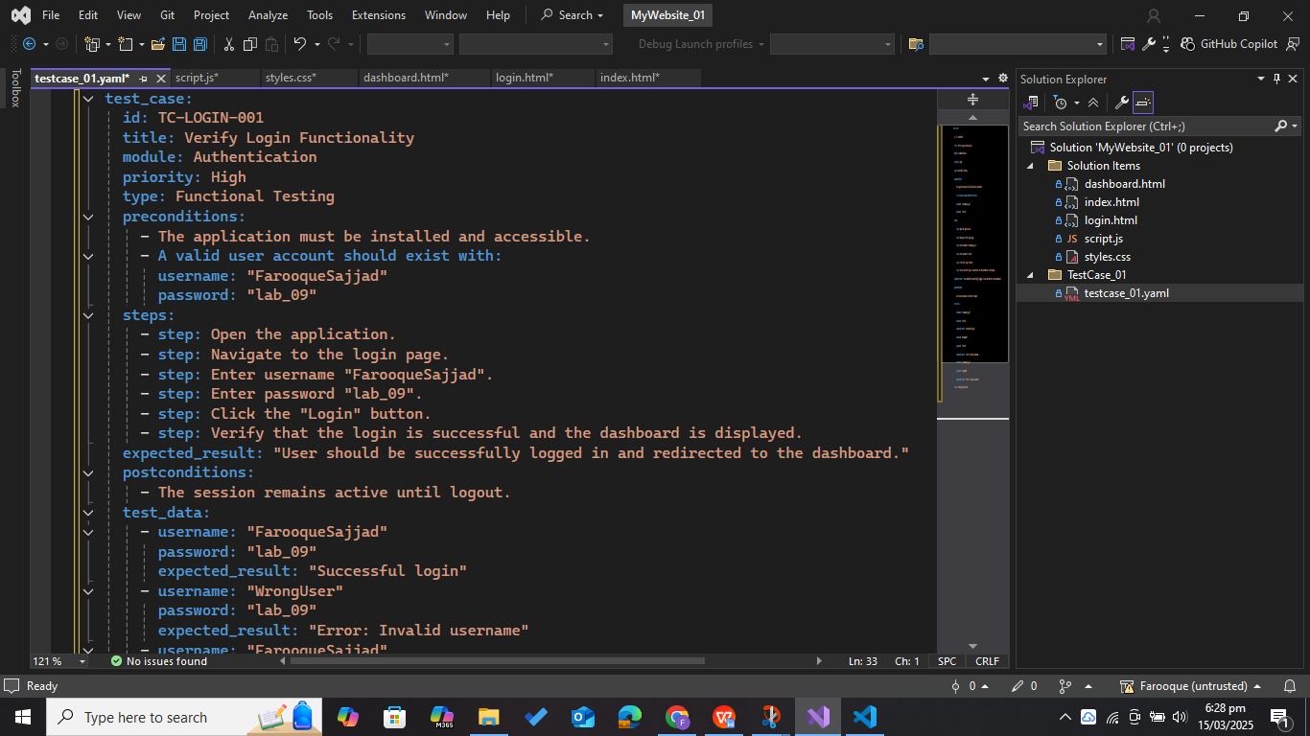

* ***Now Testing the website.***

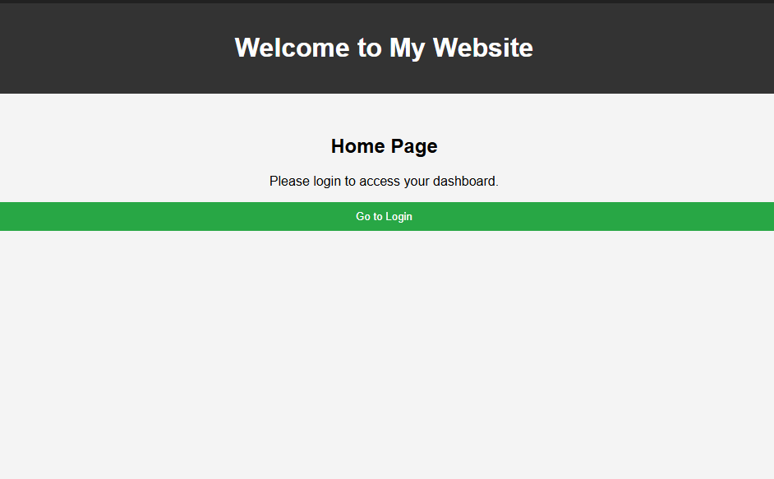

* ***Entering log in credentials (username*** 🡪 ***FarooqueSajjad, Password*** 🡪 ***lab_09).***

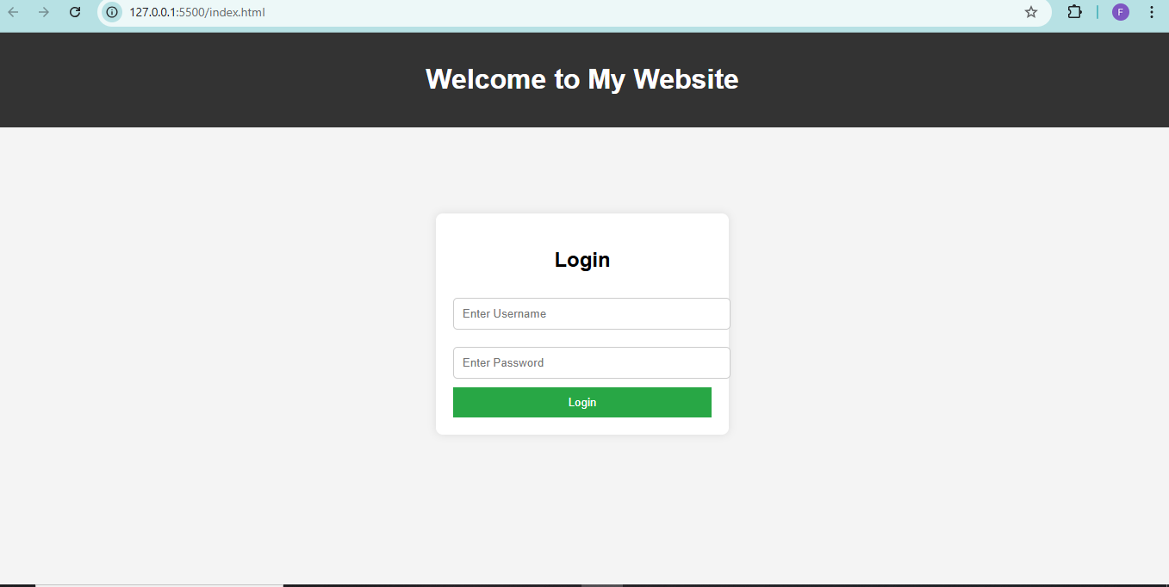

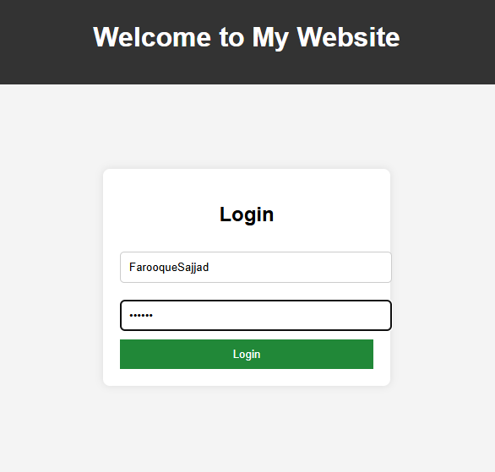

* ***Successfully Logged in.***