|  |  |
| --- | --- |
| ***Roll No*** | ***22SW040 🡪 Section_01*** |
| ***Name*** | ***Farooque Sajjad*** |
| ***Subject*** | ***SCD (lab)*** |
| ***Teacher*** | ***Ma’am Hina*** |

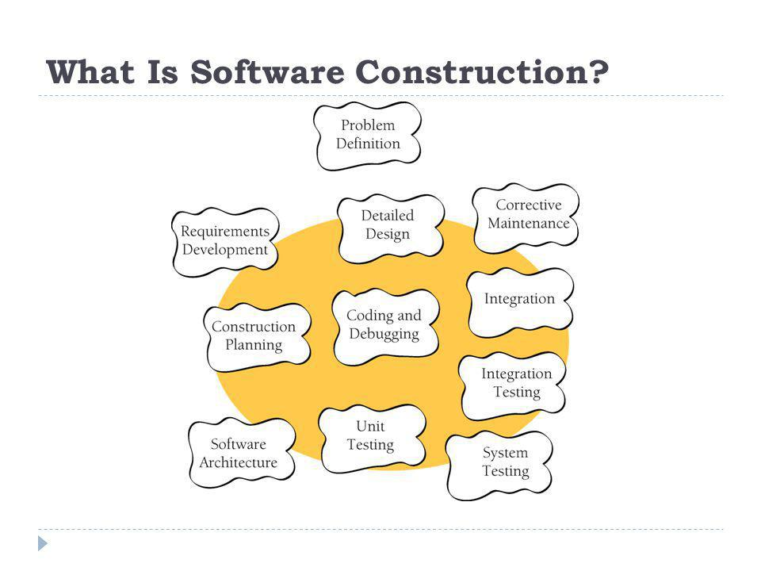

**SOFTWARE CONSTRUCTION AND DEVELOPMENT LAB PROJECT**

***Five Testing Tool***

***Comprehensive Comparison of Five Testing Tools***

***1. JUnit***

**Overview:** JUnit is an open-source framework for unit testing in Java, widely used in Test-Driven Development (TDD).

**Key Features:**

* Annotations (@Test, @Before, @After) simplify test case writing.
* Assertions validate expected outcomes.
* Test runners enable running and reporting results.
* Integration with Maven and Gradle.

**Reference:**

* JUnit 5 User Guide: <https://junit.org/junit5/docs/current/user-guide/>

**Working:**

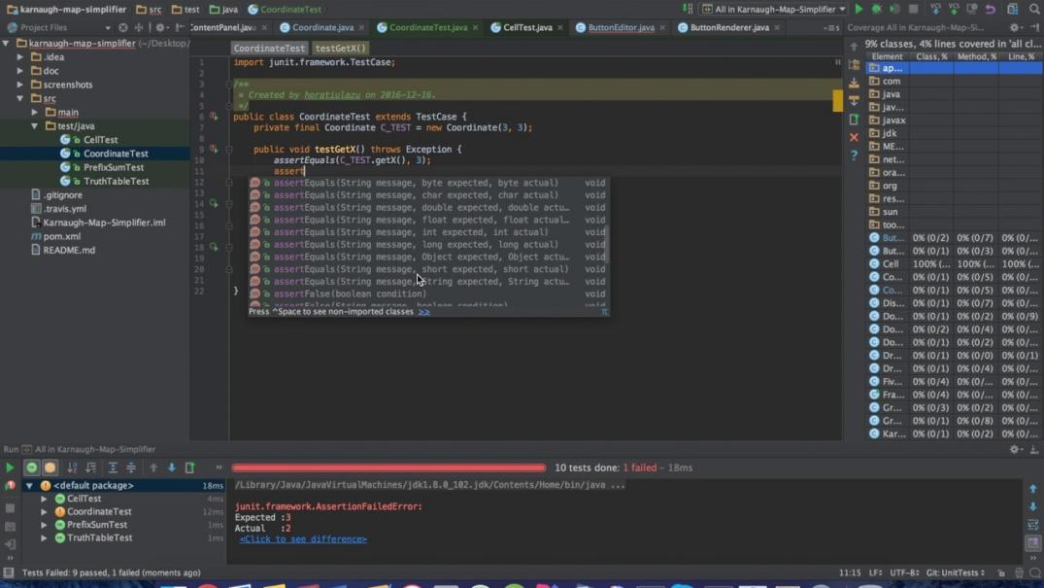

***2. TestNG***

**Overview:** Inspired by JUnit, TestNG extends its functionalities with additional features.

**Key Features:**

* Advanced annotations for flexible configurations.
* Data-driven testing with parameterized inputs.
* Parallel execution support.
* Generates detailed HTML reports.

**Reference:**

* TestNG Documentation: <https://testng.org/>

**Working:**

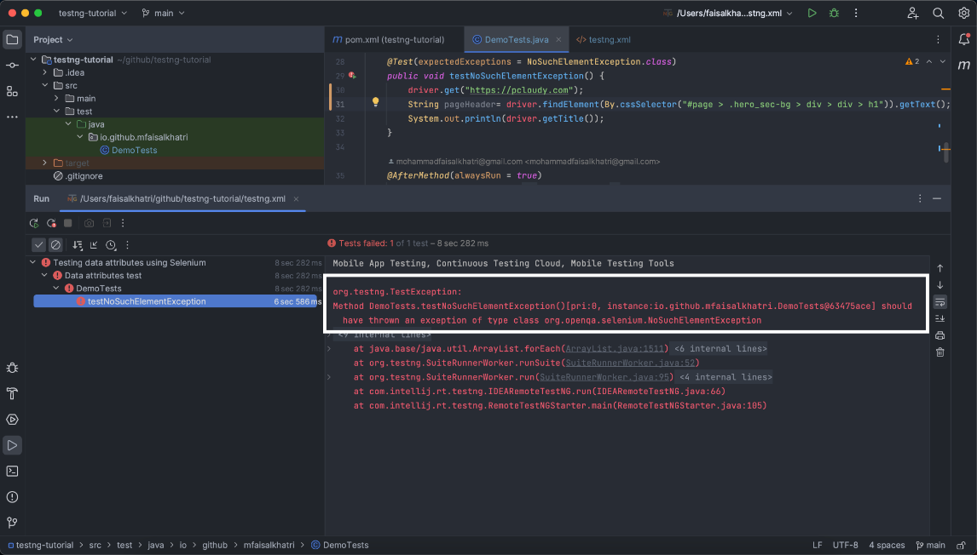

***3. Jest***

**Overview:** A JavaScript testing framework optimized for React applications.

**Key Features:**

* Zero configuration setup.
* Snapshot testing for UI consistency.
* Mocking functions for dependency isolation.
* Supports asynchronous testing.

**Reference:**

* Jest Official Documentation: <https://jestjs.io/docs/getting-started>

**Working:**

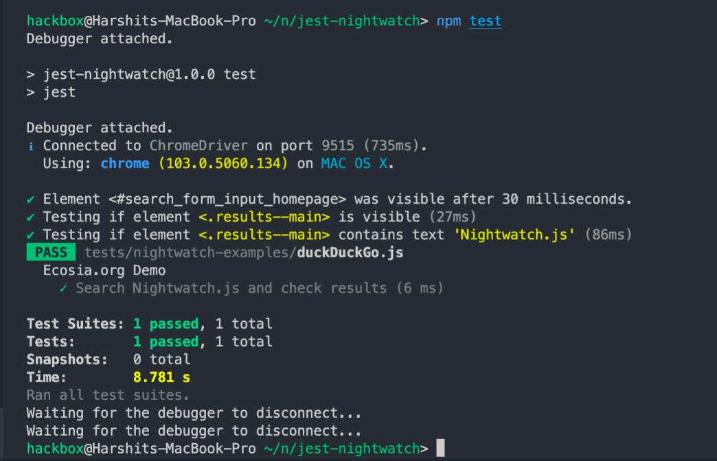

***4. Postman***

**Overview:** A powerful API testing platform designed to test API requests and responses efficiently.

**Key Features:**

* User-friendly interface for HTTP request creation.
* Automated testing with Postman Collections.
* Environment management for different testing setups.
* CI/CD integration for automation.

**Reference:**

* Postman Learning Center: <https://learning.postman.com/>

**Working:**

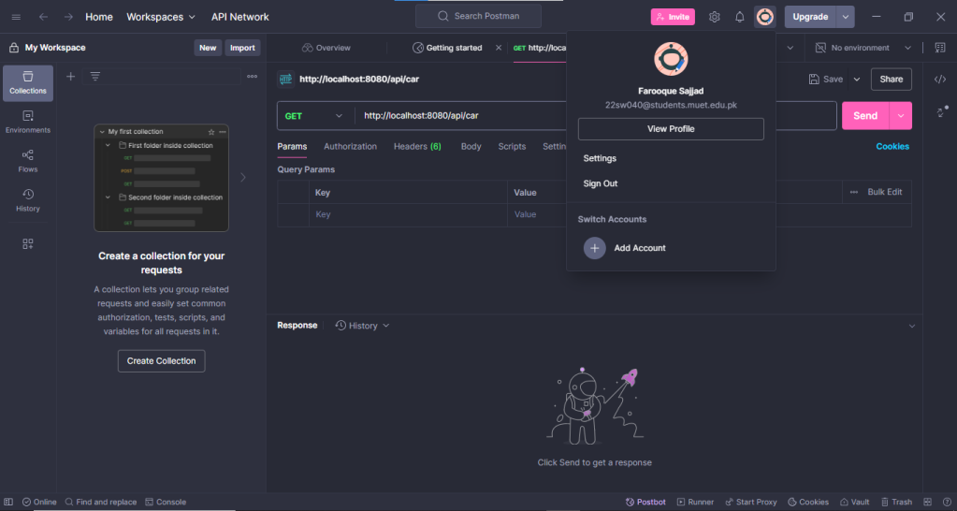

***5. Selenium***

**Overview:** An open-source web automation tool used for testing web applications.

**Key Features:**

* Cross-browser testing support.
* Supports multiple programming languages (Java, Python, C#).
* Parallel execution for efficient testing.
* Integration with TestNG, JUnit, and CI/CD tools.

**Reference:**

* Selenium Official Website: <https://www.selenium.dev/>

**Working:**

|  |  |  |  |  |  |  |  |
| --- | --- | --- | --- | --- | --- | --- | --- |
| ***Comparative Analysis of Testing Tools*** | | | | | | | |
| ***Tool*** | ***Language Support*** | ***Primary Use Case*** | ***Key Features*** | ***Integration*** | ***Learning Curve*** | ***License*** | ***Reference*** |
| JUnit | Java | Unit Testing for Java | Annotations, Assertions, Test Runners | Maven, Gradle, IDEs | Low | Open-source | [JUnit 5 User Guide](https://junit.org/junit5/docs/current/user-guide/) |
| TestNG | Java | Unit & Integration Testi  ng | Advanced Annotations, Parallel Execution, Reporting | Build Tools, CI/CD Pipelines | Moderate | Open-source | [TestNG Documentation](https://testng.org/) |
| Jest | JavaScript | Testing React Apps | Snapshots, Mocking, Async Testing | Babel, Webpack, React | Low | Open-source | [Jest Official Documentation](https://jestjs.io/docs/getting-started) |
| Postman | N/A | API Testing | Automated Testing, Environment Management, CI/CD | Jenkins, Travis CI, GitHub Actions | Low | Freemium | [Postman Learning Center](https://learning.postman.com/) |
| Selenium | Multiple | Web Application Testing | Cross-Browser Testing, Parallel Execution | TestNG, JUnit, CI/CD Tools | Moderate | Open-source | [Selenium Official Website](https://www.selenium.dev/) |

***Additional Comparative References***

1. ***JUnit vs. TestNG: A Comprehensive Comparison Guide*1. Overview:** This article provides an in-depth analysis of the differences between JUnit and TestNG, discussing features, annotations, parallel execution, and more. It offers insights into which framework might be more suitable depending on specific project requirements.  
   **2. Reference:** <https://toxigon.com/junit-vs-testng-comparison/>
2. ***Java Testing Frameworks: JUnit vs. TestNG*1. Overview:** This comparison outlines the distinct features and performance metrics of JUnit and TestNG, emphasizing their suitability for different testing scenarios in Java projects.  
   **2. Reference:** <https://www.javacodegeeks.com/2025/01/java-testing-frameworks-junit-vs-testng.html>
3. ***JUnit vs. TestNG: A Comprehensive Comparison***
   1. ***Overview:*** This article provides an in-depth analysis of the differences between JUnit and TestNG, discussing features, annotations, parallel execution, and more. It offers insights into which framework might be more suitable depending on specific project requirements.
   2. ***Reference:*** <https://www.baeldung.com/junit-vs-testng>
4. ***Jest vs. Selenium: Understanding the Differences***
5. **Overview:** This article provides an in-depth analysis of the differences between Jest and Selenium, discussing their distinct purposes, features, and use cases. It emphasizes that while Jest is tailored for unit testing in JavaScript applications, particularly those using React, Selenium is geared towards end-to-end testing of web applications across various languages and browsers.​
6. **Reference:** Knapsack Pro - Jest vs. Selenium Comparison (2024) : <https://knapsackpro.com/testing_frameworks/difference_between/jest/vs/selenium>
7. ***API Testing Tools: Postman vs. Others***
   1. **Overview:** This article provides a comparative analysis between Postman and other API testing tools, discussing their features, advantages, and potential drawbacks to help you choose the most suitable tool for your needs.
   2. **Reference:** [Medium - Postman vs. Other API Testing Tools](https://medium.com/@AlexanderObregon/postman-vs-other-api-testing-tools-a-comparative-analysis-d7fb0c13d43a)
8. ***Top JavaScript Testing Frameworks***
   1. **Overview:** This guide reviews the top JavaScript testing frameworks, including Jest, Mocha, and Jasmine, highlighting their features, use cases, and benefits to assist in selecting the appropriate framework for your project.
   2. **Reference:** [BrowserStack - Top JavaScript Testing Frameworks](https://www.browserstack.com/guide/top-javascript-testing-frameworks)
9. ***Best Postman Alternatives for API Testing in 2025***
   1. ***Overview:*** This article explores various alternatives to Postman for API testing, discussing their features, advantages, and potential drawbacks to help you choose the most suitable tool for your needs.
   2. ***Reference:*** <https://katalon.com/resources-center/blog/postman-alternatives-api-testing>

