

MEHRAN UNIVERSITY

OF ENGINEERING & TECHNOLOGY

JAMSHORO, PAKISTAN

Subject: Software Design and Architecture

(Tasks Solution)

|  |  |
| --- | --- |
| **Roll No:** | **22SW040** |
| **Section:** | **I** |

**Practical/Lab No. 01**

Introduction to UML and to become familiar with usecase diagrams.

**Task # 01**

Create a use case diagram for online Human Resource Management system. Show at least two actors and various use cases along with the relationships (extended, include, generalization) between them.

**Solution:**

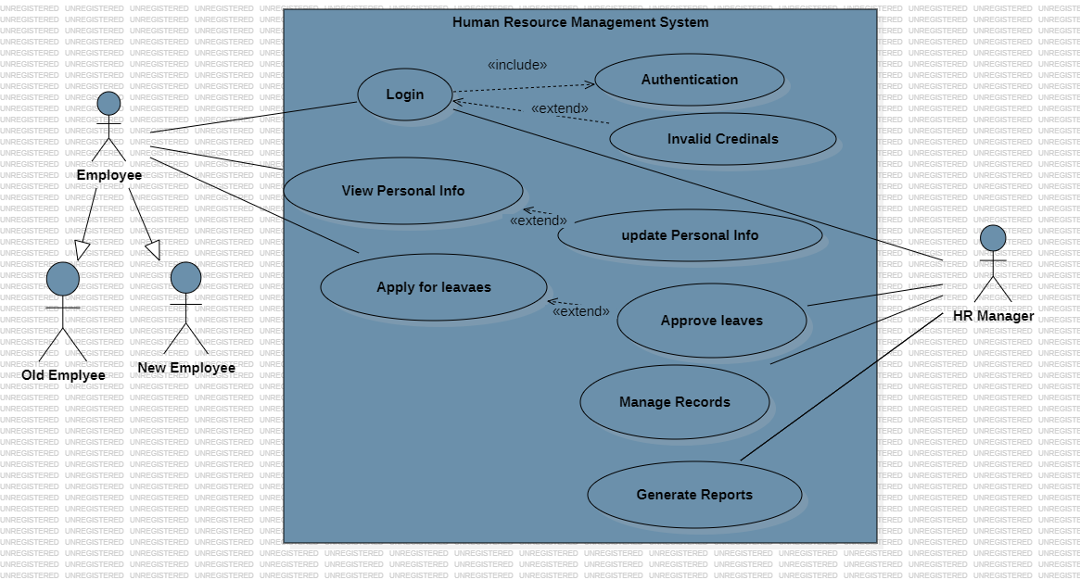

**Task # 02**

Create a simple use case diagram that identifies the actors involved in a specific scenario. For example, if you are designing a website, the actors may include users, administrators, and developers.

**Solution:**

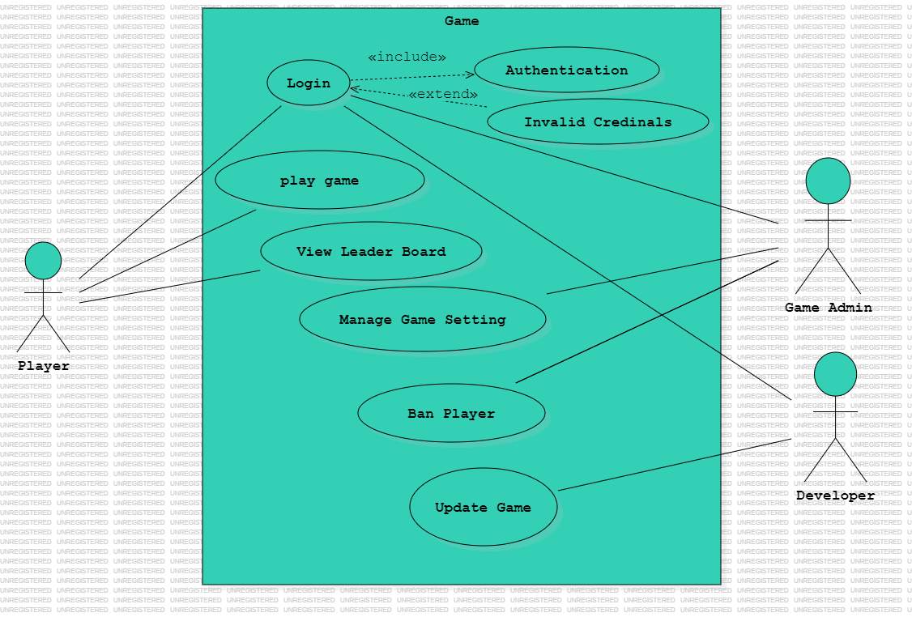

**Task # 03**

Create a use case diagram that defines the different use cases for a specific scenario. This may involve identifying the different actions that a user can take, such as searching for a product, adding a product to their cart, and checking out.

**Solution:**

