API TESTING & EXECUTION REPORT

Simple Books and Countries API Project
Assignment No. 4

Submitted By | Farooque Sajjad
Department | Quality Assurance
Organization | 10Pearls
Submission Date | 05-14-2026
Tools Used | Postman

1. Document Control
This document covers API testing design and execution using Postman for the Simple Books API project. The assignment demonstrates REST API testing using multiple HTTP methods, authentication handling, API chaining, variable management, and Chai assertions.
Version: 1.0
Prepared By: Farooque Sajjad
Status: Draft

2. Project Summary
The Simple Books API project is a REST API testing assignment executed in Postman. The collection validates API endpoints using GET, POST, PATCH, PUT, and DELETE methods. Dynamic variables, token-based authentication, request chaining, and automated assertions are implemented.
2.1 Scope of Testing
• API status validation
• Book retrieval APIs
• Authentication token generation
• Order creation and management
• CRUD operations on orders
• External API testing using REST Countries API
• Chai assertion validation
• Negative testing using intentional failures
2.2 Out of Scope
• Performance testing
• Load testing
• Security penetration testing
• UI testing

3. Test Methodology
3.1 Testing Approach
Black-box API testing was used throughout the assignment. All APIs were validated using request-response verification and automated assertions.
Testing Types Used:
• Functional Testing
• Smoke Testing
• Negative Testing
• Regression Testing
3.2 Tools Used
• Postman
• Postman Console
• REST APIs
• Chai Assertion Library
3.3 API Methods Covered
• GET
• POST
• PATCH
• PUT
• DELETE

4. Collection Variables and Environment Setup
The following collection variables were created and used for API chaining:
• baseUrl
• countriesBaseUrl
• accessToken
• orderId
• bookId
• clientName
• clientEmail
Variables were dynamically updated during execution using Postman collection variables.

5. API Requests and Execution Details
The collection contains 10 API requests covering complete CRUD workflow and external API testing.

5.1 GET - API Status Check
Purpose:
Verify API availability.
Assertions:
• Status code 200
• Status equals OK
• Response 1.65S
Intentional failing test was added for negative testing.
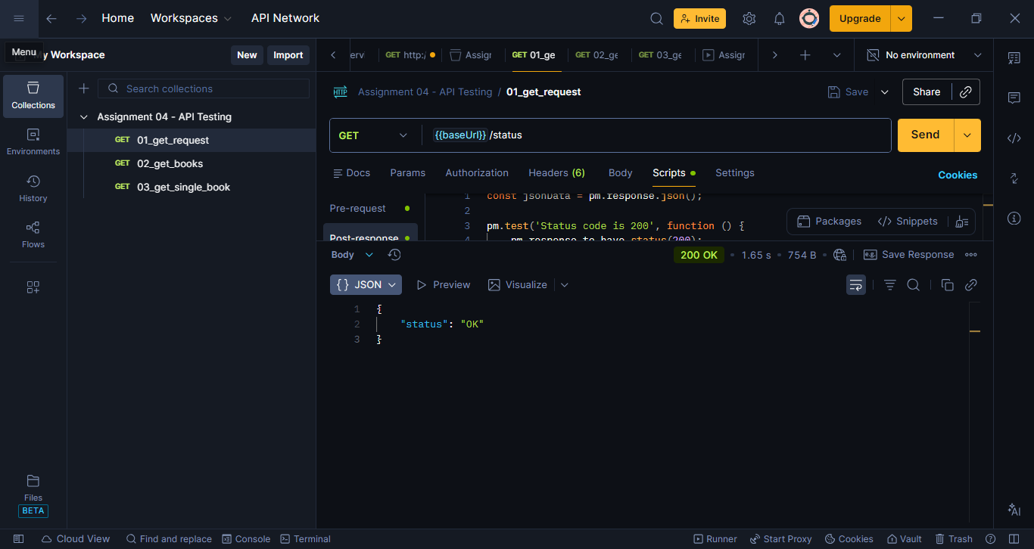
Figure 1: Postman response of GET /status

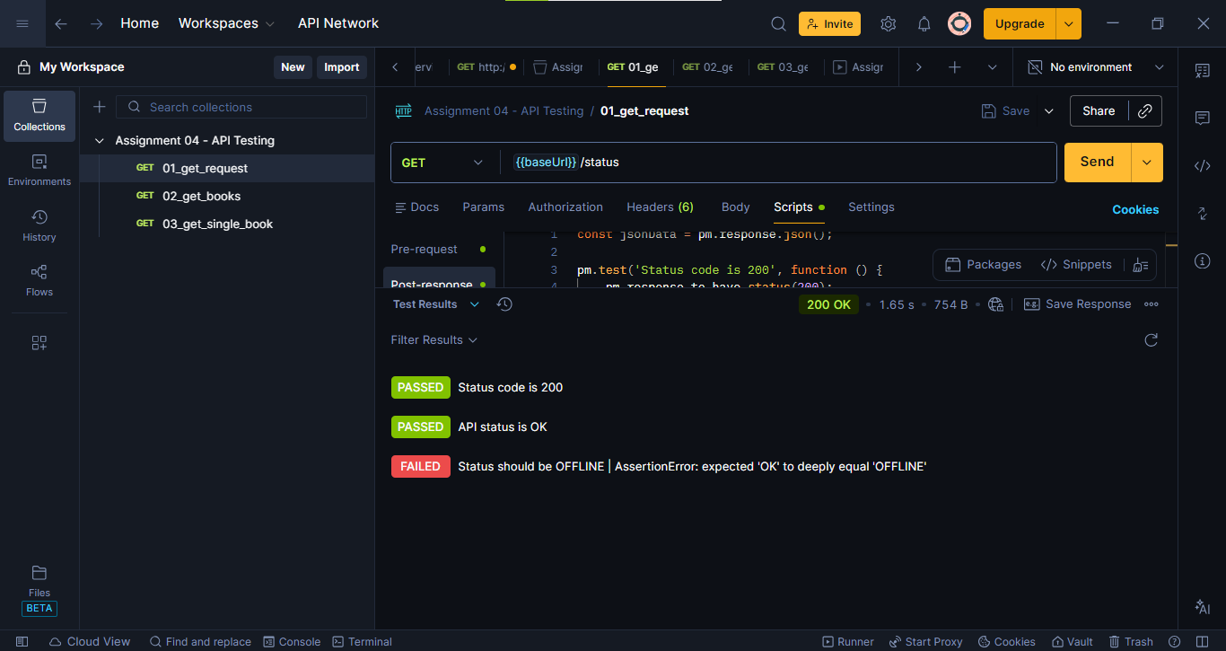
Figure 2: Failed assertion screenshot

Figure 3: Postman Console log

5.2 GET - List Books
Purpose:
Fetch fiction books list and save bookId dynamically.
Features:
• Query parameter handling
• API chaining
• Dynamic variable storage
Assertions:
• Response is array
• Books list not empty
• Book fields validation
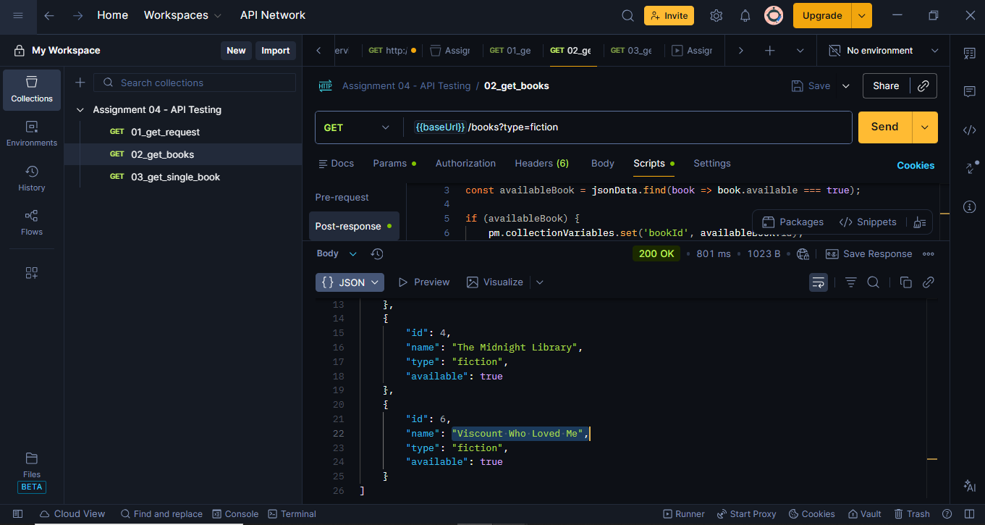
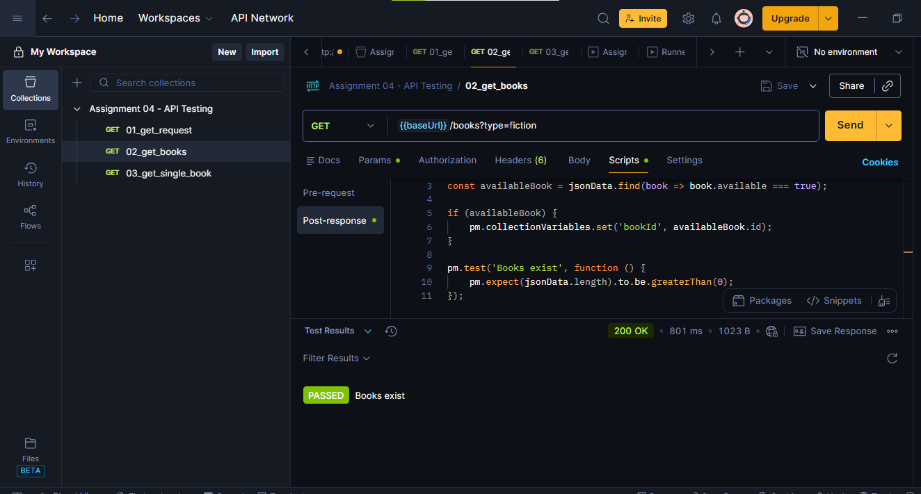

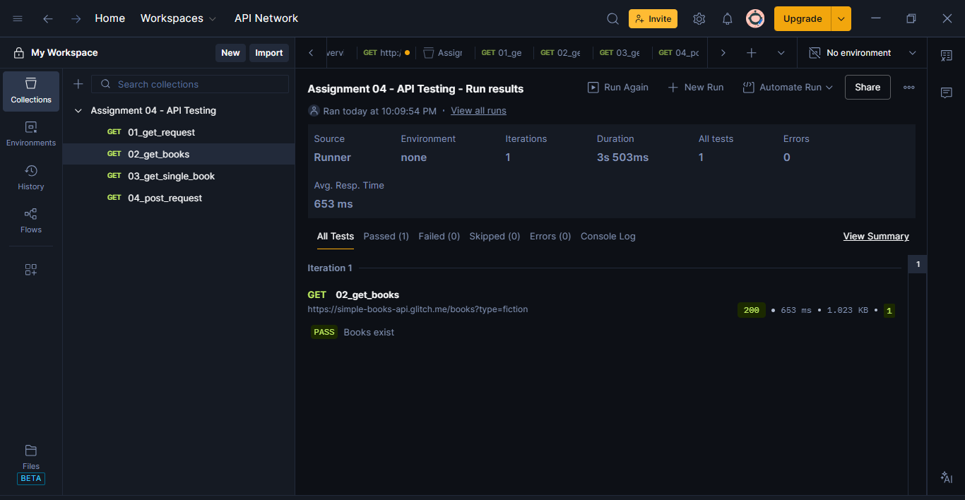

5.3 GET - Single Book
Purpose:
Retrieve a single book using chained bookId.
Assertions:
• Status code 200
• Book contains name and author
• Price validation
• Availability validation
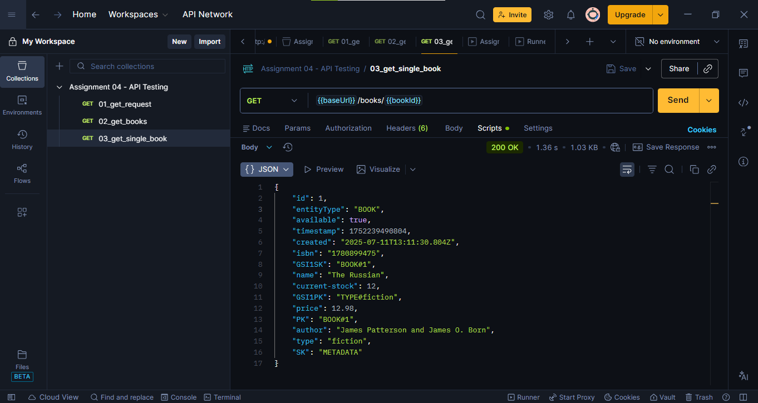

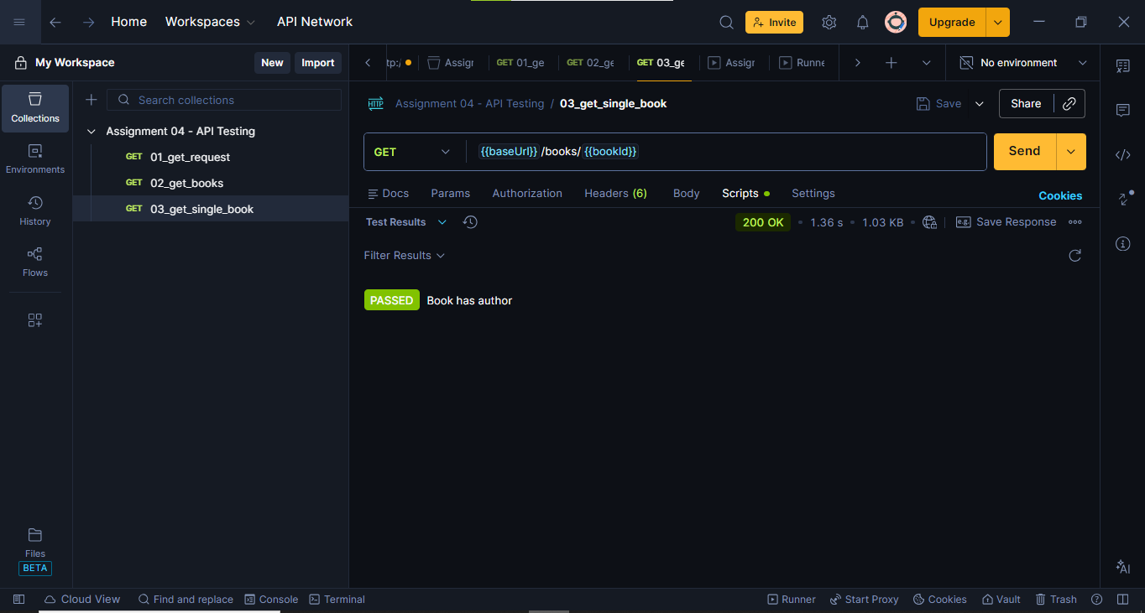

5.4 POST - Register API Client
Purpose:
Register API client and generate access token.
Features:
• Random client generation
• Dynamic email creation
• Token storage
Assertions:
• Status code 201
• accessToken exists
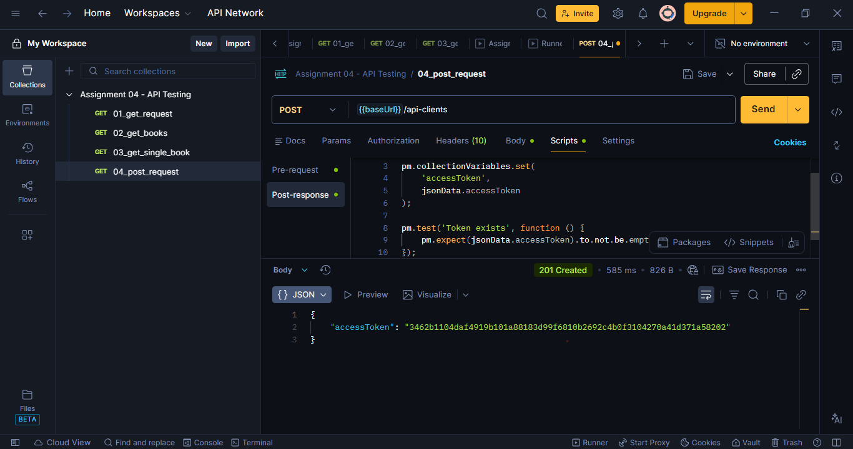
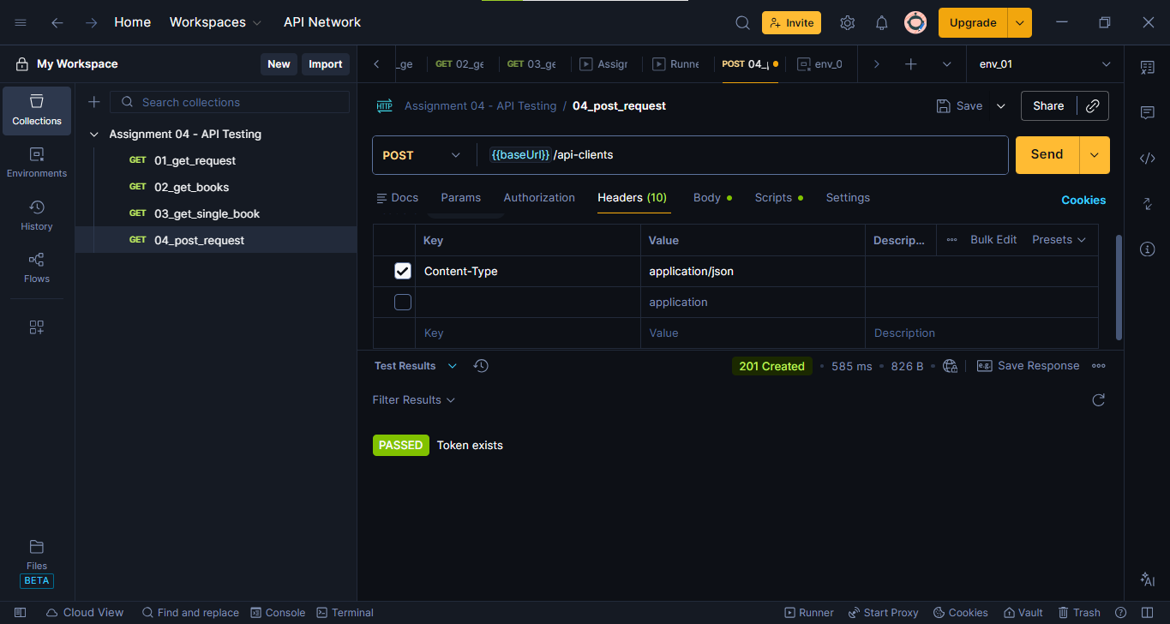

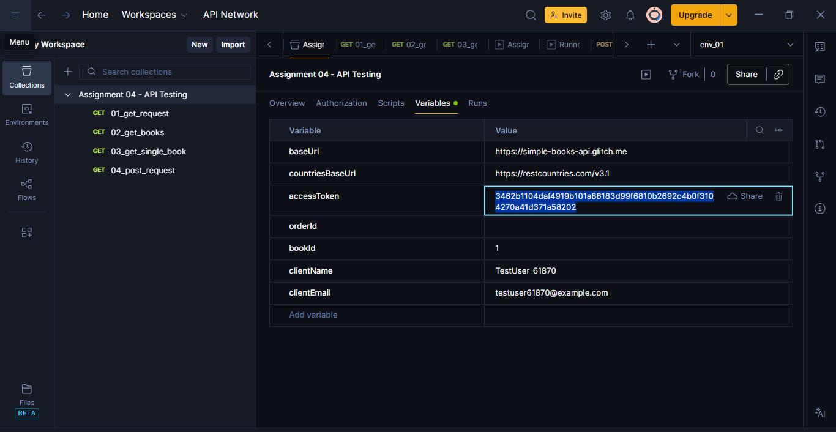

5.5 POST - Submit Order
Purpose:
Create a new book order.
Features:
• Uses chained accessToken
• Uses chained bookId
• Dynamic customer names
Assertions:
• Order successfully created
• orderId generated
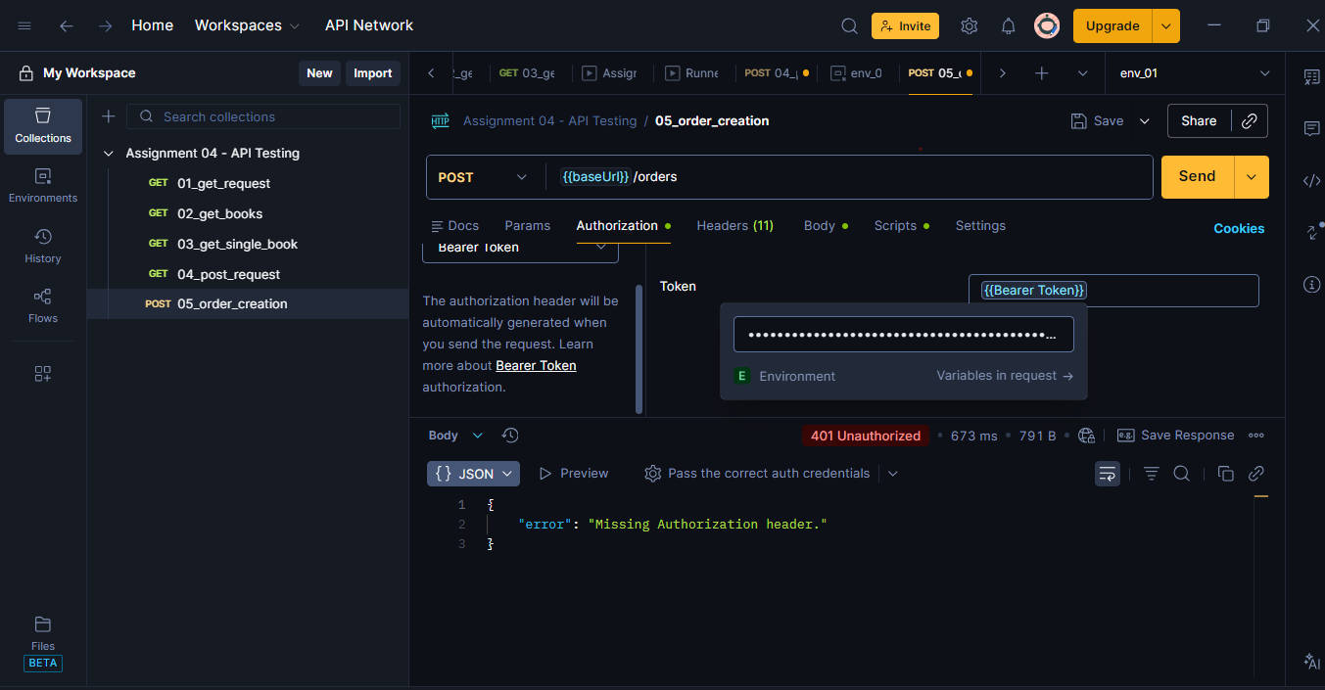

5.6 GET - Get All Orders
Purpose:
Retrieve all orders for authenticated client.
Assertions:
• Orders list validation
• Required fields verification

5.7 PATCH - Update Order
Purpose:
Update customer name partially.
Assertions:
• Status code 204
• Empty response validation

5.8 PUT - Replace Order
Purpose:
Fully replace order data.
Assertions:
• Status code 204
• Empty response validation

5.9 DELETE - Delete Order
Purpose:
Delete created order.
Assertions:
• Status code 204
• Empty response body

5.10 GET - Countries API
Purpose:
Validate external REST Countries API.
Assertions:
• Status code 200
• Population validation
• Country details verification
Intentional failing assertion added.
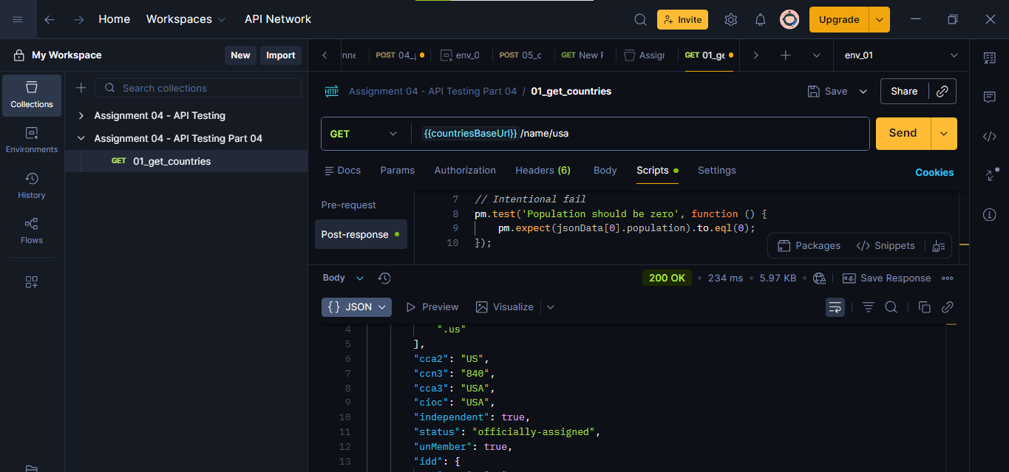
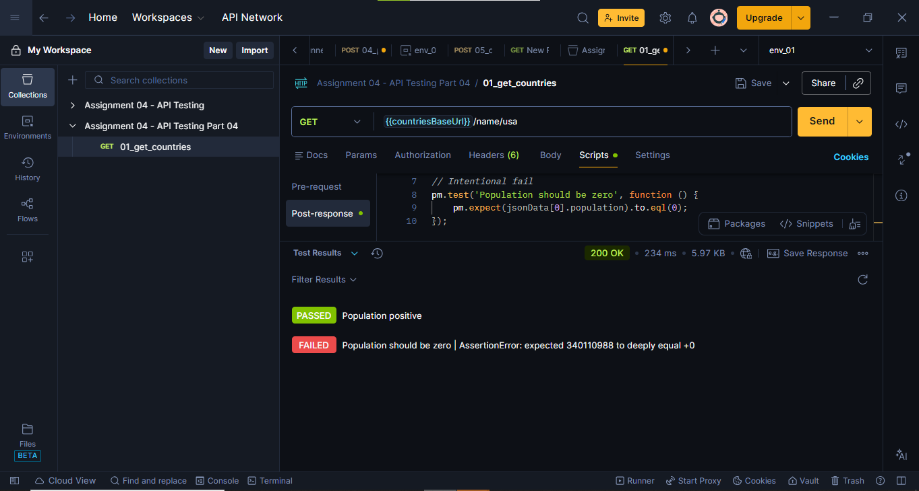

6. API Chaining Workflow
The following API chaining process was implemented:
1. Fetch books
2. Save bookId
3. Register API client
4. Save accessToken
5. Create order
6. Save orderId
7. Update order
8. Delete order
This demonstrates real-world API workflow automation.

7. Chai Assertions Used
Sample assertions used in the assignment:
pm.response.to.have.status(200);
pm.expect(jsonData).to.have.property('status');
pm.expect(jsonData.length).to.be.greaterThan(0);
pm.expect(jsonData.accessToken).to.be.a('string').and.not.empty;
pm.expect(pm.response.responseTime).to.be.below(2000);

8. Negative Testing
Intentional failing tests were added to demonstrate error reporting and validation failures.
Examples:
• Status should be OFFLINE
• Population should be zero

09. Observations and Learning Outcomes
The assignment provided practical experience in:
• REST API testing
• CRUD API operations
• Authentication handling
• Dynamic variables
• API chaining
• Chai assertions
• Automated validations
• Negative testing
• Debugging using Postman Console
The project demonstrates real-world API automation practices used in QA engineering.

11. Submission Checklist
1. Postman Collection JSON
2. Postman Screenshots
3. API Execution Report
4. Chai Assertion Examples
5. Console Log Screenshots
6. Collection Variables Screenshot
7. CRUD Workflow Screenshots
