Quiz

Python Day :

1. What will be the output of the following Python code?
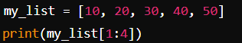

- A) [10, 20, 30, 40]
- B) [20, 30, 40]
- C) [30, 40, 50]
- D) [20, 30, 40, 50]

Answer: B) [20, 30, 40]

2. What will the following code return?
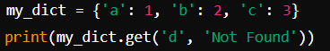

A) KeyError
B) None
C) 'Not Found'
D) 3

Answer: C) 'Not Found'

3. Which of the following is a valid way to slice a list nums to get every other element starting from the first element?
- A) nums[0:len(nums):2]
- B) nums[1:]
- C) nums[::-1]
- D) nums[::3]

Answer: A) nums[0:len(nums):2]

4. Which of the following statements about tuples is correct?
- A) Tuples are mutable
- B) Tuples can contain duplicate elements
- C) Tuples do not allow indexing
- D) Tuples cannot be nested

Answer: B) Tuples can contain duplicate elements

5. What will be the output of the following code?
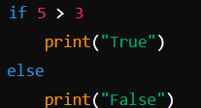

A) True
B) False
C) SyntaxError
D) Nothing
Answer: C) SyntaxError

