###### Damietta University

###### Faculty of Computers and Artificial Intelligence

###### System Analysis and Design, 2022/2023

Compound Security System

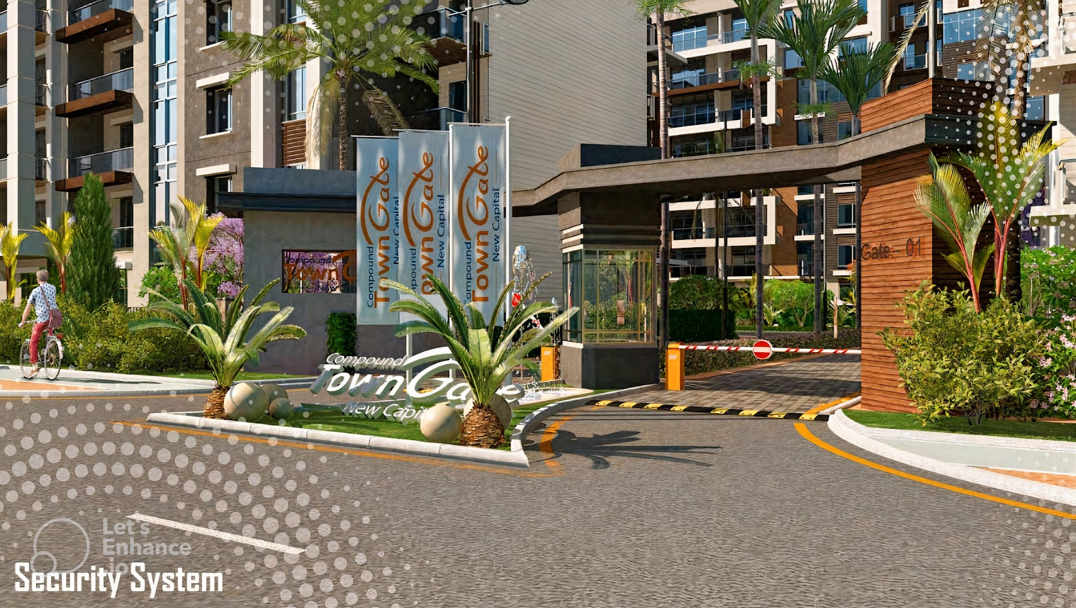

Team Members:

1. Farouk Ashraf Farouk Elshamy.
2. Mohamed Mostafa Mohamed Abdelhamed.
3. Mohamed Mohamed Mostafa Morra.
4. Omar Mohamed Ahmed Shetewy.
5. Saad Mohamed Saad Mohamed.
6. Problem Statement:  
     
    Regular compound security systems are inefficient in many ways, such as:

manually checking entering visitors whether they’re a unit owner or a visitor and confirming their visit request, and same for cars, verifying user data manually which reduces client satisfaction, the lack of data collection and processing, no calibration between the general system and the individual house security system, the inability of collecting client feedback for improvements.

1. Scope:

New system will Check clients or visitors if they are able to enter compound by storing owners’ data in Its database and check if they exist and collecting client’s data and analyze it and returns reports when need.

1. Solution Statement

The new system can be described as smart information system as it will be responsible for storing new and existing clients’ information and their cars’ plate and detect any invalid entry at the gates and alert the security guards to take place, it’ll also communicate with the individual unit security systems to capture any invalid entry while the owners are absent, it’ll will handle inputs from users such as feedback and visit requests and it’ll collect info about clients, analyze it and sends reports to the management automatically and/or when requested, the system will have different interfaces for each end-users

1. Objectives:

- The New System spends a lot of effort to improve client experience and increases the quality of services in compound by collecting client’s data and transform it into a worthy information

- This system will save much time when it scans cars automatically using digital cameras.

- It will be more efficient and accurate in scanning client’s ids.

- It will collect worthy data of clients that could be used to improve services increasing client experience.

- This system will reduce the average monthly cost, thus investing the surplus money in improving client experience in ways like:

- Adding entertainment services like swimming pools

- Adding more landscape like gardens

- This system mainly focuses on improving overall client experience, reducing annually coast and keep the compound organized and much safer.

1. Actors:

In this compound security system, there are five actors allowed to interact with the system:

1) Security guards:

He is responsible for:

- Monitoring the compound gates system and notify clients when they have visitors.

- Entering the customer's private data into the system in case the system fails to recognize it.

2) Clients:

He interacts with the system through an application linked to the system that allows him to inform the security guards of the date of his departure and return, or the presence of a visitor coming to him to ensure more security for him and his home.

3) Technical Support Specialist:

He is allowed to modify the system, add new features whenever possible, and repair the system when any sudden failure occurs

4) the system itself

The system also works automatically through artificial intelligence, and this is evident through

its ability to recognize the client face or the plate of his car, open the gates of the compound for him, and other functions. Therefore, the regime is considered one of the most important actors in this project.

5) Management

Reports are sent to management automatically or/and when requested

1. **Requirements:**
   1. Functional Requirements:
2. Register Client Information:

Actor: Technical Support Specialist.

Description: Technical Support Specialist takes Information about the client from him and enter it into system’s database then return “The Client Registered Successfully.”

1. Log in:

Actor: Security guard and Technical Support Specialist.

Description: each security guard or Technical Support Specialist has its own email. Each email has a special purposes and functions, either the user will be security guard or Technical Support Specialist.

1. Check Validation:

Actor: Smart System.

Description: when client enter the compound gate by his car the system sends an order to security gate-camera to capture the car plate then the system check if the plate belongs to client or not.

1. Say Hello:

Actor: Smart System.

Description: When check validation function Got True, then a greeting message contains client’s name appends on a screen mounted above entry gate otherwise if check validation function Got False, then apology message will append on a screen mounted above entry gate.

1. Alert:

Actor: Smart System.

Description: append alerting message to security guard if any one out of client and visitors Zones, try to enter the compound.

1. schedule:

Actor: Client.

Description: if the client has a visitor, he will schedule them to the system to let them be able to enter the compound.

1. Call:

Actor: Security guard.

Description: When a visitor not scheduled on the system The Security guard will check if he areal visitor or not by calling visitor’s client.

1. Analyze:

Actor: Smart System.

Description: System Client’s data and their feedback then creates a worthy information.

1. Log out:

Actor: Security guard and Technical Support Specialist.

Description: each security guard or Technical Support Specialist logging out their emails from system when finishing their work.

* 1. Non-Functional Requirements:

1. The Server of the system and its database should be capable enough to handle all client’s data and information in efficient way without any loss.
2. Performance:

-The system must check client validation in less than 2 seconds.

-The system should be reliable and stable.

1. Usability: System should be flexible and have a user-friendly interface.
2. Safety and security: All Owner’s or Client’s Data Should Be Secured Because Data is sensitive.
3. Context Diagram

1. Diagram

   Description automatically generatedDFD Diagram (level 1)



1. Graphical user interface, application, Teams

   Description automatically generatedDFD Diagram (level 2)