**CSE211: Web Programming, Fall Semester 24/25**

**Assignment #1: Websites conceptual Design and mock-up**

**Name: Hamed Emad Hamed Farrag ID:222100469**

**Part 1 Research:**

**Defining Characteristics of Web 2.0 to Web 4.0**

Each phase of the web comes with its own unique features. Web 2.0, often referred to as the "Participatory Web," marks a shift towards user-generated content and interactivity. This era fostered the rise of online communities, driven by platforms like social media and blogs. Following this, Web 3.0 emerged as the "Semantic Web," which enhanced the web's capability to understand data contextually, enabling meaningful connections across diverse information sources. Finally, we have Web 4.0, dubbed the "Symbiotic Web," where artificial intelligence plays a crucial role in interpreting user intentions and delivering personalized experiences that evolve based on human thoughts and behaviors.

**Key Features of Web 2.0 and the Power of Networks**

Web 2.0 revolutionized how we interact online, emphasizing participatory content creation and sharing. Users now have the power to generate, interact with, and disseminate information effortlessly. Key features of this era include social networks, blogs, and wikis, all of which promote collaboration and community building. By enabling user-generated content, Web 2.0 strengthens our connections, allowing individuals to share insights, foster relationships, and influence the broader conversation across various platforms.

**Key Features of Web 3.0 and the Power of Data Connections**

With Web 3.0, we transition from mere user participation to a focus on structuring data for deeper, more meaningful connections. Utilizing linked data principles and AI, this phase empowers machines to grasp the relationships between various data points. This structured connectivity allows users to glean insights from vast datasets, creating a web where context and relevance are paramount. Additionally, concepts like blockchain technology, decentralization, and personal data ownership take center stage in Web 3.0, emphasizing the importance of privacy and control over personal information.

**Key Features of Web 4.0 and the Power of Intelligent Connections**

Web 4.0, the Symbiotic Web, takes user experience to a whole new level by leveraging AI and machine learning for personalized interactions. This era is characterized by natural language understanding, voice and thought interfaces, and seamless communication across devices. The convergence of human cognition with digital interaction defines this phase, leading to innovative applications in various fields, including healthcare and customer service.

**The Importance of Collective Intelligence, Social Media, and Social Bookmarking**

A hallmark of Web 2.0 is the concept of collective intelligence, which empowers users to share knowledge and insights collaboratively. Social media platforms and bookmarking tools facilitate the quick categorization and dissemination of information, fostering a community-driven approach to knowledge sharing. Businesses can harness this collective intelligence to gain a better understanding of trends and consumer preferences.

**Empowerment of Business Through Web Technologies**

These advancements in web technologies enable businesses to engage with consumers more dynamically and understand their behavior patterns more deeply. Companies can leverage these evolving platforms to design data-driven marketing strategies, streamline workflows, and expand their reach to global audiences. This adaptability is essential for future-oriented business strategies.

**Integrating Latest Technologies in My Profession**

As I move forward in my career, I plan to incorporate the capabilities of React.js to build dynamic and responsive web applications. React.js will enable me to create seamless user interfaces and enhance user experiences through efficient component-based development. By utilizing this powerful library, I aim to deliver personalized services and streamline decision-making processes, ultimately responding proactively to the needs of users.

**Part 2 Website Planning:**

1. **Define the purpose of your intended website**  
   This website is for a car dealership. It aims to make the buying and selling process for cars easier by providing a platform where users can browse available cars, compare models, and list cars for sale. The site will allow users to find, evaluate, and purchase cars in an organized, user-friendly environment.
2. **What would you like the website to accomplish?**  
   The website’s goal is to streamline the process of buying and selling cars. It should allow users to view car listings with detailed specifications, compare different models, access financing options, read customer reviews, and contact sellers directly. For sellers, it provides a straightforward way to list and manage cars.
3. **Who is your intended audience?**  
   The intended audience includes individuals looking to buy or sell cars, such as private car owners, dealerships, and car buyers who want to explore, compare, and purchase vehicles online.
4. **What opportunities, problems, or issues does your planned website address?**  
   The website addresses the challenges of buying and selling cars, such as the difficulty of comparing multiple models, limited access to seller information, and the hassle of finding financing options. It also provides an online marketplace that connects buyers and sellers, solving the need for a convenient, centralized car dealership experience.
5. **What kind of content could be incorporated on your website?**  
   The website will include car listings with photos and specifications, comparison tools, financing information, customer reviews, and a contact form. Content will also feature a search bar, filters for narrowing down results, promotional banners for featured cars, and an FAQ section.
6. **How will the site serve the client?**  
   The site serves clients by making it easy to search for and compare cars, contact sellers, view financing options, and submit cars for sale. It offers a convenient way to browse and evaluate cars without visiting physical dealerships, saving time and effort.
7. **What’s the best method for the user to do what’s wanted?**  
   A clear and intuitive navigation bar will guide users to each section of the website, including the search bar, filters, and comparison tools. The site will feature easily accessible links to all main pages (Buy a Car, Sell a Car, Compare Cars, Financing Options, Customer Reviews, Contact Us).
8. **How will users find the function?**  
   Key functions, like search, compare, and contact seller options, will be prominently displayed on the home page and each relevant page. For example, a search bar on the home page and the Buy a Car page, and comparison buttons on car listings.
9. **How will the results of the function be received?**  
   Search results, car comparisons, and financing options will display immediately on the page in response to user actions. Contact submissions will be sent directly to the seller or the website’s support team, depending on the user’s inquiry.
10. **What will the receiver do with the received entries?**  
    Sellers will receive inquiries from potential buyers through the website and respond accordingly.
11. **How will the receiver deal with results?**  
    Sellers can manage inquiries through their account dashboard, allowing them to reply directly to interested buyers.
12. **What follow-up will be needed?**  
    Follow-up involves ensuring that inquiries are responded to, assisting users with any issues they encounter, and updating car listings. The website could also send reminders or notifications to sellers if there are pending inquiries or actions needed.
13. **List at least two related or similar sites found on the Web. Explain why you chose them.**

Contactcars.com and Hatla2ee.com are two examples of Egyptian car dealer ship websites

1. **Prepare the Planning Analysis Sheet**

* **Website Goal**: To facilitate a seamless experience for buying, selling, and comparing cars online, while providing necessary resources like financing options and customer reviews.
* **Page Titles**: Home, Buy a Car, Sell a Car, Compare Cars, Car Detail Page, Financing Options, Customer Reviews, Contact Us.
* **Contents for Each Page**:
  + **Home**: Search bar, featured car listings, navigation to other pages.
  + **Buy a Car**: Filterable listings, sorting options, access to individual car detail pages.
  + **Sell a Car**: Form for submitting car details, photos, and price, along with a dashboard for managing listings.
  + **Compare Cars**: Comparison tool allowing users to view specs of up to three cars side by side.
  + **Car Detail Page**: Detailed specifications, high-resolution images, and contact button.
  + **Financing Options**: Information on loan terms, interest rates, and an application guide.
  + **Customer Reviews**: User-submitted reviews, star ratings, and review submission form.
  + **Contact Us**: Contact form, customer service info, and FAQ section.
* **Forms and Information Collection**: Forms for car listings (Sell a Car), user inquiries (Contact Us), and review submissions (Customer Reviews) will allow users to input and submit necessary information.

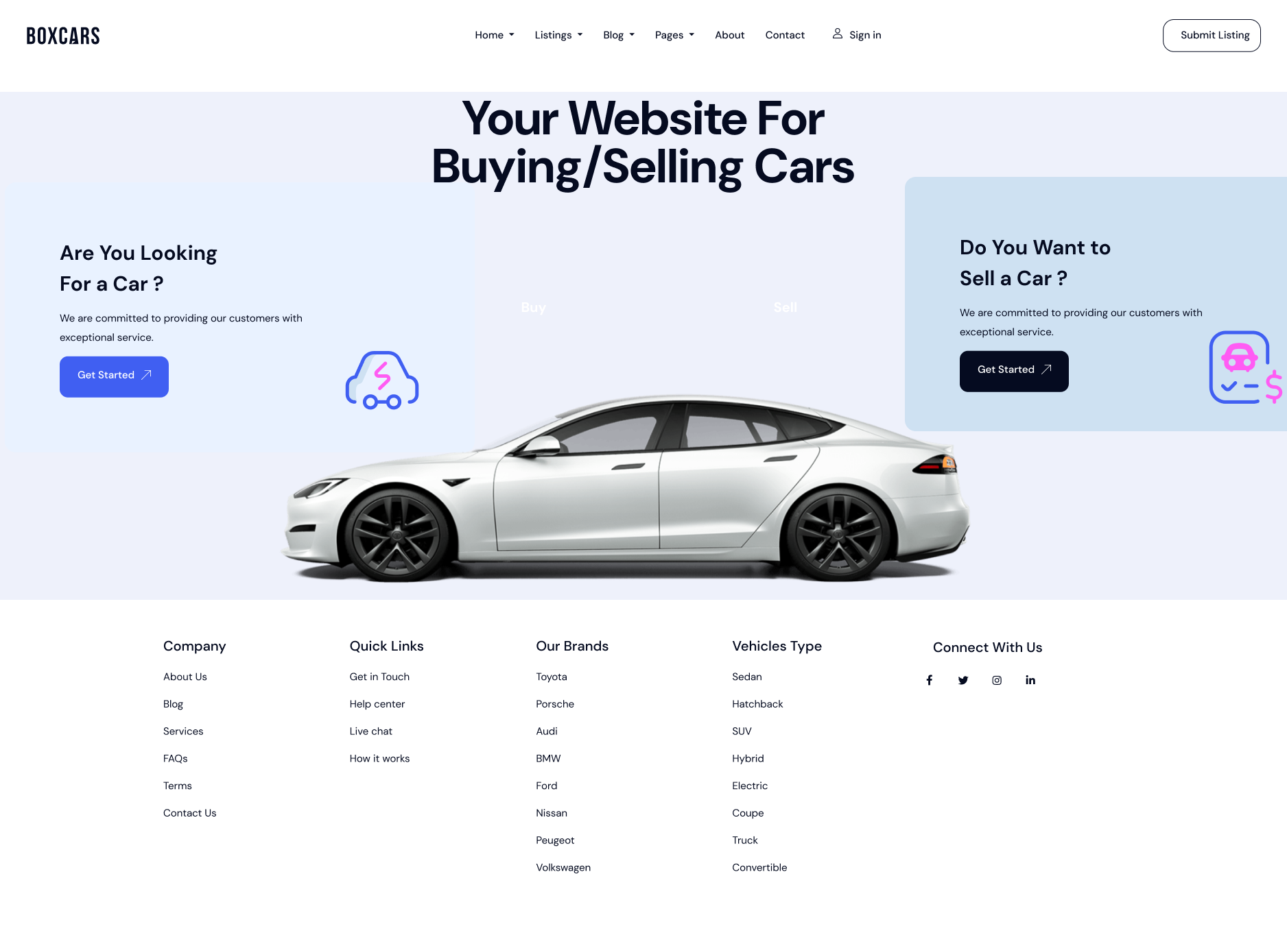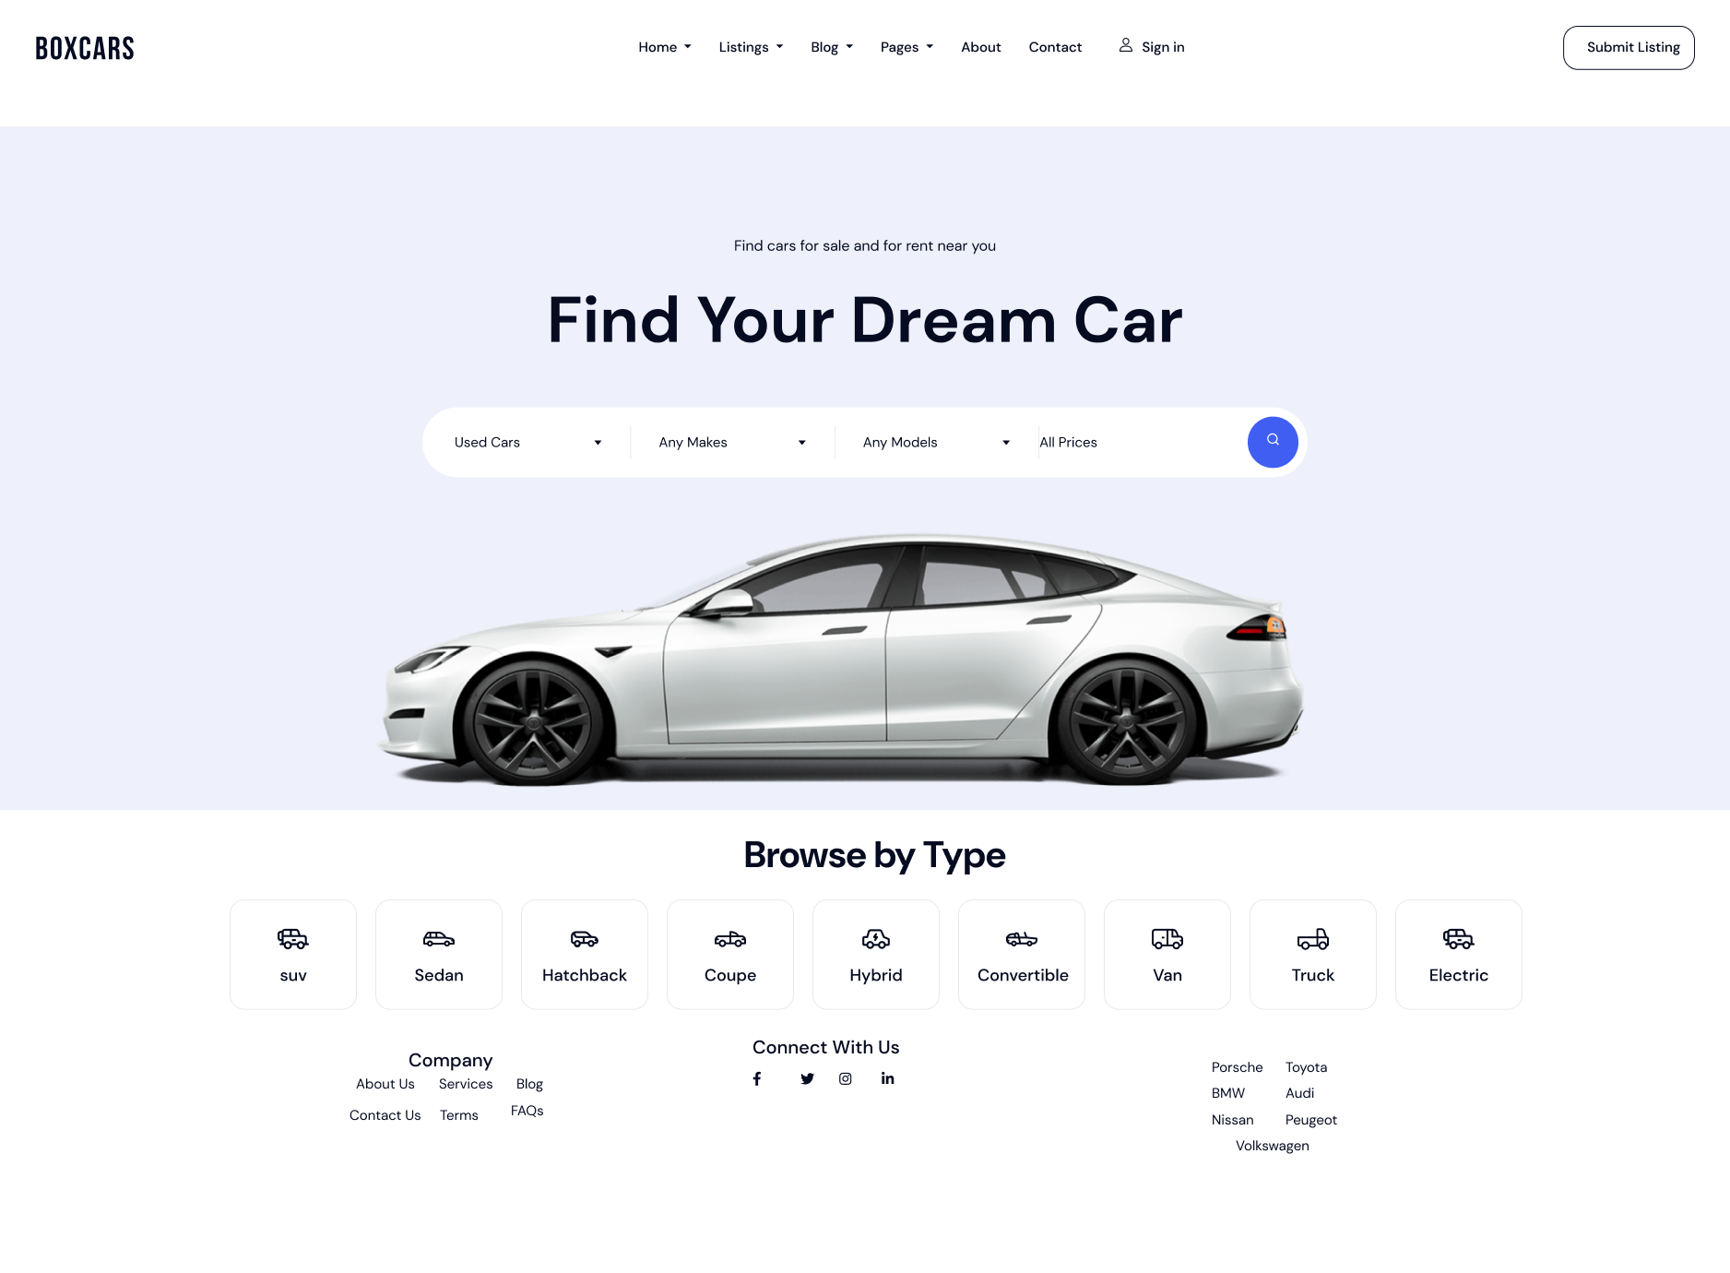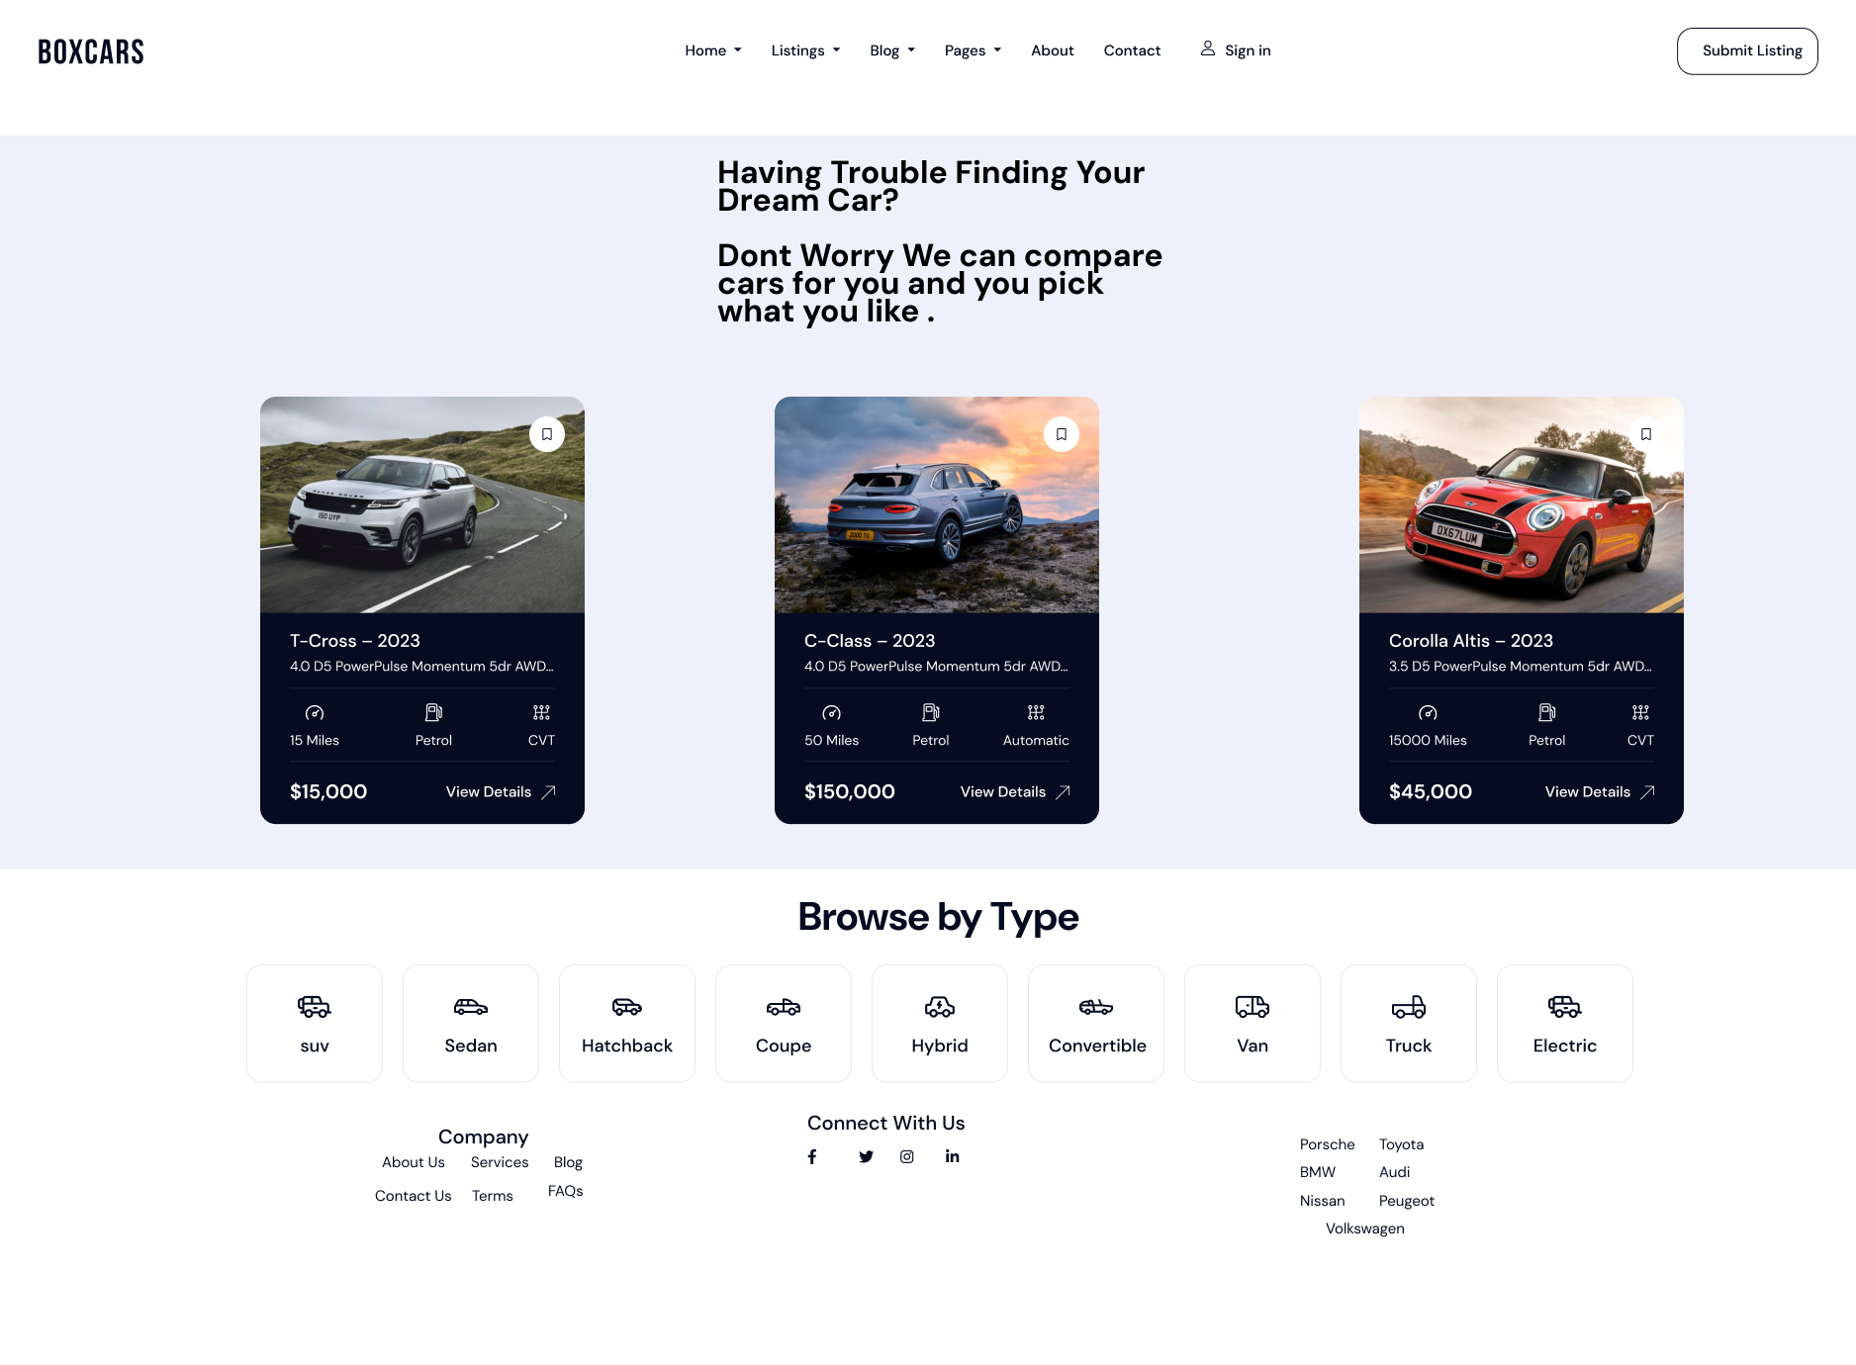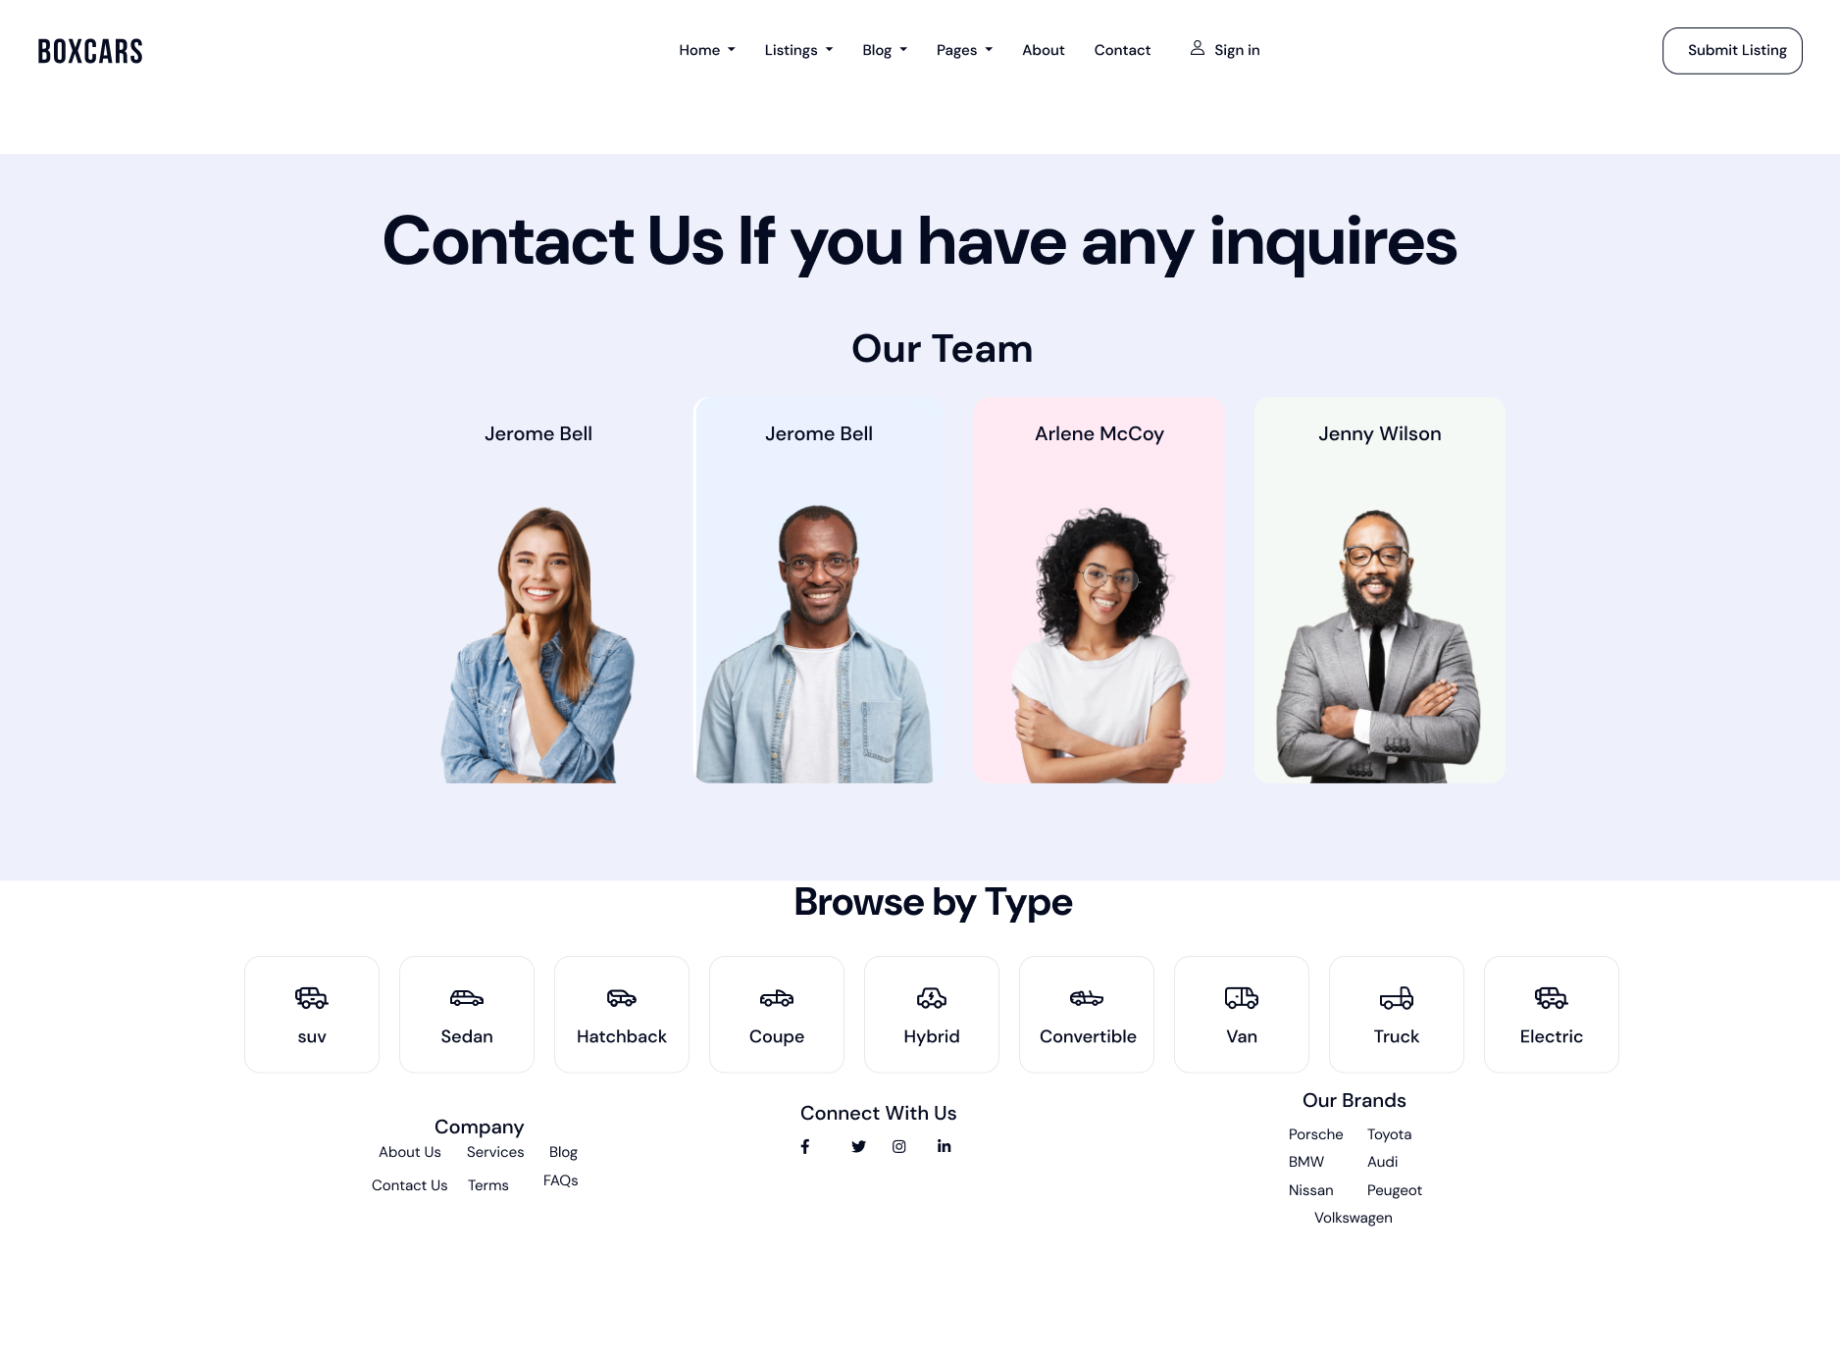

**Part 3 Website Design:**

**[A] Gestalt Web Design Principles**

1. **Law of Prägnanz (Simplicity)**:  
   Each page will feature a clean layout that emphasizes simplicity. The website will avoid clutter by using a well-structured grid, enabling users to quickly scan and understand the content on each page.
2. **Closure**:  
   Buttons, tabs, and icons will be designed to encourage interaction, making it clear when certain elements belong together, such as grouping filter options for car search and comparison.
3. **Figure/Ground**:  
   To distinguish essential elements, the design will employ strong contrasts between the background and foreground, such as dark text on a light background or using color to highlight call-to-action buttons like “Buy Now” or “Compare.”
4. **Proximity**:  
   Related content, such as car details and user reviews, will be placed close to each other to create a logical flow, enhancing the ease of comparison.
5. **Uniform Connectedness**:  
   Consistent colors and styles across the website will help users recognize similar elements, like using a uniform button style for navigation and action links, making it easy to understand their function across different pages.
6. **Similarity**:  
   Cars in the same category or tier will share similar visual elements (e.g., similar image sizes and styles), allowing users to quickly identify related items.

**[B] Deployment of Other Design Concepts**

1. **Screen Resolution**:  
   The website will be responsive, designed to accommodate various screen resolutions from mobile to desktop. This ensures that the layout adjusts seamlessly across devices, maintaining usability and readability.
2. **Color Palette**:  
   A cohesive color palette will be selected using Adobe Color Wheel CC or Paletton. This palette will reflect the brand’s identity—perhaps using colors that evoke trust and professionalism, such as blues and grays, with a contrasting color like orange or green for call-to-action elements.
3. **Minimum Contrast for Accessibility**:

The website will maintain a minimum contrast ratio of 4.5:1 between text and background to ensure readability for users with visual impairments, adhering to WCAG (Web Content Accessibility Guidelines) standards.

1. **Front-End Development Technologies**:  
   HTML5, CSS, and JavaScript will be used for the website's structure, styling, and interactive elements.
2. **Content Management System (CMS)**:  
   A CMS like WordPress or custom CMS in React can be considered for ease of updating listings and managing content dynamically.
3. **Back-End Development Technologies**:  
   Node.js or PHP can serve as back-end technologies, enabling server-side logic, data handling, and database management.
4. **Metrics for Measuring Performance**:  
   Metrics such as page load time, user engagement, bounce rate (how many visitors take actions like contacting sellers or comparing cars) will be monitored to optimize the site’s performance and user experience.
5. **HTML5 Page Structure**:  
    <!DOCTYPE html>

<html lang="en">

<head>

<meta charset="UTF-8" />

<meta name="viewport" content="width=device-width, initial-scale=1.0" />

<title>Car Dealership</title>

<link rel="stylesheet" href="styles.css" />

</head>

<body>

<header>

<div class="container header-container">

<h1 class="logo"></h1>

<nav>

<ul class="nav-links">

<li><a href="#"></a></li>

<li><a href="#"></a></li>

<li><a href="#"></a></li>

<li><a href="#"></a></li>

<li><a href="#"></a></li>

<li><a href="#"></a></li>

</ul>

</nav>

<div class="auth-links">

<a href="#" class="sign-in"></a>

<a href="#" class="submit-listing"></a>

</div>

</div>

</header>

<section class="hero">

<div class="container">

<h2></h2>

<p></p>

<div class="search-bar">

<select></select>

<select></select>

<select></select>

<select></select>

<button class="search-button"></button>

</div>

</div>

</section>

<section class="browse-types">

<h3></h3>

<div class="types">

<button class="type"></button>

<button class="type"></button>

<button class="type"></button>

<button class="type"></button>

<button class="type"></button>

<button class="type"></button>

<button class="type"></button>

<button class="type"></button>

<button class="type"></button>

</div>

</section>

<div class="container">

<footer class="foot">

<nav>

<ul class="nav-links">

<li><a href="#"></a></li>

<li><a href="#"></a></li>

<li><a href="#"></a></li>

<li><a href="#"></a></li>

<li><a href="#"></a></li>

<li><a href="#"></a></li>

</ul>

</nav>

</footer>

</div>

</body>

</html>

**References:**

K. Niederst Robbins, Learning Web Design: A Beginner's Guide to HTML, CSS, JavaScript, and Web Graphics, 5th ed. O'Reilly Media, 2018.

S. Krug, Don't Make Me Think: A Common Sense Approach to Web Usability, 3rd ed. New Riders, 2014.