Supplementary Material — Paper 1
All tables are generated from the locked v8 outputs (results/final_v7) and the Paper 1 coefficient outputs (results/final_v9/paper1). No model was re-estimated.

Table S1. Included versus excluded patients
Sources: F32 (characteristics) and F65 (standardised mean differences).
Characteristic | Included (n = 17,262) | Excluded (n = 8,832)
Patients | 17,262 | 8,832
Age at operation, years, median (IQR) | 63.4 (55.7-70.6) | 63.0 (55.3-69.9)
Male sex, n (%) | 10,676 (61.8) | 5,333 (60.4)
Synchronous presentation, n (%) | 10,015 (58.0) | 3,674 (41.6)
Number of liver metastases known, n (%) | 16,011 (92.8) | 7,068 (80.0)
Largest recorded metastasis known, n (%) | 13,956 (80.8) | 6,425 (72.7)
Pre-operative CEA recorded, n (%) | 11,364 (65.8) | 4,898 (55.5)
Deaths recorded, n (%) | 6,601 (38.2) | 3,705 (41.9)
Deaths inside the 15-year window (events), n (%) | 6,591 (38.2) | 3,696 (41.8)
Median overall survival, years (KM) | 4.15 | 3.84

Characteristic | Included | Excluded | Standardised mean difference
Age at operation, years | 63.4 (IQR 55.7-70.6; n=15,271) | 63.0 (IQR 55.3-69.9; n=7,416) | 0.051
Male sex | 61.9% (n=17,246) | 60.4% (n=8,827) | 0.031
Synchronous presentation | 58.7% (n=17,064) | 44.8% (n=8,210) | 0.282
Number of liver metastases (known) | 2.0 (IQR 1.0-3.0; n=16,011) | 2.0 (IQR 1.0-3.0; n=7,068) | 0.017
Largest metastasis, mm (known) | 30.0 (IQR 20.0-45.0; n=13,956) | 35.0 (IQR 20.0-50.0; n=6,425) | -0.186
Pre-operative CEA, ng/mL (known) | 7.2 (IQR 2.8-25.0; n=11,364) | 9.7 (IQR 3.2-41.0; n=4,898) | -0.029
Operation year | 2010.0 (IQR 2007.0-2013.0; n=17,262) | 2007.0 (IQR 2001.0-2011.0; n=8,832) | 0.584
Metachronous: interval unavailable | 55.9% (n=7,049) | 66.2% (n=4,536)

Table S2. Missing TNM components and exclusion patterns
S2a. Missing components among the 26,094 patients meeting criteria (investigation/F45).
Missing components | n | % of 26,094
none (complete) | 17262 | 66.2
T + N + M | 3041 | 11.7
T | 2324 | 8.9
M | 1358 | 5.2
T + N | 1220 | 4.7
T + M | 418 | 1.6
N | 402 | 1.5
N + M | 69 | 0.3
S2b. Exclusion by operation period (F63).
Operation years | Included | Excluded | % excluded
1990-1999 | 637 | 1466 | 69.7
2000-2004 | 1825 | 1514 | 45.3
2005-2009 | 5967 | 2353 | 28.3
2010-2014 | 6637 | 2472 | 27.1
2015-2020 | 2162 | 696 | 24.4
S2c. Exclusion clustering by site and country (F64; a site is a registry site code).
Level | Units | No exclusions | Only exclusions | ≥50% excluded | Median patients per unit | % of exclusions in 10 largest
sites | 259 | 57 | 11 | 34 | 22 | 54.0
countries | 52 | 3 | 1 | 7 | 89 | 81.6
S2d. Outcomes of included and excluded patients by era (F66).
Era | Included n | Excluded n | Included 5-y KM | Excluded 5-y KM | Included median OS (y) | Excluded median OS (y)
all | 17262 | 8832 | 0.436 | 0.407 | 4.15 | 3.84
development (<=2009) | 8463 | 5664 | 0.423 | 0.391 | 3.97 | 3.67
validation (>=2010) | 8799 | 3168 | 0.466 | 0.505 | 4.5 | 5.25
S2e. Observed/expected survival relative to a no-TNM model (F67). Interpret with caution: this is a selection check, not a validation.
Group | Period | n | Predicted 5-y (no TNM) | Observed 5-y KM | O/E
included (TNM complete) | development | 8463 | 0.411 | 0.423 | 1.028
included (TNM complete) | validation | 8799 | 0.401 | 0.466 | 1.161
excluded (TNM incomplete) | development | 5664 | 0.406 | 0.391 | 0.963
excluded (TNM incomplete) | validation | 3168 | 0.399 | 0.505 | 1.266

Table S3. Duplicate-record screen and sensitivity analyses
S3a. Screen (F60).
Item | n
records in identical-content pairs | 46
identical-content pairs | 23
pairs meeting the probable-duplicate rule | 16
pairs with copies at different countries | 16
second copies of identical pairs inside the analytic cohort | 6
near-duplicate groups (birth date, operation date, sex match; different content) | 55
near-duplicate groups with both copies in the analytic cohort | 31
near-duplicate groups with one copy in the analytic cohort | 11
later records dropped in the broad sensitivity (birth date, operation date and sex match within the cohort) | 37
S3b. Effect on validation results (F61). Columns are the primary analysis and two sensitivity analyses. C-index and survival are for the validation cohort.
Metric | Primary (locked) | Identical-pair second copies removed (6 in cohort) | Broad rule: later copies removed (37)
Analytic cohort (n) | 17262 | 17256 | 17225
Development (n) | 8463 | 8461 | 8444
Validation (n) | 8799 | 8795 | 8781
Validation C-index | 0.6216 | 0.6216 | 0.6216
Validation 5-y Kaplan–Meier survival | 46.6% | 46.6% | 46.7%
Validation O/E at 5 years | 1.143 | 1.142 | 1.145
Cut-point, lower tertile (predicted 5-y survival) | 0.3793 | 0.3794 | 0.3785
Cut-point, upper tertile (predicted 5-y survival) | 0.4756 | 0.4756 | 0.4753
Validation Favourable / Intermediate / Adverse (n) | 2662 / 2824 / 3313 | 2660 / 2825 / 3310 | 2656 / 2833 / 3292
Patients in the same group as primary (%) | — | 99.81 | 99.2
Agreement with primary grouping (κ) | — | 0.997 | 0.988
Patients reassigned to a different group | — | 33 | 138

Table S4. Candidate models and proportional-hazards tests
S4a. Candidate models on identical patients (F02). Validation n = 8,799; 5-y observed survival 46.6%.
Model | Training C | Validation C | 95% CI | 5-y AUC | 5-y Brier | Mean predicted 5-y | O/E 5 y | Calibration slope
M1 stratified sex x synchronous (M-stage covariate) | 0.5947 | 0.6218 | 0.606-0.636 | 0.674 | 0.0651 | 0.409 | 1.141 | 1.091
M2a stratified sex x synchronous x M-stage | 0.5952 | 0.6216 | 0.608-0.637 | 0.675 | 0.0651 | 0.408 | 1.142 | 1.074
M2b stratified sex x synchronous, time-varying M-stage (2-year split) | 0.5947 | 0.6219 | 0.609-0.637 | 0.674 | 0.0651 | 0.409 | 1.14 | 1.091
S4b. Schoenfeld tests, training cohort, constant terms (F03); M-stage is the term of interest.
Model | Term | Test statistic | p
M1 | AGE10_F | 0.2358 | 0.6273
M1 | DFI12_F | 0.0414 | 0.8388
M1 | DFI_NR | 0.0699 | 0.7915
M1 | M1 | 4.6772 | 0.0306
M1 | METS_F | 0.0212 | 0.8842
M1 | METS_NR | 0.3786 | 0.5384
M1 | N1 | 1.1821 | 0.2769
M1 | N2 | 1.5238 | 0.217
M1 | SIZE10_F | 1.8866 | 0.1696
M1 | SIZE_NR | 0.0039 | 0.9499
M1 | T3 | 1.9576 | 0.1618
M1 | T4 | 0.6059 | 0.4363
M2a | AGE10_F | 0.173 | 0.6775
M2a | DFI12_F | 0.1371 | 0.7112
M2a | DFI_NR | 0.0013 | 0.9714
M2a | METS_F | 0.0375 | 0.8465
M2a | METS_NR | 0.8387 | 0.3598
M2a | N1 | 1.5465 | 0.2137
M2a | N2 | 0.9072 | 0.3409
M2a | SIZE10_F | 1.5 | 0.2207
M2a | SIZE_NR | 0.0122 | 0.912
M2a | T3 | 1.7976 | 0.18
M2a | T4 | 0.5688 | 0.4508
S4c. Time-varying M-stage (M2b) (F04).
Term | Coefficient | HR early | p (time variation) | HR late
M1 early coef | 0.1148 | 1.122
M1 change after 2 years | -0.1508 |  | 0.20668107504738975
M1 late HR | -0.036 |  |  | 0.965
S4d. Selection rule (F05): choose the simplest candidate whose constant-term tests all have p > 0.05 in training data. Selected: M2a.

Table S5. Sensitivity analyses
S5a. Date conventions and same-day deaths (F10, validation cohort; primary = 15th of month, half-day rule).
Date convention | Same-day rule | Analytic n | Validation C | Cut-point 1 | Cut-point 2 | Same groups (%) | κ
first day (1st) | half | 17265 | 0.6214 | 0.3793 | 0.4755 | 99.71 | 0.996
first day (1st) | one | 17265 | 0.6214 | 0.3793 | 0.4755 | 99.71 | 0.996
first day (1st) | quarter | 17265 | 0.6214 | 0.3793 | 0.4755 | 99.71 | 0.996
first day (1st) | exclude_all | 17249 | 0.6221 | 0.3799 | 0.4761 | 99.62 | 0.994
mid-month (15th, primary) | half | 17262 | 0.6216 | 0.3793 | 0.4756 | 100.0 | 1.0
mid-month (15th, primary) | one | 17262 | 0.6216 | 0.3793 | 0.4756 | 100.0 | 1.0
mid-month (15th, primary) | quarter | 17262 | 0.6216 | 0.3793 | 0.4756 | 100.0 | 1.0
mid-month (15th, primary) | exclude_all | 17249 | 0.6221 | 0.3799 | 0.4762 | 99.62 | 0.994
month-end | half | 17262 | 0.6217 | 0.3793 | 0.4756 | 99.98 | 1.0
month-end | one | 17262 | 0.6217 | 0.3793 | 0.4756 | 99.98 | 1.0
month-end | quarter | 17262 | 0.6217 | 0.3793 | 0.4756 | 99.98 | 1.0
month-end | exclude_all | 17249 | 0.6222 | 0.3799 | 0.4762 | 99.64 | 0.995
S5b. Same-day deaths without death flag (F19).
Analysis | Analytic n | Validation C | Same groups (%) | κ
primary: half-day, all same-day deaths kept | 17262 | 0.6216 | 100.0 | 1.0
exclude same-day deaths without death flag | 17255 | 0.6226 | 99.63 | 0.994
same-day deaths without flag treated as censored at half-day | 17262 | 0.6226 | 99.63 | 0.994
S5c. Carcinoembryonic antigen (F13).
Analysis | Validation n | CEA HR per log unit | 95% CI | C without CEA | C with CEA
complete case | 5847 | 1.159 | 1.132-1.186 | 0.6276 | 0.648
multiple imputation, 10 draws (development outcome-compatible; validation predictors only) | 8799 | 1.153 | 1.127-1.180 | 0.6224 | 0.6366
S5d. Pre-operative-only models (no count or size) (F14, F23).
Model | Validation C | 95% CI | O/E 5 y | Calibration slope
pre-operative-only, M1 structure (no count or size) | 0.5913 | 0.573-0.606 | 1.126 | 1.358

Model | Validation C | 95% CI | O/E 5 y | Calibration slope
pre-operative-only, selected M2a structure (no count or size) | 0.5905 | 0.575-0.604 | 1.128 | 1.307
S5e. Recalibration from 2005–2009 baseline (F22; coefficients fixed).
Analysis | Mean predicted 5-y | O/E 5 y | Validation C | κ vs primary | % same group
primary (baseline from all training years) | 0.408 | 1.142 | 0.6216
recent-baseline sensitivity (2005-2009) | 0.418 | 1.115 | 0.6197
phenotype agreement of recent-baseline groups with primary |  |  |  | 0.883 | 92.2
S5f. No-TNM model on the same patients (F62). The TNM model is 0.6216 on the same 8,799 patients.
Analysis | Development n | Validation n | Validation C | Note
same patients: TNM M2a (primary) | 8463 | 8799 | 0.6216 | reference
same patients: no-TNM model (complete-case development) | 8463 | 8799 | 0.5994 | difference TNM minus no-TNM = 0.0222, 95% CI 0.0094 to 0.0335 (paired bootstrap, 300 resamples)
broader: no-TNM model (all development patients), same 8,799 validation patients | 14127 | 8799 | 0.5982 | same patients as the primary validation set
broader: no-TNM model (all development patients), all validation patients | 14127 | 11967 | 0.5972 | includes patients with incomplete TNM; not comparable with the TNM model

Table S6. Death flags and the 15-year window
S6a. Sources: F12. The first block covers the full extract; the last rows cover the analytic cohort.
Check | n
deceased (PATSTATC) | 11594
deceased with any DEATHKYN_F = Yes | 8520
deceased without any DEATHKYN_F = Yes | 3074
alive/lost but DEATHKYN_F = Yes | 2
LASTNDTC earlier than latest follow-up date | 9
LASTNDTC later than latest follow-up date | 1
modelling cohort with last contact before time zero | 0
modelling deaths after censoring date 2020-07-04 | 0
modelling cohort: deaths recorded (PATSTATC = Deceased) | 6601
modelling cohort: deaths inside the 15-year window (events in the models) | 6591
modelling cohort: deaths beyond 15 years (censored at 15 years) | 10
modelling cohort: PATIENTS with follow-up beyond 15 years (all statuses; not a death count) | 69
modelling cohort: of those patients, number who died | 10
S6b. Death-flag rate by time from operation (F18b).
Time from operation | Deaths | Flag = yes | % flagged
same day | 13 | 6 | 46.2
1-30 days | 197 | 99 | 50.3
31-365 days | 1163 | 843 | 72.5
1-5 years | 4470 | 3648 | 81.6
>5 years | 758 | 533 | 70.3

Table S7. Reproduction check
Source: F25. Each quantity was reproduced from the notebook against the previously validated values.
Check | This run | Previously validated | Result
selected model | M2a | M2a | PASS
cut-point q33 | 0.3793 | 0.3793 | PASS
cut-point q67 | 0.4756 | 0.4756 | PASS
primary cohort | 17262 | 17262 | PASS
M2a validation C | 0.6216 | 0.6216 | PASS
RFS primary median | 2.03 | 2.03 | PASS
pre-operative (M1 structure) validation C | 0.5913 | 0.5913 | PASS
Fong subset C | 0.6394 | 0.6394 | PASS
Nordlinger subset C | 0.6303 | 0.6303 | PASS
CEA complete-case HR | 1.159 | 1.159 | PASS

Table S8. Horizon feasibility, group events and recurrence-free survival
S8a. Group events by horizon (G02, validation).
Group | Horizon (y) | n | Deaths before horizon | At risk at horizon
Favourable | 1 | 2662 | 98 | 1470
Favourable | 3 | 2662 | 275 | 568
Favourable | 5 | 2662 | 355 | 194
Intermediate | 1 | 2824 | 151 | 1583
Intermediate | 3 | 2824 | 469 | 534
Intermediate | 5 | 2824 | 581 | 129
Adverse | 1 | 3313 | 332 | 1701
Adverse | 3 | 3313 | 800 | 472
Adverse | 5 | 3313 | 912 | 118
S8b. Centre-held-out feasibility (G04). Descriptive only; no centre-held-out model was fitted for this manuscript.
Minimum patients per site | Sites meeting threshold | Sites with ≥20 validation events | % of patients in qualifying sites | Countries meeting threshold
20 | 122 | 32 | 95.5 | 37
50 | 78 | 32 | 87.0 | 27
100 | 51 | 29 | 76.0 | 22
S8c. Recurrence-free survival handling rules (F17).
Rule | n | Events | Median (y) | 95% CI | 3-y RFS | 5-y RFS
PRIMARY: dated recurrence and death events; undated censored | 16677 | 8942 | 2.03 | 1.98-2.09 | 0.393 | 0.276
undated recurrences events at last contact | 16677 | 9672 | 1.93 | 1.88-1.98 | 0.369 | 0.244
undated recurrences events at mid-interval | 16677 | 9672 | 1.69 | 1.65-1.74 | 0.329 | 0.228
undated recurrence patients excluded | 15001 | 7996 | 1.84 | 1.78-1.90 | 0.368 | 0.268
S8d. Undated recurrence check (F11).
Group | n | Median age | T4 % | N2 % | M1 % | Median OS (y) | Deaths %
undated recurrence (count > 0, no date) | 1676 | 62.6 | 21.9 | 28.0 | 57.5 | 3.51 | 56.4
dated recurrence after operation | 5324 | 62.6 | 21.7 | 30.4 | 62.9 | 3.95 | 50.6
neither | 9677 | 64.3 | 21.3 | 25.6 | 55.0 | 5.41 | 27.6

Table S9. Reporting checklists
See Paper1_reporting_checklists.docx (TRIPOD+AI primary; STROBE; PROBAST+AI status).

Supplementary figures
Figure S1. Recurrence-free survival by prognostic group, validation cohort (primary definition).
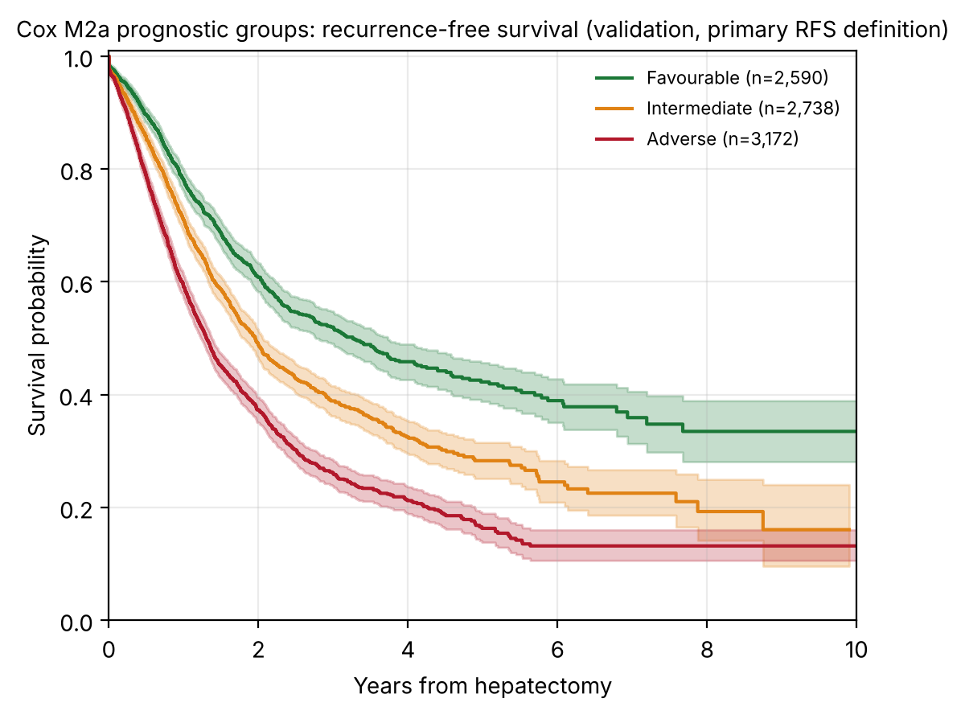
Figure S2. Calibration by validation decile of predicted 5-year survival. Open markers: fewer than 50 patients followed up to 5 years.
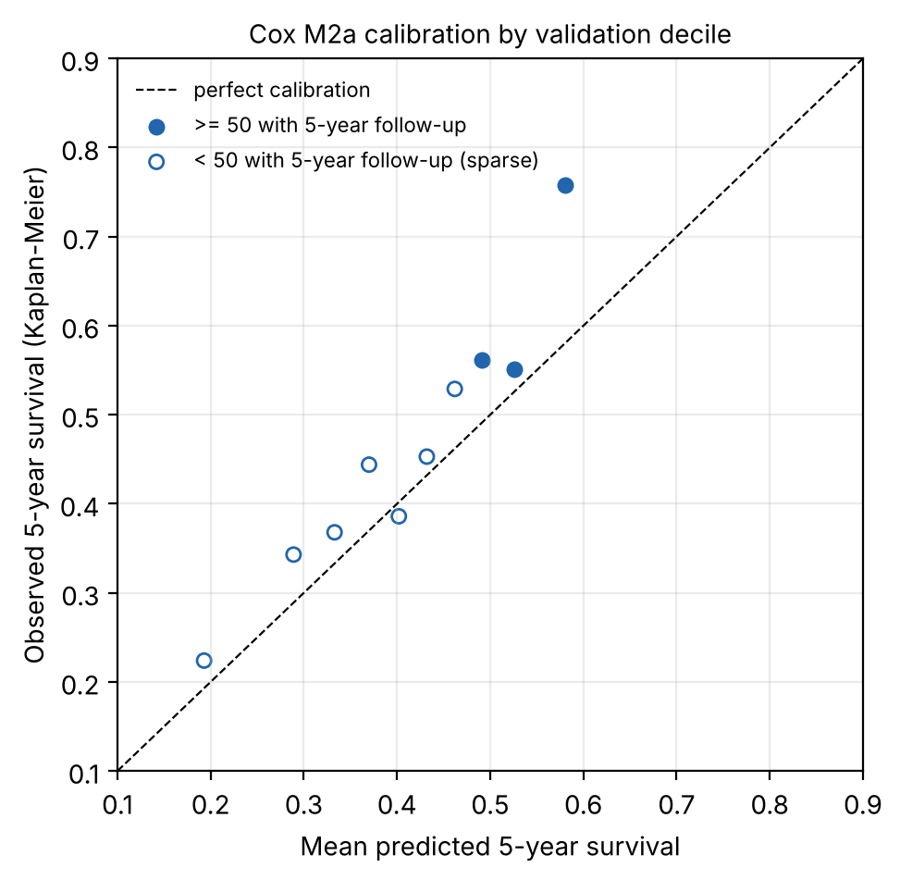
Figure S3. Observed/expected 5-year survival by operation period. The 2016+ period is omitted because no patient had 5-year follow-up.
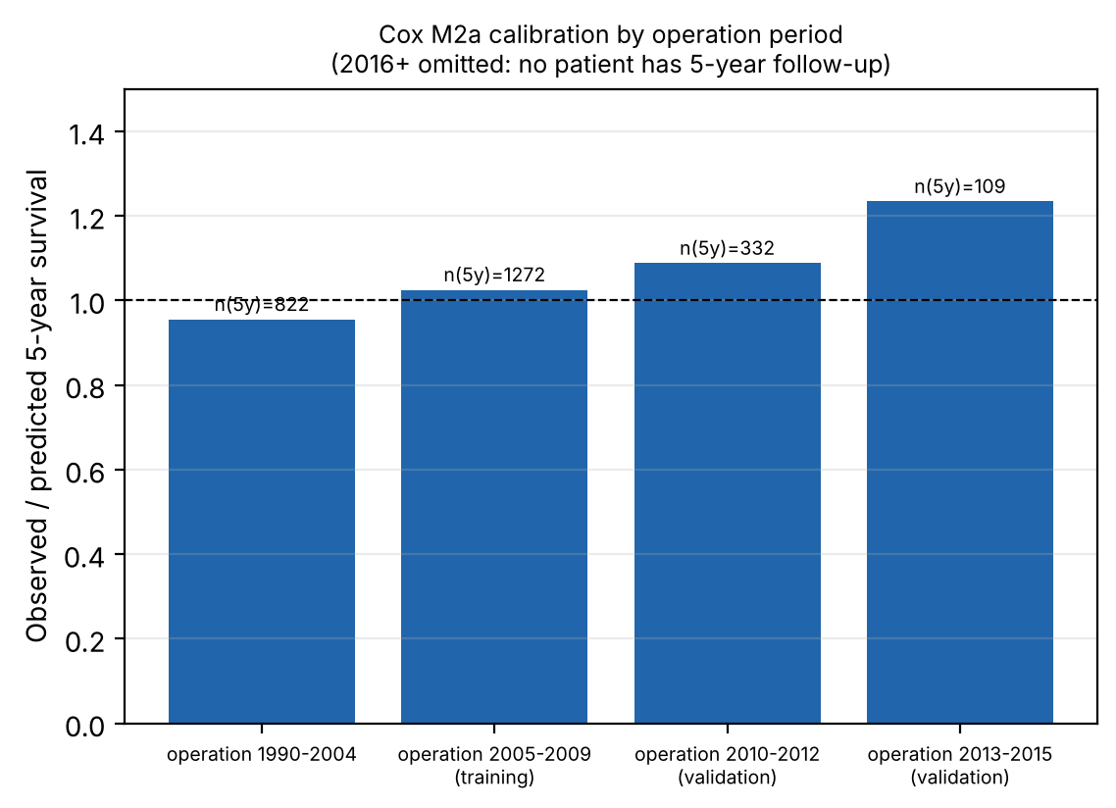

Coefficient outputs
Baseline survival by stratum (P1_baseline_survival_by_stratum.csv) and group summary (P1_group_summary.csv) are in results/final_v9/paper1/.
stratum_sex_synchrony_Mstage | baseline_survival_1y_at_reference_covariates | baseline_survival_3y_at_reference_covariates | baseline_survival_5y_at_reference_covariates
0 | 0.9762 | 0.8781 | 0.809
1 | 0.965 | 0.854 | 0.7572
2 | 0.9747 | 0.8698 | 0.802
3 | 0.9742 | 0.8852 | 0.8147
4 | 0.9765 | 0.8887 | 0.8082
5 | 0.967 | 0.8403 | 0.751
6 | 0.9771 | 0.8878 | 0.8008
7 | 0.9776 | 0.8919 | 0.8134

group | development_n | validation_n | predicted_5y_survival_range_validation | mean_predicted_5y_validation
Favourable | 2821 | 2662 | 0.476-0.711 | 0.532
Intermediate | 2821 | 2824 | 0.379-0.476 | 0.428
Adverse | 2821 | 3313 | 0.000-0.379 | 0.291

