March 30th, 2026

Hospital Fixed Asset Tracking Sensor System Design Document
Imperial Healthtech
Document Version 0 (Draft)

Supervisors: | Kemal Falatehan
 | Choirunnisa Hapsari
Author: | Farros Ramzy

Abstract
This document presents the design of an RFID-based item tracking system for hospital fixed assets. The system uses a checkpoint-based approach with UHF RFID technology, in which tagged assets are detected at fixed locations and their last known positions are determined from the most recent scan.
The system consists of RFID tags, checkpoint scanners, a backend processing platform, and a monitoring dashboard. The design focuses on scalability, reliability, and practical deployment in hospital environments, aiming to improve asset visibility and reduce search time.
Version Table
Version | Date of Creation / Change | Changes | Reviewers | Approval Status
0.0 | 30/03/2026 | Document Initiation, adding the abstract, and introduction of the design.
0.0.1 | 31/03/2026 | Adding the system overview and High-Level architecture.
0.5.0 | 01/04/2026 | Adding subsystem designs and initiating the Data design, which is the class diagram.

Contents
1. Introduction 1
1.1. Project Background 1
1.2. Problem Statement 1
1.3. Purpose of The System 2
1.4. Project Scope 2
1.4.1. In Scope 3
1.4.2. Out of Scope 3
2. System Overview 3
2.1. Registration Desk 4
2.2. Checkpoint Scanner System 4
2.3. Backend Server 4
2.4. Item Monitor Application 4
3. System Architecture 5
3.1. High-Level Architecture 5
4. Subsystem Design 6
4.1. Registration Desk Design 6
4.2. Scanner Node Design 7
4.3. Backend Design 8
4.4. Monitoring Application Design 9
5. Data Design 10
5.1. Class Diagrams 10
5.1.1. Entity Classes 10
5.1.2. Service Classes 11
5.1.3. Boundary Classes 11
5.1.4. Interfaces 11
5.2. State Machines 11
6. Data Flow 11
7. Interface Design 11
8. Error Handling 11
9. Deployment Design 11

Introduction

Project Background
Hospitals manage many movable assets such as infusion pumps, wheelchairs, portable monitors, and other medical equipment. These assets are frequently moved between departments, making it difficult to track their current location manually. Traditional tracking methods rely on manual logging or staff memory, which can lead to:
- Inefficient asset utilization.
- Time wasted searching for equipment.
- Increased risk of loss or misplacement.
To improve asset visibility and operational efficiency, an automated tracking system is required. Radio Frequency Identification (RFID) technology provides a practical solution by enabling contactless identification and detection of assets at specific locations.
This project proposes an RFID-based asset-tracking system that uses a checkpoint detection method, in which assets are detected at fixed locations (checkpoints) within the hospital environment.

Problem Statement
Hospitals face challenges in tracking the locations of movable assets due to the lack of an automated, reliable tracking system.
Key problems include:
- inability to determine the current or last known location of assets.
- Time-consuming manual searching by hospital staff.
- Lack of centralized asset tracking records.
- Inefficient asset utilization and possible duplication of equipment.
- Difficulty in monitoring asset movement across different departments.
Without a structured tracking mechanism, hospital operations can be disrupted, leading to delays in patient care and increased operational costs.

Purpose of The System
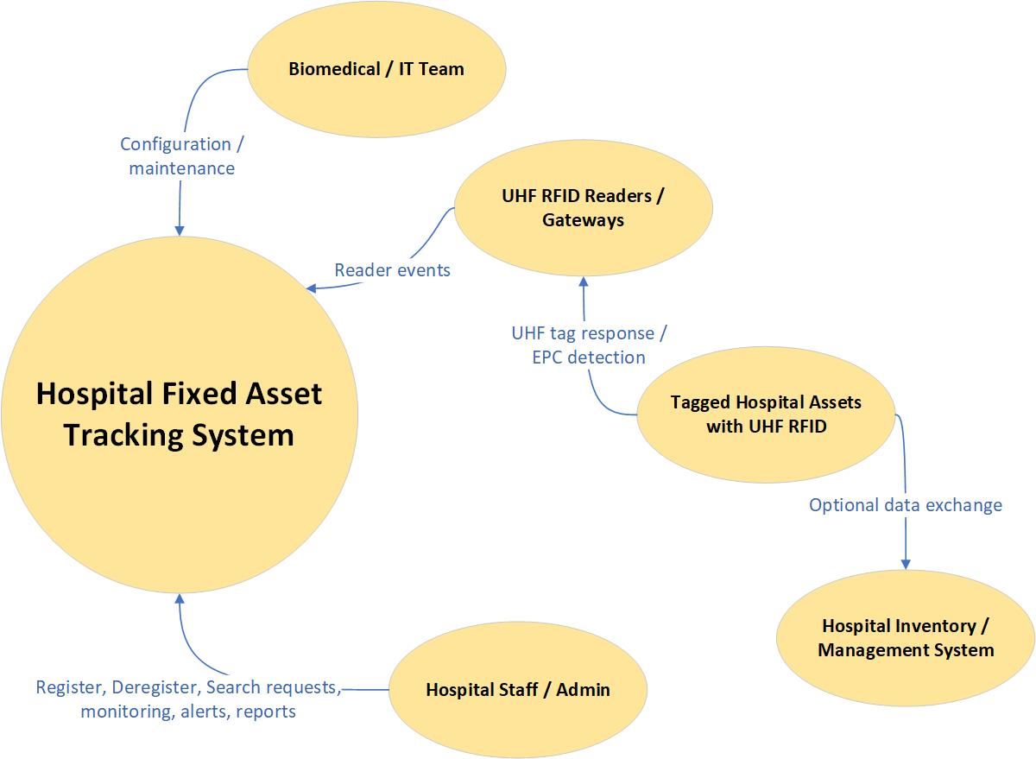

The fixed-asset tracking system is designed to provide real-time visibility of movable medical equipment within hospital indoor environments. The system aims to reduce equipment search time, improve asset utilization, and support more efficient hospital operations through automated identification and monitoring.
The system should allow users to register and deregister RFID-tagged assets at a registration desk, automatically detect tagged assets when they pass through checkpoint scanners, store scan events along with checkpoint and timestamp information, determine and display the last known location of each asset based on the most recent scan, provide a monitoring interface (web or application) for users to locate assets easily, support scalability, allowing additional checkpoint scanners to be added without redesigning the system.

Project Scope
This project has in-scope and out-of-scope items that determine what should and should not be included in the product.

In Scope
The system includes the following components and functionalities, shown in the table below.
No. | System Component | Functionalities
1. | Registration Desk System | - Asset registration and RFID tag assignment.  - Asset deregistration and tag release.  - Management of asset information.
2. | Checkpoint Scanner System | - Fixed RFID scanners installed at predefined locations.  - Detection of RFID tags within scanner range.  - Transmission of scan data (tag ID, checkpoint ID, timestamp) to the backend system.  - Support for multiple scanners that can be expanded as needed.
3. | Item Monitoring System | - Web-based or application-based interface.  - Search and view registered assets.  - Display of last known checkpoint location.  - Display of the latest scan timestamp.
4. | Backend System | - Centralized database for assets, tags, checkpoints, and scan events.  - Processing logic to determine the latest asset location.  - APIs for communication between subsystems.

Out of Scope
These approaches below are not included in this project:
- Real-time indoor positioning (continuous tracking between checkpoints).
- Patient of staff tracking.
- Integration with full hospital information systems (HIS/ERP)
- Predictive analytics or asset usage optimization.
- Advanced localization technologies.

System Overview
Based on the project plan and the operational design system overview in the proposal document, the system product will consist of four main components. These components are the Registration Desk, Checkpoint Scanner System, Backend Server, and Item Monitor Application.
The system uses RFID technology to track hospital assets through a checkpoint-based approach. Assets are registered and associated with RFID tags at the registration desk. When tagged assets pass through fixed checkpoint scanners, their presence is detected and transmitted to the backend server. The backend processes scan events and update the last known location of each asset. Users can then monitor asset information and location through a web-based or application-based interface.

Registration Desk
This subsystem is responsible for managing asset registration and RFID tag assignment.
This system allows authorized users (operators) to register any new asset, associate an RFID tag with an asset, update asset information, and deregister assets and remove tag associations.
The registration desk communicates with the backend server to store and manage asset and tag data. It ensures that each RFID tag is uniquely associated with a single active asset.

Checkpoint Scanner System
This subsystem consists of multiple UHF RFID nodes installed at fixed locations (checkpoints) within the hospital.
Each scanner node shall detect RFID tags within its reading range, identify its assigned checkpoint location, and generate scan events containing tag ID, checkpoint ID, and timestamp. And other than that, this system should be able to transmit its scan data to the backend server via the network.
The system is designed to be scalable, allowing additional scanners to be added without modifying the core system architecture.

Backend Server
This subsystem is the central processing unit of the system.
This subsystem is responsible for receiving data from the registration desk and scanner nodes, storing asset data (the tags, checkpoints, and all the scan history) in the database, processing scan history per item to determine the latest known location of each asset, and providing APIs for communication with the registration desk and the monitoring application.
The backend ensures data consistency, handles system logic, and manages user access.

Item Monitor Application
The item monitoring app provides an interface for users to monitor and retrieve asset information.
Users can search for registered assets, view asset details, check the last known checkpoint location, and view the latest detection timestamp.
The application communicates with the backend server to retrieve real-time data and present it in a user-friendly format.

System Architecture

High-Level Architecture
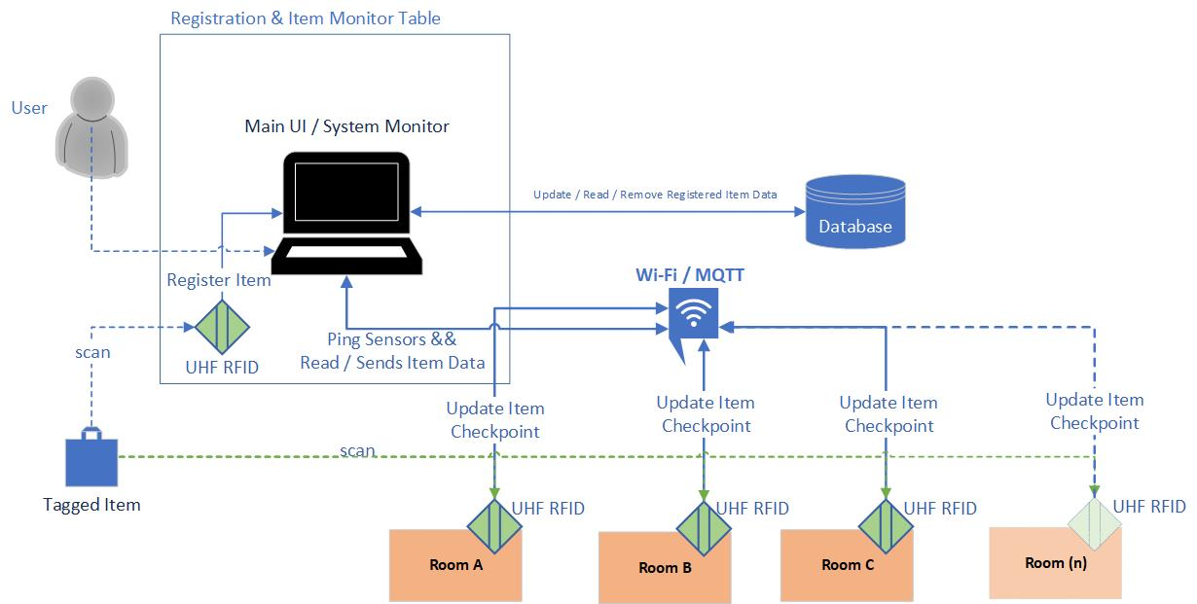

The picture above is a simple architecture that explains how the system must work by design.
The Registration & monitoring table includes a UHF RFID sensor for registering and deregistering any fixed hospital asset with an embedded RFID tag. Besides that, the same table contains the main UI, the system monitor, which displays all registered items in the system.
This monitoring system connects to the database via HTTP to save & read all registered items, and to remove them upon deregistration.
By using a Wi-Fi network and the MQTT protocol, the system monitor can see all the UHF RFID scanner nodes installed at each hospital room entrance, whether they are online or not. This feature ensures product safety by informing users when a sensor is damaged, offline, or unusable, even when the entire system is online.
These nodes are designed to be extensible, which means the base code of each node must be duplicable.
Using the same protocol, the nodes update the tagged asset's location whenever it is detected within their respective reading ranges, treating each detection as a checkpoint.
The checkpoint ping is forwarded to the main monitor, which automatically updates the tagged item's checkpoint time and location in the database.

Subsystem Design
The Hospital Asset Tracker subsystems include the registration desk, scanner nodes, backend system, and monitor app. The registration desk is being implemented in the system to register and deregister assets with tags in or out of the system database. The scanner nodes are responsible for detecting any registered asset and updating its checkpoints whenever the asset passes through the node. The backend system manages the product's logic and the communication lines between other parts of the system. And the monitor app is responsible for displaying the data for all registered items, along with their latest checkpoints, to the user.
All the details about these subsystems are provided in the subsections below.

Registration Desk Design
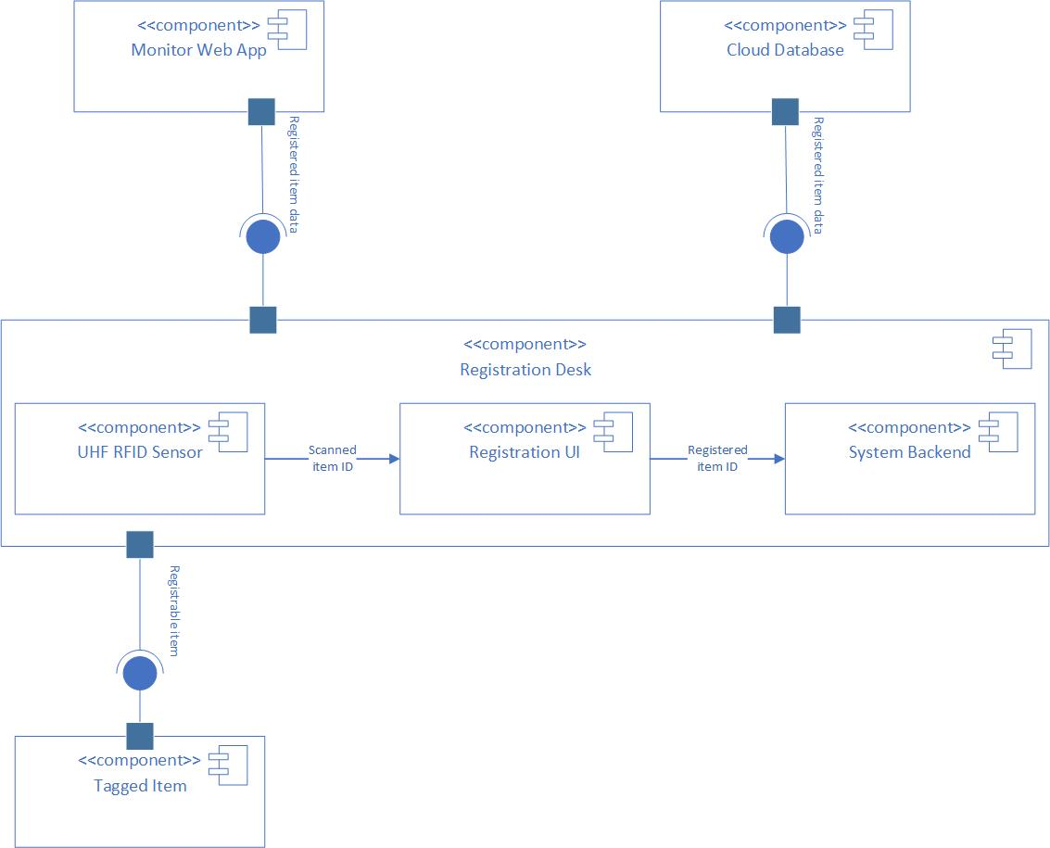

The image above is the design of the registration desk. This system comprises a UHF RFID sensor, a Registration UI, and the system's backend. The UHF RFID here is responsible for scanning the tagged item. This device will read the item's tag ID and send it to the Registration UI.
The Registration UI is responsible for scanning items. Here, users can register the scanned item in the system database or deregister it. The registered item ID would be managed by the system backend in this registration desk. From there, the system will update the database and share the data with the monitoring web app via a WebSocket API to display it to users.

Scanner Node Design
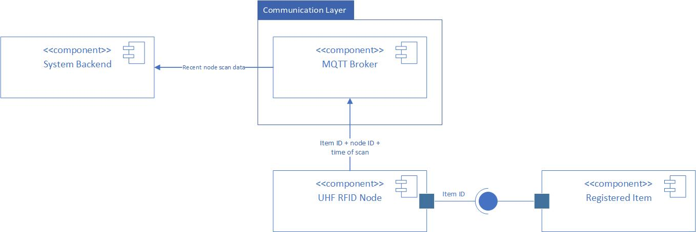

This subsystem above is the scanner node. This subsystem is extensible, meaning it can be duplicated within the same program into multiple subsystems. This subsystem is implemented as the checkpoint for the tagged item in the hospital. This node contains a UHF RFID sensor to detect registered fixed assets passing through the node and read their ID numbers from the tags.
This node then communicates the item ID, node location, and scanning time to the System Backend via the MQTT broker. The backend system will then save this data to the database cloud.

Backend Design
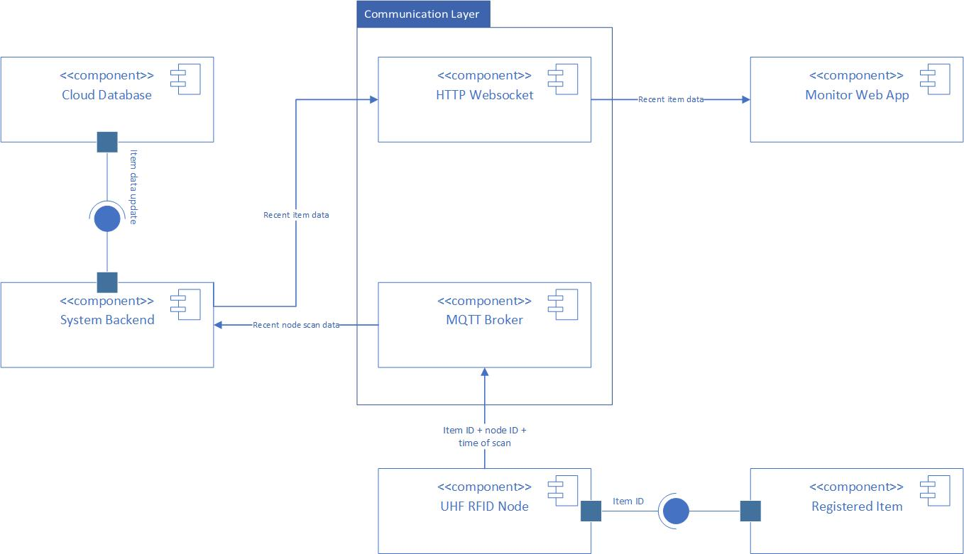

The backend system primarily handles the product's overall functionality. It is designed to be the primary system for the Hospital Asset Tracker. In the image above, the system connects both the scanner nodes via an MQTT broker and the monitor web app via a WebSocket. This system's backend also has direct access to the database to manage changes to any registered asset.
And as shown in the image below, the system backend receives the most recent node scan data for an item from the MQTT Broker and sends it to the Cloud database as an item data update.

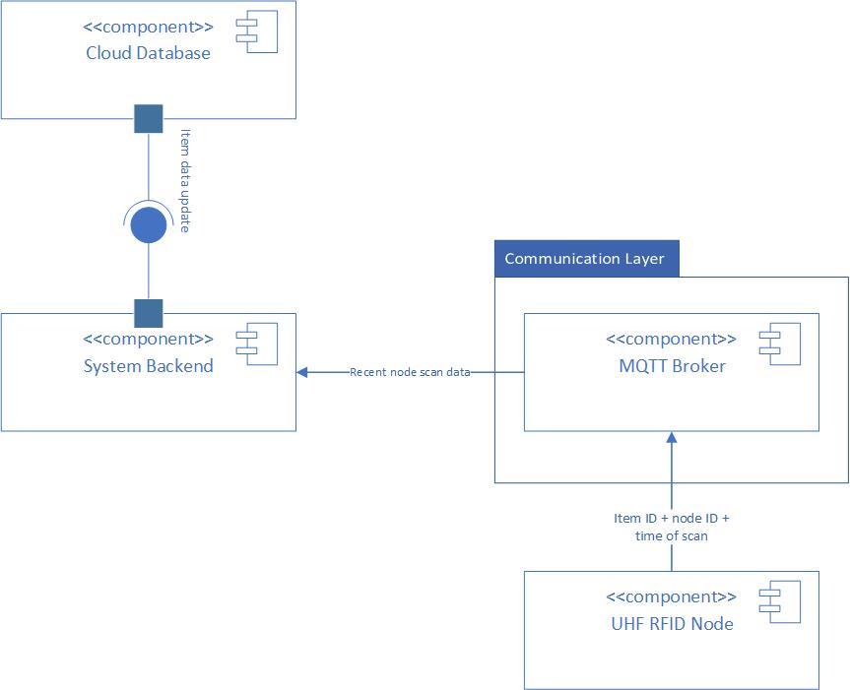

Monitoring Application Design
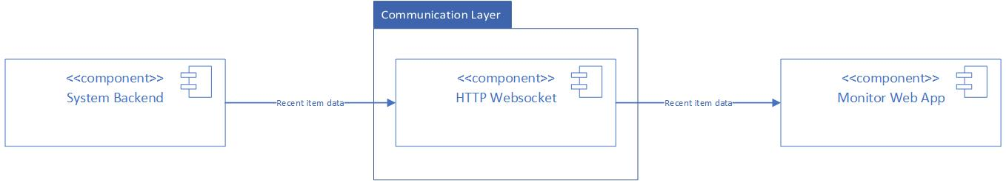

The image above shows how the monitoring application is designed. The monitor web app is connected to the backend system via the WebSocket API. There, it receives all updates and recent data of all registered items in the system.
The monitor web app is the front-end UI that lets users view hospital asset locations.
And below is how the monitor web app is connected to the registration table.

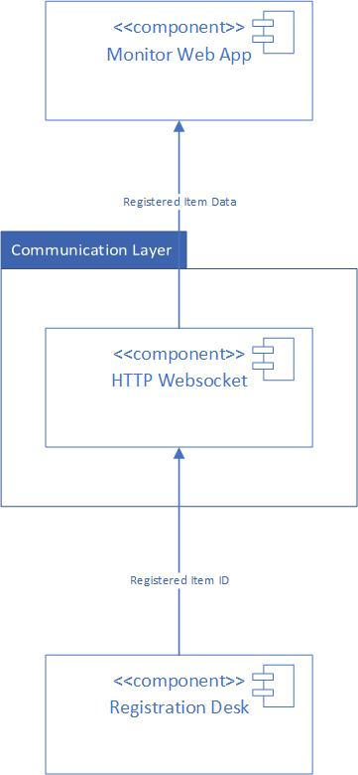 | Through the same communication layer (WebSocket API), the monitor web app receives newly registered items from the registration table. At the same time, this communication allows the monitor web app to see any item being deregistered from the system database.  The data sent via WebSocket from the registration desk to the monitor web app is the registered item data, containing the item name, tag ID, and the date & time of registration or deregistration of the scanned item.

Data Design

Class Diagrams
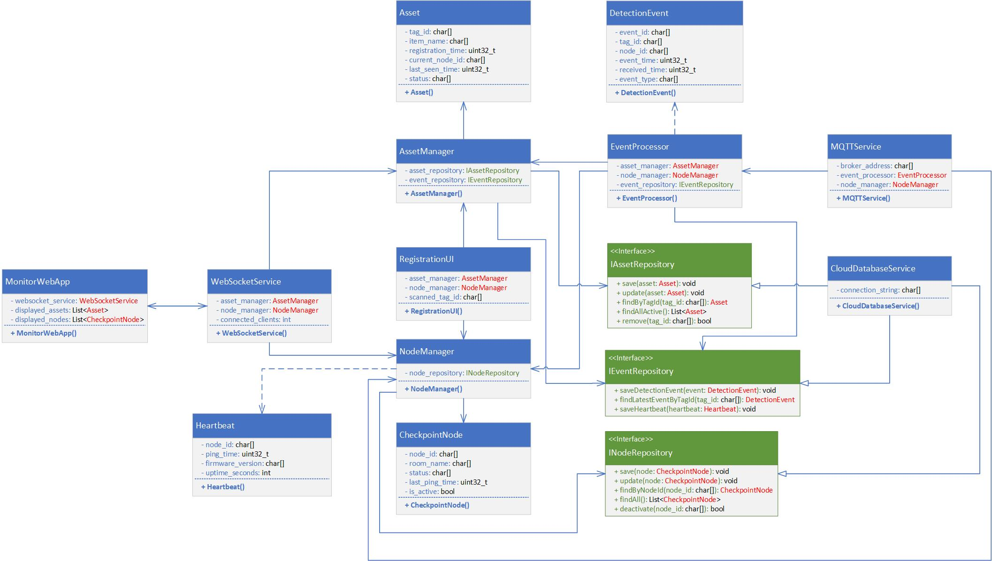

The image above is the complete class diagram of the UHF RFID Fixed Asset Tracker system. The system contains entity classes, service classes, boundary classes, and interfaces.

Entity Classes

The Asset Class
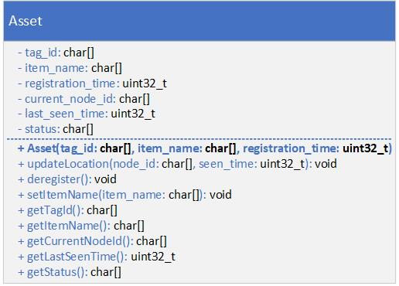

The Checkpoint Node Class
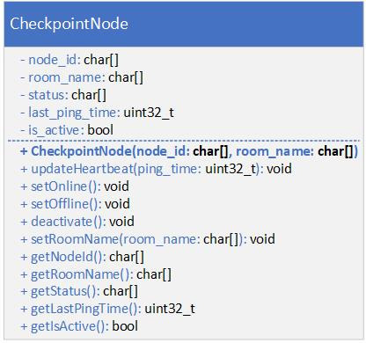

The Detection Event Class
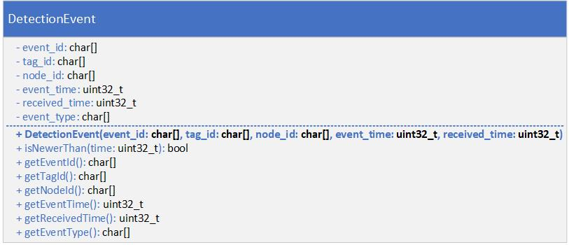

The Heartbeat Class
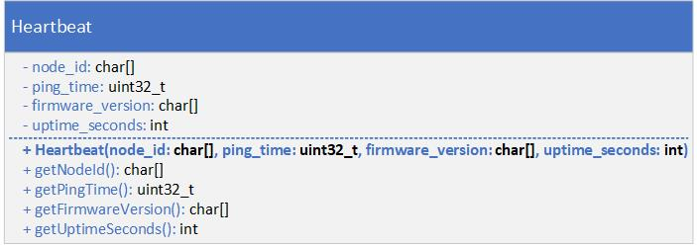

Service Classes

The Asset Manager Class
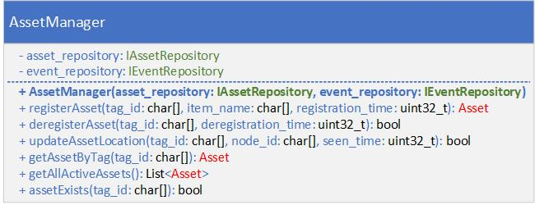

The Node Manager Class
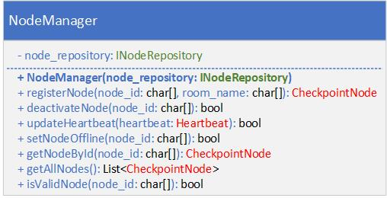

The Event Processor Class
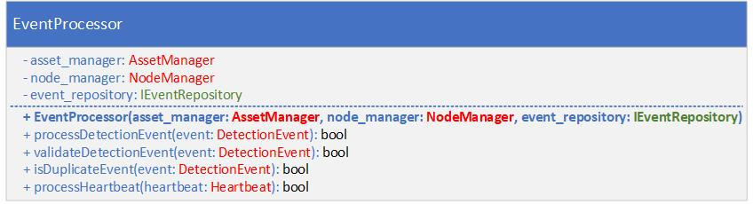

The MQTT Service Class
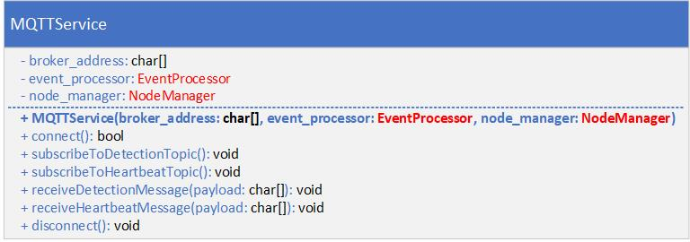

The WebSocket Service Class
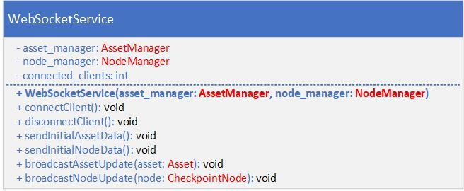

The Cloud Database Service Class
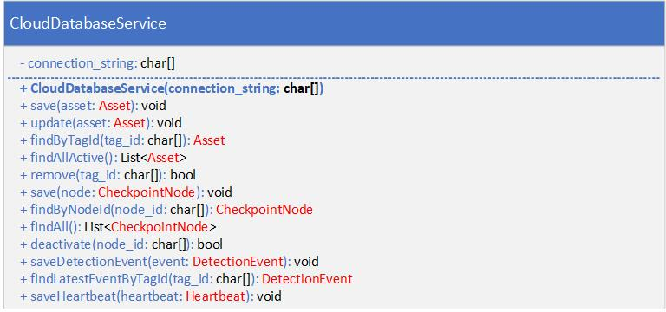

Boundary Classes

The Registration UI Class
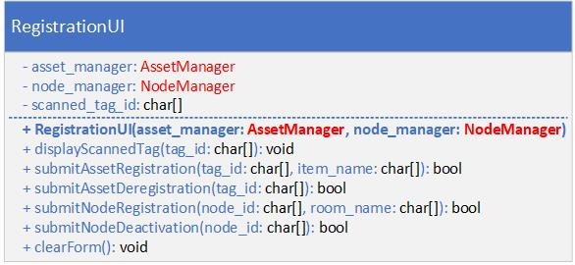

The Monitor Web App Class
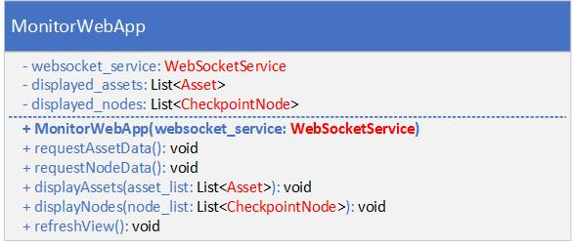

Interfaces

The Asset Repository Interface
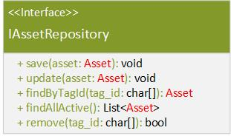

The Node Repository Interface
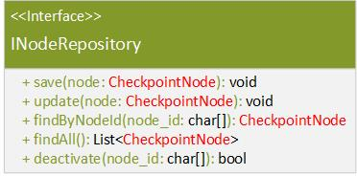

The Event Repository Interface
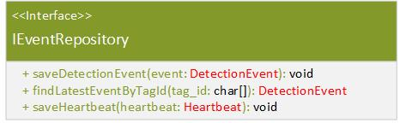

State Machines

Data Flow

Interface Design

Error Handling

Deployment Design

