March 2nd, 2026

Hospital Fixed Asset Tracking Sensor System Project Proposal
Imperial Healthtech
Document Version 1.1.1 (Draft)

Edited by:
Farros Ramzy

Version Table
Version Number | Date of Creation / Change | Changes
0.0 | 02/03/2026 | Document Initiation, adding the introduction & context (project background & stakeholders).
0.0 | 03/03/2026 | Document content reformation, adding stakeholders, problems, assignment, and planning.
0.5 | 05/03/2026 | Adding research questions & research aspects.
0.5.1 | 06/03/2026 | Rewrite the research questions and include the goals.
1.0 | 09/03/2026 | Adding risk assessment & changing phase 2, 3, and 4 of the planning & timeline
1.1 | 10/03/2026 | Rewriting the goal of the project, adding risk assessment, and the expected outcomes.
1.1.1 | 12/03/2026 | Update the project's risk assessment, benefits, and outcomes.
2.0 | 30/03/2026 | Added System Overview with its context, scope, and diagrams.

Contents
1. Introduction 1
2. Context & Problem / Opportunity 1
2.1. Context & Background 1
2.2. Current Situation & Stakeholders 1
2.2.1. Hospital Stakeholders 2
2.2.2. Solution Provider Stakeholders 2
2.3. Problem / Opportunity Description 3
3. Assignment 3
3.1. Deliverable Products 3
3.2. Research Aspects 4
3.2.1. System Requirement Analysis 4
3.2.2. System Architecture Design 4
3.2.3. Hardware Design & Prototype Development 4
3.2.4. Firmware Development 5
3.2.5. System Integration 5
3.2.6. Unit-testing & System Validation 5
5.2.7. Documentation & Evaluation 5
6. System Overview 6
6.1. System Purpose 6
6.2. Main Components 6
6.3. Operational Workflow 6
6.4. High-Level Architecture Diagram 7
6.4.1. High-Level System Diagram 7
6.4.2. High-Level Design Layer 8
6.4.3. Embedded Pattern Diagram 8
6.5. Prototype Scope 9
7. Personal & Professional Goals 9
8. Implementation Plan & Timeline 10
8.1. Phase 1 – Research & Requirements 10
8.2. Phase 2 – System Design 10
8.3. Phase 3 – Hardware Prototype + Firmware Development 11
8.4. Phase 4 – Testing & Optimization 11
8.5. Phase 5 – Final Improvements + Final Documentation 12
8.6. Timeline Table 12
9. Risk Assessment 12
10. Expected Outcomes & Benefits 13
11. Conclusion 14

Introduction
Misplaced or underutilized tools and medical equipment frequently cause inefficiencies in most hospitals, as unexpected tasks arise for medical staff while treating patients. Searching for these assets while treating patients wastes time and can be dangerous if a patient is in an emergency requiring quick treatment.
This proposal presents the development of an embedded asset-tracking system for hospital facilities using wireless communication technology.
The objective of this project is to design an efficient hardware prototype, implement secure wireless communication, and validate system performance in a hospital environment.
The system to be produced as output will consist of compact tracking nodes attached to assets, a gateway unit for data aggregation, and a centralized monitoring dashboard.

Context & Problem / Opportunity

Context & Background
Hospitals and medical clinics usually operate tens to hundreds of movable devices daily, either to treat patients, clean inpatient rooms, or sort medicines. Without a fixed asset tracker, staff often spend valuable time locating equipment, leading to workflow delays and inefficient resource utilization.
Given the rapid advances in technology and the increasing demand for efficient healthcare solutions, this is a good opportunity to design and develop a centralized, wireless tracking system to help medical staff sort and use medical equipment as efficiently as possible.

Current Situation & Stakeholders
Hospitals manage many movable devices, including diagnostic tools, infusion pumps, inpatient beds, patient monitors, ventilators, wheelchairs, surgical tools, and tables. These assets are frequently relocated between departments to accommodate changing patient needs and treatment plans.
And apparently, many hospitals rely on manual tracking methods, such as:
- Verbally communicating equipment locations between staff.
- Writing on whiteboards.
- Barcode scanning during scheduled inventory checks.
- Paper logs & Spreadsheets writing.
These methods are inefficient and error-prone because assets are moved without being logged, leading to outdated records, and asset location updates are not real-time.
As a result, hospital staff spend significant time searching for essential equipment, time that could be better spent treating patients. In large facilities, this can result in treatment delays, lower equipment utilization, and increased operational costs.
There is also a trend toward digital transformation in healthcare, where hospitals increasingly adopt IoT-based systems to improve asset visibility. However, many of them are expensive, proprietary, or even require significant infrastructure, creating barriers for mid-sized or budget-constrained facilities.
As for the primary stakeholders in this context, include:

Hospital Stakeholders
This stakeholder includes:
- Hospital Administrators
- Nursing Staff
- IT Department
- Medical Engineering Team
- Patients (Indirect)

Solution Provider Stakeholders
This stakeholder includes:
- Imperial Healthtech (project owner & system integrator)
- Embedded System Developer (technical implementation team)
As placed in the table structures, the stakeholders can be seen below:
1. Client stakeholders:
No. | Stakeholder | Interest | Responsibility
1. | Hospital Administrators | Reduce cost & inefficiency | Approve project & budget
2. | IT Department | Secure & integrate system | Ensure reliable operation
3. | Medical Engineering Team | Maintain devices | Assist with deployment
4. | Nursing Staff | Quick access to equipment | Provide user feedback
5. | Patients | Better care | Indirectly affected

2. Imperial Healthtech as the provider stakeholders:
No. | Category | Interest | Responsibility
1. | Business | Strengthening healthcare portfolio | Ensure project success
2. | Technical | Develop a scalable RTLS system | Design and validate architecture
3. | Operational | Build a long-term partnership | Deploy and support the system
4. | Strategic | Enter the IoT healthcare market | Ensure compliance and quality

3. Embedded System Developer:
No. | Category | Interest | Responsibility
1. | Technical | Build a reliable low-power system | Design hardware & firmware
2. | Learning | Gain real-world IoT experience | Debug and validate the system
3. | Performance | Optimize communication & battery life | Conduct testing & measurement
4. | Professional | Deliver a quality prototype | Provide documentation & reports

Problem / Opportunity Description
As mentioned in the situation above, the lack of real-time asset visibility can increase equipment search time, hinder reliable tracking of asset utilization, increase the risk of equipment theft or loss, and delay patient care.
With this, an embedded tracking solution is required to improve operational efficiency while maintaining low cost and high reliability.

Assignment
The primary objective of this project is to design and develop a compact asset tracking prototype suitable for hospital environments. The system will implement reliable wireless indoor communication to enable real-time monitoring of medical equipment. Special emphasis will be placed on optimizing power consumption to achieve extended battery life for practical deployment. Additionally, a basic monitoring interface will be developed to visualize asset status and location. The overall system performance will be validated through functional, communication, and reliability testing.

Deliverable Products
Deliverable products that must result from this project are:
- RFID-based hospital asset tracker.
- Hardware design and implementation, including RFID tags, readers, and microcontrollers.
- Integration of wireless communication modules for real-time data transmission.

- Software development.
- Programming of microcontrollers to interface with RFID readers and manage data communication.
- Integrated the RFID manager into the user interface using front-end web technologies for monitoring the equipment location.
- Implementation of secure data log processing.

- System unit-testing & validation.
- Documentation of the development process, including design specifications, code, and user manuals.
- Software unit-test and live simulation of the product.

Research Aspects
Looking at the assignment, which is to investigate several technical aspects of embedded asset tracking systems for hospital environments, the research question that can be fit for this project is:
What is the most reliable RFID-based asset tracker system for hospital management systems?
This question may lead to sub-questions such as:
- What wireless communication technology provides reliable indoor communication for the asset tracker?
- What is the effective communication range and reliability of the asset tracker in an indoor environment?
- How reliable is the system for continuous operation and equipment movement?
- How to make the system integrate reliably with the hospital management system?
Research approaches that can be done in this project to answer these questions are:

System Requirement Analysis
The first stage of the project involves identifying the functional and technical requirements for the hospital asset tracking system. This includes studying the hospital's operational environment, identifying typical medical equipment that requires tracking, and defining the system's performance requirements, such as communication range, power consumption, device size, Interfaces, and use case scenarios.

System Architecture Design
Based on the identified requirements, this part will consist of three primary components, which are:
- Asset tracker nodes that will be attached to the hospital equipment.
- A gateway device that is responsible for tracking signals.
- A monitoring interface for the user to visualize the asset data.
A system design document containing block diagrams and communication workflows will be developed to illustrate the interactions among these components. The architecture will also define data transmission methods, device identification, and system scalability.

Hardware Design & Prototype Development
This phase will focus on system development, including programming the microcontroller, the wireless communication module, and the prototype model.
The prototype model will be implemented on development boards and supporting modules. Hardware integration and system assembly will be conducted to produce a functional prototype.

Firmware Development
The system's firmware will be developed to control device operation and enable communication between the tracker and the gateway. It should implement the system's state machine for the initialization phase, wireless data transmission, sleep and wake cycles, and data formatting.
The system will be programmed using embedded system tools and libraries that are suitable for the selected microcontroller board platform.

System Integration
After the development phase, system components must be integrated to establish communication between tracker nodes and gateway devices. Data received by the gateway will be transmitted to a simple monitoring interface that allows visualization of asset status and identification.
This stage ensures that all components can function together as a unified asset-tracking solution.

Unit-testing & System Validation
To evaluate the effectiveness of the proposed system, several tests will be conducted. These tests will include:
- Unit-testing of the device programs.
- Communication range test.
- Reliability test under continuous operation.
The results will be analyzed to determine whether the system meets the predefined project objectives.

Documentation & Evaluation
All development processes, system designs, and testing results will be documented. The final evaluation will summarize system performance, identify limitations, and propose potential improvements for future development.

System Overview
The section below explains the system, what it consists of, and how it will work.

System Purpose
The proposed hospital asset-tracking system is designed to provide real-time visibility of movable medical equipment within indoor hospital environments. The system aims to reduce equipment search time, improve asset utilization, and support more efficient hospital operations through automated identification and monitoring.

Main Components
At a high level, the system consists of four main parts: the asset identification unit, the reader or gateway unit, the communication and processing layer, and the monitoring interface.
The identification unit consists of the assets with their tags. The gateway unit will be the receiver or the reader of the tag. The communication layer consists of a wireless connection between the sensors and the main system monitor or the user interface. The monitoring interface is an app that shows the item's identification and its location within the hospital.

Operational Workflow
The asset identification unit is attached to hospital equipment and provides a unique identity for each tracked item. The reader or gateway captures tag data and forwards it through the selected communication network. The backend processing layer manages incoming data, stores detection records, and prepares information for visualization.
The monitoring interface allows users to view equipment identity, detection status, and location-related information.
When the reader detects a tagged asset, the tag data is captured and processed by the microcontroller or gateway. The data is then transmitted to the backend system through the wireless communication layer. After processing, the information is displayed on the monitoring dashboard, where users can observe asset activity and system status.

High-Level Architecture Diagram
The architecture diagrams are shown below.

High-Level System Diagram
On a high level, the system of this project would look like this.
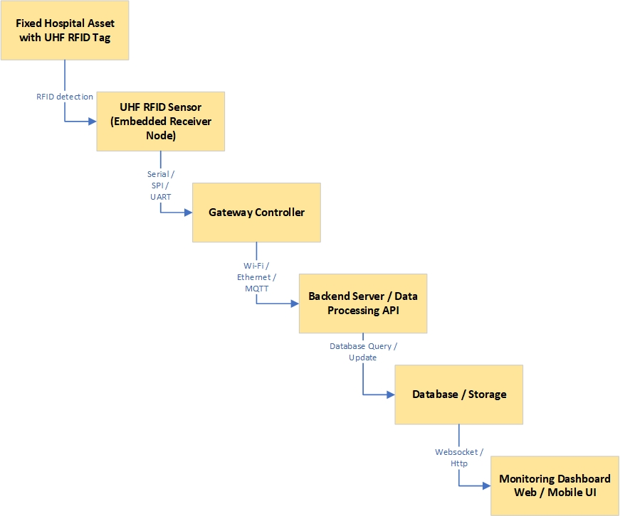

The block diagram above shows what the system would look like in a waterfall process-type diagram, illustrating its functionality. From the top, fixed hospital assets such as wheelchairs, portable monitors, and patient beds with implanted RFID tags are detected by the UHF RFID sensor. From there, the sensor will send the item's ID to the gateway controller. Using the Wi-Fi/MQTT protocol, the gateway controller sends the item ID and its status (in or out) to the data processing API. This API will save the data in the storage. And using the monitor dashboard, users can view item status data from the database via an HTTP connection.

High-Level Design Layer
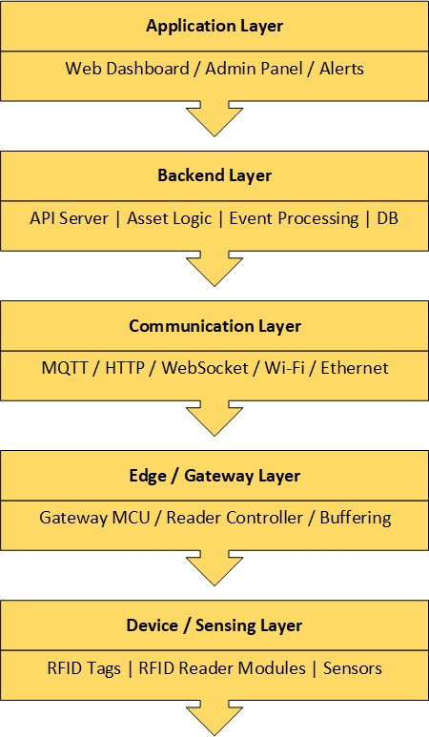 | This picture on the left is how the system is presented in a layer view. From top to bottom, the system is drawn in a high-to-low level order. On top of the system, it is visible that it has an application layer where the user can use the web dashboard and admin panel to see the tracked item status whilst receiving notifications from the alert system.  Under this system, there is a backend layer that hosts the API server, Asset Logic, Event Processing, and Database (DB), where the upper layer can access saved item data whenever the user provides input, provided the item exists in the database. Below that, a communication layer connects the Storage and UI to the device gateway, which handles item detection and registration.  And at the bottom is the device layer, which contains hardware, where item detection and registration are implemented.

Embedded Pattern Diagram
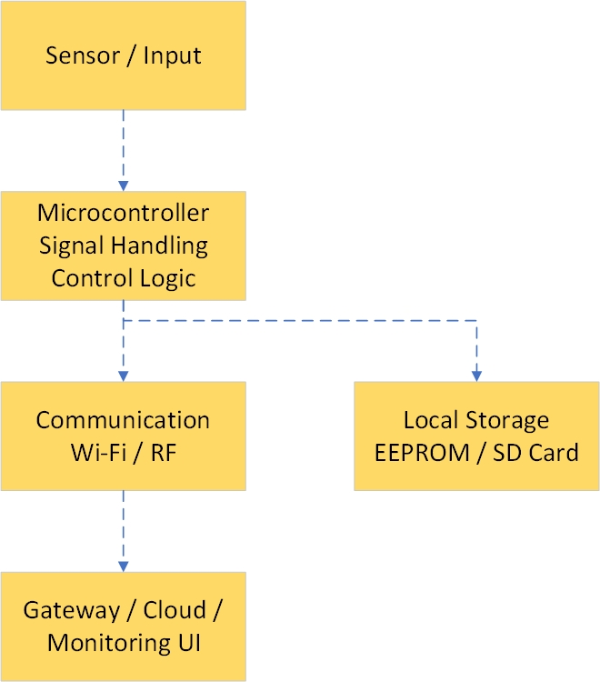 | And this diagram on the left is more focused on the embedded level. The explanation is essentially the same as the two diagrams above, but this one starts at the lower level of the system.  The sensor/input detects an item with an implanted tag and sends its ID to the microcontroller's signal-handling control logic, which is the gateway system. This gateway system uses Wi-Fi/RF to connect the hardware device to the UI and uses the EEPROM to store received data during system communication.  In the UI, system users can view the tracked item and its checkpoint.

Prototype Scope
The proposed system will be developed as a functional prototype intended to validate the feasibility of an embedded hospital asset-tracking solution. The prototype focuses on demonstrating the system's core technical operation rather than delivering a full-scale production deployment for hospital-wide use.
The prototype scope includes the development of RFID-based asset identification hardware, embedded firmware for reader and gateway communication, wireless data transmission, and a basic monitoring interface for displaying asset information. It also includes initial system integration and validation activities, such as communication testing, functional testing, and reliability observation in an indoor environment.
Through this prototype, the project aims to demonstrate that medical equipment can be identified, detected, and monitored through an embedded wireless architecture. The prototype is expected to verify the basic interaction between the tag, reader, gateway, and user interface, while also evaluating communication performance, system responsiveness, and practical implementation constraints.
The prototype does not include full hospital-scale deployment, direct integration with existing hospital information systems, advanced security infrastructure, or complete commercial product readiness. However, the system must be extendable to full-scale hospital maintenance.
Features such as large-scale multi-floor installation, enterprise-level database architecture, predictive analytics, and production enclosure optimization are considered outside the scope of this project prototype. But these features may be addressed in future development stages.

Personal & Professional Goals
In addition to the project's technical objectives, this internship provides an opportunity to support both personal and professional development. Through the design and implementation of the hospital asset-tracking system, the project aims to enhance practical engineering skills and contribute to the development of an embedded IoT solution for healthcare environments. The following personal and professional goals outline the intended learning outcomes and professional competencies to be developed throughout this project.
Goal | How to work on the goal
Improve time management | Because this internship is taking place during the gap semester of my studies, I must ensure I schedule everything precisely according to the sprint plan.
Improve communication skills for business and industry workers | I want to use this internship opportunity to enhance my communication skills by asking for feedback and clarifying aspects of this project that I do not yet understand, as well as some parts that are being asked of me.
Increase courage to solve problems and team brainstorming | I will help resolve potential issues that may arise during the project, and I will participate in collaborative brainstorming sessions to learn from others and refine my problem-solving strategies.
Widen the view of thoughts for IT development. | I want to use this opportunity to learn more about Embedded Systems, System Frameworks, and User Interface products that can be applied in real-world markets, especially within the healthcare sector, as I am working on this project.
Improve teamwork capabilities | I will actively participate in team activities and contribute my capabilities to the team I work with to ensure my reliability on the assignment.
Gather more knowledge about IT relations in the healthcare field | Since I am going to work as an intern at an IT company focused on the healthcare industry, I will actively learn about the interaction between IT and healthcare by participating in relevant project discussions and asking questions to broaden my knowledge while conducting research.

Implementation Plan & Timeline
As the project may take 4 to 5 months, the plan can be divided into 5 phases, such as:

Phase 1 – Research & Requirements
Goal: Understand the project context and hospital environment and define technical specifications.
Tasks:
- Learn the hospital asset tracking challenges.
- Create Project Plan document.
- Define system requirements.
- Estimate the price of the tools needed for development & power consumption.
- Create system architecture diagram.
Deliverables:
- Project Plan document.
- Requirement Specification document.
- Architecture diagram.
- Component selection justification.

Phase 2 – System Design
Goal: Finalize hardware & firmware architecture
Tasks:
- Select microcontroller unit.
- Select communication module.
- Design schematic.
- Define firmware structure.
- Design a communication protocol.
Deliverables:
- Final schematic.
- Flowchart.
- Data packet format (communication protocol document).

Phase 3 – Hardware Prototype + Firmware Development
Goal: Make it work
Tasks:
- Assemble the hardware.
- Bring-up board.
- Debug hardware.
- Develop firmware:
  - Communication
  - Sensor reading
  - On-Off logic
  - Data formatting
- Connect to the gateway.
- Basic Backend integration.
Deliverables:
- Working tracker node.
- Basic gateway communication.
- Test logs.

Phase 4 – Testing & Optimization
Goal: Make it reliable and efficient.
Tasks:
- Indoor range testing.
- Power consumption measurement.
- Interference testing.
- Stability testing.
- Firmware optimization.
Deliverables:
- Range performance report.
- Power estimation report.
- Improved firmware version.

Phase 5 – Final Improvements + Final Documentation
Goal: Make it professional.
Tasks:
- Improve enclosure design.
- Clean code.
- Write technical documentation.
- Demonstrate the product & record it in a video.
- Prepare for final presentation.
Deliverables:
- Final working prototype.
- Full documentation.
- Demonstration & Presentation.

Timeline Table
From those five phases mentioned above, the timeline can be shown as the table below:
Phase | Name | Duration | Date
1. | Research | 3 (week 1 - 3) | 02/03/2026 – 20/03/2026
2. | Design | 3 (week 4 - 6) | 23/03/2026 – 10/04/2026
3. | Development & Prototyping | 6 (week 7 - 12) | 13/04/2026 – 22/05/2026
4. | Testing & Optimization | 4 (week 13 - 16) | 25/05/2026 – 19/06/2026
5. | Final Improvement & Documentation | 4 (week 17 - 20) | 22/06/2026 – 17/07/2026

Risk Assessment
The development of this system entails several technical and operational risks that may affect its performance, deployment, and project timeline. Identifying these risks early enables the implementation of appropriate mitigation strategies during the development process. The following table outlines the potential risks associated with the project and the proposed mitigation approaches.
No. | Risk Category | Potential Risk | Impact | Mitigation Strategy
1. | Communication | Wireless signal interference inside hospital buildings. | Unreliable asset tracking | Conduct signal testing and optimize communication parameters.
2. | Hardware | Component failure or unstable prototype. | Device malfunction | Perform unit tests and program validation. Also, use reliable components.
3. | Integration | Difficulty in integrating the system into the hospital's IT infrastructure. | Deployment delays | Coordinate with the hospital IT team and test compatibility early.
4. | Data security | Unauthorized access to asset data. | Privacy and security risks | Implement message protocol and encryption on data transmissions.
5. | Power Consumption | The device battery drains faster than expected. | Reduced device operating time | Implement low-power modes and optimize transmission intervals.
6. | Project Timeline | Delays in hardware procurement and manufacturing. | Development schedule delays | Order components early and prepare backup development boards.

Expected Outcomes & Benefits
The project is expected to deliver a functional prototype of a hospital asset-tracking system designed with embedded technology. The main outcomes of the project include:
- A Compact Asset Tracking Prototype
A small and energy-efficient embedded tracking device that is capable of being attached to hospital equipment, such as the infusion pumps, wheelchairs, in-patient beds, or portable monitors.

- Reliable Wireless Communication System
Implementation of a wireless communication mechanism that enables asset identification and location monitoring within an indoor environment.

- Power-Efficient Embedded Design
An optimized firmware and hardware configuration that minimizes power consumption and supports extended battery life for continuous operation.

- Basic Monitoring Interface
A simple monitoring interface capable of displaying asset identification and status information received from tracking devices.

- System Performance Evaluation
Experimental results and analysis regarding communication reliability, power consumption, and system stability in indoor environments.

And, based on the expected outcomes above, the proposed asset tracking system is expected to provide several operational and technical benefits for the hospital and other stakeholders.
These benefits include:
- Improved Asset Visibility
The system enables real-time monitoring of medical equipment, allowing staff to locate critical assets when needed quickly.

- Reduced Equipment Search Time
By providing asset identification and location information, the system can significantly reduce the time hospital staff spend searching for equipment.

- Better Equipment Utilization
Hospitals can better manage equipment distribution and usage, reducing unnecessary equipment purchases and improving operational efficiency.

- Enhanced Operational Efficiency
Automated asset monitoring helps streamline hospital workflows and supports more effective resource management.

- Scalable Technology Platform
The prototype system can serve as a foundation for future expansion, including larger-scale deployments, integration with hospital management systems, or advanced tracking technologies.

Conclusion
This proposal document presents the development of a compact, energy-efficient hospital asset-tracking system using embedded technology and wireless communication.
The goal of this project is to address the challenge of locating movable medical equipment inside the hospital environment by providing a real-time monitoring solution that improves asset visibility and operational efficiency.
Through the design of the tracking device, wireless communication system, and monitoring interface, the project will demonstrate the feasibility of a scalable asset-tracking solution.
During the internship, the project will focus on prototype development, system integration, and performance evaluation. The successful implementation of this system is expected to contribute to more efficient equipment management and support future advancements in healthcare IT solutions.

Phase 3
Timeline: 6 weeks (13th April 2026 – 22nd May 2026)
No. | To Do | Deadlines | Progress
1. | Hardware Assembly | 20th April | Done (Only need to pack the product neatly)
2. | Firmware Development –  Sensor Reading | 20th April | Done
3. | Firmware Development –  Module Algorithm | 1st May | Done
4. | Firmware Development –  System Communication | 1st May | Done
5. | Firmware Development –  Backend Algorithm | 8th May | In Development (70%)
6. | Firmware Development –  Data Format | 8th May | Done
7. | Firmware Development –  User Interface (Functionalities) | 15th May | In Development (50%)
8. | User Interface (UX design) | 15th May | In Development (20%)
9. | System Integration | 22nd May | In Development (60%)

