Use Case Table
1.
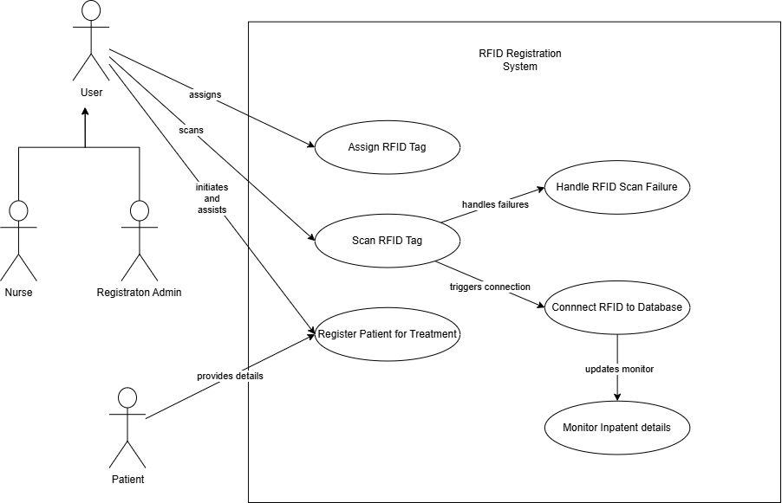

Use Case ID: UC_001 | Name: Registering an RFID tag for inpatient treatment
Description: | When a patient is admitted as an inpatient, the nurse scans an RFID tag to connect the service data of the patient in the database with the RFID ID.
Basic Flows: | - The nurse and/or admin of the hospital already has the hospital registration web app and the inpatient monitor open.  - A patient walks-in and arrives to the hospital registration desk.  - The patient registers themselves for a treatment by providing the MRN (Medical Record Number), the name, and other personal data to the nurse.  - The nurse fills in the patient’s MRN on the registration web app.  - The web app shows whether the patient is newly registered, or a returnee based on the MRN.  - If the patient is a new patient, the nurse fills in the personal data of the patient. And if the patient is a returnee, the nurse will only change the treatment type of the patient after evaluating the patient.  - The nurse evaluates whether the current patient is an inpatient, or an outpatient based on the hospital policies.  - If the patient is categorized as an inpatient, then the nurse enters the customer data to the registration centre database as an inpatient.  - The nurse takes an RFID tag and attach it on the patient wrist.  - The nurse then scans the RFID tag (with an RFID scanner) to read the tag ID. And the scan process is success.  - Hospital inpatient data cloud connects the tag ID with personal data of the patient. And the registration monitor shows a success notification.  - The inpatient monitor will show the tag ID, along with patient MRN, name, treatment type, last room location, and the duration of the treatment.
Alternative Flows: | - If the patient is not admitted as an inpatient, the patient need not to be registered for the RFID tracking device.  - Unreadable scans should do nothing to the system tag registration.  - If nothing happens for thirty seconds upon the scan registration phase, the RFID registration screen should notify the nurse or admin to repeat the scan.  - Upon cancellation, the ID of the tag will not be connected to customer data, and the database will remove the customer data.
Pre-Condition: | Customer does not already exist in the database based on their MRN. In case the patient already exists in the database, their existing record should be updated instead of creating a new entry.
Post-Condition: | Customer ID has scanned, and the RFID is recorded to the treatment database.
Actor: | Nurse, Registration Admin, Patient.

2.
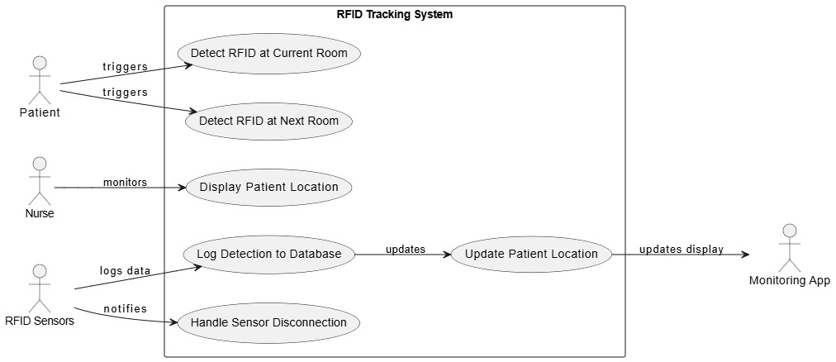
Use Case ID: UC_002 | Name: Detecting patient movements between rooms via RFID sensors.
Description: | When a patient moves from one room to another, the patient should pass two sensors. The first sensor is the RFID sensor in their current room. And the second sensor is the RFID sensor in the next room. And after the patient passed both sensors, the nurse can see the current position of the patient from the patient monitoring web app.
Basic Flows: | - The patient is already registered as an inpatient and already wears their RFID tag.  - The nurse already has the patient monitor stream web app open in the monitoring room.  - The patient walks past the first sensor nearby the door of the current room where the patient is located, before the patient is exiting the room.  - The first sensor detects the patient RFID tag and sends a detection log to the database.  - The patient walks past the second sensor nearby the door of the next room where the patient is going to, after the patient is entering the next room.  - The second sensor detects the patient RFID tag and sends a detection log to the database.  - The monitor app processes the detection logs from both sensors.  - The monitoring app matches the timestamps to identify the patient’s movement from the current room to the next one.  - The app updates the current position of the patient on the monitoring UI.  - The nurse then can see in which room is the patient right now from the monitoring room.
Alternative Flows: | - A disconnected RFID sensor will trigger a warning to the monitor room to let the nurses know and send a nurse to guide the patients manually around the disconnected sensor to enter or exit the rooms until the sensor got reconnected.  - If a patient is only detected by the first RFID sensor and not moving to the next room, which therefore the patient is not detected by the second RFID sensor within a predefined timeout (e.g. 2 minutes), the patient monitoring app will not change the current position of the patient.
Pre-Condition: | The patient should already be registered in the database as an inpatient and wears the RFID tag, given by the nurse or the registration admin.
Post-Condition: | The patient RFID tag got scanned by the sensors in each room, and the patient position data is updated.
Actor: | Patient, Nurse, RFID sensors, Monitoring app.

3.
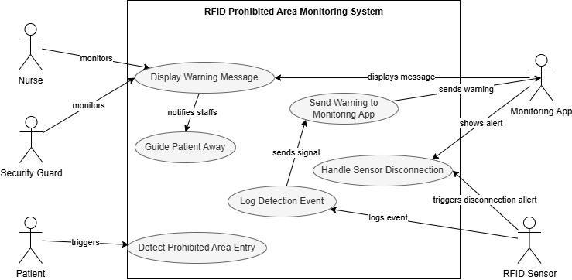
Use Case ID: UC_003 | Name: Warning the hospital workers if a patient is getting too close to any prohibited areas inside the hospital.
Description: | When an inpatient found out to be too close to the prohibited or high-risk area, the patient monitoring app should notify a nurse or a security guard to guide the patient away from that area and ensure their safety.
Basic Flows: | - The patient is already registered as an inpatient and already wears their RFID tag.  - The nurse already has the patient monitor stream web app open in the monitoring room.  - The patient walks in the detection zone of a prohibited area monitored by RFID sensors.  - The sensor reads the patient RFID tag.  - The sensor sends a detection signal to the monitoring app via the network.  - A warning message is being displayed on the monitoring app, showing the patient’s ID and location.
Alternative Flows: | - A disconnected RFID sensor will trigger a warning to the monitor room to let the nurses know and send a nurse or a security guard to standby on the entrance of the prohibited area.
Pre-Condition: | The patient should already be registered in the database as an inpatient and wears the RFID tag, given by the nurse or the registration admin.
Post-Condition: | The patient RFID tag got scanned by the sensor on the prohibited area entrance, and the patient is being guided by the nearby nurse or the security guard to move away from the area.
Actor: | Patient, Nurse, Security guard, RFID sensor, Monitoring app.

4.
Use Case ID: UC_004 | Use Case: Patient / Customer Personal Data Deleting
Description: | User can scan the RFID tag of the customer to remove the customer data from the database.
Basic Flows: | - User scans the RFID tag of the customer using an RFID scanner.  - The display device will show two choices to the user. There is a “show data” to see the summarized data of the customer and an “edit data” to change or update the personal data of the customer from the registration centre.  - The user clicked the “edit data” choice.  - The registration centre receives the edit request from the scanned customer ID.  - The registration centre deletes the data of the customer.
Alternative Flows: | - Unreadable scans result a warning to the scanner UI to tell the user to repeat the scan process.  - Upon cancellation, the ID of the customer data will not be deleted.
Pre-Condition: | The customer is already registered in the database with the ID data.
Post-Condition: | Customer data has been deleted from the database.
Actor: | User, RFID scanner, Registration centre.

Use Case ID: UC_005 | Use Case: Noticing an escapee (unpaid customer/escaped unfinished treatment patient)
Description: | User can notice an escapee who passed the long-distance RFID scanner which is placed by distance on every entrance or exit door of the hospital building.
Basic Flows: | - Registered patient with ongoing treatment or unpaid customer passed the gate area of the building from inside to outside.  - .
Alternative Flows: | - Unreadable scans result a warning to the scanner UI to tell the user to repeat the scan process.  - Upon cancellation, the ID of the tag will not be connected to customer data, and the database will remove the customer data.
Pre-Condition:
Post-Condition:
Actor:

Use Case ID: UC_006 | Use Case: Patient Locating
Description: | User can locate the patient / customer inside the building by using the Bluetooth RTLS component that is also attached to the RFID tag of the patient / customer.
Basic Flows: | - .  - .
Alternative Flows: | - .  - .
Pre-Condition:
Post-Condition:
Actor:

User Requirements
User Requirements ID | Description | Use Cases ID
UR_01
UR_02
UR_03
UR_04
UR_05
UR_06
UR_07

Functional Requirements
Functional Requirements ID | Description | Use Cases ID
FR_01
FR_02
FR_03
FR_04
FR_05
FR_06
FR_07
FR_08
FR_09

Non-Functional Requirements
Non-Functional Requirements ID | Name | Description | Use Cases ID
NFR_01 | Performance
NFR_02 | Security
NFR_03 | Reliability
NFR_04 | Maintainability
NFR_05 | Error Handling

