January 16th,2024

Free-RTOS Report
  - Embedded System 3, Assignment-2
Document Version 1.0

Edited by:
Farros Ramzy (3767353)

Abstract
This technical report is written, based on the experiment of the Free-RTOS implementations which is used for a filtering state of a very big system which need a multi-tasking feature in its application. This document will explain to the reader about the Free-RTOS, from the thread, mutex, and queue, how does each of them work, and what are the practicum results from experimenting the RTOS program.

List of Figures
Figure 2. 1. 1 taskScenarios' declaration. 3

Figure 2. 2. 1 Free-RTOS library includes. 4
Figure 2. 2. 2 Task create method in Free-RTOS thread. 4
Figure 2. 2. 3 Task Scenario implementation. 5

Figure 2. 3. 1 Semaphore Mutex variable declaration. 6
Figure 2. 3. 2 Mutex Semaphore implementation in a task. 6

Figure 2. 4. 1 Queue handler variable decalration. 8

Figure 3. 1 System wiring diagram. 9

List of Tables
Table 2. 2. 1 list of thread task scenarios. 5

Table 2. 3. 1 Mutex Scenario tasks. 7

Table of Contents

1. Introduction 1
1.1. Equipment 1
2. Procedure 1
2.1. Preparation 2
2.2. Part 1, Thread 3
2.3. Part 2, Mutex 5
2.4. Part 3, Queue 7
3. Design 9
4. Conclusion 9
5. Recommendation 10
6. References 11

Introduction
Free-RTOS, (Free Real-Time Operating System) is an open-source, real-time operating system kernel designed for embedded systems and microcontrollers. Developed by Real Time Engineers Ltd., Free-RTOS provides a robust and efficient platform for building real-time applications that require precise timing and responsiveness.
Key features of the Free-RTOS include its small footprint, portability across a wide range of hardware platforms, and a comprehensive set of features tailored for embedded systems. It offers a preemptive scheduling mechanism, allowing tasks with different priorities to run seamlessly, making it well-suited for applications with real-time constraints.
Free-RTOS has gained popularity in the embedded systems community due to its flexibility and scalability. It supports various architectures, including ARM, AVR, and x86, making it adaptable to a diverse set of microcontrollers and processors. Additionally, Free-RTOS is accompanied by a rich ecosystem, including middleware components and a supportive community, enhancing its usability and aiding developers in creating reliable and efficient real-time applications.
In this practicum, there are three experiments which have been done and will be explained throughout the Procedure section of this document.

Equipment
To do this research practicum, there are some tools needed such as:
- An ESP-32 Microcontroller board.
- A wiring breadboard.
- 4x LEDs (any color).
- 4x 220 ~ 470 Ω resistors.
- Several jumper-wires.

Procedure
There are at least four parts that must be done in this practicum. The first one is the preparation, the next one is the RTOS-Thread experiment, followed by the Mutex, then the Queue, based on the Mutex and Thread created. Each result of the experiment will be compared in the Conclusion section, and the result of that comparison will be placed with the personal recommendation in the Recommendation section of the document.

Preparation
Before starting on the assignment, it is important to understand about how the Free-RTOS works and what are the benefits of the Free-RTOS.
Based on the reference listed in the References section of this document, Free-RTOS works as a real-time operating system (RTOS) kernel, providing the essential services needed to manage and schedule tasks in embedded systems and microcontrollers.
In Free-RTOS, the basic unit of execution is a task, which can be thought of as a small program or thread. Tasks are scheduled to run on the processor, and Free-RTOS ensures that each task gets its fair share of CPU time. The tasks in Free-RTOS are typically small, lightweight, and designed to perform specific functions.
As for its features, Free-RTOS includes a preemptive scheduler that determines which task should run at any given time. The scheduler uses priority levels assigned to tasks to make scheduling decisions. Higher priority tasks preempt lower priority ones, ensuring that tasks with more critical functions get executed promptly.
Other than that, Free-RTOS provides mechanisms for synchronization and communication between tasks. This includes features like semaphores, mutexes, and queues. Semaphores and mutexes are used for resource sharing and mutual exclusion, preventing conflicts when multiple tasks access shared resources. Queues facilitate communication and data exchange between tasks in a thread-safe manner.
Its portability and design are based to handle interruptions in a looping system.
As for the benefits, Free-RTOS offers several benefits, like:
- Open Source and Free
As the name suggests, Free-RTOS is open-source and available for free, making it accessible to a broad community of developers. This open nature fosters collaboration, community support, and allows for customization to meet specific project requirements without incurring licensing costs.

- Real-Time Capabilities
Free-RTOS has a small memory footprint, making it suitable for resource-constrained embedded systems. This is crucial for devices with limited RAM and flash memory, common in many microcontrollers and embedded platforms.

- Task Scheduling and Priority
The preemptive scheduler in Free-RTOS enables effective task scheduling. It allows tasks with higher priority to preempt lower-priority tasks, ensuring that critical tasks are attended to without delay. Priority levels can be adjusted based on the urgency of tasks.

- Interrupt Handling
Free-RTOS is designed to seamlessly integrate with interrupt service routines (ISRs). It allows the execution of ISRs and ensures that tasks can coexist with interrupts, providing a robust solution for handling asynchronous events.

- Configurability
Free-RTOS is configurable, allowing developers to tailor the kernel to meet the specific needs of their applications. This includes adjusting parameters such as task priorities, stack sizes, and enabling or disabling certain features based on project requirements.
Once knowing this information about the Free-RTOS, the next step of the assignment can be approached.
The next step of the preparation process is the design. In the Design section of this document, a wiring diagram for the entire experiments is placed.
The system that will be built for all the experiments is only containing An ESP32-Dev kit module with four LEDs connected with the proper resistors, prepared in the Equipment section above this Procedure.
But to be reminded, the purpose of this experiment is to simulate an automatic garden sprinkle which uses the three of Free-RTOS method, which are the Thread, Mutex, and Queue.
The sprinkles are simulated by the LEDs which will blink in a certain pattern, based on each scenario that desired by the practicum apprentices.
The task scenarios can be declared as shown in this Figure 2. 1. 1 below.
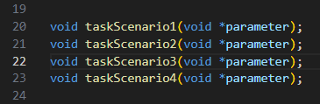
Figure 2. 1. 1 taskScenarios' declaration.
Each scenario here contains different task to the sprinkles which are simulated by the LEDs.
And the parameters within each scenario are the parameters that will be applied for the Thread, Mutex, or Queue which will be explained further below.

Part 1, Thread
Threads are the building blocks of concurrent execution, enabling a program to perform multiple tasks simultaneously. Unlike traditional sequential execution, threads allow different parts of a program to run independently. In this report, we explore the advantages and challenges associated with threading, examining how it enhances parallelism, responsiveness, and resource utilization.
In this part of the practicum, the thread utilities can be accessed via the freertos library of the ESP device such as shown in this Figure 2. 2. 1 below.
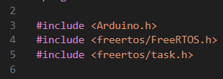
Figure 2. 2. 1 Free-RTOS library includes.
From the Figure 2. 2. 1 above, the Free-RTOS header is needed to access the utilities of a thread, while the task header below it is needed to initialize the task of each declared scenario.
Once the needed libraries and variables are declared, in the loop of the program, task handle can be used to run the thread.
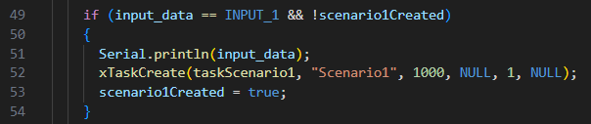
Figure 2. 2. 2 Task create method in Free-RTOS thread.
In the Figure 2. 2. 2 above, the system is creating the task of the first scenario when a certain input is detected.
And the task is implemented such as this Figure 2. 2. 3 below.
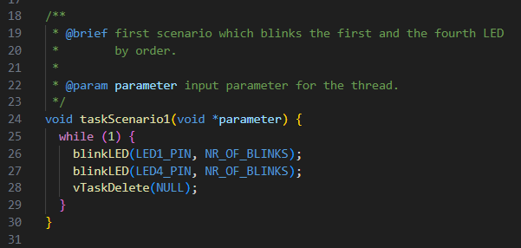
Figure 2. 2. 3 Task Scenario implementation.
Visible from the @brief of this function, the task of this scenario is to blink two LEDs for a certain time in a row.
There are three more functions that works like this scenario. And the thread program allows the system to run those functions at the same time, by splitting the task handler via interrupt.
The vTaskDelete() is used to stop the task within the scenario once the system completes the task in one iteration.
The input of the system, corresponding to the tasks of each scenario can be described as follows:
Table 2. 2. 1 list of thread task scenarios.
No. | Input value | Task | Description
1. | ‘1’ | Scenario1 | Blinks LED 1 for a certain time, then followed by LED 4
2. | ‘2’ | Scenario2 | Blinks LED 2 for a certain time, then followed by LED 3
3. | ‘3’ | Scenario3 | Blinks LED 1 for a certain time, then followed by LED 3
4. | ‘4’ | Scenario4 | Blinks all LEDs for a certain time, started from LED 1 to LED 4

Part 2, Mutex
While threads enable parallelism, they also introduce the risk of data corruption and race conditions when multiple threads access shared resources concurrently. Mutex, short for Mutual Exclusion, is a synchronization mechanism that ensures only one thread can access a critical section of code at a time. This report investigates the importance of mutex in preventing data inconsistencies and explores various mutex implementation strategies.
In this practicum, some upgrades from the thread implementations are added.
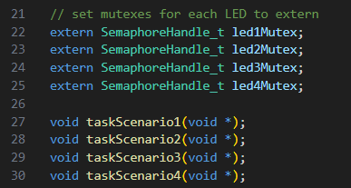
Figure 2. 3. 1 Semaphore Mutex variable declaration.
In this Figure 2. 3. 1 above, some SemaphoreHandler variables are declared to be used for the system to split up the interrupt handling time of each task scenario.
This will make each task commanded for the system run by its order, without crashing the task which is running earlier than the new one.
To handle the tasks in mutex is very different than the thread.
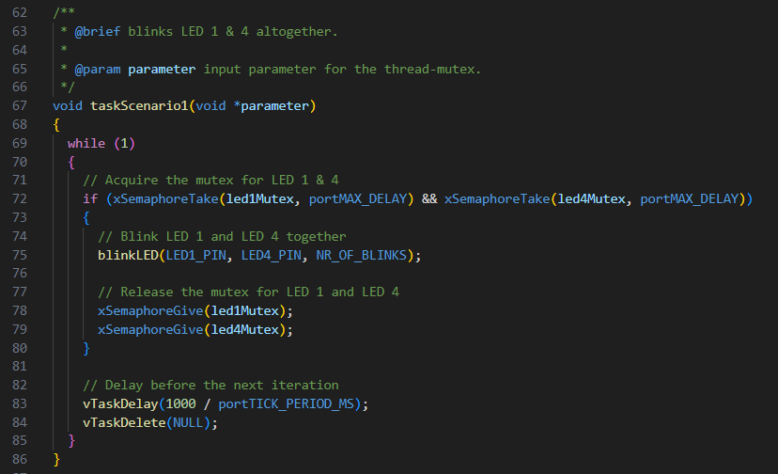
Figure 2. 3. 2 Mutex Semaphore implementation in a task.
In this Figure 2. 3. 2 above, a give and take variables in the function are visible. These give and take variables are used to let a task to take its time completely to do its task before another task listed in pending can go in and run a different task as an interrupt.
Other changes made in this thread to mutex transition are the tasks of each scene like what is listed in this Table 2. 3. 1 below.
Table 2. 3. 1 Mutex Scenario tasks.
No. | Input value | Task | Description
1. | ‘1’ | Scenario1 | Blinks LED 1 and LED 4 altogether at the same time
2. | ‘2’ | Scenario2 | Blinks LED 2 and LED 3 altogether at the same time
3. | ‘3’ | Scenario3 | Blinks LED 1 for a certain time, then followed by LED 3
4. | ‘4’ | Scenario4 | Blinks all LEDs on the system at the same time

Part 3, Queue
Queues provide an essential mechanism for communication and coordination among threads. They enable the safe exchange of data between threads by implementing a First-In-First-Out (FIFO) data structure. This report delves into the role of queues in concurrent programming, examining how they facilitate seamless communication, task scheduling, and inter-thread coordination.
This method in RTOS is almost like Mutex. However, the implementation of the task scenario is different.
Mutex is primarily used for ensuring mutual exclusion, meaning only one thread can access a critical section of code or a shared resource at a time. It prevents multiple threads from interfering with each other and helps maintain data consistency.
On the other hand, a queue is a data structure that allows elements to be inserted at the rear and removed from the front. In the context of concurrent programming, a queue is often used for inter-thread communication and coordination. Tasks or messages are passed between threads through a queue, providing a way for them to synchronize and exchange data.
The only changes happening from the Mutex implementation to Queue is captured in this Figure 2. 4. 1 below.
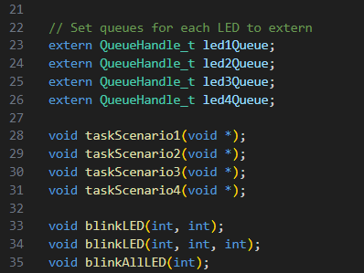
Figure 2. 4. 1 Queue handler variable decalration.
Instead of using the handler variable of semaphore, each scenario will use the queue handler variable.
Another change within the system is using the queue receive and send to handle the scenario task timer, rather than using the semaphore give and take. It will allow the system to run the scenario one by one, per-queue, without trespassing the time amount of the previous task.
If two commands run at the same time, it will prioritize the quickest task to be at the front of the queue, then followed by the other.
Other than that, the behavior of each created scenarios still the same.

Design
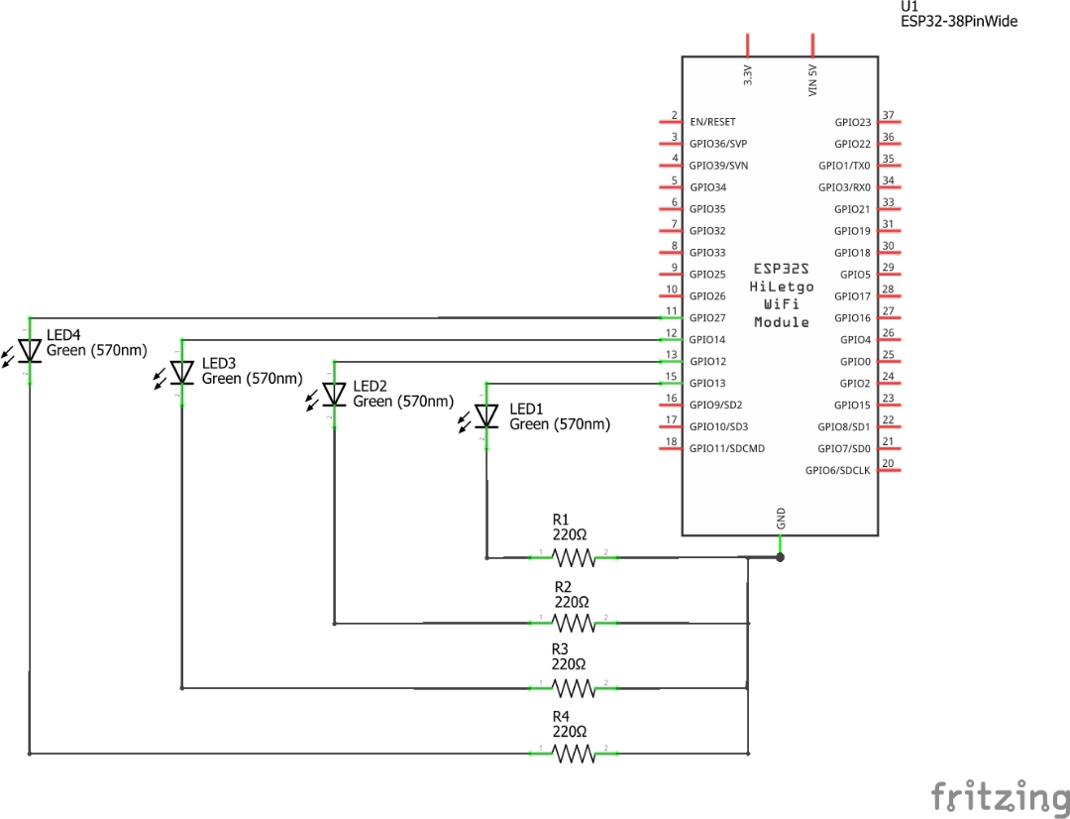
Figure 3. 1 System wiring diagram.
This Figure 3. 1 above is the wiring diagram of the Free-RTOS system which will be used for thread, mutex, and queue.
The system only needs four LEDs connected to the microcontroller as the output so the user can watch and investigate the behavior of the Free-RTOS program.

Conclusion
In conclusion, this report has delved into the fundamental concepts of Thread, Mutex, and Queue in the realm of concurrent programming, providing insights into their individual roles and how they collectively contribute to the development of robust and responsive software systems.
Threads, as the building blocks of concurrent execution, offer a means to enhance parallelism and responsiveness in applications. Understanding the benefits and challenges associated with threads is crucial for developers seeking to leverage concurrent programming effectively.
Mutex (Mutual Exclusion) serves as a key synchronization mechanism, preventing data corruption and race conditions in multi-threaded environments. The report has explored various mutex implementation strategies, emphasizing their role in ensuring data consistency and integrity.
Queues, as a coordination mechanism, facilitate seamless communication and data exchange between threads. Their importance in managing inter-thread communication has been highlighted, showcasing how queues contribute to task scheduling and coordination.
The examination of case studies and best practices has provided real-world examples of how these concepts are applied in diverse scenarios. By showcasing practical implementations, the report has demonstrated the versatility and adaptability of Thread, Mutex, and Queue in addressing the challenges of concurrent programming.

Recommendation
Given the critical role of threads in concurrent programming, developers should prioritize thread safety in their code. This involves careful consideration of shared resources, appropriate use of synchronization mechanisms, and thorough testing to identify and rectify potential race conditions.
When implementing mutexes, developers should choose the appropriate strategy based on the specific requirements of their application. Consideration should be given to factors such as the nature of the shared resource, the expected contention level, and the potential impact on overall system performance.
And beyond the basics covered in this report, developers are encouraged to explore advanced concurrency patterns and paradigms. Concepts like thread pools, futures, and reactive programming can further enhance the scalability and responsiveness of concurrent systems.

References
Along this practicum, such documents and references are being used:
- What and Why is RTOS (https://www.freertos.org/about-RTOS.html)
- Inter-task Communication (https://www.freertos.org/Inter-Task-Communication.html)
- Intro to RTOS (https://www.digikey.com/en/maker/projects/introduction-to-rtos-solution-to-part-6-freertos-mutex-example/c6e3581aa2204f1380e83a9b4c3807a6)

