**2023.03.29 Electrochemistry Online Class Student Activity**

Student Number, Name

Q1. Please explain the redox reaction in the lithium-ion battery when it is charged.

Q2. The Battery A has C rate = 2, Battery B C rate = 3. If the capacity (Ah) of the batteries are the same, what battery has the higher current flow?

Q3. Explain the redox reaction of this reaction.

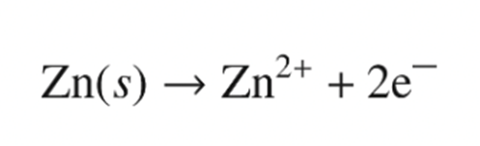

Q4. In the process of the ionization of Zn metals in Copper Sulfate solution (Slide #24),

the surface electrons are removed. Then how the electroneutrality of the whole reactions are preserved?

Q5. Explain the electroneutrality of chemical reaction in below diagram (Slide #26-28)

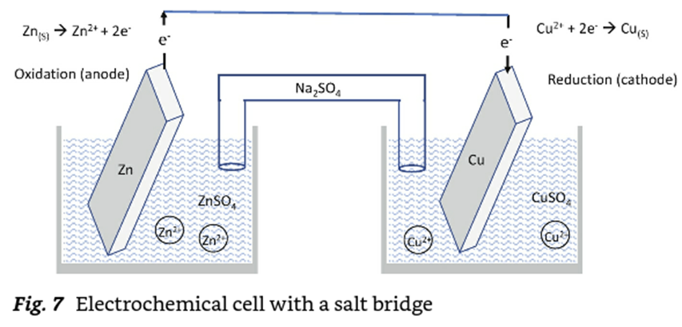

Q6. How can you measure electrode potential? (slide #36)

Q7. If the electrode potential is higher than 0V, then reduction tendency is (greater / lesser).

If the electrode potential is lower than 0V, then reduction tendency is (greater / lesser).

Q8. See the standard reduction potentials (in V) of the reactions below.

${Ag}^{+}+e^{-} -> Ag +0.80$

${2H}^{+}+2e^{-} -> H_{2} 0$

${Li}^{+}+e^{-} -> Li -3.04$

Compare (1) Ionization tendency (2) Reduction tendency of Ag, Li .

Q9. What is the first law of thermodynamics in electrochemistry (Write the equation, too)

Q10. What is the enthalpy of thermodynamics in electrochemistry (Write the equation, too)

Q11.

