**ANSIBLE-01**

**1) Watch ansible-01 video and write down notes. 2) Setup one master and two worker nodes in ansible.**

🡪create three instances with ubuntu version 22.04 ami

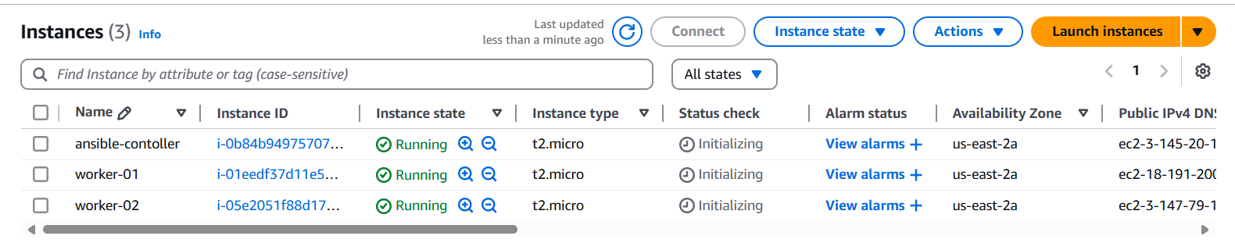

🡪Python is pre requisite for ansible check if python is installed on server



🡪update the server and install ansible

# apt update

# apt install -y ansible

# ansible –version

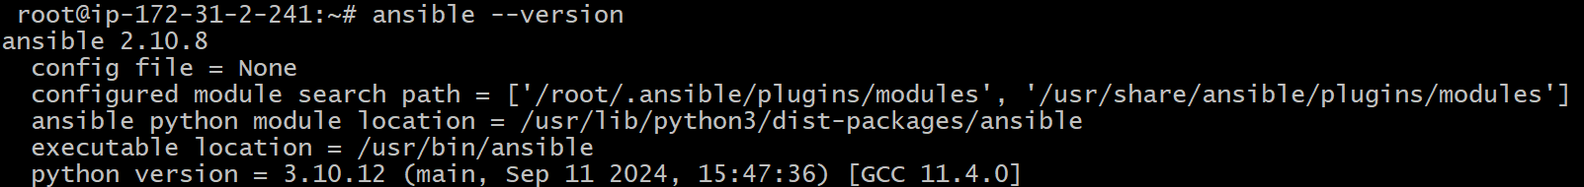

🡪create password less authentication for worker servers

<on ansible controller server>

# sudo su –

# cd

# ssh-keygen -t rsa

# cat /root/.ssh/id_rsa.pub



<on worker-01>

ubuntu@ip-172-31-5-36:~$ sudo su

root@ip-172-31-5-36:/home/ubuntu# cd

root@ip-172-31-5-36:~# cd .ssh

root@ip-172-31-5-36:~/.ssh# vi authorized_keys

**\*save the key\***

<on worker-02>

ubuntu@ip-172-31-2-248:~$ sudo su

root@ip-172-31-2-248:/home/ubuntu# cd

root@ip-172-31-2-248:~# cd .ssh

root@ip-172-31-2-248:~/.ssh# vi authorized_keys

**\*save the key\***

**🡪**check the connectivity with private ip from ansible controller server

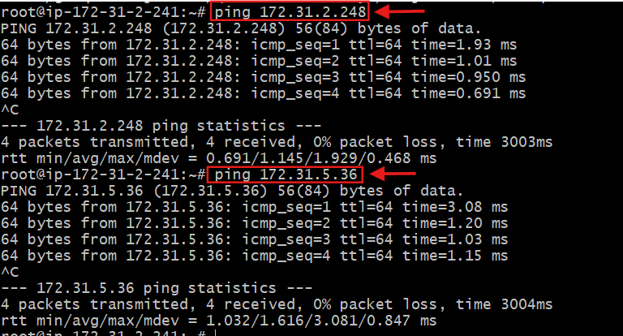

**note: after installation if ansible directory is missing in** /etc **then follow the next step with “🡪”**

**🡪**create a ansible directory with configuration file and hosts file

# mkdir /etc/ansible

# cd /etc/ansible

# touch ansible.cfg hosts

# vi /etc/ansible/ansible.cfg

<**add the following content and save the file>**

|  |
| --- |
| [defaults]  inventory = /etc/ansible/hosts  remote_user = root  host_key_checking = False  retry_files_enabled = False  [privilege_escalation]  become = True  become_method = sudo  become_user = root  [ssh_connection]  ssh_args = -o ControlMaster=auto -o ControlPersist=60s  [paramiko_connection]  pipelining = True  [inventory]  enable_plugins = host_list, script, yaml, ini, auto  [logging]  log_path = /var/log/ansible.log |

🡪add the inventory in hosts file

# vi /etc/ansible/hosts

[all]

Your-Ips

[worker_01]

Your-ip

[worker_02]

Your-ip \***save it\***

**🡪**now try the adhoc command to ping the workers

# ansible all -m ping

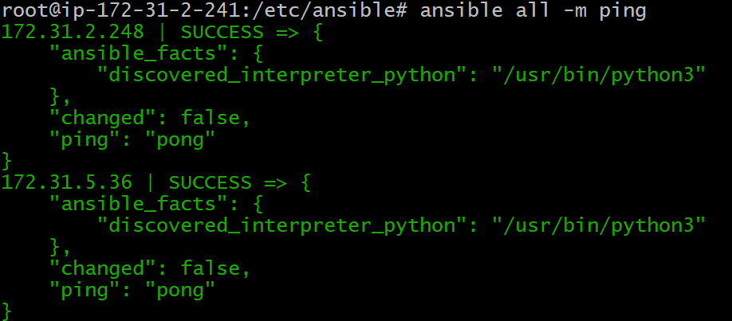

**3) Execute the adhoc command**

# To check the connetivity between slaves

ansible all -m ping

ansible all -m ping -i ansible_hosts

# How to gather facts of slave machine

ansible all -m setup

# Tips: -i is used if we are using more than one invertory file

# What if you do not have SSH key-based? How to pass username and password?

ansible all -m ping --user=ansadm --ask-pass

# TO checkthe uptime of a slave machine

ansible all -a uptime

# Tips: -m is the module and -a should contain the command it should run which goes as an argument to command and shell.

# check the free memory or memory usage of  host

ansible all -a "free -m"

# Execute a command as root user (sudo) on host

ansible all -m shell -a "cat /etc/passwd|grep -i ansadm" -s --ask-sudo-pass

# Execute a command using become module

ansible all -m shell -a "cat /etc/passwd|grep -i ansadm" -b -K

# Tips: -b is the option for become and by default it will become root user

        –K is to tell ansible to ask for SUDO password

#Execute a command as a different user  (sudo su)

ansible all -m file -a "path=/home/ansadm/test state=directory mode=0755" -b --become-user=ansadm

# Create a Linux user group

ansible all -s -m group -a "name=test state=present" -b -K

# Create a file with 755 permission

ansible all -m file -a "path=/home/asnadm/testfile state=touch mode=0755"

# Change ownership of a file

ansible all -m file -a "path=/home/ansadm group=weblogic owner=weblogic" -b

# Install a package using yum command

ansible all -m yum -a "name=httpd state=installed"

# Start or stop the service

# To Start

ansible all -m service -a "name=httpd state=started enabled=yes"

# To Stop

ansible all -m service -a "name=httpd state=stop enabled=yes"