**docker-01**

**1) Setup a virtual machine using Ubuntu image.**

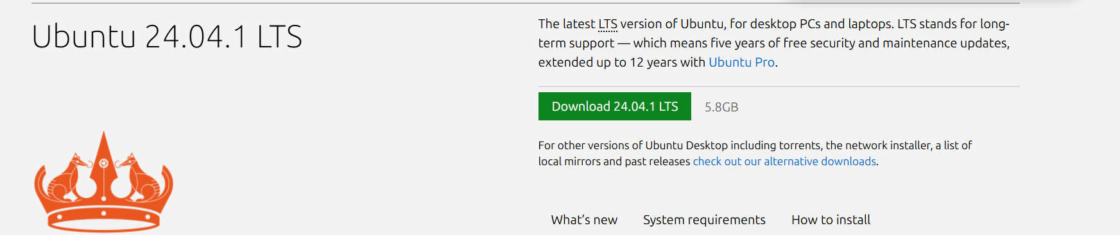

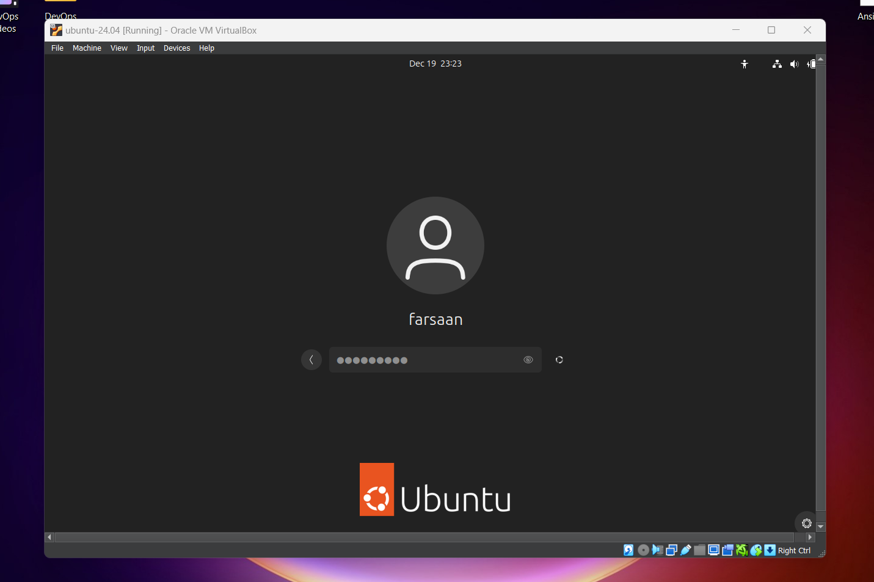

**2) Install docker on ec2.**

# sudo yum install -y docker

# docker –version  
# systemctl start docker

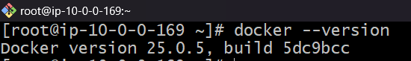

**3) Pull 5 docker images.(nginx,apache tomcat,ubuntu,jenkins,sonarqube)**

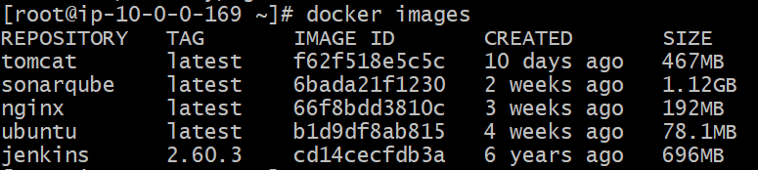

**4) Run nginx container and expose on port 81.**



**5) Delete the apache tomcat image from local.**

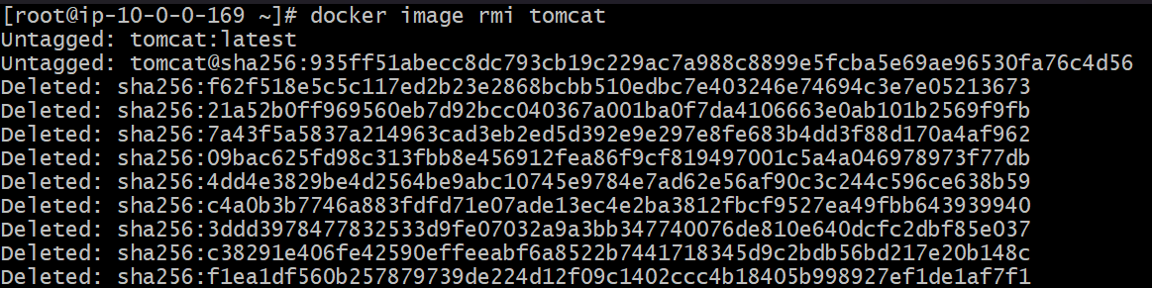

**6) Inspect the jenkins image,sonarqube image.**

# docker image inspect jenkins:2.60.3

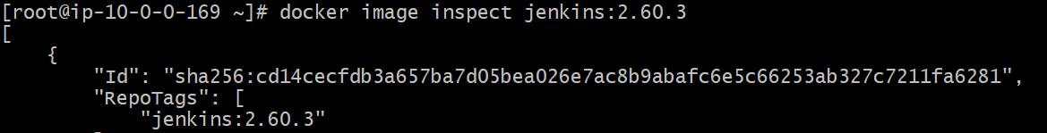

# docker image inspect sonarqube

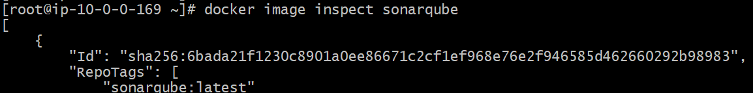

**7) Run jenkins contianer and run one sample job.**

# docker run -itd -p 8081:8080 jenkins/jenkins

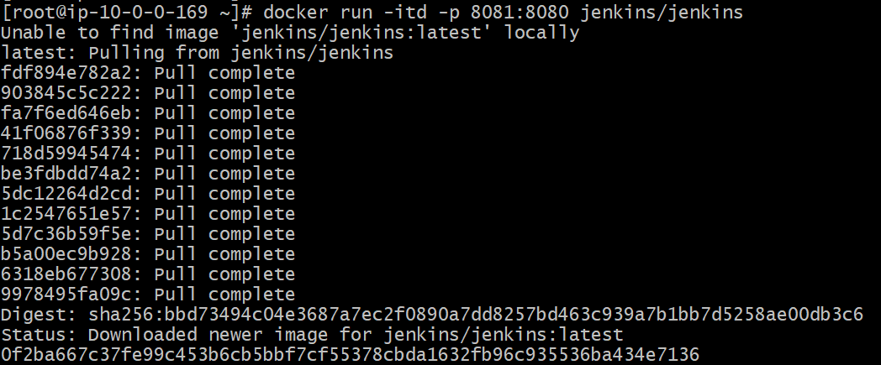

# docker exec -it <id> bash

#cat /var/jenkins_home/secrets/initialAdminPassword



