**DOCKER-02**

**1) Create a tomcat container on 8081 and deploy sample application in tomcat.**

# docker container run -itd -p 8081:8080 tomcat:latest

# docker ps



# docker exec -it 0543 /bin/bash

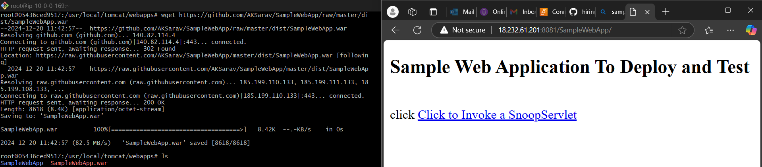

**2) Create volume and deploy tomcat container on port 8082.**

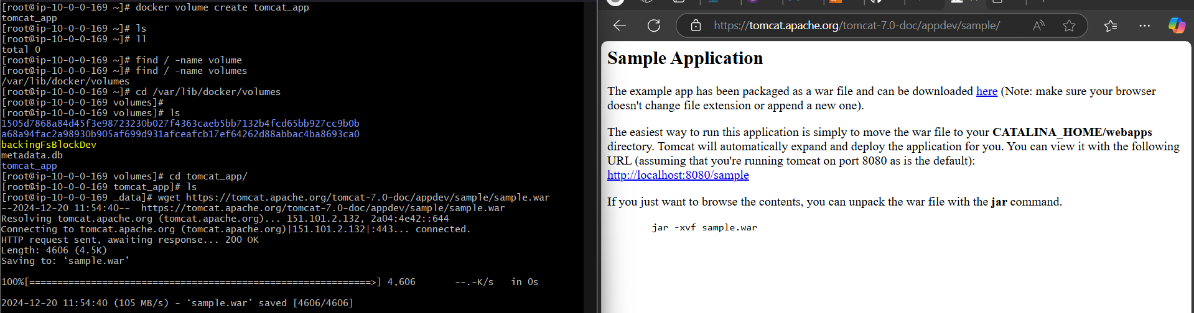

# docker container run -itd -p 8082:8080 -v /var/lib/docker/volumes/tomcat_app/_data: /usr/local/tomcat/webapps tomcat:latest

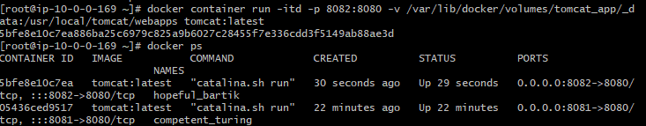

🡪checking on browser

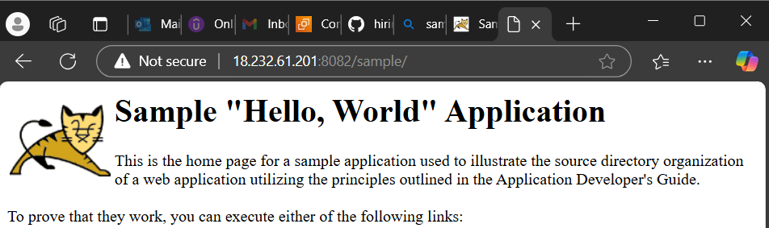

**3) Limit the nginx container to 500 MB.**

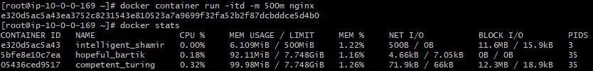

**4) Create a sample docker file using below instructions.**

* **Base module as amazonlinux:latest**
* **Maintainer you name**
* **Install nginx**
* **COPY one index.html file to image**
* **Expose on port 80**
* **Command to start the nginx container**

# vi index.html (**add the sample content)**

# vi Dockerfile

|  |
| --- |
| # Use the latest Amazon Linux as the base image  FROM amazonlinux:latest  # Maintainer information  MAINTAINER Farsaan  # Install nginx  RUN yum -y update && \  yum -y install nginx && \  yum clean all  # Copy the index.html file to the nginx html directory  COPY index.html /usr/share/nginx/html/  # Expose port 80  EXPOSE 80  # Command to start the nginx container  CMD ["nginx", "-g", "daemon off;"] |

# docker build -t nginx:v1 .

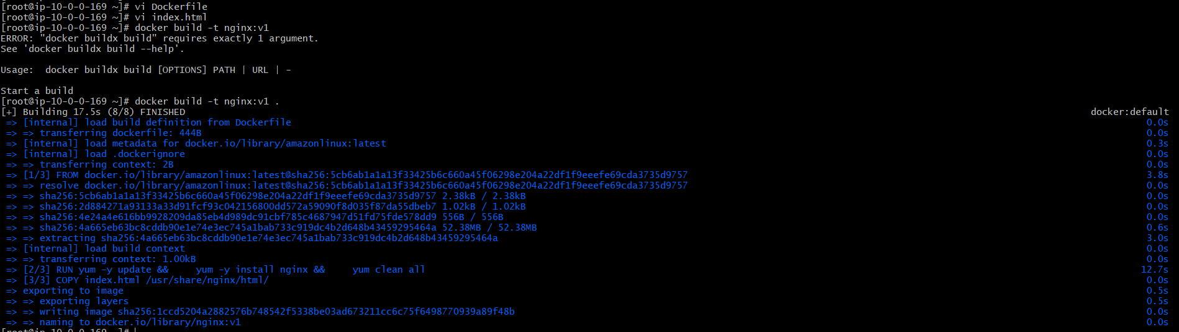

# docker ps

# docker container run -itd -p 80:80 nginx:v1



🡪check on browser with <public-ip>:80

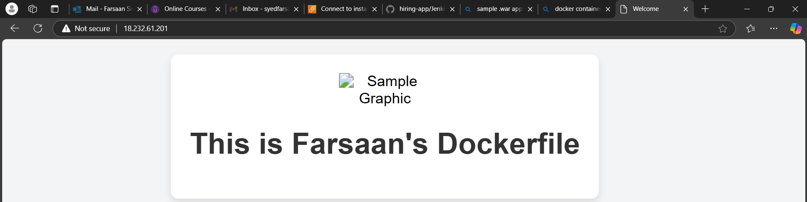

**5) Push image to dockerhub**

# docker login

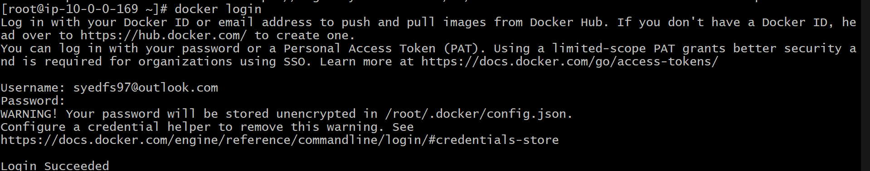

🡪create a repo in docker hub and change the tag in docker host for the image we created from dockerfile

# docker tag nginx:v1 syedfs97/nginx-repo:v1

# docker push syedfs97/nginx-repo:v1

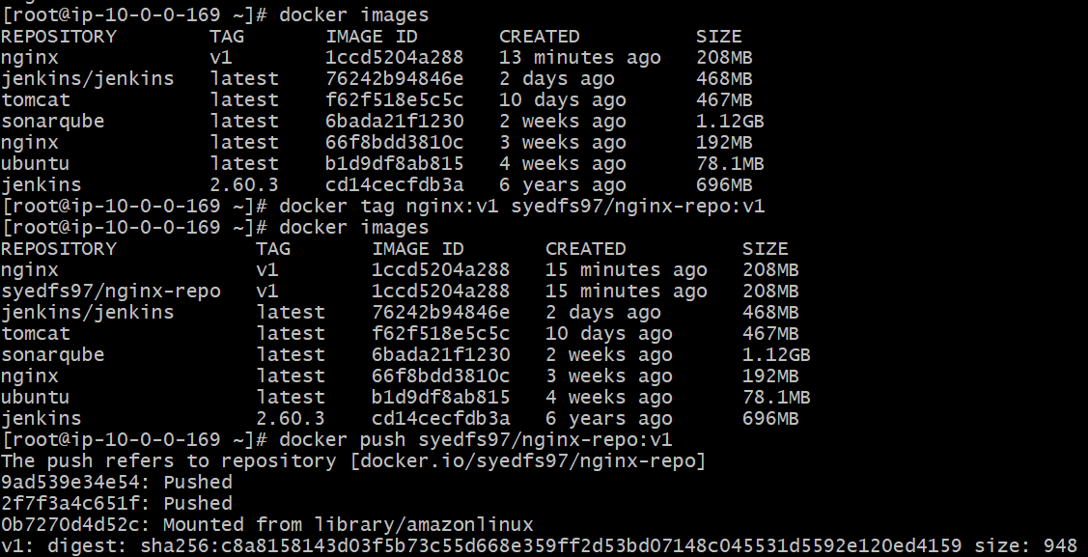

🡪 check the dockerhub

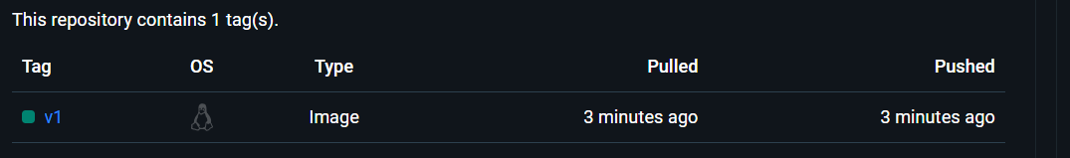

**6) push image to aws ecr**

🡪 create a repo in aws ecr and follow the instructions in view push commands

# aws configure

# aws ecr get-login-password --region us-east-1 | docker login --username AWS --password-stdin 390403872402.dkr.ecr.us-east-1.amazonaws.com

# docker tag nginx:v1 390403872402.dkr.ecr.us-east-1.amazonaws.com/nginx-repo:latest

# docker push 390403872402.dkr.ecr.us-east-1.amazonaws.com/nginx-repo:latest

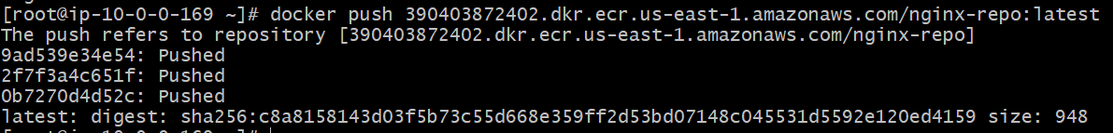

🡪checking the ecr

