International Game Design Event returns virtually to NI

20 Jan 2020 - Belfast – FOR IMMEDIATE RELEASE

Belfast based charity makerspace, [Farset Labs](https://www.farsetlabs.org.uk/), has hosted Northern Ireland’s only public site of the international “[Global Game Jam](https://globalgamejam.org/)” hackathon for the past 8 years, and this year they’re bringing it back - virtually.

Farset Labs have teamed up with the [NI Game Dev Network](https://nigame.dev/) to coordinate a Northern Ireland “site” of GGJ online due to the COVID-19 pandemic. Starting with a live-streamed kickoff event at 7pm on Friday 29th January, the jam will run from until Sunday 31st January, and is a brilliant chance to virtually meet and collaborate with people from the local games industry while making interesting games and experiences in a weekend.

There is no required skill level to take part - programmers, artists, musicians and enthusiasts are all welcome.

Global Game Jam is a worldwide weekend focused on creating games; from fully interactive video-games, to board games and card games. Some of the games are created for charitable causes, such as “Games For Change”. The global event involves a number of large industry sponsors, including PayPal, Unity, Sony Interactive, Microsoft, and it often acts as a stepping stone for new games developers.

The theme will be announced on Wednesday 27 January, and previous years have seen amateurs and professionals from all over Northern Ireland come to create thought-provoking projects, and have fun while doing it. The first Global Game Jam was run in 2009, and this year there are already over 500 individual Jam sites registered around the world for 2019. Farset Labs will be broadcasting live from Belfast throughout the event, as well as sharing feeds from Jam sites world-wide.

Participants can register now to take part in the Global Game Jam hosted by Farset Labs at <https://globalgamejam.org/2021/jam-sites/farset-labs>, and they can join the NI Game Dev Network on discord (the online platform used for the belfast GGJ site) at <https://discord.gg/vd5eRxc>.

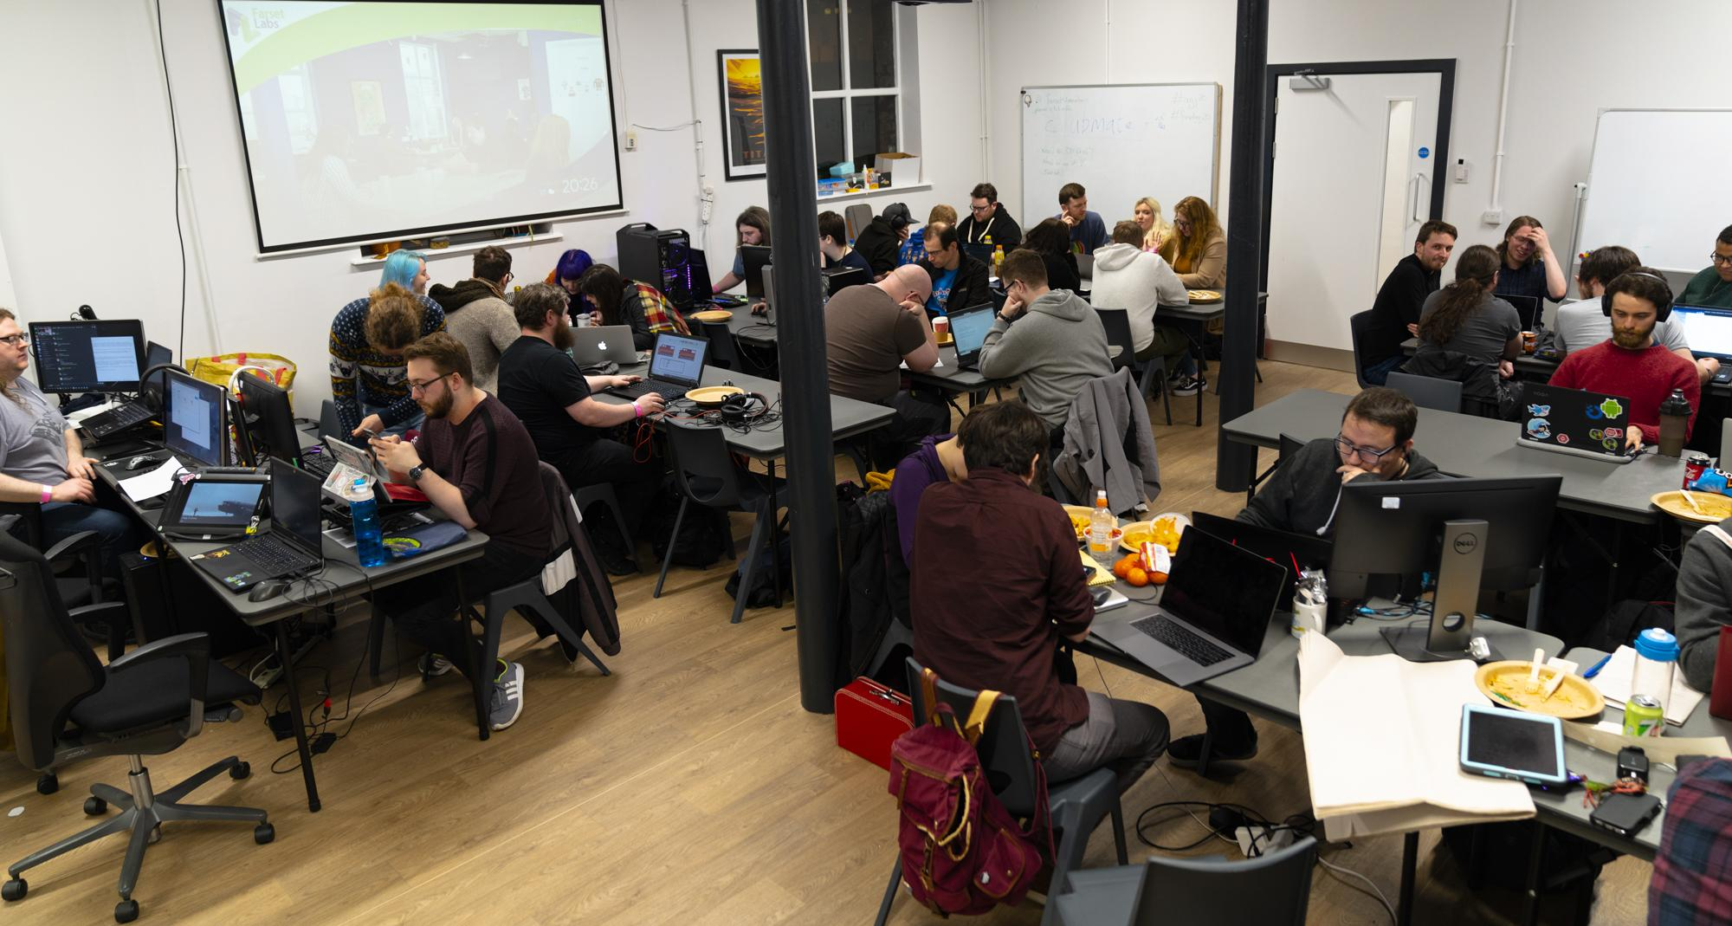

Caption: In [20](https://globalgamejam.org/2020/jam-sites/farset-labs)20, Farset Labs hosted over 50 aspiring games designers developing more than a dozen games in the 48 hour period

## 

## Notes for Editors

### Contact

For more information, contact the organisers (details below)

* **Farset Labs**: Glenn Davidson and Andrew Bolster [ [events@farsetlabs.org.uk](mailto:events@farsetlabs.org.uk) ]
* **NI Game Dev Network**: Caolan McKendry [ [events@nigame.dev](mailto:events@nigame.dev) ]

### About Global Game Jam

Global Game Jam is an annual event taking place every January, started in 2009, that brings together talented individuals from across the community. It is a unique opportunity for people to push their skills and challenge their way of working while making games. Participants work concurrently with other developers around the globe; rallying around a central theme, with 48 hours to create a game or prototype.

**More info**: [www.globalgamejam.org](http://www.globalgamejam.org)

### About Farset Labs

Farset Labs is a community funded and volunteer operated educational charity, opened in 2012 as a place for creativity and technological tinkering. It is a shared facility for creative and technological experimentation and co-working, as well as a popular event venue. The facility is open to anyone interested in tinkering and welcomes people from all walks of life to use its space, attend events, and get involved with the maker community in Northern Ireland.

**Website**: [https://www.farsetlabs.org.uk](http://www.farsetlabs.org.uk)

**Address**: Unit 1, Weavers Court, Linfield Rd, Belfast, BT12 5GH

**Contact**: [info@farsetlabs.org.uk](mailto:info@farsetlabs.org.uk)

**Connect**: <https://twitter.com/FarsetLabs> // <https://www.facebook.com/FarsetLabs>

#### Definition of “Makerspace”

“A makerspace is a community centre that provides technology, manufacturing equipment and educational opportunities to the public.”

#### Definition of “Co-working”

“Use of an office or other work-space by independent organisations or individuals, typically to share equipment, ideas, and knowledge.”

### About NI Game Dev Network

The NI Game Dev Network is the community for everyone interested in making games in Northern Ireland, from accomplished studio heads to students just getting started in the industry. We facilitate regular events and networking opportunities, and aim to help businesses here in NI collaborate for collective benefit.

**Website**: [https://nigame.dev](http://nigame.dev)

**Contact**: info@nigame.dev

**Connect**: [https://twitter.com/NIGameDev](http://twitter.com/NIGameDev)

### Media Assets

* [Farset Labs Brand Assets](https://github.com/FarsetLabs/farsetlabs.github.io/tree/main/assets/img)
* [NI Game Dev Network Brand Assets](https://drive.google.com/drive/folders/1XO50I2PFanpQjWRLzqdVV4Rh0ZxgP3O1?usp=sharing)
* [FSL x NIGDN Global Game Jam Graphic](https://drive.google.com/file/d/1mQZxkPfJbGjlkoHvAnOuZ1WeuWNqD0kP/view?usp=sharing)
* [Global Game Jam Assets](https://globalgamejam.org/media)

More photos, logos, etc. available on respective company websites and on request via events@farsetlabs.org.uk