**Passthrough:**

1. **Enable access to hardware for virtual machines from BIOS:**

* It's called IOMMU or VT-D based on the motherboard.
* On Asus modern motherboards:

BIOS -> Advanced -> System Agent Configurations -> VT-d (mark it as enabled)

1. **Enable passthrough for the hardware in ESXi client panel:**

* ESXi client -> Host: Manage -> Hardware: PCI Devices -> Enable Passthrough for hardware you want (GPUs regularly have two Audio and VGA field in this table)

1. **Assign the hardware to a VM:**

* ESXi client -> Virtual Machines -> Right click on the VM -> Edit settings -> Add another device -> PCI device -> add the passthrough enabled device to the VM (it diminishes the hardware brand name, don't worry)
* ESXi client -> Virtual Machines -> Right click on the VM -> Edit settings -> vm options -> Advanced -> Edit configurations -> Add the following three fields by clicking on "Add parameter"
* Run the machine (if it errors when you run the machine and machine won't boot up: go to Edit settings and click on "Reserve all memory" button.)

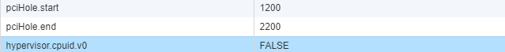

**Notice**: You cannot assign a GPU to two VMs simultaneously.

**Notice**: Ram (memory) reservation in the edit settings must be equal to memory allocated and you should modify that.