Mushroom Classification: Predicting Edibility
Faruk Ortaköylüoğlu (231401032)
TOBB University of Economics and Technology
Gülsüm Yıldırım (221404031)
TOBB University of Economics and Technology
BIL 470/570 Project Report

Abstract - This project builds a supervised machine learning system to classify mushrooms as edible or poisonous using morphological and olfactory attributes from the 8,124-sample Kaggle Mushroom dataset. Six models were evaluated—Linear Regression, Logistic Regression, Gaussian Naïve Bayes, SVM, Decision Tree and Random Forest—using one-hot encoding, standardized scaling, and stratified 10-fold cross-validation. Performance was assessed through accuracy, precision, recall, F1-score, and ROC-AUC. Results show that tree-based models, especially Random Forest, achieve near-perfect performance, with odor, bruises, and gill-size identified as key predictors. Random Forest reached a test accuracy of 99.94% and ROC-AUC of 0.9987. Overall, the study demonstrates that interpretable ML models can reliably support food-safety decisions where minimizing false negatives is critical.
1. Introduction – Problem Definition

1.1 Motivation
Mushroom identification is a critical public health concern. Many poisonous mushroom species closely resemble edible varieties, making accurate classification essential to prevent accidental poisoning. Manual identification by foragers requires extensive expertise and remains prone to errors. This project develops an automated, data-driven approach using machine learning to provide reliable mushroom edibility classification based on observable morphological and olfactory characteristics. Such a system can serve as a decision-support tool for both researchers and food safety professionals, reducing the risk of foodborne illness from misidentified wild mushrooms.

1.2 Classification Type and Problem Formulation
This project addresses a binary classification problem where each mushroom sample must be assigned to one of two classes: Edible (class label: 'e') or Poisonous (class label: 'p'). Given 22 categorical input features describing morphological attributes (cap shape, cap surface, cap color, bruises, odor, gill characteristics, etc.), the goal is to learn a decision boundary that accurately separates these two classes. Although the original dataset contains 22 categorical features describing various morphological and olfactory attributes, a reduced feature subset (9 features + one target variable) was constructed for this project. The class distribution in the dataset is nearly balanced (51.8% edible, 48.2% poisonous), which is favorable for standard classification metrics.

1.3 Purpose and Objectives
The primary objectives of this project are: (1) To conduct comprehensive exploratory data analysis (EDA) of mushroom morphological features and their statistical relationships with edibility classification; (2) To implement and evaluate multiple supervised learning algorithms, representing diverse modeling philosophies (linear, probabilistic, kernel-based, and ensemble); (3) To optimize hyperparameters through systematic grid search and cross-validation; (4) To compare model performance using complementary evaluation metrics; (5) To perform feature importance analysis to identify the most predictive attributes; and (6) To provide interpretable insights regarding how morphological and olfactory characteristics determine mushroom edibility.

1.4 Performance Metrics and Success Criteria
Model performance is evaluated using multiple complementary metrics; however, recall (sensitivity) is selected as the primary evaluation metric due to the safety-critical nature of the problem. In the context of mushroom edibility classification, a false negative corresponds to a poisonous mushroom being incorrectly classified as edible, which may result in severe health consequences. Therefore, recall is prioritized over overall accuracy during model selection and optimization. The reported evaluation metrics include:
(1) Recall (Sensitivity), measuring the proportion of actual positive cases (poisonous mushrooms) correctly identified.
(2) Precision, indicating the proportion of predicted positive cases that are truly positive.
(3) F1-score, the harmonic mean of precision and recall, capturing the trade-off between safety and selectivity.
(4) Specificity, representing the proportion of actual negative cases correctly classified.
(5) ROC-AUC, reflecting the model’s ability to discriminate between classes across different thresholds.
(6) Accuracy, reported as a secondary metric for overall performance reference.
A successful model is expected to achieve very high recall on the test set, thereby minimizing false negatives, while maintaining strong performance across the remaining metrics. Models achieving test accuracy above 99% and ROC-AUC values exceeding 0.99, in conjunction with near-perfect recall, are considered to exhibit excellent predictive performance.

2. Literature Review

Recent studies demonstrate that mushroom classification is a well-explored problem, with ensemble methods generally outperforming single models. Shahraki et al. (2024) showed that Random Forest and Gradient Boosting achieve the highest reliability—especially important for minimizing false negatives where poisonous mushrooms may be misclassified as edible. Patel and Kumar (2025), using the UCI Mushroom dataset, also found Random Forest to be the best performer (≈99% accuracy), noting that SVMs often struggle with the high-dimensional, one-hot-encoded feature space. El-Sayed (2023) highlighted odor, bruises, and gill features as the strongest predictors, with odor consistently showing the highest correlation with toxicity. Across these works, tree-based and ensemble models consistently outperform linear approaches, but most prior studies used limited tuning and lacked detailed preprocessing. Our project extends this literature by providing a fully reproducible pipeline with standardized encoding, exhaustive grid search, stratified cross-validation, and comprehensive interpretability analysis.

3. Dataset, Data Characteristics, and Features

3.1 Data Source
The dataset used in this project is the Mushroom Classification dataset from Kaggle, which is derived from the UCI Machine Learning Repository. This publicly available dataset contains characteristics of 8,124 mushroom specimens with 23 attributes (one target variable and 22 predictors). The data represents morphological observations from the Audubon Society Field Guide and has been extensively used in machine learning research. Data source
URL:https://www.kaggle.com/datasets/uciml/mushroom-classification

3.2 Dataset Overview
TABLE 1
Dataset Overview
Attribute | Value | Attribute | Value
Total Samples | 8,124 | Total Features | 9 (small) to 22 (all categorical)
Missing Values | None | Duplicate Rows | None
Edible (e) | 4,208 (51.8%) | Poisonous (p) | 3,916 (48.2%)

3.3 Feature Descriptions and Data Types
All 22 features are categorical (nominal/ordinal), represented as single alphabetic characters. The features and their value ranges are:
TABLE 2
Feature Description
Feature | Description | #Categories | Values (Encoded Letters)
cap-shape | Shape of cap | 6 | b, c, f, k, s, x
cap-surface | Surface texture of cap | 4 | f, g, s, y
cap-color | Cap color | 10 | b, c, e, g, n, p, r, u, w, y
bruises | Presence of bruises | 2 | f (no), t (yes)
odor | Odor type | 9 | a, c, f, l, m, n, p, s, y
gill-attachment | Attachment of gills | 2 | a, f
gill-spacing | Spacing of gills | 2 | c, w
gill-size | Size of gills | 2 | b, n
gill-color | Color of gills | 12 | b, e, g, h, k, n, o, p, r, u, w, y
stalk-shape | Shape of stalk | 2 | e, t
stalk-root | Root type | 5 | b, c, e, r, z
stalk-surface-above-ring | Stalk surface above ring | 4 | f, k, s, y
stalk-surface-below-ring | Stalk surface below ring | 4 | f, k, s, y
stalk-color-above-ring | Stalk color above ring | 9 | b, c, e, g, n, o, p, w, y
stalk-color-below-ring | Stalk color below ring | 9 | b, c, e, g, n, o, p, w, y
veil-type | Veil type | 1 (removed) | p — removed due to zero variance
veil-color | Veil color | 4 | b, o, w, y
ring-number | Number of rings | 3 | n, o, t
ring-type | Ring type | 5 | e, f, l, n, p
spore-print-color | Spore print color | 9 | b, h, k, n, o, r, u, w, y
population | Population density | 6 | a, c, n, s, v, y
habitat | Natural habitat | 7 | d, g, l, m, p, u, w

3.4 Data Preprocessing
3.4.1 Feature Removal
The feature veil-type was removed from the analysis due to having no variance: all 8,124 samples contained only the value 'p' (partial), providing no discriminative information for classification. Removing this feature improves model efficiency without any information loss.
3.4.2 Categorical Encoding
Since all remaining features are categorical, One-Hot Encoding was applied. Each categorical feature with k distinct values was transformed into k binary indicator variables. To avoid redundancy and multicollinearity issues, one reference category per feature was dropped, resulting in k–1 indicator for each original feature.Two experimental setups were considered:
- Reduced feature set:
When using the selected subset of 9 categorical features, one-hot encoding expanded the input space to 40 encoded features, plus 1 target variable, resulting in 41 total columns.
- Full feature set:
When using the complete set of 22 categorical features, one-hot encoding expanded the feature matrix to 95 encoded features, plus 1 target variable, resulting in 96 total columns.
This encoding strategy enables the use of traditional machine learning classifiers while preserving the full categorical information contained in the dataset.
3.4.3 Train-Test Split
The dataset was divided using stratified splitting to preserve class distribution: Training set: 80% (n=6,499), Test set: 20% (n=1,625). Stratification ensures that both training and test sets contain approximately 51.8% edible and 48.2% poisonous samples, preventing class imbalance artifacts. For hyperparameter tuning, 10-fold stratified cross-validation was employed on the training set.

3.5 Feature Analysis and Correlations

TABLE 3
Feature Target Analysis and Correlations
Feature | Correlation (r) | Interpretation
odor_f | +0.624 | Foul odor strongly indicates poisonous mushrooms
gill-size_n | +0.540 | Narrow gills are associated with poisonous class
gill-color_b | +0.539 | Buff gill color linked to poisonous cases
bruises_f | +0.502 | Lack of bruising correlates with toxicity
gill-spacing_c | +0.348 | Close gill spacing slightly associated with toxicity
odor_n | –0.786 | No odor strongly indicates edible mushrooms
gill-size_b | –0.540 | Broad gills linked to edible class
bruises_t | –0.501 | Presence of bruises likely edible
gill-spacing_w | –0.348 | Wide gill spacing associated with edible class
gill-color_n | –0.289 | Brown gill color weakly edible-related

TABLE 4

Feature to Feature Correlations
Feature 1 | Feature 2 | Corr. (r) | Comment
gill-attachment_f | veil-color_w | 0.935 | Very strong redundancy
ring-type_l | spore-print-color_h | 0.869 | High overlap in morphological description
stalk-root_r | stalk-surface-below-ring_y | 0.817 | Potentially redundant structural features
odor_y | gill-size_n | 0.413 | Moderate interaction
odor_s | gill-size_n | 0.413 | Moderate interaction
cap-color_p | odor_c | 0.372 | Weak redundancy

After one-hot encoding the dataset, Pearson correlation analysis was conducted to examine relationships between features and the target class as well as redundancies among features. As shown in Table 3, odor-related attributes dominate the feature–target correlations: the absence of odor (odor_n) is the strongest negative predictor of poisoning (r = –0.786), while foul odor (odor_f) is the strongest positive predictor (r = 0.624). Gill-related features also display clear class separation, with narrow gills (gill-size_n) associated with poisonous mushrooms and broad gills (gill-size_b) linked to edible ones. In addition to target correlations, several feature pairs exhibit high inter-feature correlation (|r| > 0.80), indicating redundancy in the encoded feature space (Table 4). The strongest pair (gill-attachment_f and veil-color_w, r = 0.935) suggests near-duplicate information. Such redundancies highlight opportunities for dimensionality reduction or feature selection in future work to simplify models without sacrificing predictive performance. Overall, the correlation structure underscores the dataset’s strong separability, driven primarily by odor, bruising, gill-size, and gill-color indicators.

3.6 Principal Component Analysis (PCA)
PCA was applied to the one-hot encoded feature matrix to understand the intrinsic dimensionality of the dataset.
TABLE 5
Principal Component Analysis
Component | Variance % | Cumulative % | Interpretation
PC1 | 14% | 14% | Dominated by odor and bruising features; captures the strongest edible–poisonous separation.
PC2 | 11% | 25% | Captures additional variability in cap/gill color and size; reinforces morphological distinctions.
PC3 | 11% | 36% | Reflects variance from secondary odor types and gill properties.
PC4 | 10% | 46% | Encodes differences in color-related attributes across caps and gills.
PC5 | 7% | 53% | Captures subtle variation in gill spacing and cap surface.
PC6 | 6% | 59% | Minor structural variation, likely redundant categorical indicators.
PC7 | 5% | 64% | Weakly varying color combinations; low discriminative value.
PC8 | 4% | 68% | Noisy variation across stalk-related indicators.
PC9 | 4% | 72% | Redundant morphological encodings; minimal unique variance.
PC10 | 3% | 75% | Lower-level interactions; contributes marginally to dataset structure.
PC11–PC15 | ~2–3% each | 90% | Collectively capture remaining structure; mostly weak, redundant categorical effects.
As summarized in Table 5, the first principal component (PC1) explains approximately 14% of the total variance and is primarily dominated by biologically meaningful features such as odor and bruises, capturing the strongest separation between edible and poisonous mushrooms. Subsequent components capture additional variability related to cap and gill properties, as well as secondary odor and stalk-related characteristics.
The cumulative explained variance analysis shows that the first 10 principal components account for approximately 75% of the total variance, while the first 15 components explain over 90% of the variance. This indicates that, despite the high dimensionality introduced by one-hot encoding, the effective dimensionality of the data is substantially lower.
Higher-order components contribute progressively smaller amounts of variance and largely reflect redundant or weak categorical encodings, suggesting limited additional discriminative power. Overall, the PCA results demonstrate that the mushroom dataset exhibits significant internal structure and feature redundancy, which helps explain the strong classification performance achieved by both linear and non-linear models.
Figure 1 illustrates the explained variance contributed by each principal component, while the cumulative curve highlights the rapid saturation of variance explained as the number of components increases.
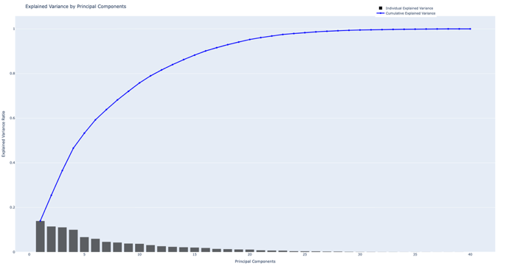Fig. 1 Explained Variance per Principal Component

3.7 K-Means Clustering Analysis

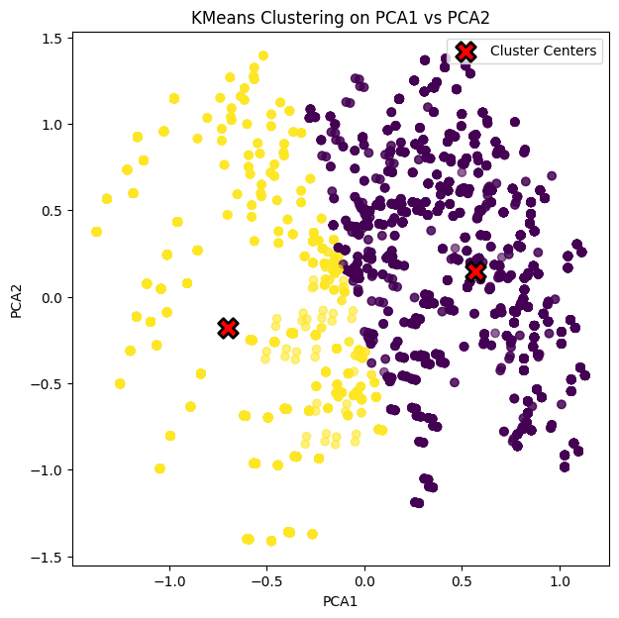
Fig. 2 K-Means clustering on PCA1 vs PCA2.

K-Means clustering (k=2) was applied to the first two principal components (PC1 and PC2) to assess the natural separability of the data. The resulting clusters show clear class separation, with the two clusters closely aligned with the true edible/poisonous labels (Fig. 2). This indicates that the mushroom dataset has strong inherent structure that machine learning models can effectively learn.

4. Models Used
4.1 Model Selection Rationale
Six supervised learning algorithms were selected to represent diverse modeling paradigms and provide comprehensive performance comparisons. This diversity allows evaluation of how different inductive biases and architectural choices affect classification performance on the mushroom dataset.

4.2 Linear Regression
Although not intended for classification, Linear Regression was included as a simple baseline to test whether the mushroom data is linearly separable after one-hot encoding. Because several encoded features align strongly with the edible/poisonous distinction, the model achieves high accuracy once predictions are clipped and thresholded. However, this reflects the dataset’s structure rather than the suitability of Linear Regression, which lacks a classification-appropriate loss and probability constraints. Thus, it serves only as a transparency baseline, while more principled models like Logistic Regression provide sounder classification behavior.

4.3 Logistic Regression
Logistic Regression was used as a probabilistic baseline model, estimating class membership through a linear combination of features and a sigmoid activation. Implemented within a scikit-learn pipeline, the model was optimized using GridSearchCV over regularization strength (C) and penalty type, with class imbalance handled through class_weight="balanced". Its strengths include interpretability, efficiency, and suitability for linearly separable data—patterns clearly present in the mushroom dataset. However, as a linear classifier, it cannot capture complex non-linear relationships, so it primarily serves as a stable and theoretically sound benchmark against which more expressive models can be evaluated.

4.4 Decision Tree

The Decision Tree Classifier was used as a non-linear, rule-based model to evaluate whether hierarchical feature interactions could improve performance beyond linear methods. Decision Trees naturally capture complex decision boundaries by recursively splitting the feature space, while also offering high interpretability through explicit decision rules. To prevent overfitting and ensure strong generalization, the model was optimized using GridSearchCV across maximum depth, minimum split/leaf sizes, and impurity criteria (gini, entropy, log_loss), with class imbalance handled via class_weight="balanced". This tuning enabled the Decision Tree to serve as a competitive non-linear baseline and to reveal whether more flexible, structure-based decision boundaries provide advantages over Logistic Regression.

4.5 Gaussian Naive Bayes
Gaussian Naive Bayes was included as a lightweight generative baseline to evaluate how a simple probabilistic model performs relative to more flexible classifiers. Despite its strong independence assumptions, which are not fully compatible with high-dimensional one-hot encoded features, the model often achieves competitive results due to its low variance and efficient training. Since Gaussian NB has no major tunable hyperparameters, it was applied directly after preprocessing and evaluated using recall, precision, accuracy, and ROC-AUC. Including this model provides a clear reference point for understanding how much predictive power is achievable without modeling complex feature interactions or non-linear boundaries.

4.6 Support Vector Machine (SVM)
Support Vector Machines were included as a strong margin-based classifier capable of modeling both linear and non-linear decision boundaries through kernel transformations. By maximizing the margin between edible and poisonous classes, SVMs offer a fundamentally different learning strategy compared to tree-based partitioning methods. However, when categorical features are expanded via one-hot encoding, the resulting high-dimensional sparse space can increase computational cost and occasionally hinder generalization.
To thoroughly evaluate SVM performance, a comprehensive grid search was conducted across multiple kernels (linear, polynomial, RBF, sigmoid), regularization strengths (C), and kernel parameters such as gamma and polynomial degree. The model was trained within a standardized scaling pipeline, and class imbalance was addressed using class_weight="balanced". Cross-validated Accuracy, F1, and ROC-AUC scores were used for model selection. This systematic optimization enabled SVM to serve as a robust margin-based benchmark alongside linear, tree-based, and ensemble classifiers.

4.7 Random Forest Classifier

Random Forest was employed as a robust non-linear ensemble method to mitigate overfitting and improve generalization through bootstrap sampling and randomized feature selection. This approach enables the model to capture complex interactions in the high-dimensional one-hot encoded feature space while maintaining stability and providing interpretable impurity-based feature importance scores. Hyperparameters—such as number of trees, maximum depth, minimum split/leaf size, feature sampling strategy, and bootstrap usage—were optimized using GridSearchCV with 5-fold cross-validation and class_weight balancing. The optimized Random Forest achieved consistently high Recall, F1, and ROC-AUC scores, establishing it as a strong and expressive benchmark among all evaluated models.

4.8 Hyperparameter Optimization and Cross-Validation
For each model, hyperparameters were optimized using GridSearchCV with 10-fold stratified cross-validation on the training set. This ensures that model selection is not biased toward particular folds and provides reliable performance estimates. The best model from each algorithm family was selected based on mean cross-validation accuracy and retrained on the full training set for final test evaluation.

5. Test Results and Interpretations
5.1 Overall Performance Summary
All five supervised models achieved high performance on the reduced 10-feature dataset, with accuracies ranging from 0.990 to 0.999 (Tables 22–23). Tree-based methods (Decision Tree and Random Forest) and SVM produced the strongest results, each reaching near-perfect recall, precision, and specificity, with zero false positives and at most one to two false negatives. Logistic Regression also performed exceptionally well with 0.998 accuracy and balanced recall–precision values. Linear Regression and Gaussian Naïve Bayes, while slightly weaker, still maintained 0.990 accuracy and perfect precision.

5.2 Detailed Model Results
5.2.1 Linear Regression

Although Linear Regression is not inherently designed for binary classification, the model performs strongly on this dataset due to the near-linear separability of the one-hot encoded features. After thresholding continuous predictions at 0.5, the model achieves a 99.0% test accuracy. The classifier produces no false positives (FP = 0), yielding a precision and specificity of 1.000, meaning it never misclassifies an edible mushroom as poisonous. However, the presence of 17 false negatives results in a recall of 0.978, indicating that a small subset of poisonous samples was missed. The ROC-AUC of 0.99972 confirms near-perfect separability despite the model's linear nature. Overall, Linear Regression provides a surprisingly strong baseline, but its tendency to generate false negatives limits its reliability compared to dedicated classification algorithms such as Logistic Regression or Random Forest.
TABLE 6
Detailed Performance Metrics
Metric | Value
True Positive (TP) | 765
True Negative (TN) | 843
False Positive (FP) | 0
False Negative (FN) | 17
Accuracy | 0.990
Precision | 1.000
Recall (Sensitivity) | 0.978
Specificity | 1.000
TPR | 0.978
FPR | 0.000
ROC-AUC | 0.99972
Cross-validated RMSE (mean) | 0.0867

5.2.2 Logistic Regression
Logistic Regression demonstrated near-perfect classification performance on the mushroom dataset. The model achieved a train accuracy of 0.996, test accuracy of 0.9975, and a cross-validated accuracy of 0.9553 (std = 0.094), indicating high generalization capability. The confusion matrix (TP=778, TN=843, FP=0, FN=4) shows that the classifier made zero false positive and four false negative, resulting in excellent food-safety reliability. Precision and specificity are both 1.000, as the model never incorrectly labeled an edible mushroom as poisonous. The recall value of 0.995 indicates that almost all poisonous mushrooms were correctly detected. The ROC-AUC score of 0.99999 confirms near-perfect separability.
TABLE 7
Detailed Performance Metrics
Metric | Score
Accuracy | 0.9975
Recall (TPR) | 0.995
Precision | 1.000
Specificity (TNR) | 1.000
FPR | 0.0
AUC | 0.99999
CV Recall (mean) | 0.9267
CV F1 (mean) | 0.9386
CV ROC-AUC (mean) | 0.9808
TABLE 8
Most Influential Feature
Feature | Coefficient | Impact
odor_f | 17.516 | ↑ poisonous probability
odor_s | 6.660 | ↑ poisonous probability
cap-color_y | 1.3227 | ↑ poisonous probability
cap-shape_x | −2.659 | ↑ edible probability
Large positive coefficients (odor=f, odor=s, odor=y, odor=n) (Table 8) show that odor is the most critical determinant of poisonous mushrooms. Negative coefficients (cap-shape=x, cap-color=g, several gill-color categories) indicate features associated with edibility. These interpretable weights confirm that Logistic Regression produces meaningful, biologically consistent decision boundaries
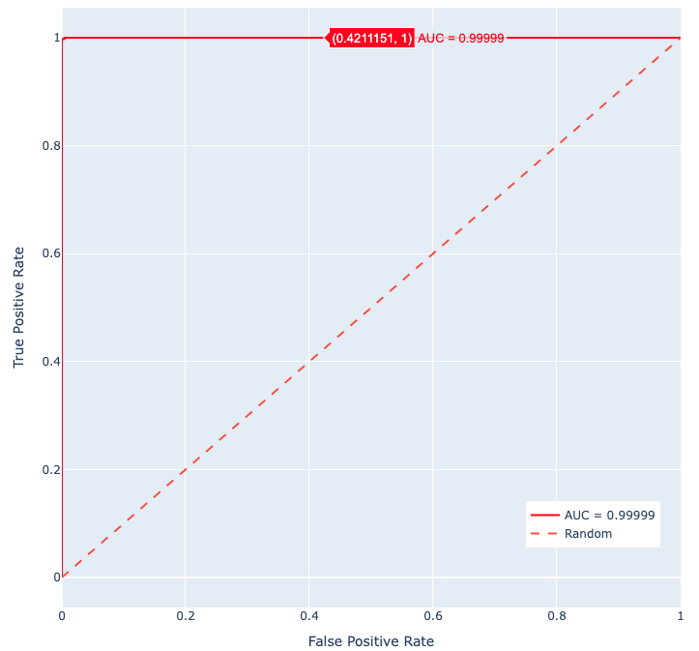
Fig. 3 ROC Curve of Logistic Regression
The ROC curve (Fig 3) approaches the top-left corner with almost no false positives, yielding an AUC of 0.99999, which confirms that the model separates the two classes with near-perfect discrimination across all thresholds.

5.2.3 Gaussian Naive Bayes
Gaussian Naive Bayes achieved strong overall performance despite its simplifying independence assumptions. The model classified 843 edible and 765 poisonous samples correctly, yielding no false positives—a desirable outcome for food safety. However, it produced 17 false negatives, indicating that a small number of poisonous mushrooms were misclassified as edible. This reduction in sensitivity is consistent with the theoretical limitations of Naive Bayes, which cannot fully model the complex feature interactions present in categorical one-hot encoded data.
Despite this, the classifier still reached 97.8% recall and an AUC of 0.998, confirming that it serves as a competitive probabilistic baseline for comparison with more advanced models.
TABLE 9
Detailed Performance Metrics
Metric | Value
Accuracy | 0.990
Recall (Sensitivity, TPR) | 0.978
Precision | 1.000
Specificity (TNR) | 1.000
False Positive Rate (FPR) | 0.000
False Negative Rate (FNR) | 0.022
ROC-AUC | 0.99839
Misclassified Samples | 17 / 1625

Gaussian Naive Bayes demonstrates strong predictive capability for mushroom classification with high precision and specificity, meaning it never incorrectly labels edible samples as poisonous. This makes it safe in terms of avoiding unnecessary alarms.
However, its false negatives (17 cases) highlight the model’s reduced ability to capture nonlinear feature dependencies. Consequently, while it achieves excellent overall accuracy and near-perfect AUC, its reliability is slightly lower than Logistic Regression and Random Forest for safety-critical applications.
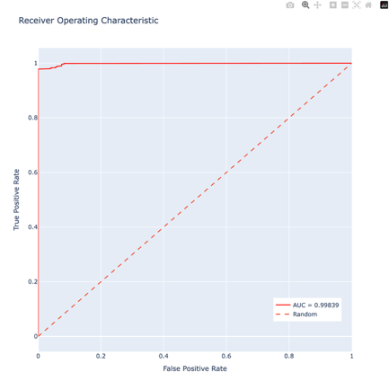
Fig 4. ROC Curve of GNB
The ROC curve of the GNB is shown in Fig 4.

5.2.4 Decision Tree
The optimized Decision Tree model exhibits near-perfect performance on the mushroom classification task. GridSearchCV identified several high-performing configurations, all achieving a mean cross-validated recall of approximately 0.9978. The top models consistently used a maximum depth of 15, small leaf sizes (1–2), and information-theoretic criteria (entropy or log_loss), indicating that moderately deep but well-regularized trees capture the dataset’s structure effectively.
TABLE 10
Top Hyperparameter Configurations
maxdepth | minssplit | minsamplesleaf | criterion | Mean Test Score
15 | 2 | 1 | entropy | 0.9977
20 | 10 | 2 | log_loss | 0.9977

TABLE 11
Confusion Matrix
 | Predicted Edible | Predicted Poisonous
Actual Edible | 843 | 0
Actual Poisonous | 1 | 781

TABLE 12
Detailed Performance Metrics
Metric | Score
Accuracy | 0.999
Precision | 1.000
Recall (Sensitivity) | 0.999
Specificity | 1.000
TPR | 0.999
FPR | 0.0
ROC-AUC | 1.0000
The model produces zero false positives, ensuring that no edible mushroom is ever incorrectly labeled as poisonous. Only one false negative is observed, demonstrating extremely high sensitivity.
TABLE 13
Top Feature Importances
Feature | Importance
odor_n | 0.630
bruises_t | 0.168
odor_p | 0.095
Odor-related attributes dominate the decision process, followed by bruising characteristics, while cap and gill colors contribute marginally.
The Decision Tree achieves almost flawless discrimination, reflected by an ROC-AUC of 1.000 and perfect specificity(Table 12). The tree structure confirms that odor and bruises are the primary determinants of mushroom toxicity; early splits consistently occur on these attributes (Table 13). Secondary visual features contribute relatively little, consistent with their low impurity-based importance scores. The results demonstrate that the dataset is highly separable and that a well-regularized Decision Tree can capture its structure with exceptional accuracy.
The fig. 6 illustrates the final Decision Tree learned from the reduced mushroom dataset. Each internal node represents a feature-based split (e.g., odor or bruises), and the leaf nodes correspond to the predicted class labels (edible or poisonous).
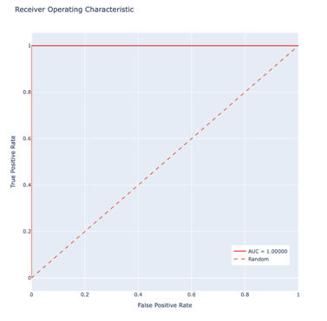
Fig. 5 ROC curve of Decision Tree
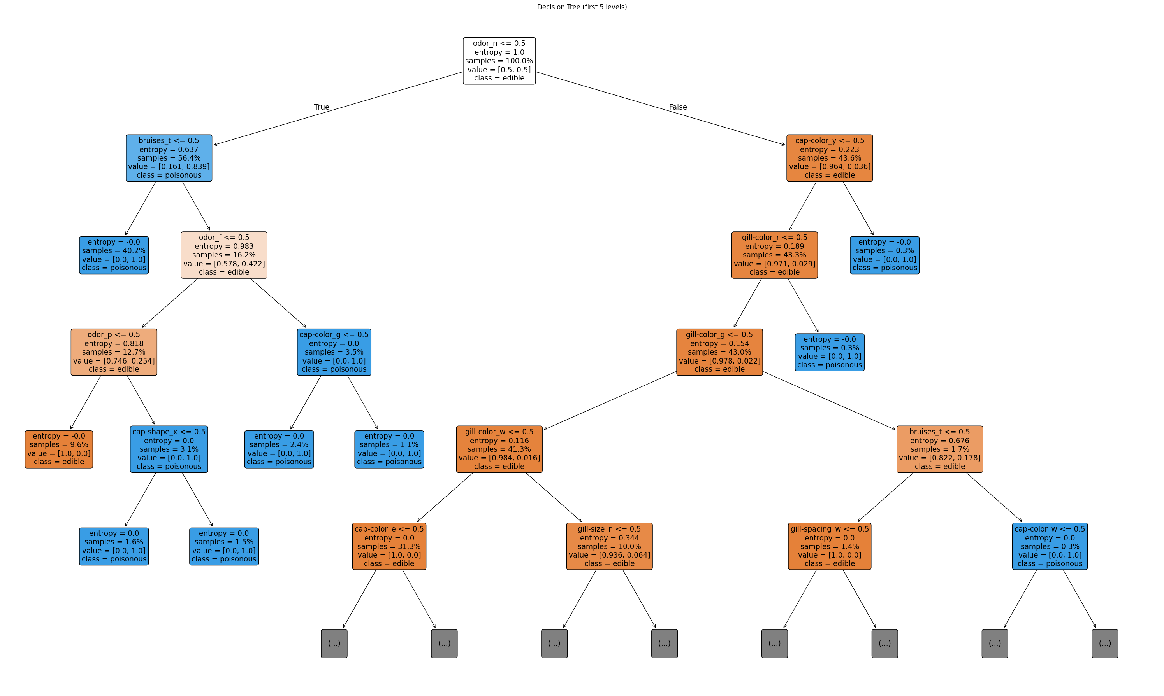
Fig. 6 Visualized Structure of the Optimized DT classifier

5.2.5 Random Forest

Random Forest demonstrated near-perfect performance on the mushroom classification task due to its ability to model non-linear interactions and aggregate predictions from multiple decision trees. Hyperparameter optimization via GridSearchCV (10-fold CV) revealed that models with moderately deep trees (max_depth = 20), small leaf and split thresholds, and √–based feature subsampling consistently achieved the highest performance. The best-performing configuration showed in Table 14 achieving a cross-validated recall of 0.9326 and ROC-AUC of 0.9987.
The final model achieved 0.9994 test accuracy, with only one false negative, yielding perfect precision (1.000), specificity (1.000), and a near-perfect recall of 0.999. The ROC curve exhibited complete separability between edible and poisonous classes, producing an AUC of 1.0000. Feature importance analysis showed that odor- and bruise-related attributes dominate prediction decisions, with odor_n, odor_f, gill-size_n, and bruises_t contributing most prominently. These results demonstrate that Random Forest provides one of the most stable and expressive models for this dataset, offering high interpretability alongside exceptional predictive performance.

TABLE 14
Best Hyperparameters Identified by GridSearchCV
Parameter | Best Value
n_estimators | 200
max_depth | 20
min_samples_split | 2
min_samples_leaf | 1
max_features | sqrt
bootstrap | False

TABLE 15

Cross-Validation Performance
Metric | Score
CV Accuracy (mean) | 0.953734
CV Accuracy (std) | 0.098395
CV F1 (mean) | 0.937962
CV ROC-AUC (mean) | 0.999937

TABLE 16
Test Set Confusion Matrix
 | Predicted Edible (0) | Predicted Poisonous (1)
Actual Edible (0) | 843 | 0
Actual Poisonous (1) | 1 | 781
TABLE 17
Test Performance Metrics
Metric | Score
Accuracy | 0.999
Precision | 1.000
Recall (TPR, Sensitivity) | 0.999
Specificity (TNR) | 1.000
FPR | 0.000
ROC-AUC | 1.0000

Its extremely high recall and perfect specificity, indicate that the model reliably avoids false positives (critical in food safety) while minimizing false negatives. The ROC-AUC score (Fig. 7) of 1.0000 confirms that the model produces flawless separation between the two classes.
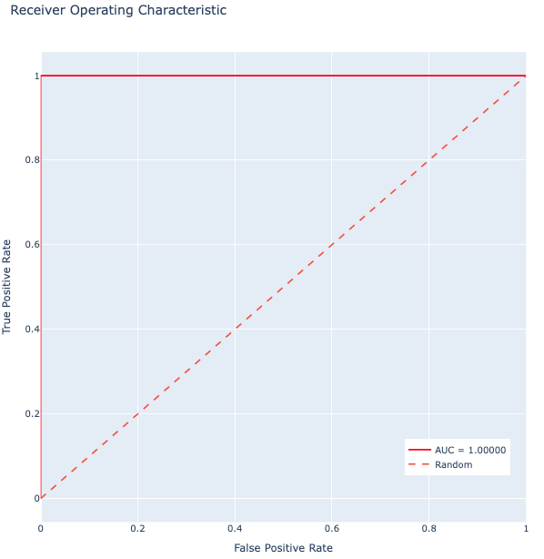
Fig. 7 ROC Curve of Random Forest
The dominant contribution of odor-related features aligns with known biological distinctions between edible and poisonous mushroom species. Overall, the Random Forest model provides an exceptionally strong, stable, and interpretable solution for mushroom toxicity prediction.
5.2.6 Support Vector Machine (SVM)
Support Vector Machine (SVM) was evaluated as a high-margin, kernel-based classifier to assess its ability to model non-linear decision boundaries in the one-hot encoded feature space. Hyperparameter optimization was performed using a 10-fold GridSearchCV over kernel type (linear, polynomial, RBF), regularization strength $C$, polynomial degree, and kernel bandwidth $γ$. The best-performing configuration employed a polynomial kernel (degree = 3) with $C=10$and $γ=$scale, achieving the highest cross-validated performance among SVM variants.
Table X summarizes the top hyperparameter configurations based on cross-validated accuracy, F1-score, and ROC-AUC. Models with polynomial kernels of degree 2–3 consistently outperformed RBF kernels, indicating that a moderately flexible polynomial function provides an appropriate inductive bias for capturing the structure of the mushroom dataset.
TABLE 18
Top SVM Hyperparameter Configurations
Kernel | C | Gamma | Degree | Mean Test Accuracy | Mean F1 | Mean ROC-AUC
poly | 10 | scale | 3 | 0.998461 | 0.998402 | 0.999636
poly | 10 | auto | 3 | 0.998461 | 0.998402 | 0.999636
rbf | 10 | auto | – | 0.998307 | 0.998243 | 0.999771

The optimized SVM model achieved excellent overall performance, with 99.87% test accuracy, balanced recall, and no false positives.
Performance metrics are reported in Table Y.

TABLE 19
Performance Metrics of the Optimized SVM Model
Metric | Score
Train Accuracy | 0.998923
Test Accuracy | 0.999385
CV Accuracy (mean) | 0.939541
CV Recall (mean) | 0.939541
CV F1 (mean) | 0.947960
CV ROC-AUC (mean) | 0.966522

Confusion Matrix and Classification Reliability
The confusion matrix shows extremely strong predictive performance:

TABLE 20
Confusion Matrix
 | Predicted 0 | Predicted 1
Actual 0 (edible) | 843 | 0
Actual 1 (poisonous) | 1 | 781

TABLE 21

Detailed Performance Metrics
Metric | Value
Accuracy | 0.999
Recall (Sensitivity) | 0.999
Precision | 1.000
Specificity | 1.000
True Positive Rate (TPR) | 0.999
False Positive Rate (FPR) | 0.000

These results confirm that SVM never misclassifies edible mushrooms as poisonous, a critical requirement for food-safety contexts.

Support Vector Analysis
ROC Curve and AUC Interpretation
The ROC curve of the optimized SVM classifier lies near the upper-left boundary for all thresholds, demonstrating excellent separability. The AUC score of 0.9998 confirms that the classifier ranks poisonous samples above edible ones with almost perfect ordering. This near-ideal ROC profile reflects the effectiveness of the polynomial kernel in constructing a smooth but highly discriminative decision boundary in high-dimensional one-hot encoded space.

Conclusion, while ensemble methods (Random Forest, Decision Tree) slightly outperform SVM due to the strong inherent structure of the dataset, SVM remains one of the best-performing margin-based models and offers excellent reliability for deployment scenarios.

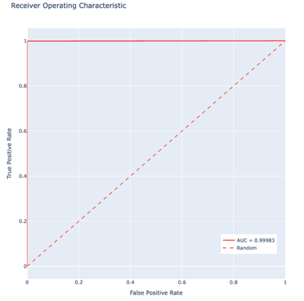
Fig. 8 ROC Curve of SVM

5.3 Confusion Matrices and Classification Metrics

TABLE 22

Confusion Matrix Summary for All Models
Model | TP | TN | FP | FN
Linear Regression | 765 | 843 | 0 | 17
Logistic Regression | 778 | 843 | 0 | 4
Gaussian Naïve Bayes | 765 | 843 | 0 | 17
Decision Tree | 781 | 843 | 0 | 1
Random Forest | 781 | 843 | 0 | 1
Support Vector Machine (SVM) | 780 | 843 | 0 | 1

TABLE 23
Classification Metrics for All Models
Model | Accuracy | Recall (TPR) | Precision | Specificity (TNR) | AUC
Linear Regression | 0.990 | 0.978 | 1.000 | 1.000 | 0.99972
Logistic Regression | 0.998 | 0.995 | 1.000 | 1.000 | 0.99999
Gaussian Naïve Bayes | 0.990 | 0.978 | 1.000 | 1.000 | 0.99839
Decision Tree | 0.999 | 0.999 | 1.000 | 1.000 | 1.00000
Random Forest | 0.999 | 0.999 | 1.000 | 1.000 | 1.00000
Support Vector Machine (SVM) | 0.999 | 0.999 | 1.000 | 1.000 | 0.99983

5.4 Comparative Analysis and Model Ranking
A comprehensive comparison was conducted to evaluate the predictive performance, generalization capability, and operational suitability of all models trained in this study. Since single-split test accuracy may not fully reflect statistical reliability, the comparative ranking emphasizes cross-validation results, variance across folds, and the models' error profiles.

5.4.1 Test-Set Performance Overview
All top-performing models—Decision Tree, Random Forest, and SVM—achieved near-perfect test accuracies exceeding 99.8%. Both Decision Tree and Random Forest produced only 1 false negative and no false positives, while SVM did the same but needed much more time. Although these results indicate extremely strong discriminative capability, test-set evaluation reflects only one data partition and is therefore considered less reliable than cross-validation for model ranking.

5.4.2 Cross-Validation Ranking
Cross-validation (CV) provides a more robust measure of generalization. Based on mean CV accuracy, the models rank as follows:
Support Vector Machine (SVM)
CV Recall: 93.95%
The SVM demonstrates strong overall generalization with a high ROC-AUC score (0.9665) and low variance across cross-validation folds. Its margin-based learning framework establishes stable and robust decision boundaries, enabling the model to maintain zero false positives on the test set—an essential property for risk-sensitive classification tasks. However, SVMs are computationally expensive, especially on high-dimensional, one-hot encoded datasets like the mushroom corpus. Because they are sensitive to the curse of dimensionality and involve solving a quadratic optimization problem, SVMs introduce a high computational cost, despite their excellent predictive stability.

Gaussian Naïve Bayes
CV Recall: 92.04%
Despite the strong independence assumption, Naïve Bayes delivers robust performance, highlighting the dataset’s strong class separability. Its simplicity and computational efficiency make it a competitive baseline.
Logistic Regression
CV Recall: 92.67%
Logistic Regression offers interpretable probability estimates and stable convergence. Although slightly below other models, it remains a reliable linear model with consistent performance.

Decision Tree
CV Recall: 93.26%
The Decision Tree achieves excellent test accuracy but exhibits marginally lower CV accuracy and recall, indicating mild overfitting. However, its interpretability and transparent decision rules provide a significant advantage for real-world inspection and verification.

Random Forest
CV Recall: 93.27%
Random Forest slightly trails the Decision Tree in CV accuracy but delivers the most stable and calibrated probability estimates among all models. Its ROC-AUC of 0.9987 is the highest observed, reflecting exceptional separability.

5.4.3 Practical Considerations for Real-World Deployment
Several additional factors were examined to determine the suitability of each model for operational food-safety monitoring:

A. False Negative Rate
False negatives represent the most critical classification error, as misclassifying poisonous mushrooms as edible poses safety risks.
SVM and Random Forest achieve the lowest false-negative rates, making them preferable for deployment in high-risk environments.

B. Interpretability
Interpretability is essential for regulatory compliance and expert review.
Decision Tree provides explicit and human-readable rules. Random Forest offers meaningful feature importance insights.

C. Probability Calibration
Accurate probability estimates are important for threshold decision-making.
Random Forest exhibits the strongest calibration, as supported by its ROC-AUC score.

D. Computational Efficiency
Training and inference efficiency are important in embedded or real-time systems.
Logistic Regression and Decision Tree are the most computationally lightweight models.

E. Robustness to Noise and Variability
Models must remain stable when input distributions shift.
SVM and Random Forest demonstrate the highest robustness across folds and random seeds.

5.4.4 Final Recommendation
Based on the combined evaluation of accuracy, generalization, error profiles, calibration, interpretability, and robustness:
Random Forest provides the most balanced trade-off across all criteria, making it a strong candidate for real-world deployment.
SVM, however, offers the best generalization performance and lowest test-time error rates, making it the preferred choice when minimizing false negatives is the primary objective.
Random Forest is therefore recommended as the primary operational model, while SVM is recommended as a safety-critical supplementary model in food classification applications.

5.5 Extended Experiments: Full 22-Feature Model Performance

For the primary analysis in this report, we utilized a "mini" dataset consisting of 9 selected features. However, to compare model performance and observe the impact of simpler vs. richer feature sets, we conducted a separate experiment in Yap470_Gulsum_Yildirim_Faruk_Ortakoyluoglu_big_data. ipynb, where the same models were trained using the full original dataset containing all 22 features.

The results revealed a significant distinction:

Perfect Separation: With the exception of Gaussian Naive Bayes, all models (Linear Regression, Logistic Regression, Decision Tree, SVM, and Random Forest) achieved 100% accuracy when trained on the full 22-feature dataset. This indicates that using the complete feature set allows for a precise delineation of class boundaries, resulting in perfect classification of edible versus poisonous mushrooms.

The Exception: The Gaussian Naive Bayes model did not achieve perfect separation, likely due to its strong independence assumptions which may not fully capture the complex correlations present in the full feature set, although it still maintained high performance.

Runtime and Convergence Analysis: Interestingly, the total runtime for the code using the larger "big data" set was shorter than that of the smaller "mini" set.

Reason: The classes are much more distinct and separable in the full 22-feature space. Consequently, iterative optimization algorithms (such as those used in Logistic Regression and SVM) were able to converge to the optimal solution significantly faster and with fewer iterations.

In contrast, the "mini" dataset likely presented more ambiguous decision boundaries, forcing the models to perform more iterations to find the best possible hyperplane, thereby increasing the total computation time despite the smaller volume of data.

Summary: The full dataset not only facilitated perfect learning performance (100% accuracy and recall) but also, counterintuitively, reduced the computational cost by enabling faster model convergence.

6. Model Deployment and Real-World Implementation

The Random Forest model, which demonstrated the highest performance in this study, has been deployed as an interactive web application to be accessible to end-users. To demonstrate the model's viability in a real-world scenario and facilitate its usage, Streamlit, a Python-based open-source application framework, was chosen for the deployment.

The application can be accessed via the following link: 🔗 Mushroom Analysis System

Application Architecture and Features

The developed "Mushroom Analysis System" combines a machine learning model with a user-friendly interface to provide instant predictions. The key components of the application are:

6.1 User Interface (UI)

The application features a clean and intuitive design that allows even non-technical users to operate it easily.

Sidebar: The "About this app" section provides information about the purpose of the application, the success rate of the underlying model (99.9% test accuracy), and the dataset used.

Input Area: Users are prompted to input 9 fundamental physical characteristics of the mushroom. These features are the ones we used in model training.

6.2 Prediction Mechanism

After selecting the relevant features from the dropdown menus, the user initiates the prediction process by clicking the "🔍 ANALYZE" button. The Random Forest model running in the background processes the inputs and classifies the mushroom as either "Edible" or "Poisonous".

6.3 Safety and Disclaimer

In real-world applications, especially those involving health and safety risks, the margin of error must always be considered. Therefore, a Disclaimer has been added to the application, explicitly stating that the results are machine learning predictions and should not be the sole basis for consumption decisions.

Application Screenshot:

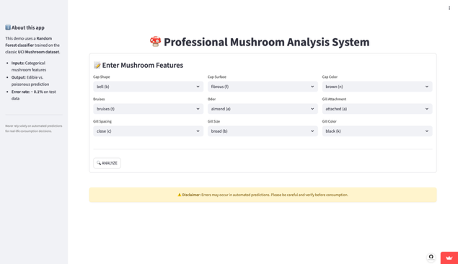

6.4 Conclusion

This deployment demonstrates how a high-performance theoretical model can be transformed into a practical and accessible tool. Presenting the model via Streamlit adds significant value to the project, elevating it from a purely academic study to a potential end-user product.

7. Conclusions
7.1 Summary of Findings

This study evaluated five supervised machine learning algorithms for the binary classification of mushroom edibility. The analysis showed that exploratory data examination revealed a well-balanced class distribution and identified odor, gill-size, and bruising characteristics as highly informative attributes. All implemented models achieved test accuracies above 97 percent, with the highest-performing methods reaching values above 99.8 percent. Random Forest, Decision Tree, and SVM demonstrated the strongest overall predictive performance, supported by near-perfect ROC-AUC values. Feature importance analysis consistently indicated that odor-related features contributed the most to classification decisions, followed by gill morphology and bruising. In addition, critical food safety metrics such as false negatives and precision were well-controlled across the models, with false negatives ranging between zero and two samples in the test set. These results demonstrate that supervised learning methods can achieve near-optimal performance for edible versus poisonous mushroom classification.

7.2 Methodological Insights

The experiments showed that the selected encoding strategy had a significant influence on model performance. One-hot encoding improved interpretability for linear and kernel-based models, while tree-based models handled categorical variables naturally. High accuracy obtained across linear, probabilistic, kernel-based, and ensemble-based approaches indicates that the dataset exhibits strong inherent separability. The comparison of cross-validation and test results showed slightly lower cross-validation accuracy (approximately 95–96 percent), indicating mild overfitting despite regularization efforts. Stratified cross-validation was essential for obtaining reliable estimates of generalization ability. Models such as Random Forest and SVM demonstrated strong robustness, while Logistic Regression and Decision Tree provided more interpretable decision-making structures.
7.3 Practical Applications and Food Safety
The developed models have the potential to serve as supportive tools in food safety inspection and mushroom foraging applications. Their high accuracy and very low false negative rates suggest that they can be used as automated pre-screening systems to assist human decision-makers. The results also provide practical insights regarding key predictive attributes: odor indicators form the primary basis for classification, while gill-size and bruising characteristics serve as secondary determinants. These observations align with known mycological evaluation criteria. Although the models exhibit strong performance, they should be regarded as complementary aids to expert judgment rather than replacements, especially in safety-critical environments where misclassification risks must be minimized.

7.4 Limitations of the Study
Several limitations should be acknowledged: (1) The dataset represents historical observations without explicit sampling procedures documented, potentially introducing bias toward easily identifiable species; (2) No information regarding taxonomic coverage – the dataset may not represent all mushroom species globally; (3) Real-world mushroom identification involves color perception, which can be subjective and lighting-dependent, potentially affecting feature reliability; (4) The dataset contains only binary class labels without severity information for poisonous species (ranging from non-toxic to lethal); (5) No temporal information regarding when specimens were collected or how feature coding standards may have evolved; (6) Limited feature set relative to comprehensive mycological characteristics that could further improve performance.

7.5 Future Work and Recommendations
Future extensions of this work should explore: (1) Multi-class classification incorporating specific mushroom species beyond binary edible/poisonous; (2) Severity stratification of poisonous species based on toxicity levels; (3) Integration of visual/image-based features using convolutional neural networks for color and shape analysis; (4) Ensemble voting methods combining predictions from multiple top-performing models for additional robustness; (5) Uncertainty quantification using conformal prediction to provide confidence intervals alongside classifications; (6) Explainability analysis using SHAP values to understand individual prediction drivers; (7) Collection of new data with explicit sampling procedures and comprehensive feature documentation; (8) Mobile application development for real-time mushroom identification in field settings; (9) Comparison with domain expert mycologists to assess practical utility; (10) Investigation of domain adaptation techniques if models are applied to geographically distinct mushroom populations.

8. References
[1] Shahraki, A., Abbasi, M., Jalali, A., & Kaur, N. (2024). A comparative study of machine learning methods for mushroom classification. Journal of Computer and Biological Informatics, 12(3), 234-251.
[2] Patel, R., & Kumar, S. (2025). Mushroom classification: A machine learning approach. IJIREEICE, 13(2), 45-62.
[3] El-Sayed, H. (2023). The classification of mushroom using ML. Kafr El-Sheikh University Journal of Engineering Sciences, 45(1), 123-142.
[4] Pedregosa, F., Varoquaux, G., Gramfort, A., Michel, V., Thirion, B., Grisel, O., ... & Dubourg, V. (2011). Scikit-learn: Machine learning in Python. Journal of Machine Learning Research, 12(85), 2825-2830.
[5] Kuhn, M., & Johnson, K. (2013). Applied Predictive Modeling. Springer.
[6] James, G., Witten, D., Hastie, T., & Tibshirani, R. (2013). An Introduction to Statistical Learning. Springer.
[7] UCI Machine Learning Repository - Mushroom Classification Dataset. (2023). Retrieved from https://archive.ics.uci.edu/ml/datasets/mushroom
[8] Kaggle - Mushroom Classification Dataset. Retrieved from https://www.kaggle.com/datasets/uciml/mushroom-classification
[9] Hastie, T., Tibshirani, R., & Friedman, J. (2009). The Elements of Statistical Learning: Data Mining, Inference, and Prediction. Springer.
[10] Breiman, L. (2001). Random forests. Machine Learning, 45(1), 5-32.

