Therapist-guided compared with self-guided virtual reality exposure therapy for social anxiety disorder: A three-arm randomized controlled trial

169
169
Department of Psychology, University of Amsterdam
7202A704XY: Practical training: Psychological Research
3761
18 January 2026

Abstract
Social anxiety disorder (SAD) is a highly prevalent and impairing condition, for which exposure-based cognitive behavioral therapy is considered the treatment of choice. Virtual reality exposure therapy (VRET) has emerged as a promising alternative, particularly in increasing accessibility and controllability of exposure exercises. However, the extent to which therapist guidance is necessary within VRET remains unclear. The present study examined the effectiveness of therapist-guided VRET compared with self-guided VRET and a waitlist control condition in young adults with SAD. In a three-arm randomized controlled trial, participants (N =90) were assigned to therapist-guided VRET, self-guided VRET, or a waitlist control condition. Social anxiety symptoms were assessed using the LSAS-SR before and after the intervention period. Results indicated that participants in all conditions showed a significant reduction in social anxiety symptoms but therapist-guided VRET led to significantly greater symptom reduction than self-guided VRET and waitlist control. These findings suggest that while self-guided VRET may be an effective low-threshold intervention for social anxiety, therapist guidance enhances treatment outcomes.

Introduction
Social anxiety disorder (SAD) is characterized by an excessive fear of social situations in which embarrassment may occur, or when there is a risk of being negatively evaluated by others (American Psychiatric Association, 2013). SAD significantly impairs an individual’s relationships, work, and overall quality of life (Stein et al., 2017; National Collaborating Centre for Mental Health, 2015; Heimberg et al., 2014; Ruscio et al.,2008). SAD is highly prevalent, affecting 12% of Americans and 4% globally (Kessler et al., 2005; Stein et al., 2017). SAD is a chronic disorder but there is a natural decrease in prevalence rates with older age (Bandelow & Michealis, 2015). Research shows that younger adults are disproportionately affected (Merikangas et al., 2010; Burstein et al., 2011; Jefferies & Ungar, 2020). Early intervention is particularly vital for adolescents, as they are the least likely to improve during adolescence (Magson & Rapee, 2022).
SAD is often unrecognized and untreated (National Collaborating Centre for Mental Health, 2015), with only one in four people receiving treatment (Alonso et al., 2018). Many people with SAD tend to avoid and hide their problems and withhold treatment until severe issues arise (Bandelow& Michaelis, 2015; Lin et al., 2019). This avoidance, along with barriers like financial costs, not knowing where to go, and wait times, keeps many from seeking help (Chartier-Otis et al., 2010).
Cognitive-behavioral therapy (CBT), exposure therapy in particular, is the gold-standard treatment for SAD (Chowdhury, 2023; Stanton & Tolin, 2022). However, exposure therapy is often underused due to therapists' concerns about causing patients too much distress, which can lead to patients refusing treatment or dropping out (Boeldt et al., 2019; Deacon et al., 2013). For SAD in particular, therapists face practical difficulties in arranging exposure and controlling the intensity, which further reduces their use (Pittig et al., 2019).
Virtual Reality Exposure Therapy (VRET) addresses several of these limitations by allowing precise control of scenarios and real-time monitoring of anxiety, while enhancing accessibility, acceptability, and effectiveness (Boeldt et al., 2019). By simulating realistic social situations with interactive avatars or video-based audiences, VRET often feels less intimidating than in vivo or imaginal exposure according to patients (Boeldt et al., 2019). Its immersive, controllable environment lowers treatment refusal rates, particularly for specific phobias, by reducing initial avoidance (Tan et al., 2025). A robust empirical base supports the use of VRET for anxiety disorders (Carl et al., 2019; Anderson & Molloy, 2020).
The therapeutic effects of exposure therapy, including VRET, are traditionally explained by Emotional Processing Theory (EPT; Foa & Kozak, 1986). According to EPT, fear is represented in memory as a structure containing information about feared stimuli, associated responses, and their meanings. In SAD, these fear structures are considered maladaptive, as they include exaggerated threat beliefs and expectations of negative evaluation. Exposure therapy is thought to modify these fear structures through two key processes: activation of the fear structure and the incorporation of corrective information that disconfirms threat-related beliefs (Foa et al., 2006). Through repeated exposure to feared situations, anxiety responses are expected to decrease via habituation and extinction, resulting in reduced fear over time (Foa & Kozak, 1986).
In the Inhibitory Learning Model (Craske et al., 2014), exposure aims to disconfirm the link between a trigger and the expected catastrophe (inhibitory meaning). The pivotal component of this model is expectancy violation, which occurs when the anticipated outcome does not happen. The greater the mismatch, the stronger the learning.
Traditionally, VRET has been delivered in therapist-guided formats, in which a clinician controls exposure progression and provides feedback. Several studies have demonstrated the efficacy of therapist-guided VRET for SAD (Anderson & Molloy, 2020). Anderson et al. (2013) showed that VRET significantly reduced social anxiety symptoms compared to a waitlist control. Similarly, Bouchard et al. (2017) also found that VRET was as effective as in vivo exposure, further supporting the use of VR as an alternative to traditional exposure methods. Kampman et al. (2016) expanded on this by demonstrating that therapist-guided VRET reduced generalized social fears.
Advances in consumer VR technology have enabled VRET to be delivered with minimal or no direct therapist involvement. In self-guided VRET, patients independently manage exposures and progress through tasks without continuous therapist support, thereby increasing accessibility and reducing costs (Graham et al., 2025). In a pilot study without a control group, Kim et al. (2017) reported significant reductions in SAD symptoms sustained at one-month follow-up. Only two studies have compared self-guided VRET for SAD to a waitlist. Zainal et al. (2021) found that a virtual-therapist program reduced SAD severity with effects lasting six months, while Kan et al. (2025) reported that a 14-day fully self-guided smartphone-based VRET significantly reduced SAD symptoms in university students compared to a waitlist, with gains maintained at one month. Comparable benefits have been observed in related anxiety conditions, including public speaking anxiety (Lacey et al., 2024; Premkumar et al., 2021) and fear of heights (Donker et al., 2019). However, the evidence base for self-guided VRET is still limited, and effect sizes vary (Scheveneels et al., 2025).
Direct comparisons between therapist-guided and self-guided VRET for SAD are lacking, but research on other forms of guided and unguided exposure therapy for related anxiety disorders offer insights. Several studies have shown superior outcomes for therapist-guided exposure (e.g., Öst, 1991, for spider phobia; Voderholzer et al., 2020, for OCD; Gloster et al., 2011, for agoraphobia; Tolin et al., 2011, for OCD; Baumeister et al., 2014, for mood disorders). Other studies find only modest differences. Campos et al. (2019) reported comparable improvements in fear of flying for therapist-guided versus self-guided internet ET, with slightly better long-term outcomes for therapist-guided ET. Oey et al. (2023) found small short-term advantages of therapist-guided internet CBT for anxiety disorders, which they attributed to better adherence. Guidance appears to enhance adherence, with substantially higher completion rates reported for guided self-help compared to unguided programs (Ciucă et al., 2018; Nordgreen et al., 2012; Oey et al., 2023).
Therapists can provide individualized feedback, discourage safety behaviors, ensure adequate exposure intensity, and offer social support, which may be particularly relevant for individuals with SAD (Abbott et al., 2008; Boeldt et al., 2019). At the same time, therapist-guided interventions are resource-intensive and difficult to scale, limiting their accessibility. Self-guided VRET offers clear advantages in terms of flexibility, cost-effectiveness, and accessibility, particularly for young adults who are comfortable with digital technologies and may prefer autonomous treatment formats (Graham et al., 2025). This creates a clear theoretical and societal need to evaluate the relative effectiveness of guided versus self-guided VRET.
In summary, while self-guided VRET has demonstrated promising effects, therapist guidance may yield greater symptom reductions. To date, no study has directly compared therapist-guided and self-guided VRET for SAD while also including a waitlist control group. Moreover, a recent review highlighted a substantial gap in VR research targeting adolescents and young adults with SAD (Shahid et al., 2024). Given the typical onset of SAD during adolescence (Leigh & Clark, 2018), suggesting potential advantages for early intervention during this developmental window, and evidence supporting the feasibility of VR interventions in younger populations (Kelson et al., 2021), further research in this area is warranted.
The present study aims to examine whether the mode of guidance (therapist-guided versus self-guided) in VRET influences symptom reduction in young adults with SAD. Both active treatment conditions are compared to a waitlist control group. It is expected that the waitlist group will show slight symptom improvement due to regression toward the mean and natural symptom fluctuations (Barnett, 2005; Beesdo-Baum, 2012; Scholten et al., 2023).
Based on previous research and theoretical accounts of exposure therapy, we formulated the following hypotheses. It is hypothesized that (1), participants in both VRET conditions (therapist-guided and self-guided) would show greater reductions in social anxiety symptoms from pre- to post-treatment than participants in the waitlist control group; (2) therapist-guided VRET would lead to larger symptom reductions than self-guided VRET; (3) the waitlist control group will show a small reduction in symptom severity between pre- and post-treatment.

Method
Participants
Participants were recruited via online advertisements and university counseling centers. A total of 90 participants took part in the study. Participants were randomly assigned to therapist-guided VRET, self-guided VRET, or a waitlist group. All participants were between 18 and 30 years of age (M = 22.64, SD = 2.29).
Eligibility required a primary diagnosis of SAD, assessed using the Structured Clinical Interview for DSM-5 – Clinician Version (SCID-5-CV; First et al., 2016), and a minimum score of 50 on the Liebowitz Social Anxiety Scale – Self-Report (LSAS-SR), indicating at least moderate social anxiety, be between 18 and 30 years old, and have sufficient English proficiency. If participants were taking psychoactive medication, the medication had to (a) be stable (same type and dosage) for at least 6 months and (b) remain unchanged throughout the study.
Exclusion criteria included: (a) currently receiving another form of psychotherapy simultaneously, (b) history of mania, psychosis, or schizophrenia, (c) Epilepsy, Claustrophobia, history of seizures, severe motion sickness, or other conditions that could be aggravated by VR, (d) significant visual or vestibular impairments. These criteria align with previous VRET studies (Bouchard et al., 2017; Kampman et al., 2016; Anderson et al., 2013; Lindner et al., 2019)

Materials
Social anxiety symptoms were measured using the Liebowitz Social Anxiety Scale – Self-Report (LSAS-SR; Liebowitz, 1987). The test assesses fear and avoidance and includes 24 items. Each item is rated on two 4-point Likert scales (fear and avoidance) ranging from 0 (none/never) to 3 (severe/usually). Sample questions include: ‘Using a telephone in public’, ‘participating in a small group activity’, ‘Eating in public’. Following rescoring, the maximum possible score on the LSAS-SR is 144, which corresponds to very severe social anxiety, and the minimum possible score, 0, which means you do not suffer from social anxiety. With a score of 30> indicating SAD, and 60> generalized SAD. The LSAS-SR is widely used to assess symptom severity and treatment response in SAD (Baker et al, 2002).
VRET was delivered via a head-mounted display (HMD) consisting of a Samsung Galaxy S6 and Samsung Gear VR powered by Oculus, providing a 360° immersive display with a 96° field of view. This VR system has been used in previous self-guided VRET approaches (Kan et al., 2025; Kim et al., 2019). The VR content developed by Kan et al. (2025) was used and included 20 exposure scenarios of varying difficulty(eye contact: 2, initial interview: 2, meeting new friends: 2, female authority: 2, aunt’s probing: 2, male authority figure: 2, arguing with uncle: 2, dating: 4, impatient leader: 2). See the appendix for a script sample.

Therapist-Guided VRET
Participants assigned to the therapist-guided VRET condition completed twelve 30-minute exposure sessions over a six-week period, with two sessions per week. Each session was conducted under the supervision of a trained clinician. The clinician monitored participants’ anxiety levels using standardized rating scales, guided the progression through increasingly challenging exposure scenarios, and ensured that the intensity of the exposure was tailored to the individual participant’s therapeutic needs.
In addition, the clinician provided structured feedback during and after each session. This feedback included psychoeducation about anxiety, verbal encouragement, reinforcement of progress, and guidance on the use of coping strategies to optimize engagement with the exposure exercises.

Self-Guided VRET
Participants in the self-guided VRET condition completed the same virtual reality exposure program independently, without direct involvement of a clinician. The structure, duration, and content of the exposure sessions were identical to those of the therapist-guided condition. Participants followed standardized text- and audio-based instructions within the virtual environment to complete the exposure tasks and to progress through the scenarios.

Waitlist
Participants assigned to the waitlist condition did not receive any intervention during the study period. They completed the same assessment schedule as the intervention groups at pre-treatment and post-treatment.

Procedure
The study was approved by the local ethics committee, and all participants provided written informed consent prior to participation. Randomization to the therapist-guided VRET, self-guided VRET, or waitlist condition was conducted using a computer-generated allocation sequence.
Assessments were conducted at pre-treatment (T1) and post-treatment (T2).
Following informed consent, participants completed baseline questionnaires online. Participants in the intervention conditions subsequently completed twelve VRET sessions over a six-week period, with two sessions per week.
Following completion of the post-treatment assessments in week six, the collected data were prepared for statistical analysis.

Results
Data from all 90 participants were used for the analysis. Preliminary inspection of the data using boxplots for the post-treatment and follow-up assessments revealed no extreme outliers (see Appendix), indicating that the dataset was suitable for subsequent statistical analyses. The descriptive statistics for the sample are presented in Table 1. Gender distribution differed descriptively across conditions; however, this difference was not statistically significant, χ² (4, N = 90) = 7.01, p = .135.
Table 1: Per Condition the Number of Participants, Male to Female to Non-binary Ratio, Mean Age and Standard Deviations (in Parentheses)
 | Therapist-guided VRET | Self-guided VRET | Waitlist
Number of Participants | 30 | 30 | 30
Female/Male/Non-binary | 19/9/2 | 10/17/3 | 18/9/3
Age | 22.93 (2.32) | 22.80 (2.31) | 22.20 (2.25)

A three (condition: Therapist-guided VRET vs. Self-guided VRET vs Waitlist) by two (time of measurement: pre- vs. post-assessment) Factorial Mixed Analysis of Variance (ANOVA) was performed for the mean scores on LSAS-SR. The assumption of normality was met, as Shapiro-Wilk tests were non-significant for all groups (p>.05). The assumption of homogeneity of variances was also met (p >0,05).
There was a significant main effect of time of measurement, F (1, 87) = 574.30, p < .001. There was no significant main effect of condition, F (2, 87) = 2.81, p = .066. Importantly, a significant interaction was observed between time of measurement and condition, F (2, 87) = 6.45, p = .002, indicating that the change in LSAS-SR scores over time differed by condition. Mean scores for each condition at each time of measurement are presented in Table 2.
Table 2: Per condition the Mean LSAS-SR scores and (Standard Deviations), at Pre- and Post-treatment
 | Therapist-guided VRET | Self-guided VRET | Waitlist
Pre-assessment | 92.77(22.42) | 96.03(22.12) | 95.77(21.20)
Post-assessment | 35.73(20.06) | 52.70(23.66) | 54.73(56.00)

Holm corrected post-hoc tests were carried out to examine differences between conditions at and between different time points. Results showed no difference in mean LSAS-SR scores between conditions at pre-measurement (p = 1.000). Between the pre- and the post-measurement, mean LSAS-SR scores decreased significantly in all conditions: Therapist-guided VRET (p < .001), Self-guided VRET (p < .001), Waitlist (p < .001). The Therapist-guided VRET condition showed the largest reduction in LSAS-SR scores compared with pre-measurement (see Figure 1), and it also showed a significant difference at post-treatment compared with both the Self-guided VRET condition (p=.008) and the waitlist condition (p=0.004). At post-treatment, there is no significant difference between the self-guided VRET and wait-list group (p=.723) (see Figure 1).
Figure 1: Average score on LSAS-SR for Condition (Therapist-guided VRET, Self-guided VRET, Waitlist) and Time of Assessment (Pre- and Post-treatment).
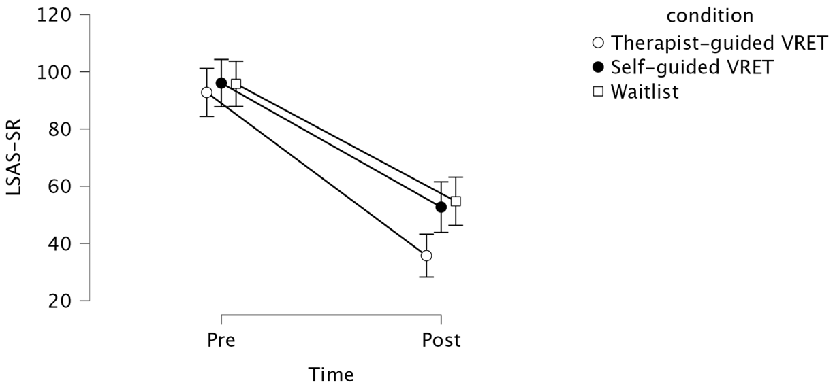

Discussion
The present study aimed to examine whether the mode of guidance in VRET affects SAD symptoms in young adults. It was hypothesized that both therapist-guided and self-guided VRET would yield greater reductions in social anxiety symptoms compared to a waitlist control, with therapist-guided VRET expected to be more effective than self-guided VRET. The results partially supported these hypotheses. Therapist-guided VRET produced significantly greater reductions in social anxiety symptoms compared to both self-guided VRET and the waitlist condition, while self-guided VRET did not significantly outperform the waitlist.

Unexpected results
The self-guided condition did not significantly outperform the waitlist group, contrary to prior research on self-guided VRET for SAD (e.g., Lindner et al., 2019; Zainal et al., 2021; Kan et al., 2025; Lacey et al., 2024).
A possible explanation for the small difference between waitlist and self-guided VRET is that, without therapist support, participants may have selected less challenging exposure intensities or failed to persist through difficult tasks. The most parsimonious interpretation of this finding is that the self-led intervention was less successful in preparing participants for the real-life exposure that followed than the therapist-guided group, because participants did not receive feedback. The similarity in outcomes between self-guided VRET and the waitlist suggests that, for this age group, self-guided exposure may not provide enough structure or support to facilitate optimal improvement.
Strangely, the reduction in LSAS for the self-guided VRET in this study (m=-43.33) was a lot larger than the prior research by Kim et al. (2017; m=- 13.09), Kan et al. (2025; m= −15.8), and Lacey et al. (2024; m=- 35.7).
It was expected that the waitlist group would show only slight improvement, however, the observed reduction in LSAS scores (m = −41.03) was much larger than anticipated and in prior research on anxiety disorders, which typically report minimal improvement in waitlist conditions (Steinert et al., 2017; Scholten et al., 2023). An explanation for the large change in the waitlist symptoms includes natural fluctuations in symptoms, which is common in SAD studies, as mentioned in the introduction (Patterson et al., 2016). Given the rapidity and size of the change in the waitlist, this pattern may reflect a sudden gains phenomenon, defined as large, abrupt improvements in symptoms relative to prior severity and fluctuations (Tang and DeRubeis, 1999). Sudden gains often reverse (Aderka et al., 2012) and may reflect symptom fluctuations that happen to be large in size rather than treatment effects (Butler et al., 2019). Although the present study was not designed to detect sudden gains, the large waitlist reduction is interpreted as such and also a regression toward the mean effect (Patterson et al., 2016) rather than a true waitlist effect. Regression towards the mean, however, does not solely explain the improvements for the therapist-guided condition, because they were significantly larger.

Comparison with previous research
The strong effects observed for Therapist-guided VRET are consistent with previous randomized controlled trials, demonstrating its effectiveness for SAD (Anderson et al., 2013; Bouchard et al., 2017; Kampmann et al., 2016). Therapist-guided VRET in this study (m=-57.03) showed a much larger LSAS-SR reduction in comparison to previous research that used the same questionnaire, which typically range from m=-1.5 to m=-33.3 (Kampman et al., 2016; Lin et al., 2019; Sarpourian et al., 2022; Bouchard et al., 2017)
The current finding highlights the superiority of guided interventions over unguided interventions, in line with previous research (Baumeister et al, 2014; Öst et al., 1991; Ciuca et al., 2018)

Theoretical Implications
These findings suggest that therapist involvement plays an important role in the effectiveness of VRET for young adults with SAD. From a developmental perspective, young adulthood is a phase in which qualities such as self-sufficiency, taking responsibility for oneself, and making independent decisions are being developed (Arnett, 2000). Young adults may be more reliant on structured external guidance than older adults, because they are less independent. This interpretation aligns with previous research that has shown the importance of therapist support and parental involvement in treating adolescents with depression and anxiety. (Garrido et al., 2019; Andersson et al., 2023)
Therapist-guided VRET may enhance corrective feedback and expectancy violation, key mechanisms in exposure therapy, making the intervention more effective.

Practical Implications
It is therefore recommended that, if implemented in a clinical setting, VRET be conducted under the guidance of a therapist. It is also recommended that clinical settings invest in VR infrastructure and consider offering hybrid models in which therapist support can be dialed up or down based on individual patient needs. Furthermore, researchers and clinicians could collaborate to develop age-appropriate and culturally relevant VR scenarios to enhance engagement and outcomes.

Limitations Several limitations should be considered when interpreting the present findings.
Firstly, this study assessed only short-term outcomes (after 6 weeks), with measurements taken at pre- and post-treatment. As a result, it remains unclear whether the observed advantages of therapist-guided VRET persist over time or whether self-guided gains may consolidate at later follow-up points (Llewellyn-Bennett et al., 2016).
Secondly, reliance on self-report measures may have introduced response bias, as participants might have underreported or overreported their symptoms due to social desirability, demand characteristics, or recall bias (Choi & Pak, 2005). Self-report can also cause response shift bias (Howard, 1980), where participants’ interpretation of symptom severity changes over time. Furthermore, repeated assessment of the same questionnaire may decrease its accuracy due to familiarity (Durham et al., 2002). Finally, using a single measure limits construct validity, as it may not fully capture the intended construct (Campbell & Fiske, 1959).
Thirdly, another limitation is that the VR exposure scenarios were not tailored to the Dutch context, which may have limited ecological validity. The VR content used in this study, was developed specifically for Chinese college students and tailored to reflect specific Chinese social pressures and contexts, such as academic competition and collectivist values (Kan et al., 2025) Many scenarios may not align with the daily experiences or cultural context of the young adults in the Netherlands that participated in this study. However, due to a lack of suitable VRET materials for this age group and disorder, this was the best available option for the current study.

Future research
As VR materials improve and become more accessible, future research should examine whether results can be replicated in better-suited VR settings and consider developing specific age-appropriate, culturally relevant scenarios for the intended audience.
Studies should also include longer follow-up assessments (e.g., 6–12 months) to examine the maintenance and delayed benefits of guidance, as little is known about the long-term effects of VRET (Tan et al., 2025). And a follow-up is important because prior research has shown that for different exposure therapies, there are fluctuations over the long term or that the effects eventually diminish, and that specifically for comparing therapist-guided and self-guided exposure therapy, differences between the two conditions at posttreatment do not persist or only show up at follow-up (Oey et al., 2023; Campos et al., 2019; Lindner et al., 2019; Ciuca et al., 2018 )
Replication with participants with lower baseline severity or/and statistical adjustments for baseline extremity, such as running an ANCOVA or calculating the expected mean shifts can quantify the regression-to-the-mean impact (Barnett et al., 2005). And this could clarify the proportion of waitlist improvement attributable to artefactual change.
A way to avoid the possible biases and risks associated with using self-report measurement instruments is to incorporate multiple outcome measures, for example, which would further strengthen the evidence base. Also, measurement theory emphasizes that using multiple methods and measures helps ensure the measure is valid, as shown by the multitrait–multimethod matrix (Campbell & Fiske, 1959).
Stochastic frontier estimation (SFE) can be used to address the previously mentioned ‘response shift bias’s (Rosenman et al., 2011).
Future research should also explore whether the developmental stage influences the need for therapist guidance in different age groups. It could be that young adults benefit more from therapist involvement, and that age may be the key moderator in the results of this study. Future research should therefore investigate this by comparing different age groups across self-guided VRET, therapist-guided VRET, and a waitlist control group. This design could offer valuable insights into age-related differences in treatment efficacy. Also, just in general, more research is needed to delve into whether young adults with SAD specifically require more guidance from a therapist, as there is a literature gap on the moderators of treatment outcome of this specific population group.

Conclusion
In conclusion, this study demonstrates that therapist-guided VRET produces robust short-term reductions in social anxiety symptoms in young adults, whereas self-guided VRET did not significantly outperform a waitlist control. These findings underscore the importance of guidance in VRET, specifically in young adults. More research is needed to generalize whether these effects persist after follow-up and whether they can be generalized to other age groups. Furthermore, researchers and clinicians should collaborate to develop age-appropriate and culturally relevant VR scenarios to enhance engagement and outcomes.

References
Abbott, J. A. M., Klein, B., & Ciechomski, L. (2008). Best Practices in Online Therapy. Journal of Technology in Human Services, 26(2–4), 360–375. https://doi.org/10.1080/15228830802097257
Aderka, I. M., Anholt, G. E., van Balkom, A. J., Smit, J. H., Hermesh, H., & van Oppen, P. (2012). Sudden gains in the treatment of obsessive-compulsive disorder. Psychotherapy and psychosomatics, 81(1), 44–51. https://doi.org/10.1159/000329995
Alonso, J., Liu, Z., Evans-Lacko, S., Sadikova, E., Sampson, N., Chatterji, S., Abdulmalik, J., Aguilar-Gaxiola, S., Al-Hamzawi, A., Andrade, L. H., Bruffaerts, R., Cardoso, G., Cia, A., Florescu, S., De Girolamo, G., Gureje, O., Haro, J. M., He, Y., De Jonge, P., . . . Thornicroft, G. (2018). Treatment gap for anxiety disorders is global: Results of the World Mental Health Surveys in 21 countries. Depression And Anxiety, 35(3), 195–208. https://doi.org/10.1002/da.22711
American Psychiatric Association. (2013). Diagnostic and statistical manual of mental disorders (5th ed.). American Psychiatric Publishing.
Anderson, P. L., & Molloy, A. (2020). Maximizing the impact of virtual reality exposure therapy for anxiety disorders. Current opinion in psychology, 36, 153–157. https://doi.org/10.1016/j.copsyc.2020.10.001
Anderson, P. L., Price, M., Edwards, S. M., Obasaju, M. A., Schmertz, S. K., Zimand, E., & Calamaras, M. R. (2013). Virtual reality exposure therapy for social anxiety disorder: A randomized controlled trial. Journal Of Consulting And Clinical Psychology, 81(5), 751–760. https://doi.org/10.1037/a0033559
Andersson, R., Vigerland, S., Ahlen, J., Widström, H., Unger, I., Serlachius, E., & Engberg, H. (2023). “Therapy without a therapist?” The experiences of adolescents and their parents of online behavioural activation for depression with and without therapist support. European Child & Adolescent Psychiatry, 33(1), 105–114. https://doi.org/10.1007/s00787-023-02142-7
Baker, S. L., Heinrichs, N., Kim, H. J., & Hofmann, S. G. (2002). The liebowitz social anxiety scale as a self-report instrument: a preliminary psychometric analysis. Behaviour research and therapy, 40(6), 701–715. https://doi.org/10.1016/s0005-7967(01)00060-2
Bandelow, B., & Michaelis, S. (2015). Epidemiology of anxiety disorders in the 21st century. Dialogues in clinical neuroscience, 17(3), 327–335. https://doi.org/10.31887/DCNS.2015.17.3/bbandelow
Barnett, A. G., van der Pols, J. C., & Dobson, A. J. (2005). Regression to the mean: what it is and how to deal with it. Int J Epidemiology, 34(1), 215–220.
Baumeister, H., Reichler, L., Munzinger, M., & Lin, J. (2014). The impact of guidance on Internet-based mental health interventions — A systematic review. Internet Interventions, 1(4), 205–215. https://doi.org/10.1016/j.invent.2014.08.003
Beesdo-Baum, K., Knappe, S., Fehm, L., Höfler, M., Lieb, R., Hofmann, S. G., & Wittchen, H. U. (2012). The natural course of social anxiety disorder among adolescents and young adults. Acta psychiatrica Scandinavica, 126(6), 411–425. https://doi.org/10.1111/j.1600-0447.2012.01886.x Boeldt, D., McMahon, E., McFaul, M. and Greenleaf, W. (2019) Using Virtual Reality Exposure Therapy to Enhance Treatment of Anxiety Disorders: Identifying Areas of Clinical Adoption and Potential Obstacles. Frontiers in Psychiatry, 10, Article 773.
https://doi.org/10.3389/fpsyt.2019.00773
Burstein, M., He, J-P, Kattan, G., Albano, A.M., Avenevoli, S., Merikangas, K.R. (2011), Social phobia and subtypes in the national comorbidity survey-adolescent supplement: prevalence, correlates, and comorbidity. J Am Acad Child Adolesc Psychiatry ;50: 870–880.
Butler, R. M., O'Day, E. B., Kaplan, S. C., Swee, M. B., Horenstein, A., Morrison, A. S., Goldin, P. R., Gross, J. J., & Heimberg, R. G. (2019). Do sudden gains predict treatment outcome in social anxiety disorder? Findings from two randomized controlled trials. Behaviour research and therapy, 121, 103453. https://doi.org/10.1016/j.brat.2019.103453
Bouchard, S., Dumoulin, S., Robillard, G., Guitard, T., Klinger, É., Forget, H., Loranger, C., & Roucaut, F. X. (2016). Virtual reality compared within vivoexposure in the treatment of social anxiety disorder: A three-arm randomised controlled trial. The British Journal Of Psychiatry, 210(4), 276–283. https://doi.org/10.1192/bjp.bp.116.184234
Carl, E., Stein, A. T., Levihn-Coon, A., Pogue, J. R., Rothbaum, B., Emmelkamp, P., Asmundson, G. J. G., Carlbring, P., & Powers, M. B. (2019). Virtual reality exposure therapy for anxiety and related disorders: A meta-analysis of randomized controlled trials. Journal of anxiety disorders, 61, 27–36. https://doi.org/10.1016/j.janxdis.2018.08.003
Campbell, D. T., & Fiske, D. W. (1959). Convergent and discriminant validation by the multitrait-multimethod matrix. Psychological Bulletin, 56(2), 81–105. https://doi.org/10.1037/h0046016
Campos, D., Bretón-López, J., Botella, C., Mira, A., Castilla, D., Mor, S., Baños, R., & Quero, S. (2019). Efficacy of an internet-based exposure treatment for flying phobia (NO-FEAR Airlines) with and without therapist guidance: a randomized controlled trial. BMC Psychiatry, 19(1), 86. https://doi.org/10.1186/s12888-019-2060-4
Chartier-Otis, M., Perreault, M., & Bélanger, C. (2010). Determinants of Barriers to Treatment for Anxiety Disorders. Psychiatric Quarterly, 81(2), 127–138. https://doi.org/10.1007/s11126-010-9123-5
Choi, B. C., & Pak, A. W. (2005). A catalog of biases in questionnaires. Preventing chronic disease, 2(1), A13.
Chowdhury, N., & Khandoker, A. H. (2023). The gold-standard treatment for social anxiety disorder: A roadmap for the future. Frontiers in psychology, 13, 1070975. https://doi.org/10.3389/fpsyg.2022.1070975
Ciuca, A. M., Berger, T., Crişan, L. G., & Miclea, M. (2018). Internet-based treatment for panic disorder: A three-arm randomized controlled trial comparing guided (via real-time video sessions) with unguided self-help treatment and a waitlist control. PAXPD study results. Journal of anxiety disorders, 56, 43–55. https://doi.org/10.1016/j.janxdis.2018.03.009
Craske, M. G., Treanor, M., Conway, C. C., Zbozinek, T., & Vervliet, B. (2014). Maximizing exposure therapy: An inhibitory learning approach. Behaviour research and therapy, 58, 10-23.
Deacon, B. J., Farrell, N. R., Kemp, J. J., Dixon, L. J., Sy, J. T., Zhang, A. R., & McGrath, P. B. (2013). Assessing therapist reservations about exposure therapy for anxiety disorders: the Therapist Beliefs about Exposure Scale. Journal of anxiety disorders, 27(8), 772–780. https://doi.org/10.1016/j.janxdis.2013.04.006
Donker, T., Cornelisz, I., van Klaveren, C., van Straten, A., Carlbring, P., Cuijpers, P., & van Gelder, J. L. (2019). Effectiveness of Self-guided App-Based Virtual Reality Cognitive Behavior Therapy for Acrophobia: A Randomized Clinical Trial. JAMA psychiatry, 76(7), 682–690. https://doi.org/10.1001/jamapsychiatry.2019.0219
Durham, C. J., McGrath, L. D., Burlingame, G. M., Schaalje, G. B., Lambert, M. J., & Davies, D. R. (2002). The effects of repeated administrations on self-report and parent-report scales. Journal of Psychoeducational Assessment, 20(3), 240–257. https://doi.org/10.1177/073428290202000302
First, M. B., Williams, J. B. W., Karg, R. S., & Spitzer, R. L. (2016). User's guide for the SCID-5-CV Structured Clinical Interview for DSM-5® disorders: Clinical version. American Psychiatric Publishing, Inc.
Foa, E. B., Huppert, J., & Cahill, S. (2006). Emotional processing theory: An update. In B. O. Rothbaum (Ed.), Pathological anxiety: Emotional processing in etiology and treatment (pp. 3–24). The Guilford Press.
Foa, E.B., & Kozak, M.J. (1986). Emotional processing of fear: Exposure to corrective information. Psychological Bulletin, 99, 20–35.
Garrido, S., Millington, C., Cheers, D., Boydell, K., Schubert, E., Meade, T., & Nguyen, Q. V. (2019). What Works and What Doesn’t Work? A Systematic Review of Digital Mental Health Interventions for Depression and Anxiety in Young People. Frontiers in Psychiatry, 10, 759. https://doi.org/10.3389/fpsyt.2019.00759

Gloster, A. T., Wittchen, H., Einsle, F., Lang, T., Helbig-Lang, S., Fydrich, T., Fehm, L., Hamm, A. O., Richter, J., Alpers, G. W., Gerlach, A. L., Ströhle, A., Kircher, T., Deckert, J., Zwanzger, P., Höfler, M., & Arolt, V. (2011). Psychological treatment for panic disorder with agoraphobia: A randomized controlled trial to examine the role of therapist-guided exposure in situ in CBT. Journal Of Consulting And Clinical Psychology, 79(3), 406–420. https://doi.org/10.1037/a0023584
Graham, W. M., Drinkwater, R., Kelson, J., & Kabir, M. A. (2025). Self-guided virtual reality therapy for anxiety: A systematic review. International journal of medical informatics, 200, 105902. https://doi.org/10.1016/j.ijmedinf.2025.105902
Heimberg, R. G., Hofmann, S. G., Liebowitz, M. R., Schneier, F. R., Smits, J. A. J., Stein, M. B., Hinton, D. E., & Craske, M. G. (2014). SOCIAL ANXIETY DISORDER IN DSM-5. Depression And Anxiety, 31(6), 472–479. https://doi.org/10.1002/da.22231
Howard, G. S. (1980). Response-shift bias: A problem in evaluating interventions with pre/post self-reports. Evaluation Review, 4(1), 93-106. https://doi.org/10.1177/0193841X8000400105
Jefferies, P., & Ungar, M. (2020). Social anxiety in young people: A prevalence study in seven countries. PloS one, 15(9), e0239133. https://doi.org/10.1371/journal.pone.0239133
Kelson, J. N., Ridout, B., Steinbeck, K., & Campbell, A. J. (2021). The Use of Virtual Reality for Managing Psychological Distress in Adolescents: Systematic Review. Cyberpsychology, Behavior, and Social Networking, 24(10), 633-641. https://doi.org/10.1089/cyber.2021.0090
Kampmann, I. L., Emmelkamp, P. M., Hartanto, D., Brinkman, W., Zijlstra, B. J., & Morina, N. (2015). Exposure to virtual social interactions in the treatment of social anxiety disorder: A randomized controlled trial. Behaviour Research And Therapy, 77, 147–156. https://doi.org/10.1016/j.brat.2015.12.016
Kan, C., Wang, Y., Hu, R., Chen, K., & Zhang, Y. (2025). Smartphone-based self-help virtual reality exposure therapy for college students’ social anxiety: a randomized controlled study. Virtual Reality, 29(3). https://doi.org/10.1007/s10055-025-01195-0
Kennedy, R. S., Lane, N. E., Berbaum, K. S., & Lilienthal, M. G. (1993). Simulator sickness questionnaire: An enhanced method for quantifying simulator sickness. The International Journal of Aviation Psychology, 3(3), 203–220.
Kessler, R.C., Berglund, P., Demler, O., Jin, R., Merikangas,K.R., Walters, E.E, (2005) Lifetime Prevalence and Age-of-Onset Distributions of DSM-IV Disorders in the National Comorbidity Survey Replication. Arch Gen Psychiatry;62(6):593–602. doi:10.1001/archpsyc.62.6.593
Kim, H. E., Hong, Y., Kim, M., Jung, Y. H., Kyeong, S., & Kim, J. (2017). Effectiveness of self-training using the mobile-based virtual reality program in patients with social anxiety disorder. Computers in Human Behavior, 73, 614–619. https://doi.org/10.1016/j.chb.2017.04.017
Lacey, C., Frampton, C., & Beaglehole, B. (2024). A self-guided virtual reality solution for social anxiety: Results from a randomized controlled study. Journal Of Psychiatric Research, 180, 333–339. https://doi.org/10.1016/j.jpsychires.2024.10.032
Leigh, E., & Clark, D. M. (2018). Understanding social anxiety disorder in adolescents and improving treatment outcomes: Applying the cognitive model of Clark and Wells (1995). Clinical Child and Family Psychology Review, 21(3), 388–414. https://doi.org/10.1007/s10567-018-0258-5
Liebowitz, M. R. (1987). Social phobia. In D. F. Klein (Ed.), Modern Problems in Pharmacopsychiatry (Vol. 22, pp. 141–173). Basel: Karger.
Lin, X. B., Lee, T., Cheung, Y. B., Ling, J., Poon, S. H., Lim, L., Zhang, H. H., Chin, Z. Y., Wang, C. C., Krishnan, R., & Guan, C. (2019). Exposure Therapy With Personalized Real-Time Arousal Detection and Feedback to Alleviate Social Anxiety Symptoms in an Analogue Adult Sample: Pilot Proof-of-Concept Randomized Controlled Trial. JMIR Mental Health, 6(6), e13869. https://doi.org/10.2196/13869
Lindner, P., Miloff, A., Fagernäs, S., Andersen, J., Sigeman, M., Andersson, G., Furmark, T., & Carlbring, P. (2019). Therapist-guided and self-guided one-session virtual reality exposure therapy for public speaking anxiety with consumer hardware and software: A randomized controlled trial. Journal of anxiety disorders, 61, 45–54. https://doi.org/10.1016/j.janxdis.2018.07.003
Llewellyn-Bennett, R., Bowman, L., & Bulbulia, R. (2016). Post-trial follow-up methodology in large randomized controlled trials: a systematic review protocol. Systematic reviews, 5(1), 214. https://doi.org/10.1186/s13643-016-0393-3
Magson, N. R., & Rapee, R. M. (2022). Sources of weight stigma and adolescent mental health: From whom is it the most harmful? Stigma and Health, 7(2), 152–160. https://doi.org/10.1037/sah0000380
Merikangas, K.R., He J-P, Burstein, M., Swanson, S.A., Avenevoli, S., Cui, L., et al. (2010) Lifetime prevalence of mental disorders in U.S. adolescents: results from the National Comorbidity Survey Replication—Adolescent Supplement (NCS-A). J Am Acad Child Adolesc Psychiatry. 49: 980–989.
National Collaborating Centre for Mental Health. (2015). Social anxiety disorder: Recognition, assessment and treatment.The British psychological society and the royal college of psychiatrists. British: Stanley L. Hunt (Printers) Ltd. https://doi.org/10.3109/9780203026106
Nordgreen, T., Havik, O., Öst, L., Furmark, T., Carlbring, P., & Andersson, G. (2011). Outcome predictors in guided and unguided self-help for social anxiety disorder. Behaviour Research And Therapy, 50(1), 13–21. https://doi.org/10.1016/j.brat.2011.10.009
Oey, L. T., McDonald, S., McGrath, L., Dear, B. F., & Wootton, B. M. (2023). Guided versus self-guided internet delivered cognitive behavioural therapy for diagnosed anxiety and related disorders: a preliminary meta-analysis. Cognitive Behaviour Therapy, 52(6), 654–671. https://doi.org/10.1080/16506073.2023.2250073
Öst, L., Salkovskis, P. M., & Hellström, K. (1991). One-session therapist-directed exposure vs. self-exposure in the treatment of spider phobia. Behavior Therapy, 22(3), 407–422. https://doi.org/10.1016/s0005-7894(05)80374-0
Patterson, B., Boyle, M. H., Kivlenieks, M., & Van Ameringen, M. (2016). The use of waitlists as control conditions in anxiety disorders research. Journal of psychiatric research, 83, 112–120. https://doi.org/10.1016/j.jpsychires.2016.08.015
Pavlov, I. P. (1927). Section on “Extinction of conditioned reflexes,” in Conditioned Reflexes: An Investigation of the Physiological Activity of the Cerebral Cortex. Oxford: Oxford University Press.
Pittig, A., Kotter, R., & Hoyer, J. (2019). The Struggle of Behavioral Therapists With Exposure: Self-Reported Practicability, Negative Beliefs, and Therapist Distress About Exposure-Based Interventions. Behavior therapy, 50(2), 353–366. https://doi.org/10.1016/j.beth.2018.07.003
Premkumar, P., Heym, N., Brown, D. J., Battersby, S., Sumich, A., Huntington, B., Daly, R., & Zysk, E. (2021). The Effectiveness of Self-Guided Virtual-Reality Exposure Therapy for Public-Speaking Anxiety. Frontiers in Psychiatry, 12, 694610. https://doi.org/10.3389/fpsyt.2021.694610
Rosenman, R., Tennekoon, V., & Hill, L. G. (2011). Measuring bias in self-reported data. International journal of behavioural & healthcare research, 2(4), 320–332. https://doi.org/10.1504/IJBHR.2011.043414
Ruscio, A. M., Brown, T. A., Chiu, W. T., Sareen, J., Stein, M. B., & Kessler, R. C. (2008). Social fears and social phobia in the USA: results from the national comorbidity survey replication. Psychological Medicine, 38(1), 15e28.
Sarpourian, F., Samad‐Soltani, T., Moulaei, K., & Bahaadinbeigy, K. (2022). The effect of virtual reality therapy and counseling on students’ public speaking anxiety. Health Science Reports, 5(5), e816. https://doi.org/10.1002/hsr2.816
Scheveneels, S., Engelhard, I., & Meyerbröker, K. (2025). Opening the black box: The underlying working mechanisms in virtual-reality exposure therapy for anxiety disorders. Clinical Psychological Science, 13(2), 207–221. https://doi.org/10.1177/21677026241267945
Scholten, W., Seldenrijk, A., Hoogendoorn, A., Bosman, R., Muntingh, A., Karyotaki, E., Andersson, G., Berger, T., Carlbring, P., Furmark, T., Bouchard, S., Goldin, P., Kampmann, I., Morina, N., Kocovski, N., Leibing, E., Leichsenring, F., Stolz, T., van Balkom, A., & Batelaan, N. (2023). Baseline Severity as a Moderator of the Waiting List-Controlled Association of Cognitive Behavioral Therapy With Symptom Change in Social Anxiety Disorder: A Systematic Review and Individual Patient Data Meta-analysis. JAMA psychiatry, 80(8), 822–831. https://doi.org/10.1001/jamapsychiatry.2023.1291
Shahid, S., Kelson, J., & Saliba, A. (2024). Effectiveness and User Experience of Virtual Reality for Social Anxiety Disorder: Systematic Review. JMIR mental health, 11, e48916. https://doi.org/10.2196/48916
Stanton, C. H., & Tolin, D. F. (2022). Exposure therapy for anxiety disorders. In Elsevier eBooks (pp. 857–865). https://doi.org/10.1016/b978-0-323-91497-0.00065-5
Stein, D.J., Lim, C.C.W., Roest, A.M. et al. The cross-national epidemiology of social anxiety disorder: Data from the World Mental Health Survey Initiative.BMC Med 15, 143 (2017). https://doi.org/10.1186/s12916-017-0889-2
Steinert, C., Stadter, K., Stark, R., & Leichsenring, F. (2017). The Effects of Waiting for Treatment: A Meta-Analysis of Waitlist Control Groups in Randomized Controlled Trials for Social Anxiety Disorder. Clinical psychology & psychotherapy, 24(3), 649–660. https://doi.org/10.1002/cpp.2032
Stefaniak, I., Hanusz, K., Mierzejewski, P., Bieńkowski, P., Parnowski, T., & Murawiec, S. (2022). Preliminary Study of Efficacy and Safety of Self-Administered Virtual Exposure Therapy for Social Anxiety Disorder vs. Cognitive-Behavioral Therapy. Brain Sciences, 12(9), 1236. https://doi.org/10.3390/brainsci12091236
Tan, Y. L., Chang, V. Y. X., Ang, W. H. D., Ang, W. W., & Lau, Y. (2025). Virtual reality exposure therapy for social anxiety disorders: a meta-analysis and meta-regression of randomized controlled trials. Anxiety, Stress, & Coping, 38(2), 141–160. https://doi.org/10.1080/10615806.2024.2392195
Tang, T. Z., & DeRubeis, R. J. (1999). Sudden gains and critical sessions in cognitive-behavioral therapy for depression. Journal of Consulting and Clinical Psychology, 67(6), 894–904. https://doi.org/10.1037/0022-006X.67.6.894
Tolin, D. F., Hannan, S., Maltby, N., Diefenbach, G. J., Worhunsky, P., & Brady, R. E. (2007). A Randomized Controlled Trial of Self-Directed Versus Therapist-Directed Cognitive-Behavioral Therapy for Obsessive-Compulsive Disorder Patients With Prior Medication Trials. Behavior Therapy, 38(2), 179–191. https://doi.org/10.1016/j.beth.2006.07.001
Voderholzer, U., Hilbert, S., Fischer, A., Neumüller, J., Schwartz, C., & Hessler-Kaufmann, J. B. (2020). Frequency and level of self-efficacy predict the effectiveness of therapist- and self-guided exposure in obsessive compulsive disorder. Behavioural and cognitive psychotherapy, 48(6), 751–755. https://doi.org/10.1017/S1352465820000582
Zainal, N. H., Chan, W. W., Saxena, A. P., Taylor, C. B., & Newman, M. G. (2021). Pilot randomized trial of self-guided virtual reality exposure therapy for social anxiety disorder. Behaviour Research And Therapy, 147, 103984. https://doi.org/10.1016/j.brat.2021.103984

Appendix

Figure x: Boxplot of pre-treatments scores per condition: Therapist-guided VRET, Self-guided VRET, Waitlist

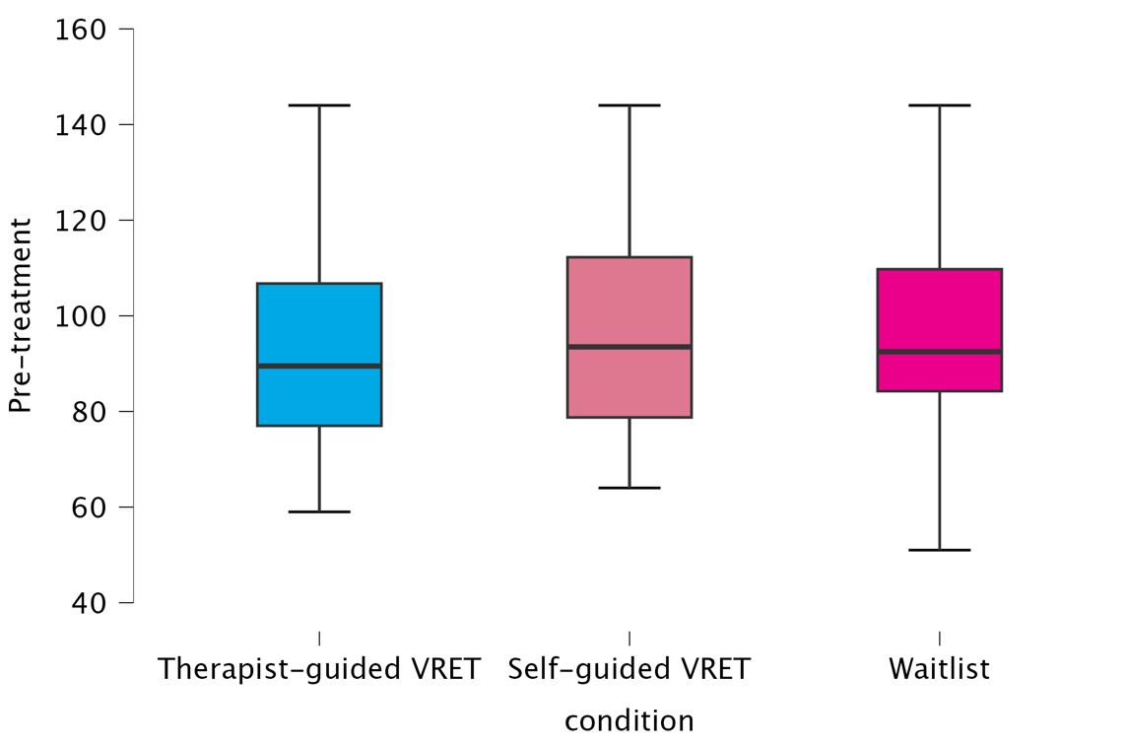
Figure x: Boxplot of post-treatments scores per condition: Therapist-guided VRET, Self-guided VRET, Waitlist

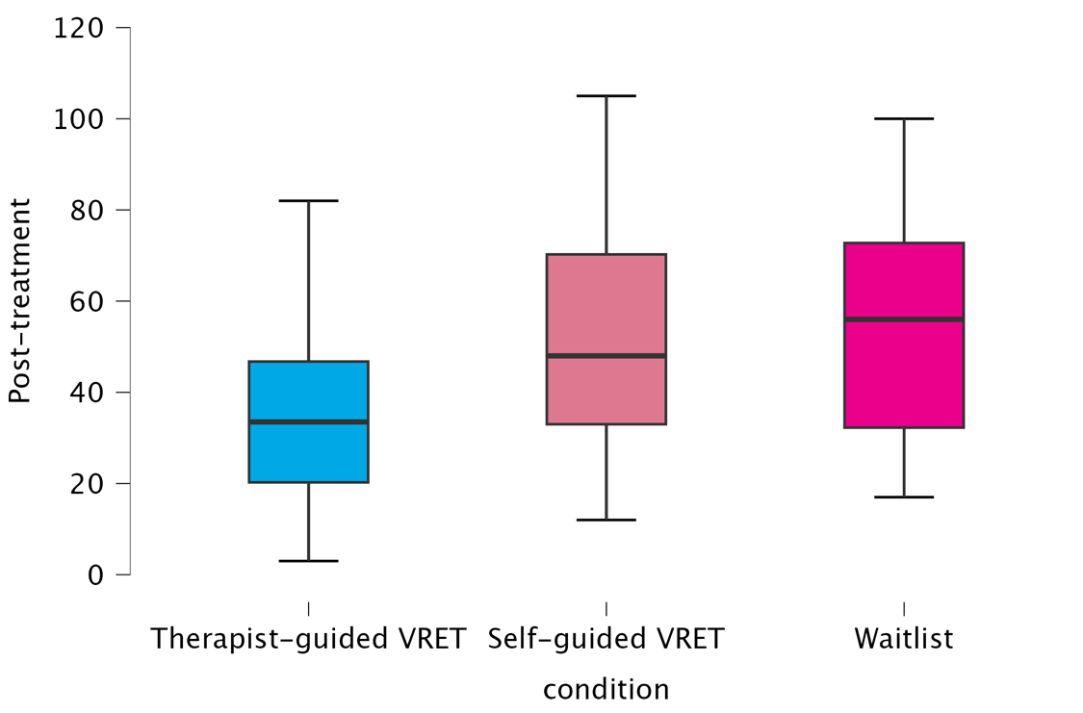

Script: Madam's Question
Number of people | Role | Age | Clothing | Expression requirements | Distracting Actions | Negative reactions
3 females | C | 40+ years old | Leisure | Absent-minded and impatient | √ | √
 | D | 40+ years old | Leisure | Enthusiastic, talkative and inquisitive | √ | √
 | E | 40+ years old | Leisure | Introvert, slightly anxious | √ | √
(All characters stand still)
C: Oh no! I told you not to come here at this time. The line is so long!
D: It’s fine. It takes at most 10 minutes. Time will pass quickly when we are chatting. (Turning head) Last time you talked about your daughter's grades in high school. You seemed worried. How did it go?
E: I don't really know. Her grades are neither high nor low. It seems that their high school doesn't pay much attention to students' grades. They say that students are allowed to develop freely, but they don't provide any information. I don't know where to ask.
D: It’s not so bad. You can ask anywhere! Aren't there resources around us?
C: Where are the resources? Should I ask you? Or myself?
D: We are rustic, but we can ask others! (Stay sideways and look at the camera) You see, we can ask for advice from people like this youngster! (Turning to face the camera) What school did you graduate from?
C: (Impatiently) Aren't you disturbing others?
D: What do you mean by disturbing? We are just chatting as waiting in line. Listen about the situation of other school and learn more! (Turning head) You say, is it right?
E: Excuse me! It depends on whether you are willing to chat with us and introduce your school. We have no ill intentions. It's mainly because my daughter is at a critical stage of going from high school to college. As a mother, I have never compared her academic performance with others. I just want to hear about the situation of school you graduated from. You can tell us!
(C: She was absent-minded the whole time and didn’t look at the camera)
(D: She was very interested at first, staring at the camera, smiling, and twice looked at the queue)
(E: She looked very interested, staring at the camera most of the time, smiling and nodding from time to time)
E: I still feel that my daughter is under a lot of pressure to study, and I feel bad for her.
C: Why should a girl study so much? There is no need! If it is a boy, then we must push him a little harder, let him go to a good university, and get a master or doctorate.
D: Girls can also go to a good university! But if they go to a higher level, it will be difficult to find a partner!
E: (Looking at the camera) What do you think? I also think that my daughter will get married in the end, so she doesn't need to study too much, but I am also worried that my ideas may be too conservative. I really want to hear your opinion.
(C: She was absent-minded the whole time, didn’t look at the camera, and shook her head twice)
(D: forced a smile, frowned twice, shook her head once)
(E: stared at the camera most of the time, occasionally thinking, forced a smile)

