<https://github.com/Farukey/JREST>

Above is the link of where the project JREST is available for download.

This is a CRUD REST API proof of concept project. Shows basic use of REST verbs (GET, PUT, POST, DELETE). This project uses jkd1.8 and Spring 4 with Tomcat 8. The project makes use of in memory H2 database with Hibernate. Data is supplied and retrieved using JSON. There is no frontend provided with this project, so Chrome’s app Postman is used for that purpose. Screenshots are given to show case the usage through Postman and JSON data formatting.

This project is done for learning purpose so it is not necessarily personal code and heavily relies on the examples and tutorials available online. This project is done without previous knowledge of REST Api, Spring Boot, maven and without any previous commercial use of core Spring.

1. POST for creating data.

http://localhost:8080/JREST/account

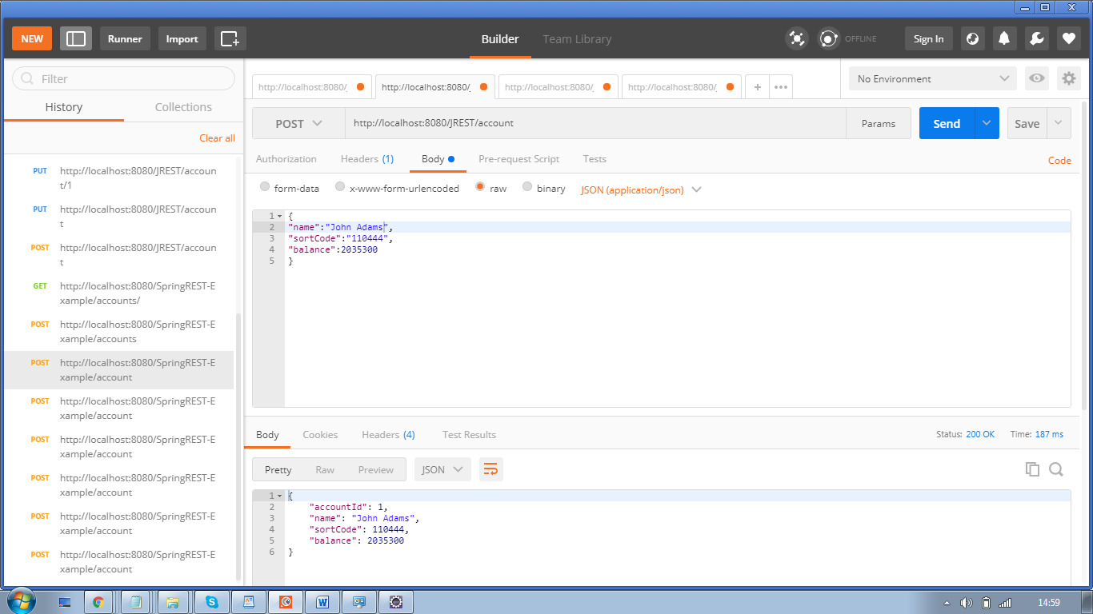

1. GET for retrieving data.

http://localhost:8080/JREST/accounts/

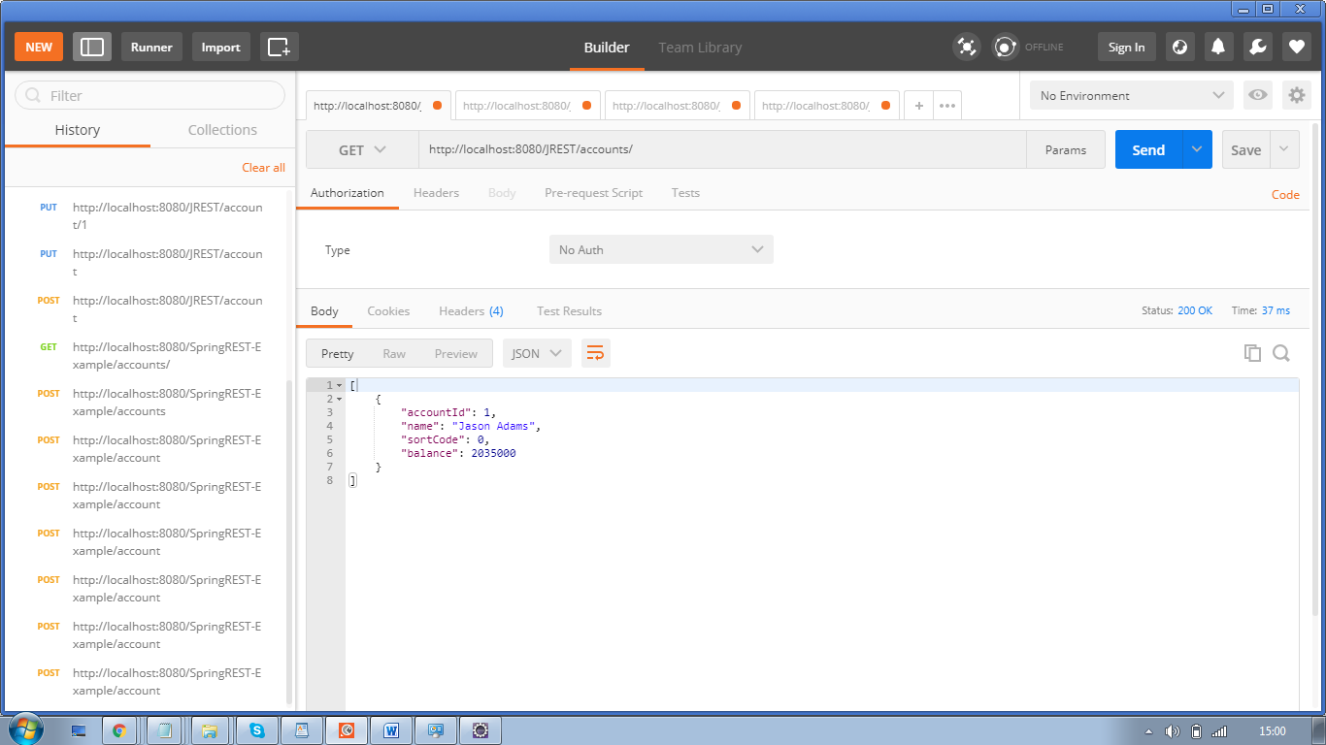

1. PUT for update

http://localhost:8080/JREST/account/1

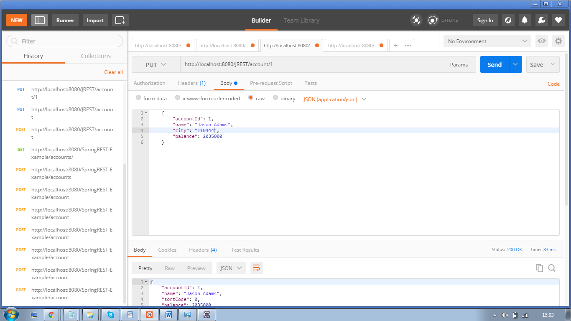

1. DELETE for deleting data

<http://localhost:8080/JREST/account/1>

