**Task 1**

**Counter.js**

import React, { Component } from 'react';

class Counter extends Component{

state={

count:0

}

Increment = ()=>{

this.setState({

count : this.state.count + 1

})

}

render(){

return(

<div>

<h1>Counter - {this.state.count}</h1>

<button onClick={()=>this.Increment()}>Increment</button>

</div>

)

}

}

export default Counter;

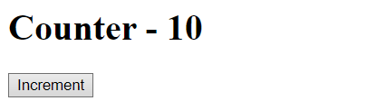

**Message.js**

import React, { Component } from 'react';

class welcome extends Component{

state= {

message: 'welcome visitor'

}

changeMessage = ()=>{

this.setState({

message:'thank you for subscribing'

})

}

render(){

return(

<div>

<h1>{this.state.message}</h1>

<button onClick={()=>this.changeMessage()}>Subscribe</button>

</div>

)

}

}

export default welcome;



**Task 2**

import React, { Component } from 'react';

import ReactDOM from 'react-dom';

import Welcome from './message';

import Counter from './counter';

class App extends Component {

state = {

minutes : 0,

seconds: 0

}

minuteHandler = (event)=>{

this.setState({

minutes : event.target.value,

seconds : event.target.value*60

});

}

timer = ()=>{

if(this.state.seconds > 0){

this.setState((prevState) => ({

seconds : prevState.seconds -1,

minutes: Math.floor((prevState.seconds -1) / 60)

}))

}

}

Starttimer = () =>{

setInterval(()=>{

this.timer()

},1000)

}

render(){

return(

<div>

<h3>Enter your desired Input</h3>

<input type="number" onChange={this.minuteHandler}/>

<button onClick={()=>this.Starttimer()}>START</button>

<br/>

<h1>{this.state.minutes}:{this.state.seconds % 60}</h1>

<Welcome />

<Counter/>

</div>

)

}

}

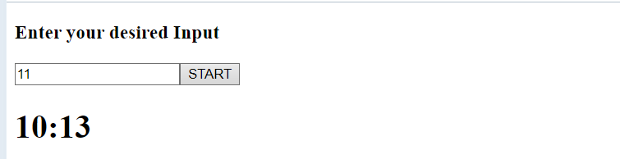

ReactDOM.render(<App />, document.getElementById('root'));