🡪This report contains

* Problem Statement of the project (CRICKET STATS MANAGEMENT)
* EERD
* Finalized Relational Schema after performing normalization process
* Functional Dependencies

**Project Idea:**

The project entails creating a database which stores the statistical data of all the cricket players whether on international or national teams. It will have all the players worldwide who have been recognized as professional players in cricket.

Furthermore, it will also include all the records of the players such as their total score or what matches has been played internationally or nationally. We will also try to implement the project using blockchain technology(not certain).

The database will include multiple tables as well as give the user to enter or retrieve data as well as edit any existing data, following the restrictions that will be placed on the database so any unnecessary information or invalid information shows up in the database.

**Project Statement:**

For an entity SERIES the database keeps information of the series Name, MOS, Winner, End_date, Start_Date,S_ID, Teams_playing. A series can have multiple matches going on.

A MATCH has an attribute Batting First, Date, MoM, M_Id, Result, Toss and inherits from Test,One day or T20. A match has more than one umpires. Each match has 1 SCORECARD.

An Umpire entity has the attributes of U-Id, Country, Name, DOB and #Matches.

STADIUM entity has the attributes St_Id, Place, Country, Capacity, Name. A stadium can have multiple matches taking place.

M_SCORECARD is the entity having the attributes Extras,Total_wkts,run_rate,Total_runs,Total_overs,MSC_ID. M_ScoreCard have more than One P_statistics.

P_STATISTICS contains the attributes overs_bowled, wkts_taken, PSC_id, sixers, fours, Maidens, Runs_scored. Every Statistics card is assigned to one player.

PLAYER is a parent class having the given attributes DOB, P_iD, country, Name, height,Debut_Date. A player can either be a bowler or a batsman or both.

A BATSMAN is an entity type with the property Fifties,style,runs,ranks,balls faced,hundreds,fours,sixers.

BOWLER has the attribute rank, best_figures, runs_conceded, wickets, balls_bowled,5 wickets taken.

A TEAM contains the attributes ties,wins,matches,loss,captain,high_total,country,rank,T_id. It also has a squad which is multi valued attribute. A team has more than one player. A team can have more than 1 coach.

COACH entity has the attributes C-id, Name ,Country, DOB, Start_date, End_date.

**ERD diagram:**

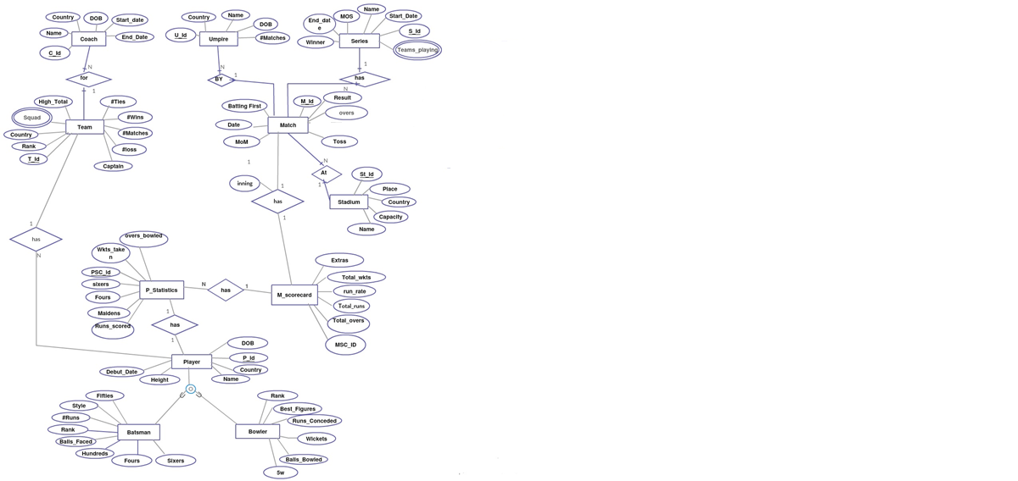

**Relational Schema:**

Coach ( coach_id, coach_name, coach_country, coach_dob, Join _date, Team_id )

Team ( team_id , team_country, team_rank, team_captain, high_total, matches_played, matches_win, matches_loss, matches_tie )

Player( player_id, player_name, player_dob , player_height, debut_date, team_id )

Squad ( players , team_id )

Bowler (bowler_rank , wickets , best_figures, balls_bowled , fivers , player_Id )

BatsMan (batting_rank , total_runs , balls_faced , style , hundreds , fifties , total_sixers , total_fours , player_id )

Matches (match_id, toss_win, batting_first, man_of_match,result,match_date, stadium_id, series_id,type)

Series (series_id, series_name, man_of_series , series_winner, Start_Date, End_Date)

Stadium (stadium_id, stadium_name, capacity, city, country)

Umpire (umpire_id, umpire_name, umpire_dob, umpire_name, matches_umpired, match_id)

Player_Statistics (p_statistics_id, runs, sixers, fours, overs_bowled, wkts_taken, maidens, match_id, Player_ID, scorecard_id)

Scorecard (scorecard_id, run_rate, total_runs, total_wickets, total_overs, extras, inning, team_id, match_id)

🡪This relational schema is in finalized form after performing normalization process.

**Functional Dependencies:**

**COACH:** coach_id 🡪 coach_name, coach_country, coach_dob, Join _date, Team_id

**Team:** team_id 🡪, team_country, team_rank, team_captain, high_total, matches_played, matches_win, matches_loss,

matches_tie

team_country 🡪 team_id, team_rank, team_captain, high_total, matches_played, matches_win, matches_loss,

matches_tie

**Player**: player_id 🡪 player_name, player_dob , player_height, debut_date, team_id

**Bowler:**  player_Id 🡪 bowler_rank , wickets , best_figures, balls_bowled , fivers

**BatsMan:** player_id 🡪 batting_rank , total_runs , balls_faced , style , hundreds , fifties , total_sixers , total_fours

**Matches:** match_id 🡪 toss_win, batting_first, man_of_match, result, match_date, stadium_id, series_id

**Umpire:** umpire_id 🡪 umpire_name, umpire_dob, umpire_name, matches_umpired, match_id

**Player_Statistics:** p_statistics_id 🡪 runs, sixers, fours, overs_bowled, wkts_taken, maidens, match_id, Player_ID, scorecard_id

**Series:** series_id 🡪 series_name, man_of_series , series_winner, Start_Date, End_Date

**Stadium:** stadium_id 🡪 stadium_name, capacity, city, country

**Scorecard:** scorecard_id 🡪 run_rate, total_runs, total_wickets, total_overs, extras, inning, team_id, match_id