Database Programming With ADO.NET

Introduction to ADO .NET –

Now days many organizations, companies, business and banks uses
Real-World Softwares to manage their huge data.

All these Real-World softwares uses Databases to manage and store their
huge data.

e.g. Banking Software, Inventory Systems, Railway Reservation Systems etc
stores their data in Database and retrieves the necessary data which is stored into database as per need.

In short we can say that all Real-World applications stores the data into -
External Database and retrieves required data as per need into applications.

So while creating applications that deals or works with database in .NET –
Microsoft .NET Framework provides us many classes. All these classes that
Deals or works with data are stored into – System.Data namespace.

All classes present in this System.Data namespace provides Core Data Access
Objects in .NET Framework.

All these data access classes and System.Data namespace collectively called
As – ADO.NET

Overview of ADO .NET –

ADO.NET –

Collection of –

1] Namespaces

And

2] Classes

Which are required to connect with various Databases collectively
called as – ADO .NET

ADO.NET is important part of .NET Framework.

It is model which can be used by .NET Framework to work / deal / communicate
with database for storing, retrieving, updating data in database.

ADO.NET Object Model –

ADO .NET object model is based on standards given by -
World Wide Web Consortium [W3C].

Microsoft designed ADO .NET object model in such way that it Programmer or
Developer can work with variety of databases.

Following figure shows ADO .NET object model –

Data Provider Model .NET Framework
Connection
DataAdapter
Command
DataReader
DataSet

Database

XML
ADO .NET Object Model

As shown into above figure there are two important components of
ADO .NET Object Model –

1] Data Provider.

2] DataSet.

Let’s see each of them in details.

1] Data Provider –

1] As shown in above figure Data Provider model is made up of various
Components such as – connection, command, datareader, dataadapter
objects.

2] This Data Provider is used for making connection with database, retrieving
data, storing and reading retrieved data into dataset, updating database.

3] There are different Data Provider Model present for different databases.

4] There are four main types of Data Provider as follows –

1] .NET Framework Data Provider for SQL Server.

2] .NET Framework Data Provider for OLEDB.

3] .NET Framework Data Provider for ODBC.

4] .NET Framework Data Provider for Oracle.

5] Following table shows each of them in details –

Data Provider | Description
.NET Framework Data Provider for SQL Server. | It is used we want to connect with Microsoft SQL Server Database.  We need to use -  System.Data.SqlClient namespace  to use this provider.
.NET Framework Data Provider for OLEDB. | It is used we want to connect with Microsoft Access Database.  We need to use -  System.Data.OleDb namespace  to use this provider.

Data Provider | Description
.NET Framework Data Provider for ODBC. | It uses the Native ODBC Driver Manager through COM interoperability to enable data access.  To use this provider we need –  ODBC Driver.
.NET Framework Data Provider for Oracle. | It is used we want to connect with Oracle Database.  We need to use -  System.Data.OracleClient namespace to use this provider.

Components of Data Provider –

1] Data Provider model is made up following components –

1] Connection.

2] Command.

3] DataReader.

3] DataAdapter.

2] Following table shows each component of Data Provider in details –

Table showing component of Data Provider in details -
Data Provider Component | Description
Connection | It is used to establish a connection with a data source such as database.
Command | It is used to retrieve, insert, delete or update data present in database.
DataReader | It is used to retrieve data from database in read – only and  forward – only mode.
DataAdapter | It is used to transfer data from and to  Database.  It retrieves data from database into  Dataset.

2] DataSet–

1] DataSet in nothing but in memory cache of data.

2] DataSet is generally part of disconnected environment.

3] AS DataSet is part of disconnected environment, data retrieved from
Database is cached into it.

4] A DataSet contains collection of one or more DataTable objects.

5] DataTable objects made up of rows and columns along with constraint and
relation.

6] DataSet is present in DataSet Class in System.Data namespace.

7] Following are various components of DataSet –

1] DataTable.

2] DataTableCollection.

3] DataRowCollection.

4] DataColumnCollection.

5] DataRelationCollection.

Table showing component of DataSet in details -

DataSet Component | Description
DataTable | It represents a table in the datatable collection of a dataset.
DataTableCollection | It contains all tables which are fetched from datasource.
DataRowCollection | It collection of all the rows in a datatable.
DataColumnCollection | It collection of all the columns in a datatable.
DataRelationCollection. | It contains relationship and links between tables in DataSet

An Database application can access data using DataSet or DataReader object –

1] Using DataSet - Here data is cached into dataset and application accesses
data from DataSet

2] Using DataReader - Here DataReader uses connection object to get
connection with Database and uses command object to
retrieve data. DataReader works in read-only and
forward – only manner.

Database Architectures / Environment –

There are two types of Database Architectures –

1] Connected.

2] Disconnected.

Following table gives information of these architectures in details –

Connected Architecture | Disconnected Architecture
Here in connected architecture user or application is continuously connected with Database.  Any Insertion, Deletion, Updation made  Into Database is immediately reflected. | Here in Disconnected architecture  application need to go through following steps –  1] Get connected with database  2] Fetch Required data.  3] Close connection.  4] Modify data i.e. Insert,delete,update  Records.  5] Again get connected with database.  6] Update the changes made.

Connected Architecture | Disconnected Architecture
Advantages –  1] Data concurreny issues are easy to control if one user is updating database and other user not making any modification on same data unless and until first user completes his updation.  2] We always get current and updated  Data.  Limitations –  1] Continuous database connection may cause network traffic.  2] Performance and scalability issues  Occurs if multiple users are get connected with same data source, this also increase the query processing time. | Advantages –  1] It allows multiple user to interact with  Database simultaneously.  2] It provides best scalability and performance to applications.  Limitations –  1] Data is not always updated,It gets updated when connection is established with Database.  2] Data concurrency issues may be get  raised as multiple users are working with database simultaneously.

Various Classes in ADO.NET –

In ADO .NET System.Data namespace contains all classes which are required to perform operations on database.

Following are various classes used in ADO .NET –

1] Connection. 2] Command.

3] DataReader. 4] DataAdapter.

5] DataSet. 6] DataTable.

7] DataView.

Let’s see each class in details –

1] Connection Class –

1] Connection Class is used to establish connection with Database.

2] For making connection with different databases we need to use different
Connection classes.

3] .NET provides following connection classes to get connected with different
Databases -

1] SqlConnection Class –

It is used to make connection with SQL Server Database.

2] OleDbConnection Class –

It is used to make connection with Microsoft Access, Oracle Database.

4] Using appropriate connection class we need to create connection object
to get connected with Database.

5] Connection object have ConnectionString property.

6] Connection String is nothing but string of information which is needed to get
connected with database.

7] Connection String has various parameters.

8] ConnectionString Parameters are as follows –

1] Provider.

2] Initial Catalog.

3] Data Source.

4] User ID.

5] Password.

6] Integrated Security.

9] Following table shows ConnectionString Parameters and their description in
details –

ConnectionString Parameter | Description
Provider | It is used to set name of provider for  connection.
Initial Catalog | It is used to name of database with which making connection.
Data Source | It is name of computer or server on which database is installed.
User ID | It is user name which is used to get connected with database.
Password | It is password which is used to get connected with database.
Integrated Security | It is used to decide we want make this connection secure or not.  When it is False then –  User Name and Password are given in the connection.  When it is True then –  Windows accounts credentials are used for authentication.  Possible values for this parameter are-  True, False , SSPI  [i.e. Security Support Provider Interface] which same as True.

2] Command Class –

1] Command Class is used to execute PL/SQL commands or queries on
Database.

2] Command Class has following important properties and methods using which
Command object executes queries on database.

3] Command Class has following Important Properties –

1] CommandType.

2] CommandText.

3] Connection.

4] Following table shows all these properties in details –

Command ClassProperty | Description
CommandType | It is used to execute PL/SQL statement or query on database.  CommandType executes one type of statements from following three types or options -  1] Text - It executes plain PL/SQL statement or query.  2] Stored Procedure - It executes Stored Procedure so here we need to specify Name of Stored Procedure which we want to execute.  3] TableDirect- Here we need to specify only Name of Table.

Command ClassProperty | Description
CommandText | It is used to specify actual PL/SQL statement i.e. query or Name of Stored procedure which we want to execute.
Connection | Here connection object is used to get connected with database and to execute command.

5] Command Class has following Important Methods –

1] ExecuteNonQuery().

2] ExecuteScalar().

3] ExecuteReader().

6] Following table shows all these methods in details –

Command Class Method | Description
ExecuteNonQuery(). | This method returns number of rows affected.
ExecuteScalar(). | This method returns a single value and also pointer to first row of first record.
ExecuteReader() | This method returns DataReader object.  DataReader object is used to store data in connected architecture.

3] DataReader Class –

1] DataReader Class helps us to create DataReader object.

2] DataReader is used to retrieve a Read-only, Forward-only stream of data
from database.

3] Read – only means that records of table can not be modified or updated.

And

Forward – only means you can not be traverse back to previous record into
table.

4] DataReader can increases performance of application both by –

1] Retrieving records / data as soon as it is available.

And

2] By default storing only one row at a time in memory, reducing system
overload.

5] Each .NET Framework Data Provider has their own provider specific
DataReader object.

So,

.NET Framework Data Provider for SQL Server have SqlDataReader object.

.NET Framework Data Provider for OLEDB have OleDbDataReader object.

.NET Framework Data Provider for ODBC have OdbcDataReader object.

.NET Framework Data Provider for Oracle have OracleDataReader object.

4] DataAdapter Class –

1] DataAdapter Class helps us to create DataAdapter object.

2] Data Adapter acts as bridge between Database and DataSet.

3] DataAdapter retrieves data from Database into DataSet.

4] DataAdapter communicates with Database while retrieving, inserting,
deleting and updating data.

5] Each .NET Framework Data Provider has their own provider specific
DataAdapter object.

So,

.NET Framework Data Provider for SQL Server have SqlDataAdapter object

.NET Framework Data Provider for OLEDB have OleDbDataAdapter object.

.NET Framework Data Provider for ODBC have OdbcDataAdapter object.

.NET Framework Data Provider for Oracle have OracleDataAdapter object.

6] DataAdapter class has following important properties –

1] SelectCommand.

2] InsertCommand.

3] UpdateCommand.

4] DeleteCommand.

7] Following table shows DataAdapter class properties in details –

DataAdapter Class Property | Description
SelectCommand. | It refers to DML statement or any stored procedure which retrieves data from DataSet.
InsertCommand. | It refers to data command which insert data into a dataset.
UpdateCommand. | It refers to data command which updates data into a dataset.
DeleteCommand. | It refers to data command which deletes data from a dataset.

8] DataAdapter class has following important methods –

1] Fill ().

2] Update ().

9] Following table shows DataAdapter class methods in details –

DataAdapter Class Method | Description
Fill () | It Fills DataSet with records from Database.
Update () | It Executes corresponding insert,update,delete command to reflect changes in Database

5] DataSet Class –

1] DataSet Class helps us to create DataSet object.

2] DataSet is in memory cache of data.

3] DataSet stores data fetched by DataAdapter temporary.

4] DataSet is not Provider Specific.

5] DataSet consists of collection of DataTable objects.

6] DataTable Class –

1] DataTable Class helps us to create DataTable object.

2] DataTable is one table’s data present in memory cache.

3] DataTable internally contains –

1] Columns Collection.

2] Rows Collection.

4] DataTable object contains one or more columns, each represented by a
DataColumn object.

5] To Add Column to a DataTable, we need to create DataColumn object and
Use Add() method.

6] This columns collection allows us to access columns in DataTable.

7] DataColumn object has following important properties as shown in table
below –

DataColumn Property | Description
ColumnName | It sets the name of column in the DataColumnCollection.
Caption | It sets the caption for the column.
DataType | It sets the Data Type for that column.
AllowDBNull | It gets or sets the value which indicates  Null values are allowed or not.
ReadOnly | It gets or sets the value which indicates  Column is read only or not.

8] DataTable object also has Rows collection.

9] DataTable object contains one or more rows, each represented by a DataRow
Object.

7] DataView Class –

1] DataView Class helps us to create DataView object.

2] DataView allows us to create various views of data stored in DataTable.

3] DataView gives Dynamic View of data stored in DataTable.

4] As DataView gives Dynamic View of data, due to this any changes made in
DataTable also gets reflected into DataView.

5] DataView can be also used to Sort / Filter data present in DataTable.

6] Somehow DataView is similar to View in Database.

7] DataView has following limitations –

1] We can treat it as Table.

2] It can not provide view of joined DataTable objects.

3] It can not exclude columns present in source DataTable.

Now after learning a lot of theory about ADO.NET.
Let’s move towards practical.

To work or to do Connected and Disconnected architecture Demo we need
Database and Tables.

Let’s see How to create tables in SQL Server Express Edition.

SQL Server Express Edition means when we install Visual Studios Setup on our machine it gets installed by default with Visual Studios Setup.

Connected Architecture Demo –

Following Demo demonstrates how connected architecture works.

1] Create one Windows Application and Name it as –
ConnectedArchitectureDemo.

2] To work with connected architecture we need Database and tables.
Lets see How to Create Tables in SQL Server Express

How to create tables in SQL Server Express Edition –

For Doing same follow following steps -

1] In ConnectedArchitectureDemo’s IDE
Click on View as shown below -

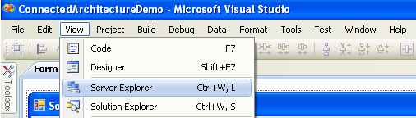

2] Then following Server Explorers window gets opened.

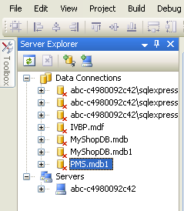

3] Now Right click symbol in Server Explorer as shown
below -

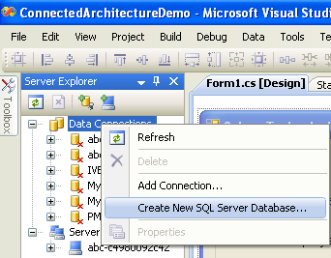

3] Now click Create New SQL Server Database in above window
After clicking on Create New SQL Server Database we get following window –

Here Add Server Name as - .\SQLEXPRESS [For Old Versions Of VS]

For VS 2017 Community Edition Server Name as – (localdb)\mssqllocaldb

New Database Name – Employee as shown below -

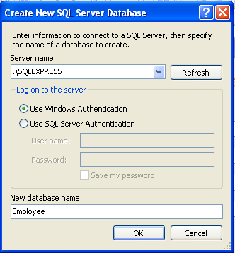

4] Now after clicking on OK button in above window we will get following window-

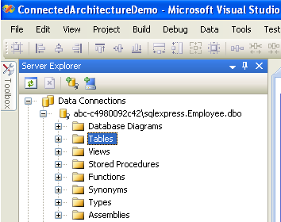

5] Now right click Tables folder as shown below and
After that click – Add New Table

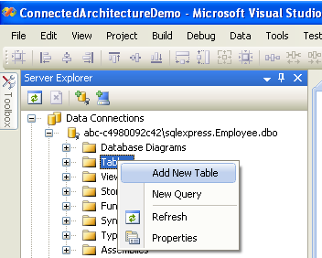

6] After clicking – Add New Table we get following window -

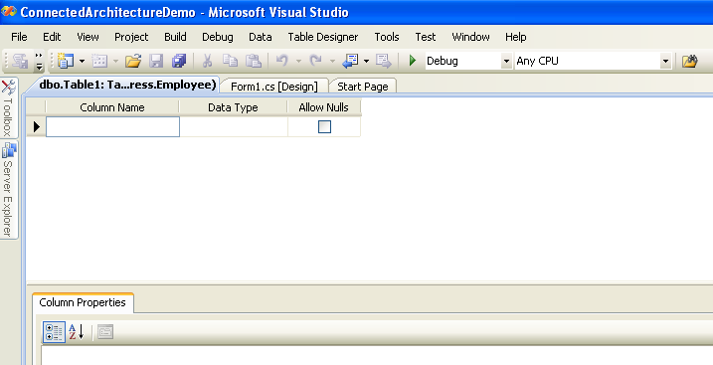

7] Add Column names and their Data Types as shown below -

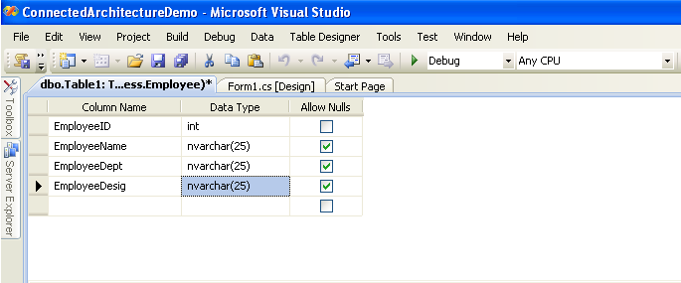

8] After adding required columns names its time to save that table. To save table
do the steps as shown below -

9] Click on Save Table1.

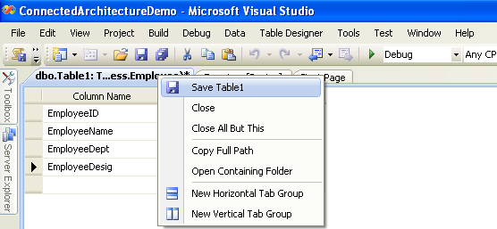

9] Give Table Name as – EmployeeInfo. and Click OK button.

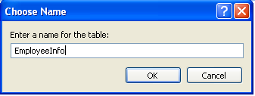

10] We will get this table as shown below, Now our table is ready.

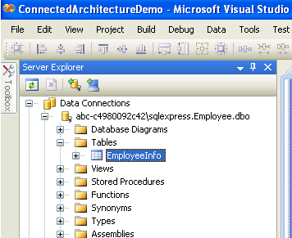

For making connection with database using connection object we need –
Connection String.

Let’s see how to make connection string. Follow following steps.

How to create Connection String-

1] Open Notepad.

2] Save it as – ConnectionString.udl

Here .udl extension stands for – Universal Data Link.

3] After saving notepad with .udl extension we will get following icon –

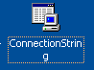

4] Right Click above icon and Click Open with –
Microsoft Data Access – OLE DB Core Services.

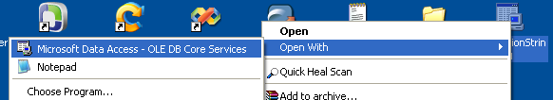

4] After clicking - Microsoft Data Access – OLE DB Core Services we gets
following window –

In its Provider tab –

Select – Microsoft OLE DB Provider for SQL Server and
Click Next button as shown below.

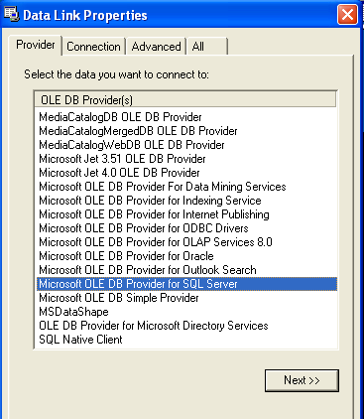

5] After clicking Next >> Button we will get following connection tab –

Add –

1] Server Name - .\SQLEXPRESS

2] Select Radio Button – Use Windows NT Integrated Security.

3] Select the Database on Server – Employee.

As shown below -
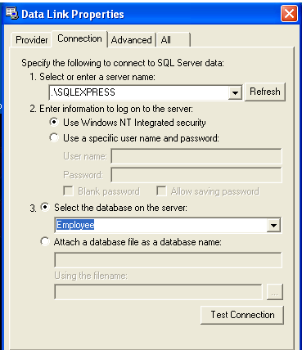

6] Click on – Test Connection Button. We will get following message box –

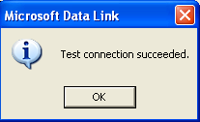

7] Click on OK Button and OK Button present at the Bottom.

8] Now again Right Click icon and Click Open with –
Notepad.

9] Thus we will get connection string generated in notepad as shown below -

Now just copy past this connection string where it is needed.

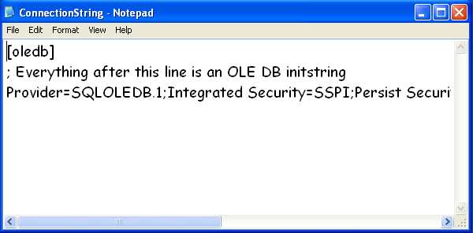

Connected Architecture Demo –

1] Create Windows application.

2] Set Form1 Text Property - Solace Technologies Employee Database

3] Drag Drop Three GroupBox Controls on Form.

Set their Text Properties as and Font size to 10 –

groupBox1 - Employee Information
groupBox2 – Operations

4] Drag Drop Five Label Controls on Employee Information GroupBox
Set Their Text properties as follows –

label1 - Employee ID
label2 - Employee Name
label3 - Employee Department
label4 - Employee Designation
label5 - Employee Database

Set label5 ForeColor – Orange, Font – Comic Sans MS, Size – 12.

5] Drag Drop Four TextBox Controls on Employee Information GroupBox
Set Their Name properties as follows –

textBox1- txtEmpID

textBox2- txtEmpName

textBox3- txtEmpDept

textBox4- txtEmpDesig

6] Drag Drop Nine Button Controls on Operations GroupBox

Set Their Name and Text properties as follows –

Name Text

button1 - btnAdd Add

button2 – btnDisplay Display

button3 – btnUpdate Update

button4 – btnDelete Delete

button5 – btnFirst First

button6 – btnLast Last

button7 – btnNext Next

button8 - btnPrevious Previous

button9 - btnExit Exit

7] Drag Drop One DataGridView Control on Third GroupBox.

8] Add code from Whole Code part on respective controls events.

9] Press F6 key to Build/Compile application.

10] Press F5 key Run application.

11] Whole Code will like this -

using System;
using System.Collections.Generic;
using System.ComponentModel;
using System.Data;
using System.Drawing;
using System.Text;
using System.Windows.Forms;
using System.Data.SqlClient;// Add This Namespace.

namespace ConnectedArchitectureDemo
{
public partial class Form1 : Form
{
public Form1()
{
InitializeComponent();
}

SqlConnection con; // Declared connection object.
SqlDataReader dr; // Declared DataReader object.
DataTable dt; // Declared DataTable object
static int pos; // Declared pos for navigation.

// Bind() Method To Bind Control with Datasource/Database

public void Bind()
{
txtEmpID.DataBindings.Add("Text", dt, "EmployeeID");
txtEmpName.DataBindings.Add("Text",dt,"EmployeeName");
txtEmpDept.DataBindings.Add("Text",dt,"EmployeeDept");
txtEmpDesig.DataBindings.Add("Text",dt,"EmployeeDesig");

}

// ClearBind() Method to clearing Bindings of controls.

public void ClearBind()
{
txtEmpID.DataBindings.Clear();
txtEmpName.DataBindings.Clear();
txtEmpDept.DataBindings.Clear();
txtEmpDesig.DataBindings.Clear();
}

private void Form1_Load(object sender, EventArgs e)

{

// Here we are initializing con
// i.e. connection object.

// Copy below connection String from
// ConnectionSrting.udl which we have created.

con = new SqlConnection("Integrated Security=SSPI;Persist Security Info=False;Initial Catalog=Employee;Data Source=.\\SQLEXPRESS");

// Open connection

con.Open();

}

// DisplayData() Method for fetching records from database
// to show them on DataGridView Control.

public void DisplayData()
{
SqlCommand cmdDisplay = new SqlCommand();

cmdDisplay.CommandType = CommandType.Text;
cmdDisplay.CommandText = "Select * From EmployeeInfo";
cmdDisplay.Connection = con;

dr = cmdDisplay.ExecuteReader();

dt = new DataTable();
dt.Load(dr);

dataGridView1.DataSource = dt;

}

private void btnAdd_Click(object sender, EventArgs e)
{
SqlCommand cmdInsert = new SqlCommand();

cmdInsert.CommandType = CommandType.Text;
cmdInsert.CommandText = "Insert Into EmployeeInfo
Values("+txtEmpID.Text",'"+txtEmpName.Text+"',
'"+txtEmpDept.Text+"','"+txtEmpDesig.Text+"')";

cmdInsert.Connection = con;

int i = cmdInsert.ExecuteNonQuery();

if (i > 0)

MessageBox.Show("Record Inserted Successfully To
Database");
else

MessageBox.Show("Insertion Failed");

DisplayData();

txtEmpID.Text = "";
txtEmpName.Text = "";
txtEmpDept.Text = "";
txtEmpDesig.Text = "";

txtEmpID.Focus();

}

private void btnDelete_Click(object sender, EventArgs e)
{
SqlCommand cmdDelete = new SqlCommand();

cmdDelete.CommandType = CommandType.Text;
cmdDelete.CommandText = "Delete From EmployeeInfo Where
EmployeeID = " + txtEmpID.Text + " ";

cmdDelete.Connection = con;

int i = cmdDelete.ExecuteNonQuery();

if (i > 0)

MessageBox.Show("Record Deleted Successfully From
Database");
else

MessageBox.Show("Deletion Failed");

DisplayData();

txtEmpID.Text = "";
txtEmpName.Text = "";
txtEmpDept.Text = "";
txtEmpDesig.Text = "";

txtEmpID.Focus();

}

private void btnUpdate_Click(object sender, EventArgs e)
{
SqlCommand cmdUpdate = new SqlCommand();

cmdUpdate.CommandType = CommandType.Text;
cmdUpdate.CommandText = "Update EmployeeInfo Set
EmployeeName ='" + txtEmpName.Text + "',EmployeeDept =
'"+txtEmpDept.Text+"',
EmployeeDesig ='"+txtEmpDesig.Text+"'
Where EmployeeID = " +txtEmpID.Text + " ";

cmdUpdate.Connection = con;

int i = cmdUpdate.ExecuteNonQuery();

if (i > 0)

MessageBox.Show("Record Updated Successfully To
Database");

else

MessageBox.Show("Updation Failed");

DisplayData();

txtEmpID.Text = "";
txtEmpName.Text = "";
txtEmpDept.Text = "";
txtEmpDesig.Text = "";

txtEmpID.Focus();
}

private void btnFirst_Click(object sender, EventArgs e)
{
ClearBind();
this.BindingContext[dt].Position = 0;
pos = 0;
Bind();
}

private void btnLast_Click(object sender, EventArgs e)
{
ClearBind();
this.BindingContext[dt].Position = dt.Rows.Count - 1;
pos = dt.Rows.Count - 1;
Bind();
}

private void btnNext_Click(object sender, EventArgs e)
{
ClearBind();
pos = pos + 1;
if (pos > dt.Rows.Count - 1)
{
pos = dt.Rows.Count - 1;

MessageBox.Show("You are at Last Record", "Message",
MessageBoxButtons.OKCancel, MessageBoxIcon.Hand);

}

this.BindingContext[dt].Position = pos;
Bind();

}

private void btnPrevious_Click(object sender, EventArgs e)
{

ClearBind();
pos = pos - 1;
if (pos < 0)

{
pos = 0;
MessageBox.Show("You are at First Record", "Message", MessageBoxButtons.OKCancel, MessageBoxIcon.Information);
}

this.BindingContext[dt].Position = pos;
Bind();

}

private void btnDisplay_Click(object sender, EventArgs e)
{
DisplayData();
}

private void btnExit_Click(object sender, EventArgs e)
{
Application.Exit();
}

}
}

Output –

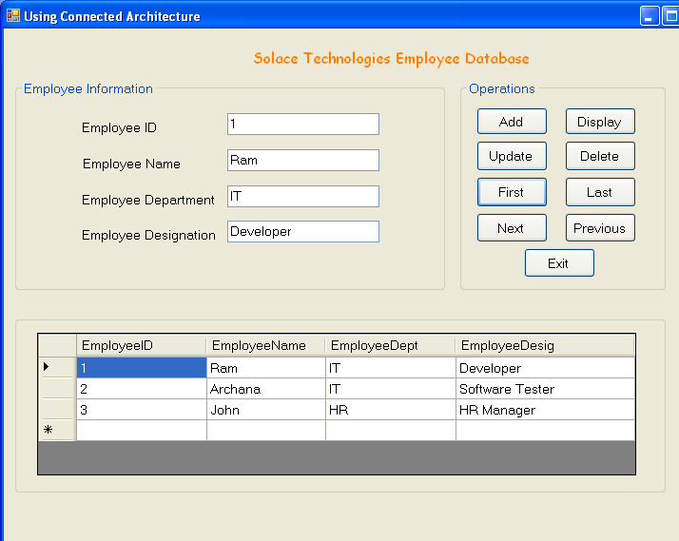

Disconnected Architecture Demo –

1] Here we are going to do above same application using
Disconnected Architecture.

2] So we will keep the GUI and all Interface or Form design same as above
Windows Application,

3] Do this small change in above GUI
We will add one additional button on Form –
i.e. Update To Database Button.

And

Instead of Display Button we will add Insert Button to Demo.

4] So, Here in demo After Clicking Add Button all textboxes gets clear.

And

If we want add new record First click Add Button and then Click Insert
Button.

5] Whole Code will like this -

using System;
using System.Collections.Generic;
using System.ComponentModel;
using System.Data;
using System.Drawing;
using System.Text;
using System.Windows.Forms;
using System.Data.SqlClient;// Add this namespace

namespace DisconnectedArchitectureDemo
{
public partial class Form1 : Form
{
public Form1()
{
InitializeComponent();
}

SqlConnection con;
SqlDataAdapter adp;
DataSet ds;
SqlCommandBuilder cmb;

int pos;

// Bind() Method To Bind Control with Datasource/Database

public void Bind()
{
txtEmpID.DataBindings.Add("Text", ds.Tables[0],
"EmployeeID");
txtEmpName.DataBindings.Add("Text", ds.Tables[0],
"EmployeeName");

txtEmpDept.DataBindings.Add("Text", ds.Tables[0],
"EmployeeDept");
txtEmpDesig.DataBindings.Add("Text", ds.Tables[0],
"EmployeeDesig");

}

// ClearBind() Method to clearing Bindings of controls.

public void ClearBind()
{
txtEmpID.DataBindings.Clear();
txtEmpName.DataBindings.Clear();
txtEmpDept.DataBindings.Clear();
txtEmpDesig.DataBindings.Clear();
}

private void Form1_Load(object sender, EventArgs e)
{

con = new SqlConnection("Integrated Security=SSPI;Persist
Security Info=False;Initial Catalog=Employee;Data
Source=.\\SQLEXPRESS");

ds = new DataSet();

adp = new SqlDataAdapter("select * from EmployeeInfo",
con);

adp.MissingSchemaAction = MissingSchemaAction.AddWithKey;

adp.Fill(ds, "EmployeeInfo");

Bind();

dataGridView1.DataSource = ds.Tables["EmployeeInfo"];

}

private void btnUpdateToDatabase_Click(object sender, EventArgs e)
{
cmb = new SqlCommandBuilder(adp);
adp.Update(ds.Tables["EmployeeInfo"]);
}
private void btnAdd_Click(object sender, EventArgs e)
{
txtEmpID.Text = "";
txtEmpName.Text = "";
txtEmpDept.Text = "";
txtEmpDesig.Text = "";

txtEmpID.Focus();

ClearBind();
}

private void btnUpdate_Click(object sender, EventArgs e)
{

ClearBind();

DataRow dr;

dr = ds.Tables[0].Rows.Find(txtEmpID.Text);

if (dr != null)
{
dr[0] = txtEmpID.Text;
dr[1] = txtEmpName.Text;
dr[2] = txtEmpDept.Text;
dr[3] = txtEmpDesig.Text;

Bind();

dataGridView1.DataSource = ds;
dataGridView1.DataMember = "EmployeeInfo";
}
else
{
MessageBox.Show("EmployeeID Doesn't Exists");
}
}

private void btnDelete_Click(object sender, EventArgs e)
{
ds.Tables[0].Rows.Find(txtEmpID.Text).Delete();
}

private void btnFirst_Click(object sender, EventArgs e)
{
this.BindingContext[ds.Tables[0]].Position = 0;
pos = 0;
}

private void btnLast_Click(object sender, EventArgs e)
{
this.BindingContext[ds.Tables[0]].Position =
ds.Tables[0].Rows.Count - 1;

pos = ds.Tables[0].Rows.Count - 1;
}

private void btnNext_Click(object sender, EventArgs e)
{
pos = pos + 1;
if (pos > ds.Tables[0].Rows.Count - 1)
{
pos = ds.Tables[0].Rows.Count - 1;
MessageBox.Show("You are at Last Record", "Message",
MessageBoxButtons.OKCancel, MessageBoxIcon.Hand);
}
this.BindingContext[ds.Tables[0]].Position = pos;
}

private void btnPrevious_Click(object sender, EventArgs e)
{
pos = pos - 1;
if (pos < 0)
{
pos = 0;

MessageBox.Show("You are at First Record",
"Message", MessageBoxButtons.OKCancel,
MessageBoxIcon.Information);

}

this.BindingContext[ds.Tables[0]].Position = pos;
}

private void btnInsert_Click(object sender, EventArgs e)

{
DataRow dr;
dr = ds.Tables[0].NewRow();

dr[0] = txtEmpID.Text;
dr[1] = txtEmpName.Text;
dr[2] = txtEmpDept.Text;
dr[3] = txtEmpDesig.Text;

ds.Tables[0].Rows.Add(dr);
Bind();

dataGridView1.DataSource = ds;
dataGridView1.DataMember = "EmployeeInfo";
}

private void btnExit_Click(object sender, EventArgs e)

{
Application.Exit();
}
}
}

6] Press F6 key to Build/Compile application.

7] Press F5 key Run application.

Output –

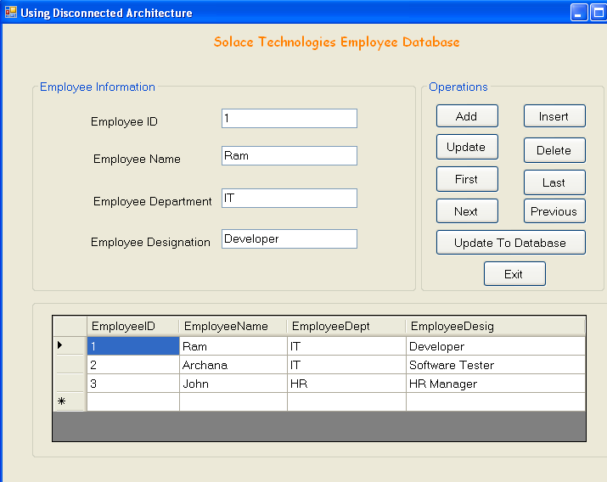

DataView Demo –

1] Create Windows application.

2] Set Form1 Text Property - Use of DataView.

3] Drag Drop Two GroupBox Controls on Form.

Set their Text Properties as and Font size to 10 –

groupBox1 - Selected Table From Database.
groupBox2 – Created DataView Showing Employees Working in IT Dept

4] Drag Drop Two DataGrid Controls

dataGridView1 on Selected Table From Database.

dataGridView2 on Created DataView Showing Employees Working in IT
Dept.

5] Drag Drop One Button Control.

Set Name property as Name – btnDataView.

And

Set Text property as Text – Show Records of Employees Working in
'IT Dept' Using DataView

6] Double click on button so that we will get btnDataView_click Event.

7] Put respective code on this event from Whole Code Part.

8] Whole Code will like this –

using System;
using System.Collections.Generic;
using System.ComponentModel;
using System.Data;
using System.Drawing;
using System.Text;
using System.Windows.Forms;
using System.Data.SqlClient;// Add This Namespace.

namespace DataViewDemo
{
public partial class Form1 : Form
{
public Form1()
{
InitializeComponent();
}

SqlConnection con; // Declared connection object.
SqlDataReader dr; // Declared DataReader object.

DataTable dt, dt1; // Declared DataTable object

private void Form1_Load(object sender, EventArgs e)
{
con = new SqlConnection("Integrated Security=SSPI;Persist Security Info=False;Initial Catalog=Employee;Data Source=.\\SQLEXPRESS");

con.Open();

DisplayData();

}

public void DisplayData()
{
SqlCommand cmdDisplay = new SqlCommand();

cmdDisplay.CommandType = CommandType.Text;
cmdDisplay.CommandText = "Select * From EmployeeInfo";
cmdDisplay.Connection = con;

dr = cmdDisplay.ExecuteReader();

dt = new DataTable();
dt.Load(dr);

dataGridView1.DataSource = dt;
}

private void btnDataView_Click(object sender, EventArgs e)
{
SqlDataAdapter da = new SqlDataAdapter();

da.SelectCommand = new SqlCommand("Select * from
EmployeeInfo",con);

DataSet ds = new DataSet();

da.Fill(ds,"EmployeeInfo");

DataTable dt1 = ds.Tables["EmployeeInfo"];

DataView dv = new DataView(dt1,"EmployeeDept ='IT'","EmployeeDept",DataViewRowState.CurrentRows);

dataGridView2.DataSource = dv;

}
}
}

Output –

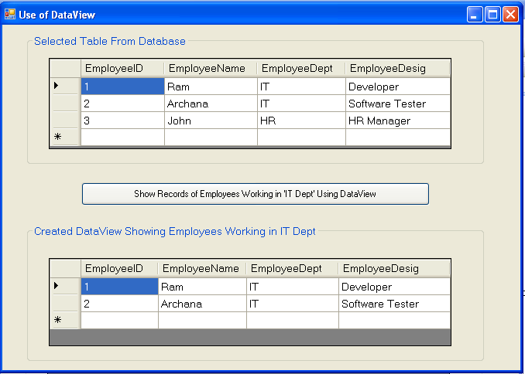

Summary

1] ADO.NET –

Collection of –

1] Namespaces

And

2] Classes

Which are required to connect with various Databases collectively
called as – ADO .NET

2] ADO.NET is important part of .NET Framework.

3] Two important components of ADO .NET Object Model –

1] Data Provider.

2] DataSet.

4] Data Provider model is made up following components –

1] Connection.

2] Command.

3] DataReader.

3] DataAdapter

5] DataSet in nothing but in memory cache of data.

6] There are two types of Database Architectures –

1] Connected.

2] Disconnected.

7] Following are various classes used in ADO .NET –

1] Connection. 2] Command.

3] DataRaeder. 4] DataAdapter.

5] DataSet. 6] DataTable.

7] DataView

8] Connection Class is used to establish connection with Database.

9] Command Class is used to execute PL/SQL commands or queries on
Database.

10] Command Class has following Important Properties –

1] CommandType.

2] CommandText.

3] Connection.

11] Command Class has following Important Methods –

1] ExecuteNonQuery().

2] ExecuteScalar().

3] ExecuteReader().

12] DataReader is used to retrieve a Read-only, Forward-only stream of data
from database.

13] Data Adapter acts as bridge between Database and DataSet.

14] DataSet is in memory cache of data.

15] DataTable is one table’s data present in memory cache.

16] DataView allows us to create various views of data stored in DataTable.

Exercise

1] What is ADO.NET?

2] What are different components of Data Provider Model?

3] What is DataSet?

4] What are different types of Database Architectures?

5] Explain Connected Architecture.

6] Explain Disconnected Architecture.

7] What are different classes used in ADO.NET?

8] Explain use of following classes which are used in ADO .NET –

1] Connection. 2] Command.

3] DataRaeder. 4] DataAdapter.

5] DataSet. 6] DataTable.

7] DataView

9] Explain important properties of Command Class.

10] Explain important methods of Command Class.

