CSCU9E5 Individual Modelling Assignment (Resit)
Computing Science and Mathematics — University of Stirling
Student Number: YOUR_STUDENT_NUMBER

State Machine Diagram
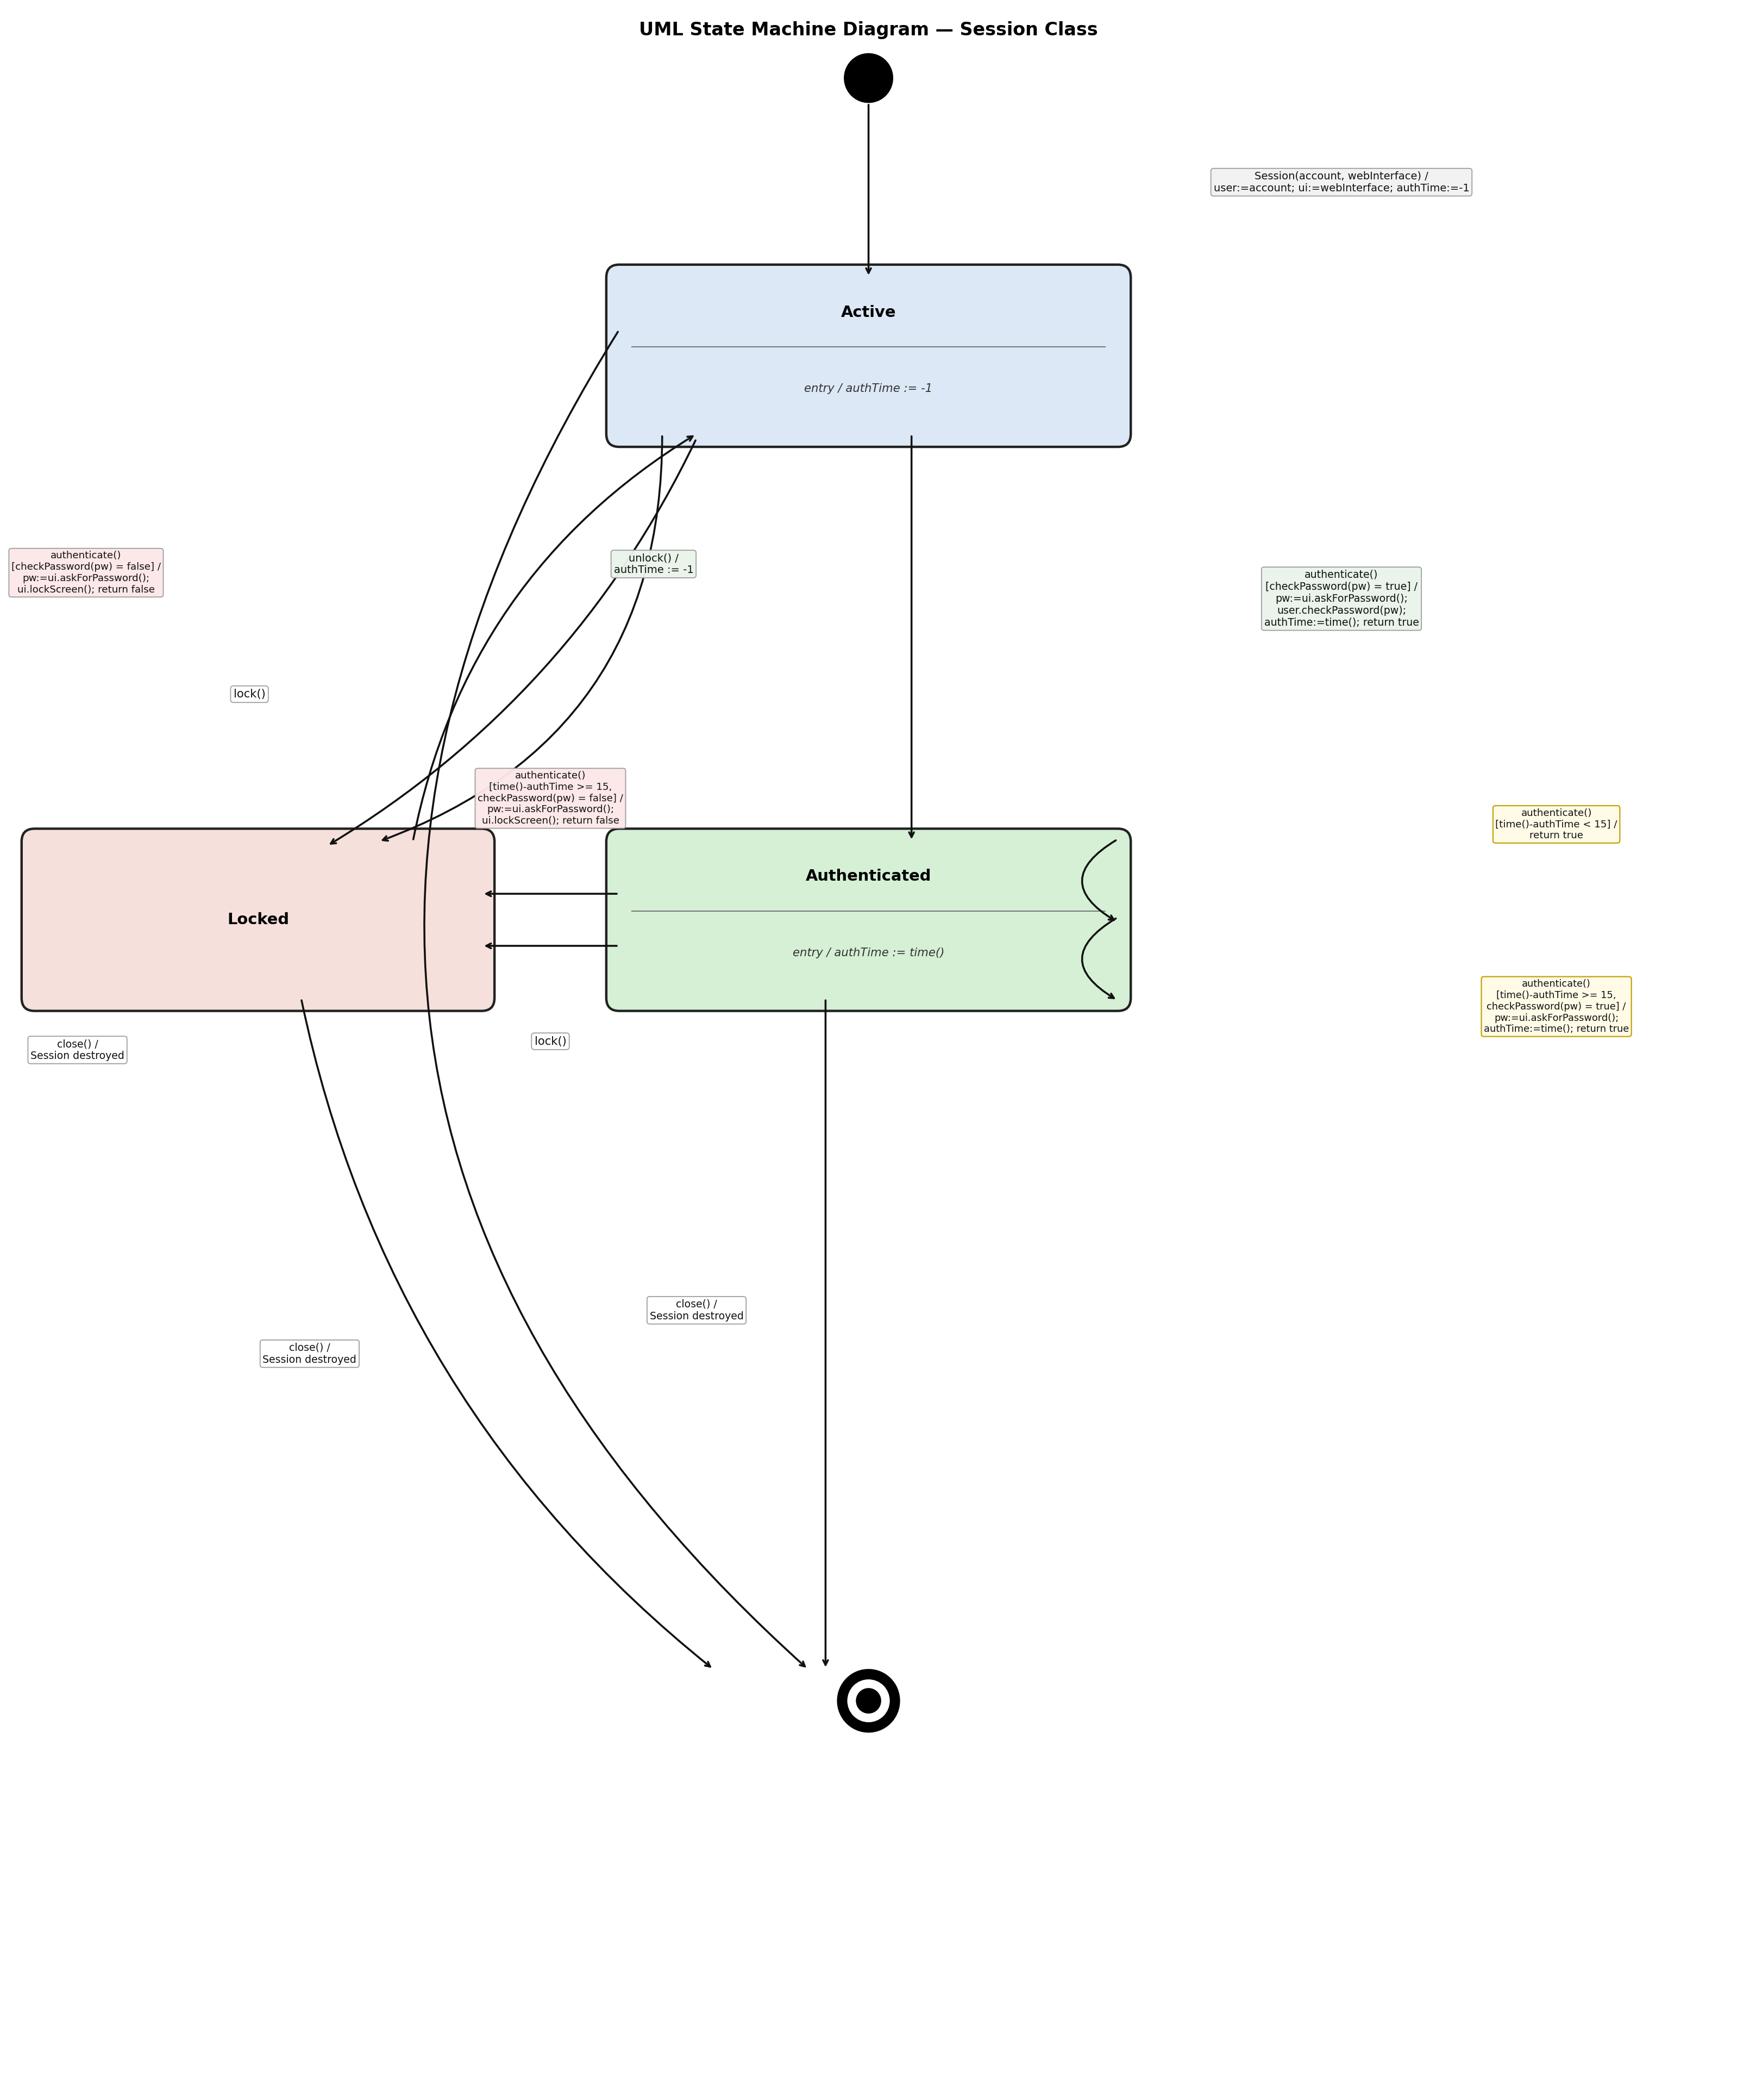
This state machine diagram was produced using Python (matplotlib library).

State Descriptions
Active
The Active state is the default running state entered immediately after the Session object is constructed. No valid authentication is currently held: this occurs either because the session has just started, because the 15-minute authentication window has expired, or because the screen was just unlocked after a lock event, requiring the user to re-authenticate before accessing the system.
Authenticated
The Authenticated state represents a session in which the user has successfully supplied the correct password within the last 15 minutes. While in this state the user may call access() repeatedly without being asked for their password again, as the guard condition time() − authTime < 15 will evaluate to true and authenticate() returns true immediately. Once 15 minutes have elapsed the session transitions back to requiring re-authentication on the next access() call.
Locked
The Locked state is a suspended state in which the screen is inaccessible. It is entered either when the user manually calls lockScreen() (which invokes lock() on the Session) from either the Active or Authenticated state, or automatically when checkPassword() returns false after a password attempt. The session object is preserved but no further access is possible until the user calls unlockScreen(), which invokes unlock() and resets authTime to −1, ensuring full re-authentication is required on the next access() call.
Final State
The Final State is the terminal pseudostate that represents the destruction of the Session object. It is reached when close() is called from any active state — Active, Authenticated, or Locked — confirming that the user may end the session at any time regardless of authentication status or screen lock. Once this state is entered the Session object is destroyed and the interaction ends.

Added Attributes
−authTime : Integer
Type: Integer. Purpose: Records the value returned by time() at the moment the user last successfully authenticated. The attribute is initialised to −1 at session creation (in the T1 constructor transition) and reset to −1 whenever unlock() is called (T11), indicating that no valid authentication is currently held. It is used in the guard conditions of the authenticate() transitions: the condition time() − authTime < 15 determines whether the 15-minute window is still active (permitting re-use of the cached authentication in T6), while time() − authTime ≥ 15 determines that the window has elapsed and full re-authentication is required (T7 and T8).

