ICT292 Information Systems Management

# Lab 03: SharePoint Lists

SharePoint is used for many things, including the capacity to store and view data. One of the tools it uses to do this is the List. There are a number of different pre-defined lists that come with SharePoint and can be used out of the box. You may already have experimented with them at some point during your exploration of SharePoint so far.

## Aims:

The primary aims of this lab are for you to:

* Be able to create a range of SharePoint lists

## To be prepared for this lab, you will need to:

* Be correctly enrolled in the unit, and
* Have a web-browser ☺
* Have access to: [ICT292_2023TSA - Home (sharepoint.com)](https://murdochuniversity.sharepoint.com/sites/ICT292_2023TSA)

Introduction

*“A list in SharePoint is a collection of data that gives you and your co-workers a flexible way to organize information.*

*Add columns for different types of data, such as text, currency, or multiple choice. Create views to display data effectively. Sort, group, format and filter lists to highlight the most important information. A list can include people, links, pictures, dates, and more. Track history of a list item over time with versions and use Microsoft Flow to automate processes.”*

(<https://support.office.com/en-us/article/what-is-a-list-in-sharepoint-93262a88-20ad-4edc-8410-b6909b2f59a5> )

There is a wide range of out-of-the-box lists that you can create. You create a list by creating an App (you also create libraries using Apps, but we will look at libraries in the next lab). In order to create a list, you first select the template to use as a starting point; the templates that are available to you include the data types, views and forms that will allow you to edit, retrieve and view the data stored in the list.

### Task 1: Creating Lists Using List Templates.

There are a number of lists you can create using existing list templates. In this task, you will create two lists and then add them to a page.

**Go to your own subsite! Please do not create Lists in the ICT292 Subsites site.**

* 1. **Create a Contacts List**
* Click Settings and Add an App

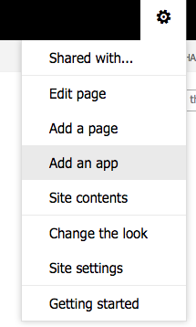

* Type ‘Contacts’ in the search box and search *(You may have to select* ***classic experience*** *to get here – see arrow in the figure)*:

**Find classic experience**

**Search Contacts App**

* Select the Contacts App

* Name your new Contacts list using your Student number.
* In your subsite you should now be able to see your new list in Site Contents area:

* Open your contacts list
* If you are not already in “Classic View” you will see a link at the bottom LHS of the screen, that you should select:

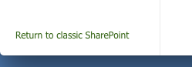

* Then select List settings:

* *Note: You can get List Settings from the List toolbar (if you have selected classic experience):*

* Either way click the ‘List name, description and navigation’ option:

* …and select Yes for “Display this list on the Quick Launch”, and Save.

* Add a new item to the Contacts list by opening your contact list and clicking (you could add your own details and click Save).

We will be coming back to this list later.

* 1. **Create a Discussion Board List**
* Using a similar approach to that which you used to create the Contacts list, create a Discussion Board list, and explore some of its functionality.
* Go to the List Settings and Share the Discussion Board with another student in your class to learn more about how it works.
* Following previous steps, search discussion and you will see something like this:

### Task 2: Create a Custom List

In this task, you will create a custom list that shows you some of the options you have when creating input forms.

* Create a Custom List and call it Demo List. (Remember go to site setting, add an app, classic experience) You will see this and then select custom list

* Open the list. You should see there are no entries in the list, and the only column in the list is called “Title”
* Go to site content and select demo list

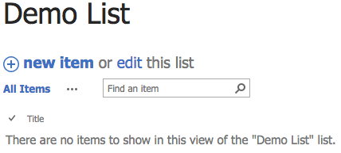

* Go to the List toolbar and select Create Column from the Manage Views area:

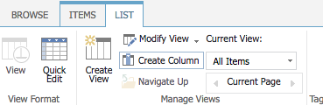

* In the Create Column dialogue:
  + Name the column Favourite Food, and select “Single Line of text” as the type of information in the column:

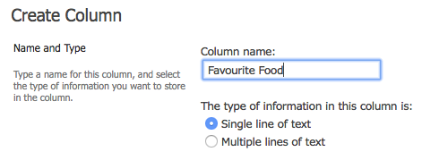

* Click OK to add the column.
* Add another column:
  + Column name: Favourite Colour
  + Type of information: Choice

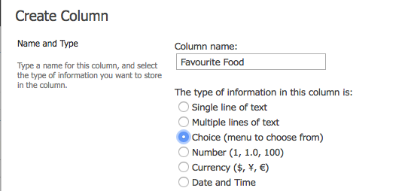

* + Add the following to the “Type each choice on a separate line” text box:
    - Red, Blue, Green, Orange

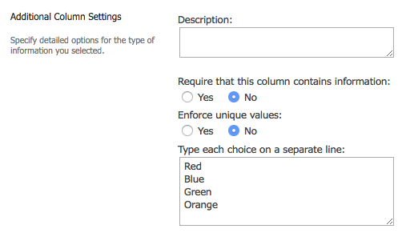

* + Click OK to add the column
* Add another column:
  + Column name: Birthday
  + Type of information: Date and Time
  + Require that this column contains information: Yes
  + Default Value: Today’s Date

* + Click OK
* Add another column:
  + Column Name: Who
  + Type of information: Person or Group
  + Choose From: All Users
  + Show Field: Name

* Click OK.

Create a new sample item in your Demo list by adding your lecturer’s details.

### Task 3: Column Validation

As discussed in the lecture for this topic, being able to create data that has already been added to our databases can add value; better, though, to have some form of validation on data entry. In this task you will add validation to the Birthday column of the Demo List you created previously to make sure that any values entered are earlier than today’s date.

* Open your Demo List in List view and select List Settings

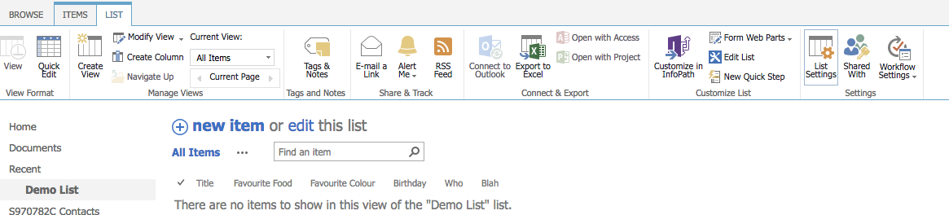

* In order to Edit the Birthday column, Go to List Settings, select Birthday from the Columns area:

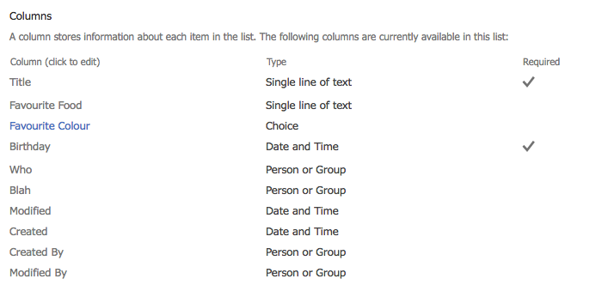

* At the bottom of the Edit Column page is Column Validation. Expand this, and add the following formula into the Formula box: =[Birthday]<TODAY()
* Enter a useful message for the user below and Click OK

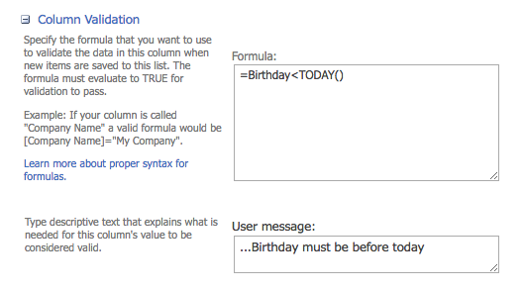

* Now add a new item to the Demo List to see if your validation works and what happens if you enter a value for Birthday that is after today’s date.

### Task 4: Working with Team Site Lists

In this task, you will look at two very useful lists that will be useful for group and team work; calendars and task lists. Instructions can be found at: <https://www.webucator.com/tutorial/learn-microsoft-sharepoint/sharepoint-list-basics/working-with-team-site-lists-exercise.cfm#tutorial>

## Challenge Task

This is an optional task, but you might like to try it. When you complete it, please feel free to post a screen shot to the Discussion Forum.

You have been given the task of creating a task list. If you have done any project management in the past, you will know what a Gantt chart is; if you are not sure see: <http://www.gantt.com>

You can create Gantt charts using the Tasks list app in SharePoint. Your task here, is to find out how to do it and create a Gantt chart that shows the following:

Project Name: Getting the Job Done

|  |  |  |  |  |
| --- | --- | --- | --- | --- |
| Task Title | Start Date | Due Date | % Complete | Predecessors |
| Project Kickoff Meeting | 15th January 2019 | 15th January 2020 | 100 |  |
| Complete Stakeholder Interviews | 24th January 2019 | 30th January 2020 | 50 | Project Kickoff Meeting |
| Create Requirements Document | 31st January 2019 | 4th February 2020 | 0 | Complete Stakeholder Interviews |
| Complete Staff Hiring | 20th February 2019 | 22nd February 2020 | 0 | Project Kickoff Meeting |

## In the next lab:

We will be looking at libraries. Make sure that you understand what we have covered in this lab so you will be able to make best use of the next lab.

Version 1.0: 15th August 2016

1.1: 8th August 2017

2.0: 9th May 2018

SPO Version: 26th January 2019

SPO.1: 11th August 2019

2.1: 28th April 2020

2.2: 16th July 2020