**INDOOR MEASUREMENT OF MILLIMETER WAVE THROUGH HYBRID BEAMFORMING**

Submitted By

Faryal Naeem D-15-T.E-45

Asma Wassan D-15-T.E-43

Amna Tariq D-15-T.E-40

Jaweria Asif D-15-T.E-48

**Supervised By**

**Engr. Bushra Shaikh**

**&**

**Co-Supervised by**

**Engr. Tayyaba khurshid**



A PROJECT THESIS SUBMITTED IN PARTIAL FULFILLMENT OF THE REQUIREMENT FOR THE DEGREE OF

Bachelor of Engineering in Telecommunication

Department of Telecommunication Engineering

Dawood University of Engineering & Technology, Karachi

**Batch 2015**

# ACKNOWLEDGMENT

We express our overall submission and everlasting appreciation to **ALMIGHTY ALLAH,** the most gracious, the most merciful, without **HIS** help, mercy and grace, this enterprise could not have been possible even in its slightest.

We would like to thank all of the respected human beings whose support and encouragement made this assignment a probable. We consider it an honor and privilege to pay our heartfelt appreciation and gratitude to our chairman **Dr. Izhar Hussain Zaidi** for his steerage, recommendation and non-stop encouragement in difficult and anxious segment of our task. He helped us in all steps on finishing this tedious project and in obtaining promising effects.

Deepest thanks and appreciation to our parents, Vice Chancellor **Dr. Faizullah Abbasi,** Academic Coordinator **Dost Ali Khuwaja** and our Dean, **Dr. Waheed Bhutto,** without their encouragement, the prevailing observe could have been our merry dream.

Furthermore, we would really like to provide our whole coronary heart thanks to our Telecommunication Engineering Department, Dawood university of Engineering and technology Karachi and its all faculty contributors for supplying necessary help and steerage during project

# ABSTRACT

The increasing demand of high data rate and high speed of internet makes it incapable for 3G and 4G communication technologies to meet user needs. 5G implementation will become necessary in coming years. The two main technologies of 5G are Millimeter (MM) wave and Beam forming. The combination of these technologies is the greatest need for future wireless communication systems. Most of existing wireless technologies work at RF and microwave spectrum. MM wave is the radio band having frequency range from 30 GHz and 300 GHz, highly suitable for high speed broadband access, based on spectral efficiency and bandwidth. It has short wavelengths and narrow beam width, hence cannot penetrate. In mm-wave scenario, the path loss is very high. High path loss can be combatted by antenna array and beam forming via channel pre-coding. Multiple-input-multiple output (MIMO) is necessary for mm-wave frequencies because it achieves beam forming gain for providing enough signal-to-noise-ratio (SNR) hence MM-wave combined with MIMO communication is more effective in future. In short, this research aims to perform hybrid beam forming and identify the optimal parameters of MIMO transceiver suitable for mm-wave frequency band on MATLAB. This is done through different parameters of beam forming. Further, it is analyzed that how the millimeter wave behaves with beam forming, and what are its effects on channel parameters under AWGN fading model. SNR and BER are evaluated for this MIMO system comprising of 8 and 16 array elements and hybrid beamforming through simulations. Increasing antenna effects and their resulting SNR effects are checked. The main aim of this project is to find the best possible solution for 5G communication. This research helps to conclude beneficial results for telecom industry.

Table of Contents

ACKNOWLEDGMENT 2

ABSTRACT 4

LIST OF ABBREVATION: 11

CHAPTER 1 13

INTRODUCTION TO MILLIMETER WAVE 13

1.1.Basic concept 13

1.1.1.Why millimeter wave is used: 14

1.2.key challenges and solution 15

1.2.1System design and integrated circuit: 15

1.2.2 Spatial reuse and interference management: 16

1.2.3 Anti- blockage: 16

1.2.4 Low latency and high data rate: 17

1.3ADVANTAGES AND DISADVANTAGES OF MILLIMETER WAVE 17

1.3.1 Advantages: 17

1.3.2 Disadvantages: 18

1.4.Application 18

1.4.1 5G and small cell concept: 18

1.4.2 HD video applications: 18

1.4.3 IEEE 802.11ad WI GIG technology: 19

1.4.4 Satellite communication: 19

1.4.5 Millimeter automotive applications: 19

1.4.6 Body scanners: 19

1.4.7 Radar communication: 19

1.5BEAMFORMING: 20

1.5.1 What is beamforming? 20

1.5.2 What happening with beamforming? 20

1.5.3 What is beamforming in LTE? 21

1.5.4 What is the reason of doing beamforming? 21

1.5.5 What is beamforming innovation? 21

1.6 Advantages of beamforming: 21

1.6.1 Disadvantage of beamforming: 21

**CHAPTER 2** 23

**LITERATURE REVIEW** 23

2.1 FROM MIMO TO MASSIVE MIMO 23

2.2 SYSTEM CHARACTERISTICS: 24

2.2.1 Scalability: 24

2.2.2 TDD scheme is more favorable: 25

2.2.3 ANTENNA ARARY SIZE: 25

2.3 MASSIVE MIMO TYPES 25

2.3.1 Single user mimo: 25

2.3.2 Multi user mimo: 25

2.3.3 Multi user MIMO with cell scenario: 26

2.3.4 Distributed massive mimo: 26

2.4 BENEFITS OF MASSIVE MIMO: 26

2.4.1 Spectral efficiency: 26

2.4.2 Energy efficiency: 26

2.4.3 User tracking: 26

2.4.4 Increasing capacity: 27

2.4.5 Robustness against interference and jamming: 27

2.4.6 Inexpensive and low power components: 27

2.4.7 Low latency: 27

2.5 CHALLENGES: 27

2.5.1 Uplink pilot contamination: 27

2.5.2 Pilot allocation: 28

2.5.3 Smart estimation: 28

2.5.4 TDD scheme: 28

2.5.5 Channel response: 28

2.6 MILLIMETER WAVE: 29

2.6.1 MM wave systems: 29

2.7 CHALLENGE OF USING MMWAVE LINKS: 30

2.7.1 Challenges of directivity: 30

2.7.2 Challenges of antenna allocation: 30

2.7.3 Challenges of phase noise: 30

2.7.4 Challenges of downlink channel estimation: 30

2.7.5 Atmospheric effects: 31

2.7.6 Fading: 31

2.8 HYBRID BEAMFORMING: 31

2.8.1 Background: 31

2.8.2 Going Hybrid beamforming: 32

2.9 SOFT ANTENNA SELECTION: 32

2.9.1 Adaptive beamforming: 32

2.9.2 Structure type of antenna beam formers: 33

2.10 CHALLENGES OF HYBRID BEAMFORMING: 33

2.10.1 Narrowband single user system with perfect CSI: 33

2.10.2 Narrowband multi user system with perfect CSI: 34

**CHAPTER 3** 35

**METHODOLOGY** 35

3.1 SCNERIO OF RESEARCH: 35

3.2 RESEARCH AIM: 36

3.3 WHY HYBRID BEAMFORMING IS USED 36

3.4 SOFTWARE: 37

3.4.1 Introduction to software (MATLAB). 37

3.5 MEASURMENT PARAMETERS: 38

3.6 PROJECT ALGORITHM: 38

3.6.1 MECHANISM: 38

3.6.2 Working 39

3.6.3 Modulation technique used in MU-MIMO hybrid system: 40

3.7 PRECODING OF HYBRID: 41

3.8 HYBRID BEAMFORMING EFFECTS: 42

**CHAPTER 4** 44

**RESULTS AND ANALYSIS** 44

4.1 SIMULATION PARAMTERS: 44

4.1.1 Number of Users 44

4.1.2 Number of Data streams per user 44

4.1.3 Number of Base stations Antennas 44

4.1.4 Modulation Scheme 44

4.1.5 Channel Information 44

4.3 SNR VS SPECTRAL EFFECIENCY: 46

**CONCLUSION AND FUTURE WORK** 48

REFERENCES: 49

# LIST OF ABBREVATION:

5G Fifth Generation

MMWAVE Millimeter Wave

MIMO Multiple Input Multiple Output

MU-MIMO Massive Multiple Input Multiple Output

BF Beamforming

ITU International telecommunication union

CBS Cavity-Backed Shot

TDMA Time Division Multiple Access

LOS Line Of Sight

NLOS Non Line Of Sight

MEC Moving Extended Cells

HD High Definition

UHD Ultra-High Definition

LTE Long Term Evolution

3GPP 3rd Generation Partnership Project

BS Base Station  
MS Mobile Station

TDD Time Division Duplex

FDD Frequency Division Duplex

SU-MIMO Single User Multiple Input Multiple Output

ADC Analog Digital Converter

DAC Digital to Analog Converter

HB Hybrid Beamforming

T/R Transmitter and Receiver

SVD Singular Value Decomposition

ZF Zero Function

UE User Equipment

MATLAB Matrix Laboratory

RF Radio Frequency

SNR Signal to Noise Ratio

BER Bit Error Rate

CSI Channel State Information

SE Spectral Efficiency

OFDM Orthogonal Frequency Division Multiplexing

AWGN Additive White Gaussian Noise

JSDM Joint Spatial Division Multiplexing

EE Energy Efficiency

# CHAPTER 1

# INTRODUCTION TO MILLIMETER WAVE

## BASIC CONCEPT

Millimeter wave means waves from Extremely high frequency (EHF) band. In millimeter wave the band of spectrum is 30 GHz and 300 GHz. Basic concept of millimeter wave is also referring to the latest technology of fifth generation (5G). International telecommunication union (ITU) has used Millimeter band for high speed wireless broadband communications and used for a variety of services on mobile networks.

Researchers are using millimeter wave spectrum for the testing purpose of 5G wireless broadband technology. Millimeter wave has very high frequency which means it has short wavelength in the range of 10 mm to 1 mm due to short wavelength the power consumption of the millimeter wave is very high. So, this is the disadvantage of millimeter wave in communication. In order to fulfill the requirement of 5G technology to achieve higher data rates, millimeter wave technology can be used because it has higher frequency and higher data rate. As compared to the 4G, the 5G has more data rate, faster and more efficient. So, 4G has low speed and low data rate than 5G. Today’s mobile user and companies need faster data speeds and more reliable services, such as faster internet, video streaming, HD movies and femto cell. This type of services used more data speed and the 5G promises to fulfil this type of issues and problem of high data rate. Because of high speed of 5G. Until now the real-world application like operators of satellites and radar system used millimeter waves. Now a day, researchers and companies have set more expectations for 5G by promising the higher data rate for consumers or users and engineers hope to build the high-speed wireless broadband networks like video streaming, HD movies, future smart phones and VR gamers will rely on every time and every day. Millimeter wave is an unlicensed band of spectrum that can be used in a broad range of products and services like high speed, point to point WLANS and broadband access.

Due to its short range of about a kilometer, millimeter wave travels by line of sight. So, its high frequency wavelengths can be blocked by physical objects like gain antenna to compensate high path loss, and the transmission of channel on-off behavior and booster network architecture for connectivity. To assure the higher directional millimeter signals, we need beamforming or spatial filtering is signal processing technique used in sensor arrays for transmission or reception of directive signals to achieve spatial diversity.

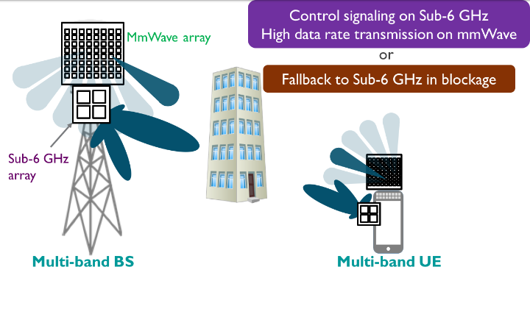

# **Figure 1. Millimeter wave [1]**

### WHY MILLIMETER WAVE USED IN 5G:

Millimeter wave (mm wave) has very high frequency, high data rate, high capacity and high-speed latency. In this era of Internet of things, more number of devices need to be accommodated so a new bandwidth is used to satiate this need of high speed devices, streaming videos, faster internet speed and VR gamers. In telecommunications, the United States used the band of 36.0 – 40.0 GHz for licensed high-speed microwave data links, and the 60 GHz band it is the millimeter band can be used for unlicensed short range (1.7 Km) data links. However, there are many reasons why millimeter technology has used within astronomy, military, and research applications for so many years because of the high cost of the components and the relative to testing 5G wireless network equipment evaluating and aligning the hardware. Another concept of millimeter is that the signals at 24 GHz and above can be absorbed by the any type of objects in their propagating path, such as buildings trees. But millimeter wave frequencies also have benefits, they offer freehanded bandwidth such as their use of much small antennas compare to lower frequencies and this use of small antennas makes it possible to pack many of them together in to small type of factors to benefit from antenna arrays. 5G network architecture will be much different than earlier wireless high-speed broadband network generations in fact because of use of millimeter wave frequencies. In millimeter the smaller size of antennas will be used in mobile handset to transmit and receive those higher frequency signals and this type of reasons and opportunities the 5G used millimeter technology for high communications networks and fulfil the future requirements.

## KEY CHALLENGES AND SOLUTIONS

* Integrated Circuits and System Design
* Interference Management and Spatial Reuse
* Anti - blockage
* High Data Rate and Low Latency
  + 1. System Design and Integrated Circuit:
* Severe nonlinear distortion of power amplifiers
* Phase noise
* Highly directional antennas

**Solutions:**

* Phased array antennas operating at 28 GHz with near spherical coverage
* Cavity-backed shot (CBS) antenna
* Planer aperture antenna with different feeding
* Planner superstrate antenna suitable for integration with millimeter wave transceiver integrated circuits

## 1.2.2 Spatial Reuse and Interference Management:

Interference in the network can be divided into inter-BSS interference and intra- BSS interference

**Solutions:**

* Power control and transmission coordination
* Spatial reuse
* TDMA
* Centralized coordination

### 1.2.3 Anti- Blockage:

**Solutions:**

* Switch LOS link to NLOS link
* Equal- gain diversity scheme
* Maximal selection by tracking the shadowing process

**Dynamics due to user mobility**

* Channel variation cause significant and rapid load fluctuations in each BSS

**Solutions:**

* Optimal distributed association algorithm
* Handover scheme based on Moving Extended Cells (MEC)

### 1.2.4 Low Latency and High Data Rate:

**Solutions:**

Depending on the considered scenarios and use-cases, there are some basic requirements for 5G provided by Next Generation Mobile Networks Alliance

* Very high data rates: 1 to 10 Gb/s (e.g., virtual reality office)
* Large number of connected devices: up to 300,000 devices per access point (e.g., massive deployment of sensors)

## ADVANTAGES AND DISADVANTAGES OF MILLIMETER WAVE

### 1.3.1 Advantages:

* Millimeter wave can support higher data rate and higher frequency due to higher bandwidth
* Millimeter wave has difficulties for implementations, maintenances and it is not economical
* Main advantage of millimeter wave can easily have achieved 10 Gbps data rate for communication
* another major advantage of millimeter wave is its small component size and it is necessary for communication because of modern smart devices and mobiles phones must efficient and small
* Millimeter waves are complex. Because of higher power consumption
* The main advantage of this technology is that it reduces hardware size means it has higher frequency and smaller the antenna size
* More number of subscribers can be accommodated due to the larger bandwidth of millimeter wave

### 1.3.2 Disadvantages:

* Main disadvantage of millimeter wave technology is that it has higher power consumption due to a greater number of antennas and it has required line of sight communication
* One of major disadvantage of millimeter wave technology are distortion from atmosphere
* Millimeter waves are not suitable for long distance communication because of higher distortion from atmosphere conditions like (fog and dust)
* The main disadvantage of millimeter wave is that it only support LOS (line of sight) propagation
* The millimeter wave has higher cost in manufacturing and the penetration power of millimeter wave-concrete walls is known less

## APPLICATIONS

### 1.4.1 5G and Small Cell Concept:

5G is one of the latest technologies which is discussed in present times and due to its requirements of higher data rate 5G will be used millimeter wave (between 30 GHz and 300GHz range) with the support of millimeter wave many companies are investing and testing in WLAN infrastructure. However, the well-known concept of small cell could choose millimeter waves for its future implementation and requirements

### 1.4.2 HD Video Applications:

The basic role of millimeter wave in HD video application is that it can be used to convert the transmission of ultra-high definition (UHD) video in to HDTV wirelessly. Small type of transmission modules can be integrated to devices for HD transmission from HD game, digital set top boxes and other high definition video sources.

### 1.4.3 IEEE 802.11ad WI GIG Technology:

Basically, the work of WI Gig technology is that it is designed and support future audio and virtual media services using WI Gig transmission protocol the higher performance transmission of data between devices and computers can be achieved and all type of wireless network interfaces is display at gigabit rate.

### 1.4.4 Satellite Communication:

Until now, the operators of satellite communication used millimeter wave because the millimeter wave has high frequency. So, it is perfect for satellite communication and gives better results and it is perfectly operated with massive data and low latency at the higher altitudes of orbits platform.

### 1.4.5 Millimeter Automotive Applications:

Millimeter wave are best option for detection radar and satellite system for automobiles. It required best and accurate detection of obstruction (like buildings and tress) and other passengers in real time and low latency because the accurate detection and necessary decision is important for automotive applications in milliseconds time frame.

### 1.4.6 Body Scanners:

Sometimes the millimeter wave is used in the form of human body scanners and getting popular now a day. We used millimeter wave human body for security purpose (like airport security). The main function of the millimeter wave human body scanners is that it can scan with high precision and cause less harm to human body. In millimeter wave human body scanners, the transmit power range is 1mW and operates at frequency range between 70GHz to 80Ghz.

### 1.4.7 Radar Communication:

Millimeter wave is perfect for high frequency radar technology and has been developing and emerging for multiple applications sometimes the property of millimeter wave called beam width and it can be used for some other forms of applications like, motions scanners, speed detection of vehicles, automatic doors, air craft, collision avoidance etc.

## BEAMFORMING:

### 1.5.1 What is beamforming?

It is a procedure that pass a signal from router and enable to focus on it. Put basically when router conveying a WIFI signal, it become extend and more extend while thee router leave the signal. It reduces the quality of a signal like signal strength for a specific area [2].

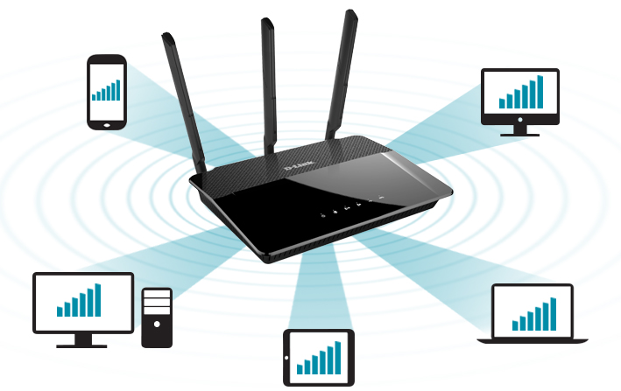

**Figure 2. BEAMFORMING [2]**

### 1.5.2 What happening with beamforming?

Transmitter and receiver of router and other internet devices used a technology of MIMO. Ability of MIMO is to receive and transmit a few signals at a time along a decided way at the end of workstation. By executing beamforming, get ready for an expansion in brilliant spilling HD video and higher data transfer capacity transmissions.

### 1.5.3 What is beamforming in LTE?

Different information various yield (MIMO) innovation is a fundamental piece of 3GPP E-UTRA long haul development (LTE). As a major aspect of MIMO, beamforming is likewise utilized in LTE. In this paper describes the fundamentals of beamforming. In LTE MIMO transmission mode clarifies the 10 downlink and 2 uplinks.

### 1.5.4 What is the reason of doing beamforming?

Beamforming is a signal preparing method utilized in sensor antenna for directional signal transmission or gathering.it has application in sound wave.

### 1.5.5 What is beamforming innovation?

Beamforming or spatial sifting is a signal handling procedure utilized in sensor exhibits for directional signal transmission or gathering. The change contrasted, and omnidirectional gathering/transmission is known as the directivity of the signal. Beamforming can be utilized for radio or sound waves.

## 1.6 Advantages of beamforming:

Several advantages are given below.

1. Beam power enhance in chosen direction. Also have to upgrade the size of cellular tower in the form of subscriber.
2. For close subscriber beam power decreases and adjacent base station interference problem may be escaped.
3. It stated that C/N ration of signal rises and besides the noisy and attenuating channel environment. Signal can be resisting so the coverage capability of base station is expanded.
4. It is generally utilized with MIMO in most recent remote advancements viz. Versatile WiMAX (IEEE 802.16e), LTE, LTE-Advanced, 5G and so forth because of its fading and interference [2].

### 1.6.1 Disadvantage of beamforming:

Some drawbacks of beamforming are given below.

1. Designing of hardware is very difficult because it has many antennas and hardware system.
2. The beamforming framework requires utilization of cutting-edge high handling DSP chip because of utilization of mathematical calculations in the outline.
3. Due to expanded equipment assets and utilization of cutting-edge DSP chip, cost of beamforming framework is higher contrast with non-beamforming framework. a
4. Power necessity in beamforming framework is higher because of utilization of more assets. Henceforth battery in beamforming framework depletes quicker [1].

# **CHAPTER 2**

# **LITERATURE REVIEW**

## 2.1 FROM MIMO TO MASSIVE MIMO

As MIMO is sub divide into two categories namely SU-MIMO and Multi user MIMO. In SU-MIMO, there are more than one antenna at the transmitter and receiver. To yield good performance in terms of link reliability, coverage and sum rate. Some of the strategies are beam forming, diversity –oriented space time coding, and spatial multiplexing of numerous data streams. Not all these can be used at once, so there will be trade-off between them.

Different situation in MU MIMO. Here different UTs shared spatially the same wireless channel and joint encoding and detection is being carried out for all. Due to facing differences in spatial signatures at BS antenna, the BS communicates directly. The BS communicate with user timely by exploiting differences in spatial signatures at BS, the BS communicates directly. The BS communicate with user timely by exploiting differences in spatial signatures at BS antenna array caused due to dispersed users will be good and yield beneficial performance [4].

The problem of co-channel interference can be resolve to some extent and MU-MIMO will suppress inter user interference. Thus, technique of spatial exploitation turns into beneficial.

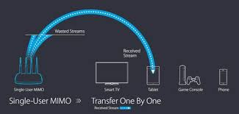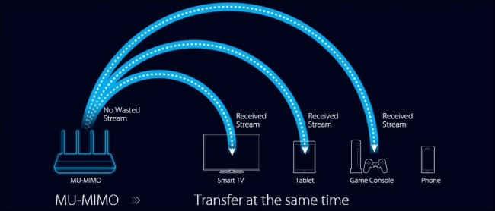

**FIG 3: Single user MIMO and Multiuser MIMO [5]**

Massive Mimo is new version of previous ones, that serves hundreds of users simultaneously in same time and frequency resource by deploying hundreds of antennas at the BS. Massive mimo can provide the benefits of previous mimo as well as enhance it more 100 times. Spectral efficiency and radiated energy efficiency enhance by using large number of antennas as compared to the present technologies. To maximize the radiated energy in preferred direction and to intended users, beamforming is best way to minimize interference and radiates energy in particular direction [5].

Massive mimo helps to increase the sum rate and energy consumption will be reduced to much extent of this. On basis of these advantages we can predict that Massive mimo is candidate for the 5G technology. Pilot contamination is however a limiting factor that has to be resolved.

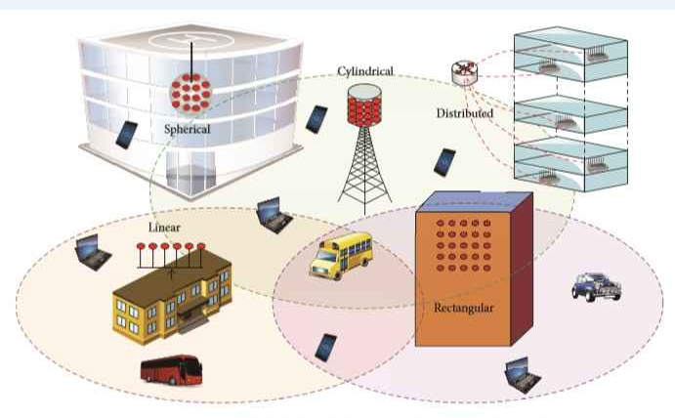

**FIG 4: MASSIVE MIMO CONFIGURATION [6]**

## 2.2 SYSTEM CHARACTERISTICS:

### 2.2.1 Scalability:

Channel estimation is done via uplink training, with TDD operation which has no concern with the number of BS antennas. Then increase number of BS antennas it does not affect the channel estimation overhead. In the same way UTs can be added or remove without affecting the service activities of other UTs as signal progressing of each UTs do not have any effect on each other.

### 2.2.2 TDD scheme is more favorable:

Working with FDD scheme the number of BS antennas matters a lot and channel estimation relies on it. For TDD the channel BS get no effect from BS antenna. In massive mimo due to large antenna array M, TDD is preferable. The figure shows that FDD need more sources for channel estimation but in TDD no such situation arises.

### 2.2.3 ANTENNA ARARY SIZE:

From all previous research the antenna sizes are concluded to be very small. A research carried at 2.6 GHz predicts the distance between adjacent antennas to be only 6cm in case of cylindrical array of 128 antennas. Hence very small antenna dimensions are required for massive mimo to work it smoothly [4].

## 2.3 MASSIVE MIMO TYPES

### 2.3.1 Single user mimo:

Presence of large number of user terminal require greater amount of service and MBs are required by all of them at once. The physical hassle of terminals requires more BS antennas but there are far less BS antennas which are less than M can’t handle the physical hassle of the terminals Therefore, the SU-Mimo lies in a category where massive antenna present at BS can achieve maximum advantages of channel orthogonalization if there is suitable channel propagation environment is present. The situation of antennas at terminals faces difficulty due to short distances between them and causes correlation. Highly LOS environment is only suitable. Moreover, this will increase the energy consumption. So SU-MIM O can be limited.

### 2.3.2 Multi user mimo:

The user terminals are allowed to share same frequency-time resource. MU-mimo is more energy efficient system. Taking single cell Mu-mimo system where K UTs are served by the BS with its own antenna. In this situation if K>2, the obtained of terminals interfere with each other but as we increase the BS, the obtained signals of each UT is mainly orthogonal. In this way the UTs are more autonomous, uncorrelated and uncoupled [5]. This shows MU-MIMO support massive mimo.

### 2.3.3 Multi user MIMO with cell scenario:

For single as well as multi cell, the increasing number of BS antennas vanish thermal noise and Raleigh fading. However, increase in cell increases the adjacent cell interference due to pilot contamination. The channel estimation by BS in one cell can be contaminated by other cells pilot transmission. As M goes on increasing the multi cells face more interference from adjacent cells.

### 2.3.4 Distributed massive mimo:

This type of massive mimo supplies greater system capacity by deploying transmitter and receiver at dispersed places. The cooperation among dispersed BS can resolve the inner cell interference but synchronization of these antennas at one BS still to be maintained [6].

## 2.4 BENEFITS OF MASSIVE MIMO:

### 2.4.1 Spectral efficiency:

As the usage of spectrum is increasing more and more spectrum is needed. So to meet this situation the unlicensed spectrum is being used in next 5G. Massive mimo antenna due to having large antenna array give rise to short wavelength of antenna which is more favourable in high frequency signals.

### 2.4.2 Energy efficiency:

Large antenna arrays help in increasing the gain of transmitting signals. So less power signals are radiated when transmitting data. In this way more energy efficiency systems are able to produce and cost of electronic device reduces to some extent.

### 2.4.3 User tracking:

This energy efficiency in massive mimo system helps in tracking individual users accurately. The beamwidth decreases for more focussed antenna in achieving high gain. So narrow beam signals are used by tower to track these individual users. In this way more reliable and distant communication become possible. Instead of wider beam signals that causes problem in some places.

### 2.4.4 Increasing capacity:

In massive mimo the aggressive spatial multiplexing results in increase in capacity. Energy efficiency become possible due to large antenna array, more intense signals with more power are transmitted. Here the main focus is on shaping of signals. The BS emits signal constructively at places of dedicated terminals. Interference can be suppressed by linear precoder example MMSE, ZF [7].

### 2.4.5 Robustness against interference and jamming:

Private wireless systems are facing intentional jamming causing cyber security risk. Due to shortage of spectrum the data spreading methods are no longer possible. In massive, the intentional jammers can be avoided by cancelling signals through DoF. The smart jammers can cause hazardous interference to the channel estimation process but this problem can be solved by joint efforts of decoding and channel estimation [8].

### 2.4.6 Inexpensive and low power components:

With massive mimo new cheap amplifiers are being used instead of traditional expensive, ultra linear 50W amplifiers. Several costly cables can be eradicated. massive mimo helps in increasing accuracy and limitations on various of electronic devices. These all characteristics makes the system performance more resilient in opposition to fading and increases the robustness.

### 2.4.7 Low latency:

Fading is major restrictive factor in wireless communication. It makes the received signals much small. This happens due to multipath signal faded completely before reaching its intended user. So it becomes difficult to construct low latency wireless links. Massive mimo using large number of antennas and beamforming presents fading from limiting latency.

## 2.5 CHALLENGES:

### 2.5.1 Uplink pilot contamination:

An orthogonal uplink pilot is assigned to every terminal in massive ideally. To obtain the maximum possible range of these pilot sequence divides the length of coherence interval with delay spread of channel [9]. Pilot sequence contamination is basically the reusing mechanism of pilots from one cell to another. When the antenna array pilot sequence correlates with pilot sequence of another terminal. The channel estimation we obtained will be mixed by linear mixture of channel and contaminated. This pilot contamination increases interference in downlink beamforming among all UTs sharing same pilots. The increasing number of antenna in massive mimo increases the resulted in growth of interference [10]. Although the previous system faces such problems but not to this extent. Pilot contamination will cause a major problem in achieving optimal performance for mitigating pilot contamination, some approaches are listed below.

### 2.5.2 Pilot allocation:

Pilot should be assigned less aggressive frequency reuse factor. In this cell contamination can be reduced. In assigning pilot sequences, coordination or adaptive allocation to the UTs are more feasible methods. For more detail see [11].

### 2.5.3 Smart estimation:

For mitigating pilot contamination blind algorithms might be helpful. Where pilots are not used in combine form. The joint estimation in blind algorithms are more promising paths [12].

### 2.5.4 TDD scheme:

For obtaining beamforming benefits chains for uplink and downlink terminals are not required. The appropriate calibration of BS tools can ensure the transmission of coherent beam to the terminal. Absolute array calibration is not required [12]. If one antenna serves as locus, and switching of signals is performed between the reference antenna and each of different antennas for compensation for that antenna. The maximum phase shift between uplink and downlink chains should be greater than 60 degrees otherwise beamforming could not occur [13].

### 2.5.5 Channel response:

Favourable propagation mainly effects linear processing in massive mimo. The propagation channel responses are sufficiently different from BS to the distinct terminals defines favourable propagation. Channel performance using traditional smaller array differs when new massive array arrives. The behaviour of fading models and large scale fading may vary over such arrays. From previous experiments it is seen that with increase un number of antenna, the variance of sum rate decreases.

## 2.6 MILLIMETER WAVE:

The unused spectrum available from (30-300) GHz spectrum available for wireless communication and is suitable for wireless communication and is suitable for use instead of current microwave spectrum. The researchers are exploiting the unused mm Wave bands to design 5G networks. Such frameworks are proposed to analyse the rate performances and coverage in mm Wave networks. Remembering that propagation environment effects mm Wave communication heavily. These signals cannot pass through obstacles like walls, building, trees etc. O2 absorption and atmospheric conditions also effects these waves. As mm wave signals comprises of high frequency signals, these waves high path loss with Omni directional antennas making such band suitable for cellular communication.

The natural way for overcome such problems is to proportionally increase antenna aperture by using Massive mimo this can be achieved. The large array gains can reduce the path loss issues due to high frequency signals. Hence in mm wave system to improve system performance, Massive mimo setup is considered to be an integral part.

### 2.6.1 MM wave systems:

In mimo antenna arrays common element spacing is λ/2. In massive mimo due to mm Wave signals, large antenna arrays can be closely packed. The operating level of antennas are in mm Wave level. Required direction can define the actual shape of antenna for signal radiation.

Further exploitation of beamforming through appropriate antenna array shape and size is basic principle. To allocate unique beams to every individual terminal large increasing no of antennas are preferable. Such accurate beams help in reducing multipath scattering based intra cell and inter cell interference. We can say that time resources and single spectrum could be reused for every UTs. In this way capacity and power efficiency of serving BS increases up to 100 times than current system. Such high power efficiency become much possible due to accurate beams radiated towards intended terminals and avoid leakage of undesired power to other direction.

## 2.7 CHALLENGE OF USING MMWAVE LINKS:

Here we will discuss several challenges arising implementing and using mm Wave links. Nature of mm Wave is a big challenge and plays critical role in its propagation to atmosphere to atmosphere effect.

### 2.7.1 Challenges of directivity:

Mm wave signals have high directivity which is a benefit as well as challenge. Narrow beam signals yields high gain with less power leakage which is good aspect. During initial link establishment if there is no prior knowledge about beam direction where it to be sent, so it might be hard to establish such link. A tree based beamforming codebook search present a method in which search for intended point or user started from wide beam and continued by searching it by narrow beam. Any small misalignment of half power beam width can result in loss of transmitted /received power. This can be reduced by having beam tracking capabilities in the node.

### 2.7.2 Challenges of antenna allocation:

There are several affecting components that highly effects attenuation in millimetre wave links. High attenuation in mm wave links, frequency selective free space path loss and distance are distance are basic component. Beside this other components causing high attenuation are rain and atmospheric absorption. In short range attenuation does not causes such problems but for larger spans it might become an obstacle.

### 2.7.3 Challenges of phase noise:

Crystal oscillators are essential for frequency conversion. All oscillators are unstable which is a fundamental problem in oscillation. Certain control loops are required to maintain oscillation. Carrier frequencies of mm wave is much higher than basic crystal oscillator base frequency. To generate such high carrier frequencies base frequency of oscillation is increased by several time. Phase noise close to base frequency might not be issue, but when noise is multiplied several time in same way it will become an issue. Communication system get affected by this phase noise and seen as random rotation of constellation diagram. It will also affect SNR.

### 2.7.4 Challenges of downlink channel estimation:

Detailed knowledge is required for both uplink and downlink channels in massive mimo system. In uplink channel estimation terminal can send uplinks beacons to the BS based on which channel estimation is performed. In massive mimo it is more difficult to obtain downlink CSI as amount of beacon is directly proportional to the number of antenna elements. This received CSI has to be reported back to the BS by terminals. So, more information transfer take place. TDD is more possible solution to this problem instead of FDD as channel reciprocity between channels would be utilized.

### 2.7.5 Atmospheric effects:

Absorption of atmospheric molecules causes severe attenuation and affects millimeter wave than more than low frequency signals. From recent research it is observed that these high affected frequencies are being utilized in unlicensed band. Until now least affected mm wave bands are under regulation. Atmospheric loses greatly affected by rain attenuation as wavelengths are almost same as size of raindrops. This can cause severe scattering of signal from rain drops.

### 2.7.6 Fading:

Fading is another major issue while the defining total link budget. Slow and fast fading are types depending on the optical type and speed. In mm wave communication LOS paths are preferable, so Rican models are considered instead of Raleigh. Beam misalignment is another element for causing possible fading the beams are very narrow with few degrees of HPBW is mm wave communication. Beam alignment should be very accurate while combining narrow beam for short distances. for outdoor scenarios the BS nodes must adjust itself while facing wind instead of elements of nodes. The BS without beam hacking functionality faces such kind of issues.

## 2.8 HYBRID BEAMFORMING:

### 2.8.1 Background:

For improving system performance, system losses should be reduced. To offset such losses, we have to design system array with intelligence and use spatial processing techniques like beamforming. Large array gains enabled such processing and provide so much higher gains that can reduce path loss and undesirable interference. Beamforming techniques can provide more control and flexibility while designing such array design. Each antenna element has such weighting controls that can help the signal transmission in intended direction. Each element then require a separate TR module dedicated. This will bring a limitation such as power, cost and space in designing mimo systems. These limitations make it difficult to design massive mimo systems. Secondly very high performance DAC and ADC converters are required for every channel which can also brought more burden on power and cost allocation.

### 2.8.2 Going Hybrid beamforming:

Hybrid beamforming is a popular technique that is actually combination of analog and digital beamforming. Through hybrid beamforming can be perform in portions in digital and RF domain. By having a trade-off between flexibility and cost. We can implement hybrid beamforming that meets the required performance through parameters. For implementing hybrid beamforming constitute such subarray modules that contain multiple array element. Each module has its T/R module and this system requires few T/R modules than previous. Subarray module should contain such number of elements that can sustain the system level performance around range of steering angles.

## 2.9 SOFT ANTENNA SELECTION:

In this approach, the base band signal is connected with the antenna array with the help of phase shifters. Digital and analog beamforming are two major parts of beamforming. In RF beamforming, the phases of the signals on antenna are changed by using analog circuits. Here each antenna element has its dedicated phase shifter. By adjusting phase of each element signal performance can be enhanced. This type of beamforming is being used for mm wave short range communication. Problem with analog beamforming arises due to constraint of huge phase shifters. Quantized resolution of these shifters can bring more computational and cost burden.

### 2.9.1 Adaptive beamforming:

Through previous research it is proposed. In this type of beamforming transmitter and receiver collaborate with each other continuously through iteration transmission algorithm and have beamforming weights. The problem with this approach is that with increasing no of antennas it also increases complexity and training time. In previous researches, it was proposed to reduce training time of signals that every signal should have unique signature. In all these previous works the authors discuss digital phase shifters and problems arises due to wind and misalignments. Major problem of these systems and algorithm is that they only support single streams of data transmission and the required spatial transmission gain cannot be obtained.

### 2.9.2 Structure type of antenna beam formers:

Hybrid beamforming provides a trade-off between performance and cost of digital beamforming and becomes a milestone. As shown in figure 1 there are two types, in first the networks of phase shifters are sub connected and in second one they are fully sub connected. In sub connected structure, each RF chain is connected to a sub group of antennas where every antenna has its single-phase shifter. The fully connected structure is different, here RF chain has connection with every single antenna thus require more phase shifters. This situation can provide more spectral efficiency and higher beamforming gains. However, such fabrication is quite complex due to high power consumption and complexity. For practical applications sub connected structures are more suitable.

## 2.10 CHALLENGES OF HYBRID BEAMFORMING:

The constant modulus property and to maintain resolution of huge phase shifters are considered to be great challenges in its system designing. These problems limit the optimization of hybrid beamforming. As we know that the overall performance of hybrid beamforming depends on joint combination of analog and digital beam formers, the design is different from previous traditional techniques in mimo systems. The system based on hybrid can be investigated through different scenario like maximization of spectral efficiency or whether CSI is perfect or imperfect.

### 2.10.1 Narrowband single user system with perfect CSI:

In single user systems, there is a complete collaborate between radiating elements at each transmission side. In such systems, channel remain same on frequency and does not vary, and coherence bandwidth is longer than transmission bandwidth. It is noted that singular value decomposition (SVD) of the channel matrix give optimum transmission scheme with digital beamforming. In this situation right singular vectors and water filling are used to set optimum precoder. In hybrid beamforming approach it has been proposed from [13,8] that base band precoder and RF beam formers can be designed either separately or jointly. In two stage approach based on channel matrix firstly RF beam former is calculated. Then the channel matrix and RF beam former impact can be considered by base band precoder. Initially fully connected hybrid beamforming was studied in [4]. It was that if number of streams are less than RF chain then it can achieve the performance of full digital beam former.

### 2.10.2 Narrowband multi user system with perfect CSI:

In this situation, the BS interact with single or multiple mobile station. For multi scenarios the main idea of hybrid algorithm is based on increasing SNR at each user equipment through analog beamforming and then at baseband signals apply digital beamforming such as ZF to reduce the remaining interference, for example as in [17,18]. A hybrid algorithm for multiuser multi antenna scenario suitable for millimeter wave systems was proposed in [55]. Considering as reference the achievable sum rate of block diagonalization with fully digital beam former, based on orthogonal matching and weighted-sum mean square error, a hybrid beam former is designed. It was shown that by increasing number of RF chains the performance gap between hybrid and digital beam formers can be reduced. In [56] it was shown that with the help of block diagonalization with digital beamforming.

# **CHAPTER 3**

# **METHODOLOGY**

## 3.1 SCNERIO OF RESEARCH:

In this research we discuss about two main technologies of 5G these are MM wave and Beam forming. The combination of these technologies are greatest for future wireless communication system. Most of existing wireless technologies work at RF and microwave spectrum. Overcrowding of available spectrum. Expansion of users, high latency and less throughput are woes of modern communication experts. Fast spread of internet and increasing demand of higher data rates. MM wave is a technology for future wireless systems. Its data rate is expected to be 40-100 time faster than before technologies. Its Frequency range from 30GHZ-300GHZ and wavelength is between 10mm-1mm. More bandwidth is available, so security and privacy is better at mm wave. Millimeter wave cannot be penetrate.it has Narrow beam width. It reduces hardware size such as higher the frequency is the smaller the antenna size can be used extremely high frequencies allow multiple short distance. Such as (multiple transmitter can be placed in nearby location to each other) usage at the same frequency without interfacing each other. In mm wave scenario, the path loss is very high. High path loss can be adjusted by large antenna array to rise the array gain and beam forming via channel pre coding. The increasing demand of wireless technology based on spectral efficiency and bandwidth. Now, wireless technologies are working on 300 MHz to 3 GHz band. Therefore, the key technologies of 5G wireless technologies depends on high-frequency mm Wave band. It range from 3 GHz to 300 GHz. further, multiple-input-multiple-output (MIMO) technology is the use of multiple antennas at transmitter (TX) and receiver (RX), is to improve spectral efficiency.it enhanced from MIMO by two ways Firstly, multiple data streams are possible between the UE and each BS. Secondly, base-station can connect with multiple user equipment at same time-frequency. The MIMO model changes from multi-user to massive MIMO, where the number of antenna elements at BS can spread to hundreds or thousands. It can reduce the small-scale fading and required transmission energy due to beam forming gain. Massive MIMO is necessary for mm Wave frequencies because it achieve beam forming gain for gaining enough signal-to-noise-ratio (SNR) hence mm Wave with massive multiple-input-multiple output (MIMO) communication is more effective in future. For these two 5G technologies massive MIMO channel is more essential for cellular communication system.

## 3.2 RESEARCH AIM:

Our research aimed to perform hybrid beam forming and identify the optimal parameters of Massive MIMO transceiver suitable for mm-wave frequency band on MATLAB. This is done through different parameters of beam forming. Keeping in view the outcomes of our joint venture we have to design a scenario meeting the required requirements for infrastructure need for analysis due to the increasing demand of high data rate and high speed of internet makes it incapable for 3G and 4G communication technologies to meet user needs. 5G implementation will become necessary in coming years. The two main technologies of 5G are Millimeter (MM) wave and Beam forming. The combination of these technologies is the greatest need for future wireless communication systems. Most of existing wireless technologies work at RF and microwave spectrum. MM wave is the radio band having frequency range from 30 GHz and 300 GHz, highly suitable for high speed broadband access, based on spectral efficiency and bandwidth. It has short wavelengths and narrow beam width hence cannot penetrate. In mm wave scenario, the path loss is very high. High path loss can be combatted by antenna array and beam forming via channel pre-coding. Multiple-input-multiple output (MIMO) is necessary for mm Wave frequencies because it achieves beam forming gain for providing enough signal-to-noise-ratio (SNR) hence MM-wave combined with MIMO communication is more effective in future. In short, this research aims to perform hybrid beam forming and identify the optimal parameters of MIMO transceiver suitable for mm-wave frequency band on MATLAB [1]. This is done through different parameters of beam forming. Further, we analyze that how the millimeter wave behaves with beam forming, and what are its effects on channel parameters under different fading models such as AWGN, Rayleigh. SNR and BER are evaluated for this MIMO system comprising of 16 and 8 array elements and hybrid beam forming through simulations. We check increasing antenna affects and their resulting SNR effects. The main aim of this project is to find the best possible solutions for 5G. This research helps to conclude beneficial results for telecom industry.

## 3.3 WHY HYBRID BEAMFORMING IS USED

Millimeter wave frequency band describes a new era of wireless system. MMWAVE frequency band gives the wireless field higher bandwidth than the Past. The MMWAVE applications are massive in wireless personal area and local area networks in the unlicensed band. By using large antenna arrays at the transceiver side by Combing with radio frequency band and mixed signal power we need multiple input multiple-output MU-MIMO signal processing systems. MU-MIMO wireless systems have developed as a primary technology for 5G beside with MMWAVE. MILLIMETER WAVE deals with higher capacities and data rates than old-style MIMO systems. The usage of large antenna arrays at both the transceiver holds the possibility for maximum array gain than earlier. To use this gain, we use combining pre coding methods are used in hybrid system. Usually applied on the baseband these techniques required a dedicated RF hardware per antenna but when taking a massive quantity of antennas into account, in the result the massive cost and load because the RF apparatuses are luxurious and have high power consumption, particularly for MMWAVE technologies. It is necessary to design cost-effective hardware that will use the potential gain from many low-priced antenna elements by a small number of costly RF chains. Because of its property of wide bandwidths low complexity transceiver algorithms and the wide bandwidths. MILLIMETER WAVE needs a hybrid beam forming technology because of getting high data rate, low latency rate and energy efficient. Its main advantages are working on both digital domain and analog domain. So, pre coding function is applied on both digital and analog domains it performs pre coding/beam forming at both baseband and radio frequency baseband. That’s why it can implemented in millimeter wave band.

## 3.4 SOFTWARE:

In our research we use MATLAB software. We take all the measurement on it and analyze the result of the parameters.

### 3.4.1 Introduction to software (MATLAB).

MATLAB is a powerful high-level programming language for technical and computing domain such as visualization, data analysis, and algorithm development. MATLAB is an effective and comprehensive computer language for telecommunication engineering such as C++, C and for tan. We used MATLAB for optimization, analysis, signal and image processing, Fourier transform, measurements and testing and many more [2]. MATLAB works on the 4 main domain

* Environment development
* Graphics
* MATLAB language
* The MATLAB mathematical function library

Our main aim to choose MATLAB work for research problems and resolved those difficulties founded on several techniques, algorithms and methods. MATLAB supports to implement research work or ideas in an operative method. Research work on MATLAB has supported by our concern with 100% success and confidence. MATLAB gives us independent platform for our research work. MATLAB has extensive graphical support to us. By using predefine functions we develop a new program. Further researchers in engineering and science field need platforms where they discover and search different concepts, resolve challenging difficulties, and make tools and comprehensive concepts. MATLAB is [broadly used through industries](https://www.mathworks.com/company/user_stories/search.html) for development of product and research on interesting ideas and challenge the examples of real-world.

## 3.5 MEASURMENT PARAMETERS:

In our research we are going to simulate the mm wave and beam forming results on MATLAB by using different parameters, what are the effects on signal due to the combination of these two technologies of 5G. In our project we use hybrid beam forming technique for transmitting a MMWAVE signal. Hybrid technology is a various-antenna transmitter and receivers, which are the combination of analog beam forming and digital beam forming. It is the most favorable method for reduce the training overhead and hardware cost in massive MIMO systems.in modern era we need high efficiency and low cost define as spectral efficiency and energy efficiency have more increment in the 5th generation communication model. Increment in hardware cost, energy consumption, and mobile traffic. Hybrid is the best method for transmitting signal according to researcher. In our research we perform SNR (signal to noise ratio) and BER (bit error rate) and analyze its effects in an indoor scenario. Further we perform path loss and distance and analyze its effects in an indoor scenario. We pass through the signal in different fading model such as AWGN, Rician and Rayleigh fading models.

## 3.6 PROJECT ALGORITHM:

### 3.6.1 MECHANISM:

Hybrid beam forming is best option for practical scenario such as in our project an indoor scenario when Hybrid beam forming combines with MU-MIMO network. This technique is implemented on multi-user and single-user network. Our project scenario shows the behavior of hybrid beam forming implemented on the massive MIMO transmitter. It has full channel sounding for defining the channel state information (CSI) at MU-MIMO transmitter. It divides the required pre coding into digital baseband and analog RF mechanism by different methods.in this project we used scattering based spatial model. It is beneficial for this scenario it tells us about transceiver antenna patterns and spatial positions [3].

Increasing demand in user capacity and high data rate used available spectrum efficiently.  MU-MIMO network increase system spectral efficiency (SE). It allows transmitter on base station to communicate simultaneously by allowing a base-station transmitter to communicate simultaneously with several mobile receivers at same frequency and time. By using massive-MIMO technique, several antenna elements can achieve hundreds of array gain required equal propagation losses at millimeter-wave. Data streams in a system also rises according to number of antennas.

### 3.6.2 Working

In this project, system parameters are defined for the scenario. These parameters are worked upon to discover their influence on the system. Also, OFDM modulation parameters are used in the system. Then, the transmitter and receiving arrays and position of the parameters of the system are defined.

In a spatially multiplexing system, the channel information is given to transmitter. It allowed pre coding to maximize the signal energy in the direction of the intended channel. System slowly varied the channel because it enabled to sound the channel. BS on the transmitter sounds the channel through a transmission of reference signal and receiver on the mobile station used estimate channel. Receiver (MS) transmit CSI which get back to the transmitter (BS) for calculation of pre-coding which is used for data transmission.

MU-MIMO used joint spatial division multiplexing (JSDM) technique for multi-user system, to define the RF analog FRF precoding and digital baseband FBB weights for the MU-MIMO system.

Orthogonal matching is used to pursuit algorithm for single-user system, it is quite dedicated to the array response [3]. On the other hand, JSDM algorithm is used for multi-user network. The users used JSDM have same transmit channel and compressed the interference by an analog pre-coder. Then, every consumer is allocated to its own cell. In the OFDM shown the, MFRF (analog weights) are the averaged weights than many subcarriers. The array feedback pattern determine different streams of data denoted by the stronger lobes. This lobes pattern shows the maximum signal strength achieved by beam forming.

Then, the data stream is arranged for the transmitter. Every data stream map with single RF chain and every antenna element is linked to every RF chain. This is known as channel coding dividing the single data stream to multiple stream. OFDM modulation with RF analog beam forming and pilot signal mapping for all the transmitting antennas.

MIMO system used scattering model such as, the number of scatters is set to 50. In scattering model, the scatters are randomly placed within a sphere everywhere in the receiver. The channel models give opportunity to path-loss parameter on both LOS and N-LOS propagation model.

Same channel is used for data transmission and sounding. The data transmission has controlled by the number of data symbols. The channel progress between the sounding and transmission stages is shown by the data signal. Multi-user system is independent channels per user. In the end at the receiver side reverse these processes.

It can be concluded hybrid beam forming is for multi-user (MIMO-OFDM) systems. It gives different parameters of the system for number of channels by changing a few system parameters.

Configurable parameters are the channel models, number of users, transceiver antenna elements, data streams per user and array locations. Changing these parameters, you can study the effects of individual and combine MU-MIMO such as:

* Type of channel PRM. Chan Type
* number of rays, PRM. n Rays used for a single-user
* number of users, PRM .num Users
* No of data streams, PRM .num STSVec, to switch between single-user and multi-user systems.

### 3.6.3 Modulation technique used in MU-MIMO hybrid system:

In 5G system, OFDM is used and it is mother of FDM technology. Its function is that simultaneous signals are transmitted over multiple frequencies, in OFDM every sub carrier is modulated separately through different data stream and guard band placed between subcarriers.

OFDMA has three kinds of subcarriers Data subcarriers, pilot subcarrier and null subcarrier. Pilot subcarriers for estimation and synchronization purposes, Null subcarriers for no transmission and Data subcarrier for data transmission.

## 3.7 PRECODING OF HYBRID:

A combination of analog and digital pre-coding, is a challenge to reach a compromise between performance and complexity. By using more one radio frequency chain, hybrid pre-coding allows a millimeter wave system to have advantage of beam forming gain and spatial multiplexing of both. A major challenge with hybrid pre coding is its configuration in wideband systems because the analog beam forming weights should be the same across the entire band.

 Hybrid pre coding is generally consider in MM-wave with massive MIMO schemes because this scheme is used to low power consumption as well as low power consumption.

It has two categories of hybrid pre coding

* one is fully connected structure

In fully connected structure RF chains are connected to all antenna.

* partially connected structure

In partially connected structure RF chains are connected to all sub array antenna. The key purpose of a hybrid beam forming scheme is a planning that is suitable between digital domains and digital domains. The scheme also contains the arrays of RF phase shifts and pre coding weights.it is require to fulfill the goal of improve the effective connections between the base station and the mobile station.  
  
The balance comes for discover the optimal subdividing between digital beam forming and RF Partitioning is potential and engineers can capable to build a system without applying a different mapping the transmit/receive signal and the MIMO array elements

More RF connections for each element add complexity. The array plan must agree for MIMO operations for maintenance of the spatial multiplexing which turn into higher channel capacity. These reasons increase the complexity of system because more controls and hardware are needed. By using large numbers of antenna elements in a MIMO system the design must for the reality of mutual coupling among antenna elements.    
  
A MIMO array applied with hybrid beam forming provide a range of spatial processing capabilities. Signal processing systems including direction of beam forming, arrival estimation and spatial multiplexing all make the application effective. The algorithms support to characterize the channel between the base station and the MS. From an architectural perception, hybrid beam forming partitioned schemes can take shape in a no of ways. 

It can be observed that in transmit side number of transmit and receive switches NTRF is smaller than the number of antenna elements NT. To deliver more flexibility. Each antenna element can be linked to one or more transmit and receive modules. In addition, analog phase shifters can be introduced between each transmit and receive module and antenna to provide some limited directing capability.

The maximum number of data streams NS that can be support by hybrid system is the smaller of NTRF and NRRF. It is no longer potential to implement digital weights on all antenna element for all-digital case. As an alternative, the digital weights can only be applied at all RF chain. At the element level, the signal is adjusted by analog phase shifters, which only change the phase of the signal. So the combining and pre coding is complete in two phases. Since this method accomplish beam forming in both digital and analog domains. It is denoted as hybrid beam forming.

3.8 HYBRID BEAMFORMING EFFECTS:

In 5G MIMO system growth is a challenge however the essentially the hybrid beam forming system schemes can be shown previous to any hardware being built. The hardware model is very costly and require a lot of time for progress and design. Design problems can be recognized at the initial step wherever they are the most cost effective. The causing for design the system to full system requirements.    
Hybrid with massive MIMO systems consist of digital pre coding and analog processing digital pre coding, are alternate with capable techniques in 5G communication structures. Such designs not only achieve energy consumption and high total achievable SE. There are a lot of work dedicated to developed analog beam forming plan. For example, there is a process for point-to-point MIMO systems which meant to decrease the complexity of system and maximize the spectral efficiency at different subcarriers. To hold the basic energy consumption and hardware cost proposed to use hybrid algorithm. It also aims to maximize achievable energy efficiency (EE) on hybrid massive system. Then all the above-mentioned instructions are based on the perfect phase shifters at the analog domain, which has a potential to improve the difficulty of the system particularly for a massive amount of numbers. In order to simplify the complication of system the work of hybrid design with a switches system. Where the ideal phase shifters are changed by a switches network. In the results described that the switches network is easier key but suffers from the considerably performance loss of the structure

# **CHAPTER 4**

# **RESULTS AND ANALYSIS**

## 4.1 SIMULATION PARAMTERS:

The simulation was made with following parameters

### 4.1.1 Number of Users

There were three users in the simulation. The location of the users was random within the maximum radius of 1000 meters.

### 4.1.2 Number of Data streams per user

The numbers of data stream per user were assigned as below;

* User 1 was given 3 data streams
* User 2 was given 2 data streams
* User 3 was given 3 data streams

### 4.1.3 Number of Base stations Antennas

The base station was equipped with 32 Transmit antennas and 16 Receiver antennas, 6 antennas for user 1 and user 3, and 4 antennas for user 2.

### 4.1.4 Modulation Scheme

Modulation scheme was selected to be 16QAM with 4 bits per carrier 10 OFDM data symbol.

### 4.1.5 Channel Information

The frequency of the system was selected to be 28 GHz. The channel sampling rate was 100Msps. The Channel type was ‘MIMO’. Noise figure was 5db.

|  |  |  |
| --- | --- | --- |
| **USER NO** | **TRANSMITTING AND RECEIVING ANTENNA** | **TRANSMITTED DATA STREAMS** |
| USER 1 | 32 Transmit and 6 Receiving antennas | 3 data streams |
| USER 2 | 32 Transmit and 4 Receiving antennas | 2 data streams |
| USER 3 | 32 Transmit and 6 Receiving antennas | 1 data stream |

**TABLE OF INFORMATION OF CONSTELLATION DIAGRAM**

**4.2 CONSTELLATION DIAGRAM:**

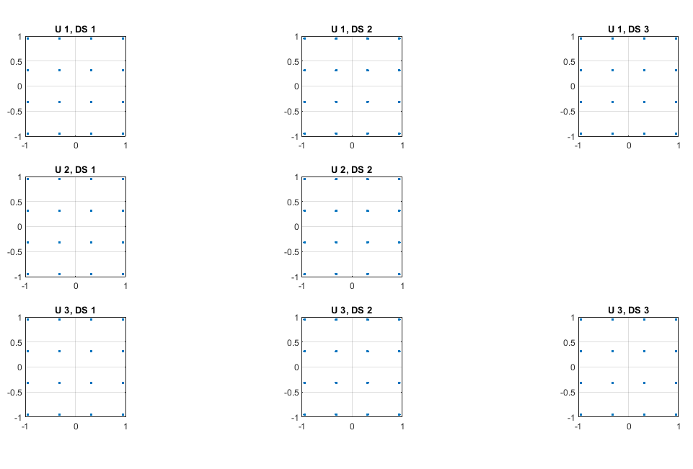

**Figure 5. CONSTELLATION DIAGRAM OF HYBRID PRECODING**

The constellation diagram of each user is shown in the **figure**. Each user has 16 symbols because of the modulation scheme to be 16QAM.

As we can see in the constellation diagram that all the data dots are at their respective point without too much distortion. This shows there is very low distortion due to noise. Hence the noise figure is not disturbing the system due to hybrid beam forming and mm wave.

## 4.3 SNR VS SPECTRAL EFFECIENCY:

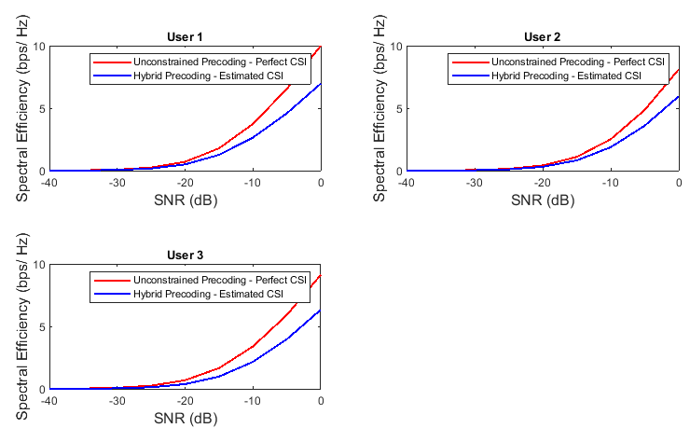

**Figure 6. SNR VS SPECTRAL EFFECIENCY**

Spectral efficiency is the information rate which could be transmitted over a given bandwidth.

As we can see in the graphs given below that the unconstrained pre coding is shown in red color. Unconstrained Pre coding is the ideal results we should achieve. The Blue line on the graph shows the result we got after Hybrid Pre coding. This is the result we will get after applying the hybrid beam forming. The hybrid beam forming result is too much close to the ideal result. This means that the maximum bandwidth is utilized.

As the SNR increases the bandwidth efficiency is increased and the difference between both unconstrained and hybrid pre coding is low which indicates that the noise effect is too much reduced and our signal contains 70% of the data.

**CHAPTER 5**

# **CONCLUSION AND FUTURE WORK**

5.1 CONCLUSION:

In this research we implemented hybrid beamforming on massive mimo channel and analyze the effects. It is analyzed that hybrid precoding enhances the system performance, noise figure is reduced to much extent. Data transmitted is almost recovered. Interference resulted from large antenna arrays does not affect much. By using comparison of two techniques hybrid precoding and constrained precoding, difference is shown. Increasing SNR increases bandwidth efficiency and estimated results of hybrid precoding are much close to the perfect CSI case. In this way bandwidth can be maximally utilize.

5.2 FUTURE WORK:

In future energy efficiency effects can be analyze by using different beamforming techniques. In future research we will develop imperfect CSI also. Ideal conditions are considered in our research. Transmitting and receiving antennas can be increased for further improvement in system. Distances between BS and antennas are not considered in research, in future we can consider distance as well.

# REFERENCES:

**BOOKS:**

[1] <https://searchnetworking.techtarget.com/definition/beamforming><http://www.rfwireless-world.com/Terminology/Advantages-and-Disadvantages-of-Beamforming.html>

[2] D. Lee et al., “Coordinated multipoint transmission and reception in LTE-advanced: Deployment scenarios and operational challenges,” IEEE Commun. Mag., vol. 50, no. 2, pp. 148–155, 2012.

[3] E. Larsson, O. Edfors, F. Tufvesson, and T. Marzetta, “Massive MIMτ for next generation wireless systems,” Commun. Mag. IEEE, vol. 52, no. 2, pp. 186–195, 2014.

[4] H. Q. σgo, E. G. Larsson, and T. L. Marzetta, “Energy and spectral efficiency of very large multiuser MIMτ systems,” IEEE Trans. Commun., vol. 61, no. 4, pp. 1436–1449, 2013.

[5] X. Gao, O. Edfors, F. Rusek, and F. Tufvesson, “Linear pre-coding performance in measured very-large MIMτ channels,” IEEE Veh. Technol. Conf., 2011.

[6] H. Q. σgo, E. G. Larsson, and T. L. Marzetta, “Aspects of favorable propagation in Massive MIMτ,” Eur. Signal Process. Conf., no. 1, pp. 76–80, 2014.

[7] A. Pitarokoilis, S. K. Mohammed, and E. G. Larsson, “τn the optimality of single-carrier transmission in large-scale antenna systems,” IEEE Wirel. Commun. Lett., vol. 1, no. 4, pp. 276–279, 2012.

[8] P. Stenumgaard, D. Persson, E. Larsson, and K. Wiklundh, “An early-warning service for emerging communication problems in security and safety applications,” IEEE Commun. Mag., vol. 51, no. 5, pp. 186–192, 2013.

[9] C. Studer and E. G. Larsson, “PAR-aware large-scale multi-user MIMO-τFDM downlink,” IEEE J. Sel. Areas Commun., vol. 31, no. 2, pp. 303–313, 2013.

[10] T. L. Marzetta, “σoncooperative cellular wireless with unlimited numbers of base station antennas,” IEEE Trans. Wirel. Commun., vol. λ, no. 11, pp. 35λ0–3600, 2010.

[11] R. R. Müller, L. Cottatellucci, and M. Vehkaperä, “Blind pilot decontamination,” IEEE J. Sel. Top. Signal Process., vol. 8, no. 5, pp. 773–786, 2014.

**THESIS:**

[12] H. Q. σgo and E. G. Larsson, “EVD-based channel estimation in multicell multiuser MIMO systems with very large antenna arrays,” in 2012 IEEE International Conference on Acoustics, Speech and Signal Processing (ICASSP), 2012, no. 1, pp. 3249–3252.

[13] C. Shepard et al., “Argosμ practical many-antenna base stations,” Proc. 18th Annu. Int. Conf. Mob. Comput. Netw. - Mobicom ’12, p. 53, 2012.

[14] F. Kaltenberger, H. Jiang, M. Guillaud, and R. Knopp, “Relative channel reciprocity calibration in MIMτ/TDD systems,” 2010 Futur. σetw. Mob. Summit, pp. 1–10, 2010.

[15] Bo Ai, Senior Member, IEEE, Ke Guan, Member, IEEE, Ruisi He, Member, IEEE, Jianzhi Li, Guangkai Li, Danping He, Member, IEEE, Zhangdui Zhong, Senior Member, IEEE, and Kazi Mohammed Saidul Huq, Member, IEEE

16] https://en.wikipedia.org/wiki/MATLAB

[17] El Ayach, Oma, et al. "Spatially Sparse Precoding in Millimeter Wave MIMO Systems." IEEE Transactions on Wireless Communications, Vol. 13, No. 3, March 2014, pp. 1499-1513.

[18] https://www.mathworks.com/help/comm/examples/massive-mimo-hybrid-beamforming.html