GLOBAL ENERGY TRANSITION
& Market Reliability

Data Visualisation Project Report
United Kingdom · United States · Australia
Coverage: 2019–2025 (Australia: 1999–2025)

1. Introduction
The global electricity sector is undergoing its most significant structural transformation since electrification. Solar and wind generation capacity are growing at unprecedented rates, yet their intermittent nature raises fundamental questions about grid reliability and market stability. This project investigates those questions through a comparative analysis of three national electricity grids — the United Kingdom, the United States, and Australia — which represent three distinct stages and approaches to the energy transition.

The United Kingdom has pursued a deliberate coal phase-out, completing it in September 2024, while expanding offshore wind to cover over 30% of annual generation. The United States operates the world's largest electricity market with significant regional diversity, transitioning more slowly due to structural inertia and political variation. Australia, heavily dependent on coal historically, has experienced one of the fastest renewable buildouts globally, driven by exceptional solar resources and competitive market incentives.

Three research questions guide the investigation:

- RQ1 — Transition Velocity: Between 2019 and 2025, which country moved away from fossil fuels (Coal + Gas) fastest? The speed of fossil decline is compared against Wind and Solar growth across all three grids to identify the most aggressive transitioner.
- RQ2 — Grid Stress-Testing: During peak demand periods — winter nights in the UK, summer heatwaves in Australia, and summer heat in the US — when renewable output is low, which backup sources fill the gap, and how fossil-dependent does each grid become under stress?
- RQ3 — Market Volatility: Does a higher share of variable renewables (Wind + Solar) make wholesale electricity prices more volatile? Statistical measures (Standard Deviation, Coefficient of Variation) are applied to the Australian wholesale market — the only dataset with price data — spanning 1999 to 2025.

The motivation for this work is practical: policymakers, investors, and grid operators need evidence-based answers to these questions as they design transition pathways. The analysis combines three publicly available datasets, processed through a four-stage R pipeline, and visualised using interactive Shiny dashboards.

2. Data Wrangling and Checking

2.1 Data Sources
Three national-level datasets were obtained from official grid operators and energy statistics agencies:

Dataset | Country | Provider | URL | Granularity | Coverage
gridwatch.csv | UK | GridWatch / National Grid ESO | gridwatch.templar.co.uk | 5-minute | 2019–2025
US Energy generation dataset.csv | USA | EIA Hourly Grid Monitor | eia.gov/electricity/gridmonitor | Daily | 2019–2025
19990101 All Regions Australia.csv | AU | AEMO / OpenNEM | opennem.org.au | Monthly | 1999–2026

Raw file sizes were substantial: the UK GridWatch file contained 734,336 rows, the US EIA production file 5,048,813 rows, and the Australian AEMO file 326 rows. Together, these represented over 5.7 million records before processing.

2.2 Data Wrangling Pipeline
A four-script R pipeline was developed using tidyverse, lubridate, and janitor. Each script handles one country and outputs a standardised monthly CSV; the fourth script combines all three.

Pipeline: 01_clean_uk.R → 02_clean_us.R → 03_clean_australia.R → 04_combine.R
Output: uk_monthly.csv | us_monthly.csv | au_monthly.csv → combined_energy.csv

United Kingdom — GridWatch
- Leading whitespace: All 734,336 timestamp values contained a leading space character (' 2019-01-01 00:00:36'). This caused silent NA production in all datetime parsers until str_trim() was applied before ymd_hms().
- Data gaps: 13 gaps exceeding one hour were identified by computing consecutive timestamp differences. The largest gap was 72.3 hours in March 2025. These were documented as known limitations rather than imputed, as monthly aggregation reduces their impact to below 0.5%.
- Sensor dropouts: 2,888 rows recorded frequency = 0.000 Hz — physically impossible on the UK grid (nominal 50 Hz). These rows were retained since generation data remained valid; the frequency column was excluded from all analysis.
- Gas technology merger: The raw data splits gas into ccgt (Combined Cycle, baseload) and ocgt (Open Cycle, peaking). Both were recoded to 'Gas' after pivot_longer() to match the single NG code used by the US EIA.
- Unit conversion: Each 5-minute MW instantaneous reading was converted to GWh using: GWh = MW × (5 ÷ 60) ÷ 1,000, then summed monthly.

United States — EIA
- Scale: The production file contained 5,048,813 rows — five times the development sample of 1,055,000 rows.
- readr type coercion bug: The period column ('2019-01-01' format) was silently coerced to a Date object by readr before mutate() was called, causing ymd_h() and parse_date_time() to fail with 'All formats failed to parse.' Fix: col_types = cols(period = col_character()) at read time, plus as.character() as a defensive cast.
- Duplicate rows: 4,029,404 rows (79.8%) were duplicates arising from overlapping utility-level and pre-aggregated regional records. These were collapsed by group_by(country, date, source) |> summarise().
- Negative values: 151,492 rows carried negative generation values representing battery charging, pumped hydro charging, and grid imports. These were removed with filter(value >= 0).
- Unmapped fuel codes: 7 new EIA codes (BAT, SNB, PS, OES, WNB, UNK, UES) representing hybrid storage technologies were absent from the original fuel_map dictionary. These were mapped to appropriate categories (Other, Solar, Hydro, Wind).
- Unit conversion: EIA values are in MWh. Divided by 1,000 to produce GWh, then summed monthly.

Australia — AEMO / OpenNEM
- Structural zeros: Solar (zero before 2016), Wind (zero before 2009), and Bioenergy (zero before 2009) carried zero values in early years — not missing data, but correct records of zero generation before deployment. Retained as valid data points.
- Negative generation: 6 rows held negative generation_gwh from pumped storage charging periods. Removed in the combine step with filter(generation_gwh >= 0).
- Price missing marker: The 'Volume Weighted Price - AUD/MWh' column used 0 as a missing-value marker in years with sparse reporting. Zero values were replaced with NA before any price analysis.
- No unit conversion required: The AEMO file is already monthly GWh.

2.3 Cross-Country Harmonisation
- Units: All three datasets were standardised to GWh per month.
- Source vocabulary: 12 standardised source labels were defined. CCGT + OCGT → Gas. Pumped storage → Hydro. EIA codes mapped to readable names.
- Renewable flag: A boolean renewable column was added: TRUE for Wind, Solar, Hydro, Bioenergy, and Biomass.
- Scale disparity: The US generates ~260× more electricity than the UK or Australia. All cross-country comparisons therefore use percentage share of total generation, not absolute GWh.
- Date filter: The combined dataset uses 2019–2025 as the common window. Australia's full 1999–2025 data is retained separately for RQ3 price analysis.

2.4 Data Quality Verification
Check | UK | US | AU | Combined
Null values | 0 | 0 | 0 | 0
Negative GWh (post-filter) | 0 | 0 | 0 | 0
Date range correct | Yes | Yes | Yes | Yes
Expected row count | 504 | 686 | 2,268 | 1,778
All sources present | 6 | 9 | 7 | 12
Renewable flag coverage | N/A | N/A | N/A | 1,778/1,778

All checks passed after the wrangling pipeline. The combined dataset is fully clean with zero nulls, no negative values, correct date coverage, and consistent source vocabulary across all three countries.

3. Data Exploration
The exploration was conducted in three phases, one per research question, using R Shiny dashboards with plotly visualisations. The choice of interactive dashboards was deliberate: electricity data is highly seasonal and multi-dimensional, and static charts cannot adequately support the filtering and drill-down needed to examine patterns across countries, years, and source types simultaneously. All tools used were R, plotly, bslib, lubridate, tidyverse, and the slider package for rolling windows.

3.1 RQ1 — Transition Velocity

Approach and justification
Percentage share of monthly generation was chosen as the primary metric rather than absolute GWh, because the US generates approximately 260 times more electricity than the UK. Without normalisation, visual comparison is impossible. Linear regression was applied to each country's monthly fossil share and Wind+Solar share time series, producing a slope coefficient (percentage points per month) as the 'transition velocity' — a single comparable number per country.

Visual analysis — fossil share decline
Figure 1 plots the monthly fossil (Coal + Gas) share of generation for all three countries from January 2019 to December 2025. The raw monthly lines reveal the volatility that trend lines alone would hide: Australia's share fluctuates seasonally around a clear downward trajectory, the UK exhibits sharp month-to-month swings driven by wind variability, and the US moves within a tight band around 55–65%, confirming its structural inertia.
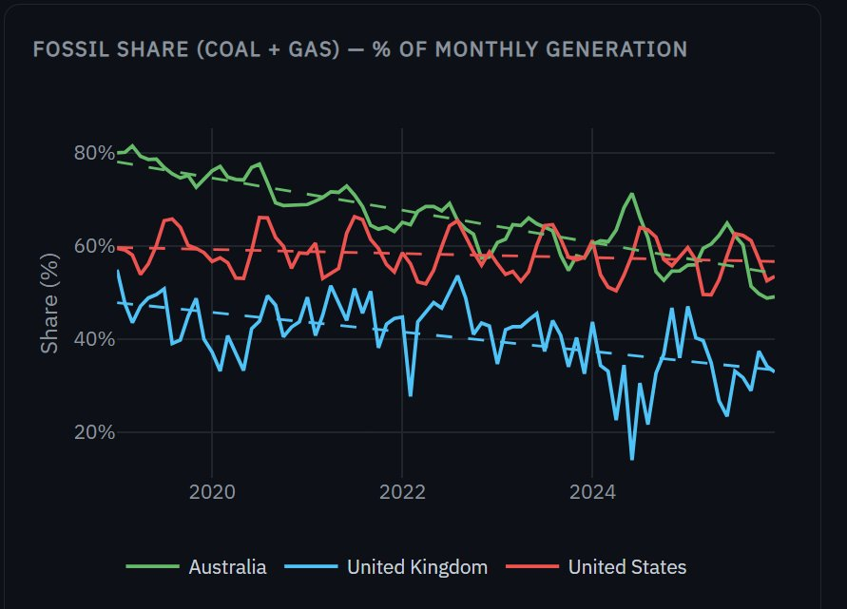
Figure 1. Monthly fossil share (Coal + Gas) across UK, US, and Australia, 2019–2025. Dashed lines show linear regression fits. All three countries show declining trends, but Australia's slope is visibly steepest.
Figure 2 isolates the linear regression fits from Figure 1, making the relative speeds of decline visually unambiguous. Australia's trajectory crosses the US line in 2024 — despite starting ~17 percentage points above it in 2019. The UK sits on a parallel lower path, reflecting its earlier coal exit.
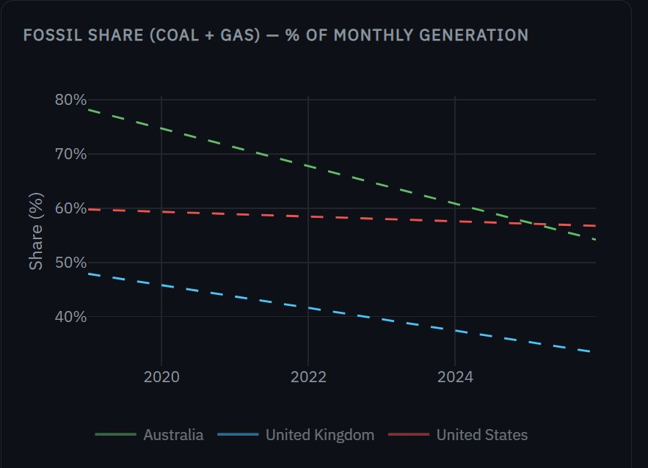
Figure 2. Linear regression fits only — fossil share trend lines for UK, US, and Australia, 2019–2025. Australia (green) shows the steepest decline, crossing below the US (red) by 2024.

Visual analysis — Wind + Solar growth
Figure 3 shows the corresponding trend lines for Wind + Solar share. The three paths are nearly parallel in slope — but at very different levels. The UK and Australia both approach 40% Wind+Solar by 2025, while the US reaches only 18%. Critically, Australia's slope matches the UK's despite starting 7 percentage points lower.
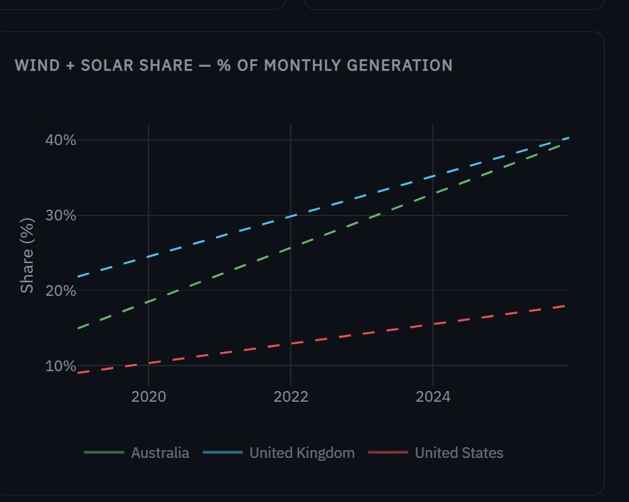
Figure 3. Wind + Solar share — trend lines only. UK and Australia follow near-parallel growth paths reaching ~40% by 2025; the US trails at ~18%.
Figure 4 overlays the raw monthly data on the trend lines. The UK's extreme month-to-month variability — spikes above 50% in some months, dips below 20% in others — demonstrates wind intermittency. Australia's seasonal pattern is more regular, reflecting the stable solar resource base.
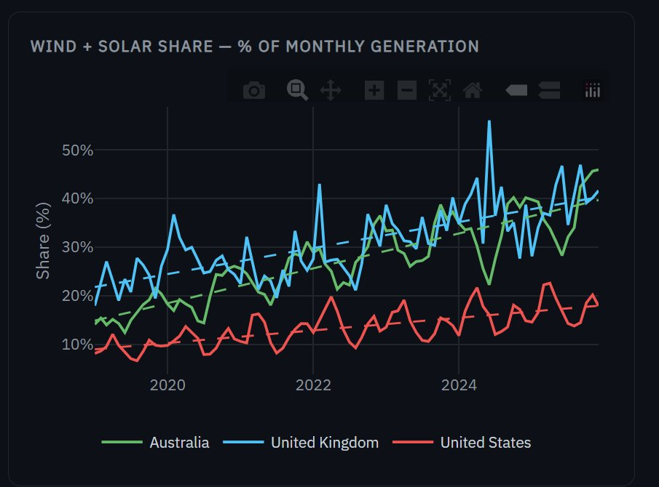
Figure 4. Wind + Solar share with raw monthly data. UK shows extreme month-to-month volatility reflecting wind intermittency; Australia exhibits a smoother seasonal pattern driven by solar.

Visual analysis — transition velocity comparison
Figure 5 distils the regression results into a single direct comparison. The bar heights are the slope coefficients from the linear regressions in Figures 1–4. Australia's fossil decline (−0.289 pp/month) is roughly 1.7× faster than the UK's and 8× faster than the US's. Australia also has the strongest Wind+Solar growth (+0.298 pp/month). The symmetry between the bars within each country is striking — the fossil energy being displaced is being replaced almost one-for-one by variable renewables.
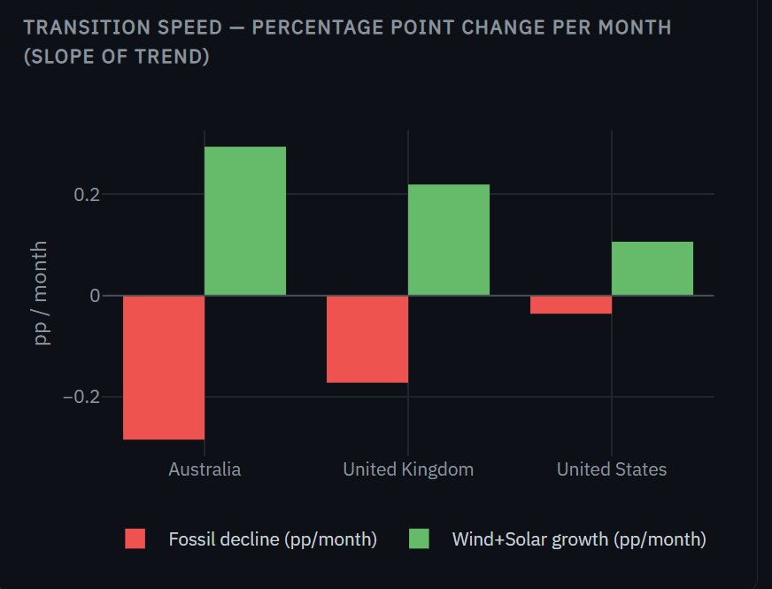
Figure 5. Transition speed comparison — linear regression slope (percentage points per month) for fossil decline (red) and Wind+Solar growth (green). Australia is the fastest transitioner on both metrics.

Key findings
Country | Fossil 2019 | Fossil 2025 | Δ Fossil | Slope (pp/mo) | W+S 2019 | W+S 2025 | Δ W+S | Slope (pp/mo)
Australia | 77.3% | 56.8% | -20.5 pp | -0.289 | 16.4% | 37.7% | +21.4 pp | +0.298
United Kingdom | 46.3% | 34.2% | -12.1 pp | -0.175 | 23.2% | 39.1% | +15.9 pp | +0.223
United States | 60.1% | 56.4% | -3.7 pp | -0.036 | 9.2% | 17.7% | +8.5 pp | +0.108

- Australia fastest transitioner: Australia recorded the steepest fossil decline slope (−0.289 pp/month) and the largest absolute shift of any country (−20.5 pp fossil, +21.4 pp Wind+Solar). Crucially, Australia started from the highest fossil base (77.3% in 2019), demonstrating that even a deeply coal-dependent grid can transition rapidly with the right policy and resource conditions.
- UK steady and structural: The UK's transition predates the study window — it entered 2019 already at 46.3% fossil, having exited coal years earlier. Its slope (−0.175 pp/month) reflects a mature, ongoing transition rather than a sudden shift.
- US structural inertia: The US moved slowest on both metrics (−0.036 pp/month fossil decline). The scale and diversity of the US grid — 81 utility respondents, large coal-dependent regions — create structural barriers that aggregate statistics mask.
- Coal absence in UK: Coal does not appear in the UK processed dataset — a real-world finding, not a data gap. Great Britain's last coal plant closed in September 2024.

Visualisations used for RQ1
- Line charts (fossil share & Wind+Solar share): Monthly time series for all three countries on shared axes with trend lines overlaid. Line charts were chosen over bar charts because the continuous temporal trend is the key quantity of interest. Figures 1–4 demonstrate the value of showing raw and fitted data side-by-side.
- Slope comparison bar chart (Figure 5): A grouped bar chart comparing fossil_slope and ws_slope across countries. This translates the regression outputs into a directly scannable visual showing which country changed fastest on each metric.
- Dumbbell chart (in dashboard): Start (2019) and end (2025) fossil share plotted as dots connected by a horizontal line per country. This makes the absolute magnitude of change immediately readable, which line charts do not emphasise.
- Stacked area chart (in dashboard): Full generation mix by source over time, faceted by country. Useful for confirming that observed share changes reflect real source shifts, not merely total generation fluctuations.

3.2 RQ2 — Grid Stress-Testing

Approach and justification
Peak stress periods were defined per country based on known grid stress patterns: UK winters (December–February) when solar output is near zero and heating demand peaks; Australian summers (December–February) when extreme heat drives air-conditioning load to record highs; and US summers (June–August) when heat events stress the southern and central grids. The reliability gap was computed as the difference in renewable share between non-peak and peak months — a positive gap means the grid's clean energy share falls during stress periods, revealing fossil backup dependency.

Visual analysis — backup source mix during peak
Figure 6 presents three donut charts side-by-side showing what sources each grid relies on during its peak-stress season. The composition differences are dramatic and reveal each country's structural strategy.
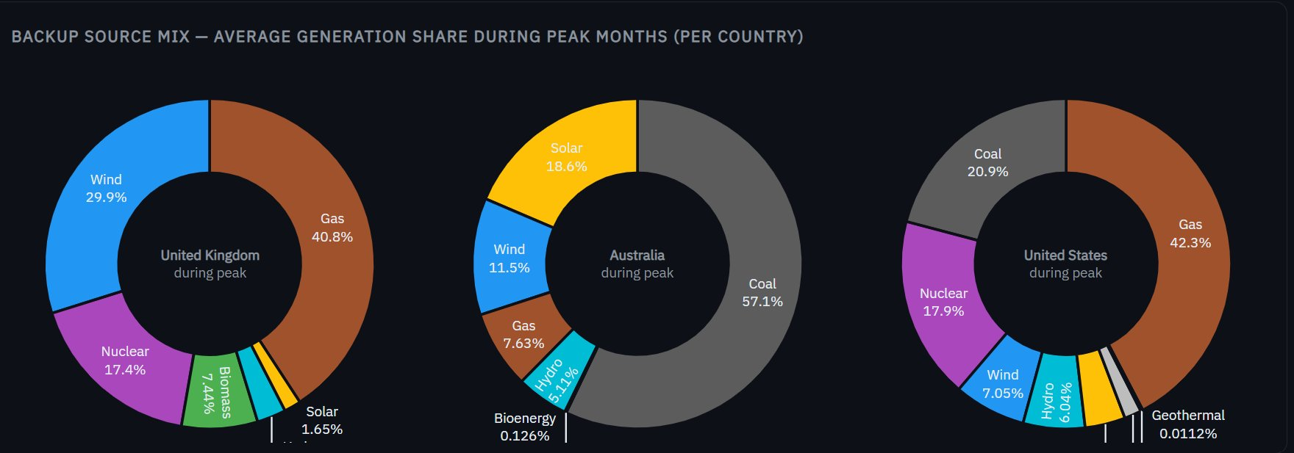
Figure 6. Backup source mix during peak months — UK (winter), Australia (summer), and US (summer). Donut charts show each country's dispatchable backup dependency.
Three observations emerge from Figure 6. First, the UK's peak mix is the most diversified — Gas (40.8%), Wind (29.9%), Nuclear (17.4%), and Biomass (7.4%) form a balanced portfolio where no single source dominates. Second, Australia's peak generation is 57.1% Coal alone — the legacy coal fleet still carries the grid during summer stress, even as Solar contributes 18.6%. Third, the US depends on three fossil sources plus Nuclear, with Gas (42.3%) and Coal (20.9%) together covering nearly two-thirds of peak demand.

Visual analysis — reliability gap over time
Figure 7 plots the reliability gap (non-peak renewable share minus peak renewable share) annually for each country. A positive gap means renewable share drops during peak months; a negative gap means renewable share is actually higher during peak. The orange dashed line at zero is the critical reference point.
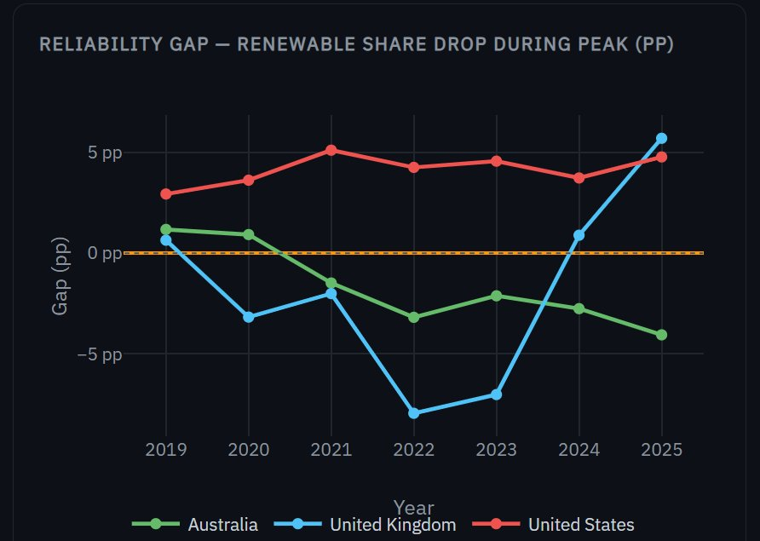
Figure 7. Reliability gap over time — renewable share drop during peak (percentage points). The US consistently runs positive (gap grows during summer); UK and Australia hover around zero or negative.
The US (red line) is consistently above zero across the entire 2019–2025 window — its renewable share always drops during summer peaks because solar output cannot compensate for collapsed wind generation during heatwaves. Australia (green) stays below zero most years: its solar resource is strongest precisely when demand peaks, so renewable share is actually higher in summer than winter. The UK (blue) shows the most volatile behaviour, with sharp dips to −8 pp in 2022–2023 (extreme winter wind shortages) and a jump to +6 pp in 2025.

Visual analysis — fossil dependency trend
Figure 8 shows how fossil share during peak months has evolved year-by-year. Where the reliability gap chart above shows the relative change, this chart shows the absolute fossil dependency level during stress periods.
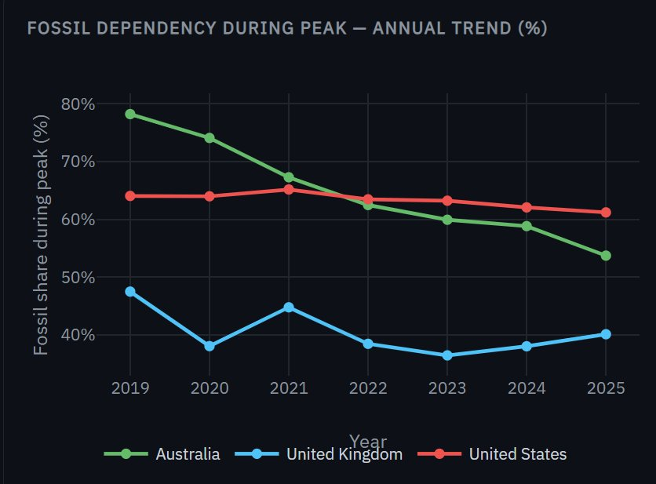
Figure 8. Fossil dependency during peak — annual trend. Australia's peak fossil share fell sharply from 78.2% (2019) to 53.7% (2025); UK stayed below 50%; US declined slowly from 64% to 61%.
Australia's trajectory is the most striking — peak fossil dependency fell from 78.2% in 2019 to 53.7% in 2025, a 24.5 percentage point reduction in just six years. The UK stayed consistently below 50% throughout, reflecting its mature transition. The US declined only marginally from 64% to 61%, confirming that its peak-period fossil lock-in is substantially stronger than the other two grids.

Key findings
Country | Peak season | Renewable (peak) | Renewable (non-peak) | Reliability gap | Primary backup
United Kingdom | Winter (Dec–Feb) | 41.8% | 39.9% | -1.9 pp | Nuclear + Gas
Australia | Summer (Dec–Feb) | 35.2% | 33.5% | -1.7 pp | Coal + Gas
United States | Summer (Jun–Aug) | 17.0% | 21.1% | -4.1 pp | Gas + Coal + Nuclear

- US most vulnerable: The US exhibits the largest reliability gap (−4.1 pp). During summer peaks, renewable share drops from 21.1% to 17.0% while fossil dependency rises to 63.4%. Gas (42.3%) and Coal (20.9%) together cover nearly two-thirds of generation during peak stress (Figure 6).
- UK most resilient: The UK's reliability gap is the smallest (−1.9 pp). Nuclear (17.4% of peak generation) provides stable baseload unaffected by weather, and Wind is often strong in winter months — meaning peak and non-peak renewable shares are nearly equal.
- Australia coal-heavy backup: Despite significant renewable growth, Coal still dominates peak-period generation in Australia (57.1% of peak mix — Figure 6). This reveals the structural persistence of coal as the primary backup even as Solar and Wind expand rapidly.
- Annual trend — improving resilience: All three countries show declining peak-period fossil dependency year-over-year from 2019 to 2025 (Figure 8). Australia's peak fossil share fell from 78.2% to 53.7%, suggesting that growing renewable capacity is gradually reducing stress-period vulnerability even before storage solutions are deployed at scale.

Visualisations used for RQ2
- Donut charts (Figure 6): Backup source mix during peak months shown as donut/pie charts, one per country. Chosen over bars because the composition-of-a-whole question is naturally suited to a part-whole chart format. Side-by-side placement enables direct comparison of mix structure.
- Reliability gap line chart (Figure 7): The difference (non-peak minus peak renewable share) plotted annually per country. A line chart was chosen to show whether the gap is widening or narrowing over time, which a single bar cannot capture. Zero reference line provides the critical interpretive threshold.
- Fossil dependency line chart (Figure 8): Peak-period fossil share tracked annually. Provides the absolute dependency level that complements the relative reliability gap chart.
- Grouped bar chart (in dashboard): Renewable share during peak and non-peak months shown side by side per country. Simple, direct comparison of the reliability gap.
- Monthly scatter with peak highlighted (in dashboard): Individual monthly data points coloured by peak status. Provides granular evidence for the aggregate statistics and reveals seasonal patterns within years.
- Stacked bar — annual backup breakdown (in dashboard): Year-by-year source breakdown during peak months, faceted by country. Allows tracking of how the backup mix evolves — for example, whether Gas is gradually replacing Coal in Australia's peak mix.

3.3 RQ3 — Market Volatility

Approach and justification
Price data is only available for Australia (AEMO monthly wholesale price, AUD/MWh, 1999–2025). Two volatility metrics were computed: Standard Deviation (SD) measures absolute price swings, while Coefficient of Variation (CV = SD ÷ Mean × 100) measures relative volatility — essential because nominal Australian electricity prices tripled over the study period, meaning rising SD alone could simply reflect higher prices rather than more instability. Annual CV was correlated with annual Wind+Solar share to test the core hypothesis. Three historical eras were defined to contextualise the analysis: Pre-renewable (1999–2009), Early transition (2010–2016), and High renewable (2017–2025).

Visual analysis — rolling price volatility
Figure 9 shows the rolling 12-month standard deviation of Australian wholesale electricity prices from 1999 to 2025. This metric acts as a seismograph for market instability — each spike corresponds to a discrete event that destabilised wholesale prices. The pre-2015 period is remarkably flat, with rolling SD rarely exceeding $20 AUD/MWh. Three major spikes punctuate the record: 2017 (South Australia gas crisis), 2019 (drought-driven hydro shortage), and the dominant 2022 peak reaching $120 AUD/MWh — the largest volatility event on record, driven by coal plant outages and global gas price contagion from the Ukraine conflict.
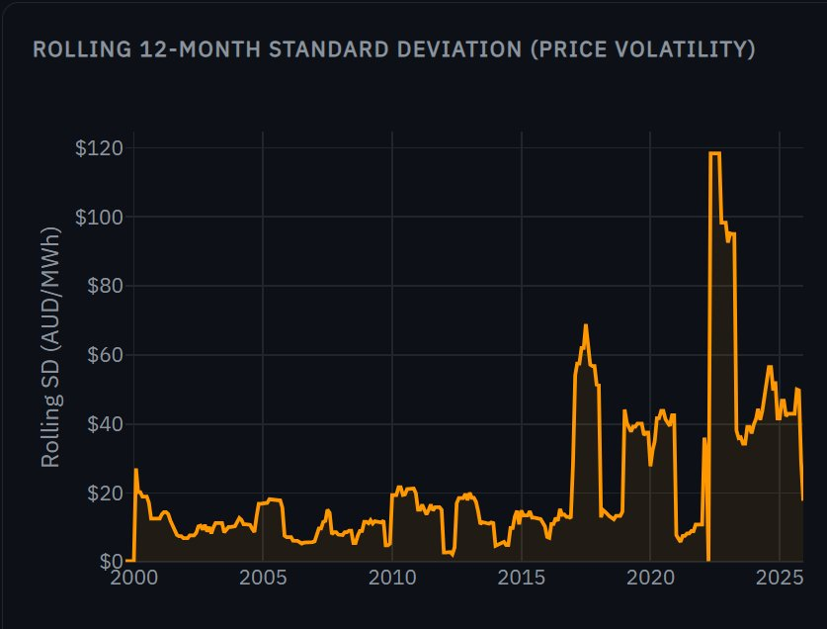
Figure 9. Rolling 12-month standard deviation of Australian wholesale electricity prices (AUD/MWh), 1999–2025. Major spikes in 2017 and 2022 correspond to fossil fuel supply shocks, not renewable intermittency events.

Visual analysis — annual coefficient of variation
Figure 10 presents the annual CV coloured by era — grey for the pre-renewable period (1999–2009), orange for early transition (2010–2016), and blue for the high-renewable era (2017–2025). If renewables systematically caused volatility, the blue bars should be consistently taller than the orange and grey bars. Instead, the pattern is irregular: 2020 (CV = 69%, driven by COVID demand collapse) and 2022 (CV = 57%, energy crisis) are the highest blue bars, but 2010 (CV = 60%, carbon tax uncertainty) in the orange era is comparable. Several blue-era years (2018, 2021, 2025) have lower CV than the pre-renewable baseline.
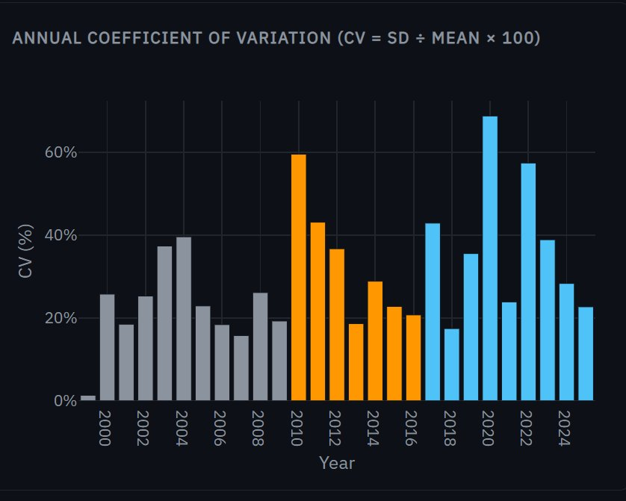
Figure 10. Annual coefficient of variation by era. Grey = pre-renewable (1999–2009), orange = early transition (2010–2016), blue = high renewable (2017–2025). No systematic pattern of higher CV in the high-renewable era.

Visual analysis — emissions intensity co-trend
Figure 11 tracks Australia's emissions intensity (kgCO₂e/MWh) over the full 1999–2025 period. The curve demonstrates that the energy transition is achieving its primary environmental goal: emissions per unit of electricity fell from approximately 1,000 kgCO₂e/MWh in 1999 to roughly 520 kgCO₂e/MWh in 2025 — a 47% reduction. The decline rate accelerates visibly after 2017 (the shaded high-renewable era), coinciding with rapid Wind and Solar deployment. This chart provides important context for the price volatility question: even if prices have become more volatile, the grid is delivering substantially lower-carbon electricity.
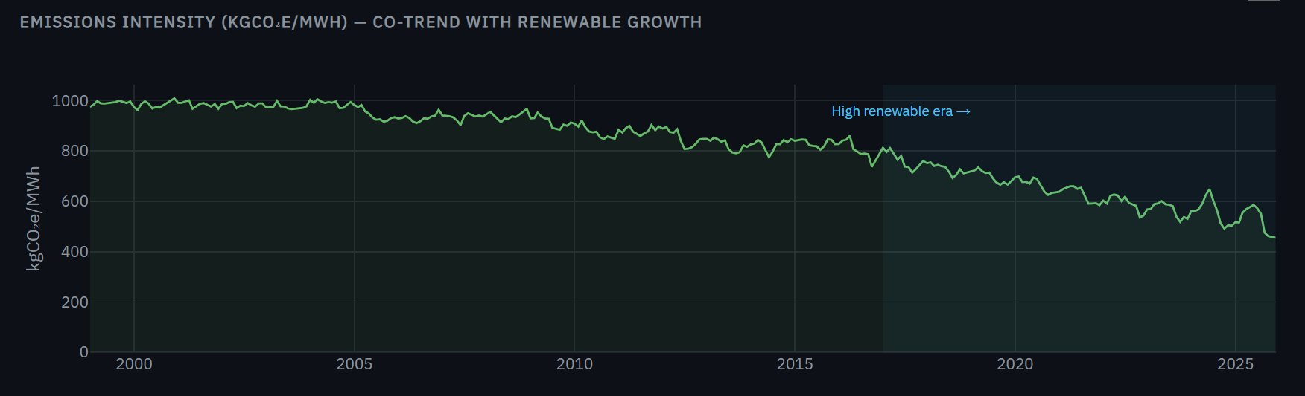
Figure 11. Emissions intensity (kgCO₂e/MWh) for the Australian NEM, 1999–2025. The decline accelerates sharply after 2017, coinciding with the high-renewable era. The shaded region marks the period when Wind+Solar exceeded 10% of generation.

Key findings
Era | Mean price (AUD/MWh) | Std dev | Max price | Avg W+S share
Pre-renewable (1999–2009) | $37.4 | $12.7 | $69.5 | ~0%
Early transition (2010–2016) | $47.7 | $17.4 | $86.3 | ~5%
High renewable (2017–2025) | $100.1 | $52.6 | $317.1 | ~25%

- Prices rose sharply in the high-renewable era: Mean wholesale price more than doubled from the early-transition to the high-renewable era ($47.7 → $100.1 AUD/MWh). Standard deviation also increased substantially ($17.4 → $52.6).
- Weak correlation between W+S share and CV: The correlation between annual Wind+Solar share and annual CV was r = 0.26, indicating a weak positive relationship. This suggests renewable penetration is not the primary driver of price volatility.
- 2022 as a confounding outlier: The 2022 peak of $317.1 AUD/MWh — the highest price on record — occurred during the global energy crisis triggered by Russia's invasion of Ukraine and Australian domestic coal supply disruptions. This event, unrelated to renewable penetration, dominates the statistical picture. Excluding 2022 weakens the correlation further.
- Emissions declining consistently: Emissions intensity (kgCO₂e/MWh) fell from ~975 in 1999 to ~520 in 2025 — a 47% reduction. This decline accelerates after 2017, coinciding with the rapid deployment of Wind and Solar, confirming that the transition is achieving its primary climate goal regardless of price effects.
- Price volatility driven by fuel markets, not renewables: The evidence suggests that fossil fuel market shocks (2007 gas prices, 2017 coal supply tightness, 2022 global crisis) explain most of the observed CV spikes, rather than renewable intermittency. This is consistent with international literature on wholesale electricity market dynamics.

Visualisations used for RQ3
- Monthly price line chart (with era shading): Full 1999–2025 price timeline with background shading for the three eras. Allows identification of specific spike events and contextualises when price instability increased.
- Rolling 12-month SD area chart: Smoothed volatility signal using a 12-month rolling standard deviation. Better than annual SD for identifying when volatility regimes changed, without being dominated by individual outlier months.
- Annual CV bar chart (coloured by era): Enables year-by-year comparison of relative volatility, with era colour encoding providing immediate visual grouping.
- Scatter plot — W+S share vs CV: The critical chart for answering RQ3. Each point is one year; trend line with R² and slope annotated. An interactive toggle allows exclusion of 2022, demonstrating the sensitivity of the result to the energy crisis outlier.
- Era box plot: Price distribution within each era shown as box plots. Median, interquartile range, and outliers visible simultaneously — superior to era-mean tables for showing how the full distribution changed.
- Dual-axis trend — W+S share and mean price: Two y-axes showing renewable share growth and price level over time. Makes the co-movement (or lack thereof) visually apparent.

4. Conclusion
This project set out to answer three questions about the global energy transition. The data provided clear answers to two and a nuanced answer to the third.

RQ1 is answered decisively: Australia transitioned fastest, recording a fossil share decline of 0.289 percentage points per month and a Wind+Solar gain of 0.298 pp/month from 2019 to 2025 — approximately 8× faster than the US on fossil decline (Figure 5). The UK maintained a steady transition from an already-lower fossil base. The US moved slowest, reflecting structural and political barriers that short analysis windows cannot overcome.

RQ2 revealed that all three grids remain fossil-dependent during peak stress, but to varying degrees. The UK is most resilient (reliability gap of just 1.9 pp, Figure 7), supported by Nuclear as firm baseload. The US is most vulnerable (gap of 4.1 pp), with Gas and Coal covering 63.4% of peak generation (Figure 6). Australia's backup mix remains coal-dominated despite rapid renewable growth, though year-on-year improvement is measurable (Figure 8).

RQ3 produced the most nuanced finding: the correlation between Wind+Solar penetration and price volatility in Australia is weak (r = 0.26), and the dominant volatility events are attributable to fossil fuel market shocks rather than renewable intermittency. The 2022 energy crisis provides a stark natural experiment — price volatility spiked to its highest level precisely when global gas and coal markets were most stressed, not when renewables were highest.

5. Reflection
The most important lesson from this project is that data wrangling consumes the majority of effort and that datasets from official sources are far from clean. The readr type coercion bug in the US dataset, the 4 million duplicate rows, the 2,888 sensor dropout readings in GridWatch, and the leading whitespace on every UK timestamp were all invisible until explicitly investigated. A key principle that emerged: never trust that a dataset is clean because it comes from a government agency — always verify programmatically.

On visualisation, the decision to use interactive Shiny dashboards rather than static figures was vindicated by the exploration process: the ability to filter by country, adjust year ranges, and toggle trend lines repeatedly revealed patterns that would have been missed in fixed charts. In hindsight, a greater investment in annotation — labelling specific events (2022 energy crisis, the UK coal closure date, Australia's policy inflection points) directly on the charts — would have made the findings more self-explanatory to a general audience. The dashboards currently require prior knowledge to interpret some of the anomalies.

A limitation of the project is the absence of price data for the UK and US, which constrains RQ3 to Australia alone. Future work could incorporate UK Balancing Mechanism data from Elexon and US day-ahead market prices from CAISO or PJM to enable a genuine cross-country price volatility comparison. Additionally, sub-monthly granularity (hourly or daily prices) would allow a much more rigorous test of the renewable-volatility hypothesis, as monthly averages smooth out the intraday price swings that drive retailer and consumer risk.

6. Bibliography

Data Sources
[1] GridWatch, "GB National Grid Live Status," Templar Consultants Ltd., 2025. [Online]. Available: https://gridwatch.templar.co.uk. [Accessed: Apr. 19, 2026].

[2] U.S. Energy Information Administration, "Hourly Electric Grid Monitor," U.S. Department of Energy, Washington, DC, 2025. [Online]. Available: https://www.eia.gov/electricity/gridmonitor. [Accessed: Apr. 19, 2026].

[3] Australian Energy Market Operator and OpenNEM, "NEM All Regions Generation and Price Summary," AEMO, Melbourne, Australia, 2025. [Online]. Available: https://opennem.org.au. [Accessed: Apr. 19, 2026].

Software and R Packages
[4] H. Wickham et al., "Welcome to the tidyverse," J. Open Source Softw., vol. 4, no. 43, p. 1686, 2019. doi: 10.21105/joss.01686.

[5] G. Grolemund and H. Wickham, "Dates and Times Made Easy with lubridate," J. Stat. Softw., vol. 40, no. 3, pp. 1–25, 2011. doi: 10.18637/jss.v040.i03.

[6] S. Firke, "janitor: Simple Tools for Examining and Cleaning Dirty Data," R package version 2.2.0, 2023. [Online]. Available: https://CRAN.R-project.org/package=janitor.

[7] C. Sievert, Interactive Web-Based Data Visualization with R, plotly, and shiny. Boca Raton, FL: CRC Press, 2020. [Online]. Available: https://plotly-r.com.

[8] W. Chang et al., "shiny: Web Application Framework for R," R package version 1.8.0, 2023. [Online]. Available: https://CRAN.R-project.org/package=shiny.

[9] T. Kalinowski and D. Vaughan, "slider: Sliding Window Functions," R package version 0.3.1, 2023. [Online]. Available: https://CRAN.R-project.org/package=slider.

[10] H. Wickham, M. Çetinkaya-Rundel, and G. Grolemund, R for Data Science, 2nd ed. Sebastopol, CA: O’Reilly Media, 2023. [Online]. Available: https://r4ds.hadley.nz.

Domain Literature
[11] D. Newbery, M. G. Pollitt, R. A. Ritz, and W. Strielkowski, "Market Design for a High-Renewables European Electricity System," Renew. Sustain. Energy Rev., vol. 91, pp. 695–707, Aug. 2018. doi: 10.1016/j.rser.2018.04.025.

[12] L. Hirth, "The Market Value of Variable Renewables: The Effect of Solar and Wind Power Variability on Their Relative Price," Energy Econ., vol. 38, pp. 218–236, Jul. 2013. doi: 10.1016/j.eneco.2013.02.004.

[13] International Renewable Energy Agency, Renewable Power Generation Costs in 2022. Abu Dhabi: IRENA, 2023. [Online]. Available: https://www.irena.org/publications/2023/Aug/Renewable-Power-Generation-Costs-in-2022.

[14] National Grid ESO, Future Energy Scenarios 2024. Warwick, U.K.: National Grid ESO, 2024. [Online]. Available: https://www.nationalgrideso.com/future-energy/future-energy-scenarios.

