**HEAT & COOL TOWER FANS:**

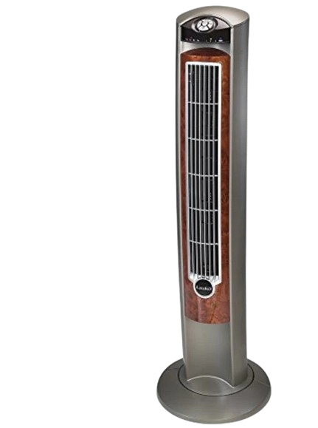

**Price: 13,000.00**

The Heat and Cool Tower Fan is a versatile and innovative solution for year-round climate control. This fan combines powerful cooling airflow with a built-in heating function, providing both warm and cool air circulation as needed. With its sleek tower design, adjustable temperature settings, and energy-efficient operation, this fan is perfect for homes, offices, and bedrooms, offering a convenient and cost-effective way to stay comfortable in any season.

**Key features of heat & cool tower fans include:**

* **Dual Functionality**: Provides both cooling and heating options.
* **Adjustable Temperature**: Customizable climate control.
* **Multiple Fan Speeds**: Adjustable airflow for comfort.
* **Oscillation**: Even air distribution across the room.
* **Energy Efficient**: Low power consumption for cost savings.