***TAOISM:***

***5.*** ***All Souls Festival:***

**During the **All Souls Festival**, various traditions are observed to honor the deceased and ensure the spirits of ancestors are well taken care of. Families offer food, incense, and other symbolic gifts to their ancestors’ spirits, ensuring they are not forgotten and that they can enjoy peace in the afterlife. It is also common to burn **joss paper** or **ghost money**, symbolic offerings intended for the spirits, allowing them to receive material comforts in the afterlife. Street performances, including **Chinese opera** and **puppet shows**, are often held to entertain the wandering spirits and keep them satisfied.**

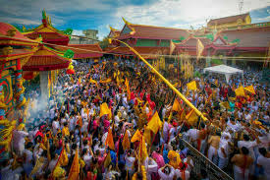

***About All Souls Festival:***

**The **All Souls Festival**, also known as the **Ghost Festival** or **Hungry Ghost Festival**, is an important traditional festival in Chinese culture, celebrated on the 15th day of the seventh lunar month. It is a time to honor deceased ancestors, offer food and prayers, and appease wandering spirits believed to return to the earthly realm during this time. According to Chinese belief, the gates of the underworld open during the seventh month, allowing the spirits of the deceased to visit the living. The festival is marked by various rituals, including the burning of incense and paper offerings, as well as providing food to both ancestors and wandering spirits to ensure their peace and avoid misfortune.**

