***ZOROASTRIANISM:***

1. ***Ayathrima Festivals:***

**During **Ayathrima**, families come together to celebrate the divine by performing **special prayers (pujas)**, offering **fruits**, **flowers**, and **sweet offerings** to deities, particularly for blessings related to prosperity, good health, and protection. Fasting is a common practice during the festival as a way to purify the body and spirit.**

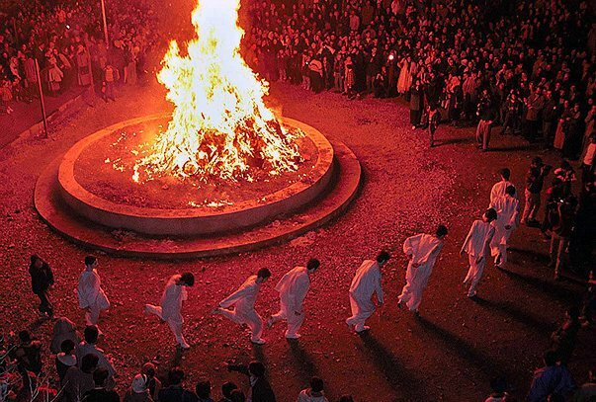

***About Ayathrima:***

**\*Ayathrima** is an important festival celebrated in some South Indian and Tamil communities, particularly in the Tamil Nadu region. This festival is deeply rooted in Hindu traditions and is a time for honoring divine forces and seeking blessings for prosperity, health, and protection. The festival is often associated with specific rituals that include prayer, fasting, and offerings to deities, particularly those that are believed to bring good fortune and well-being to individuals and families. Ayathrima is also a celebration of the harvest and marks a time of gratitude towards nature and the divine for bountiful yields.**

