**ISLAM**

**Commemoration of Sacrifice**

Eid ul Adha honors the willingness of Prophet Ibrahim to sacrifice his son in obedience to God.

About Eid Al-Adha

The celebration of sacrifice, faith, and community.

Eid Al-Adha, also known as the "Festival of Sacrifice," is one of the most important Islamic holidays. It commemorates the willingness of Prophet Ibrahim (Abraham) to sacrifice his son Isma'il in obedience to God's command. Just as Ibrahim showed his faith and devotion, Muslims worldwide celebrate this festival by performing the act of Qurbani (animal sacrifice). The meat from the sacrifice is distributed among family, friends, and the less fortunate. Eid Al-Adha occurs annually on the 10th day of Dhu al-Hijjah, the last month of the Islamic lunar calendar, and coincides with the completion of Hajj, the annual pilgrimage to Mecca.

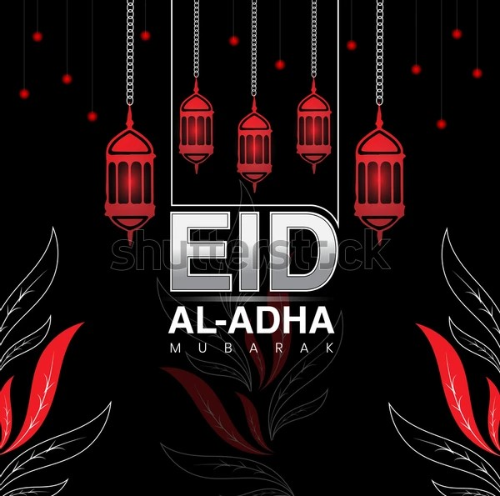

Eid ul-Adha Traditions

A celebration of sacrifice, faith, and gratitude.

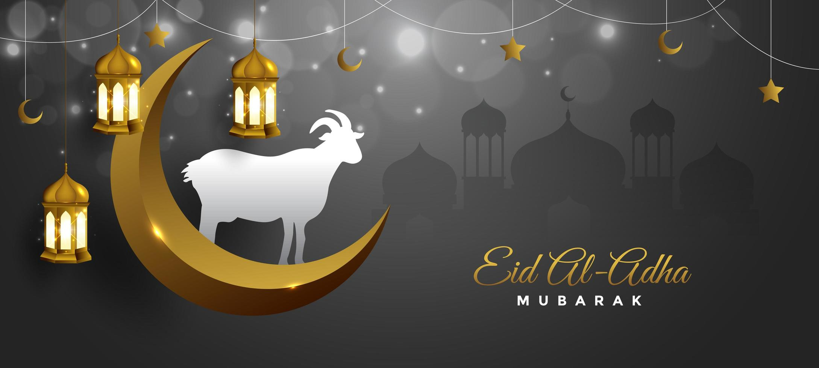

On Eid ul-Adha, Muslims gather for the special Eid prayer, usually held in congregation at mosques or open fields. The key ritual of this day is Qurbani, the sacrifice of an animal, often a goat, sheep, cow, or camel, in remembrance of Ibrahim's devotion to God. The sacrifice symbolizes the willingness to give up something precious in the name of faith and charity. The meat from the sacrifice is divided into three parts: one for the family, one for relatives, and one for the less fortunate. After the prayers and sacrifices, families come together to share festive meals. The day is also a time to visit friends and family, exchange gifts, and engage in charitable acts, reflecting the spirit of generosity and community.

Celebrate the Spirit of Sacrifice

Eid ul-Adha teaches us the value of sacrifice, faith, and compassion. It is a reminder to give selflessly, support those in need, and strengthen our bonds of community. May this Eid bring peace, joy, and blessings to you and your loved ones