**CHRISTIANITY**

**Halloween Traditions**

Halloween originated from ancient Celtic festivals, especially Samhain, marking the end of harvest and the start of winter.

About Halloween

The history and cultural significance of Halloween.

Halloween, celebrated on October 31st, is a spooky and fun-filled holiday that traces its origins to ancient Celtic traditions, particularly the festival of Samhain, which marked the end of the harvest season and the beginning of winter. Over time, Halloween has evolved into a global celebration, with a mix of cultural, religious, and secular elements. It is a time for people to embrace the thrill of the supernatural, celebrate creativity through costumes, and enjoy treats. In modern times, Halloween is widely associated with activities like trick-or-treating, haunted houses, pumpkin carving, and costume parties. In 2024, Halloween will fall on Thursday, October 31.

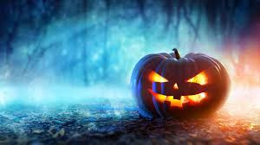

Halloween Celebrations

A spooky celebration of fright, fun, and creativity.

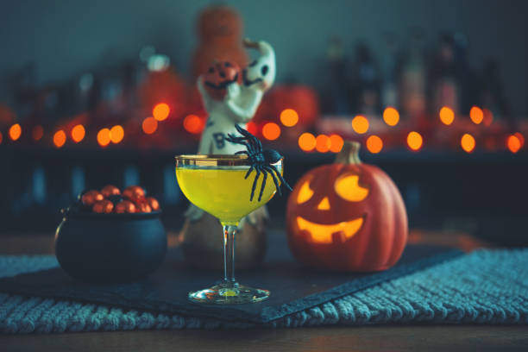

Halloween is a time for people to embrace the eerie and supernatural. One of the most popular traditions is trick-or-treating, where children dress up in costumes and go door-to-door collecting candy. Halloween parties are common, with costumes ranging from spooky ghosts and witches to pop culture icons. Pumpkin carving is another beloved activity, with people creating intricate designs or spooky faces on pumpkins, which are then displayed with candles inside to light up the night. Haunted houses, horror movie marathons, and creepy decorations are also part of the fun. Whether it's through frightful fun or community bonding, Halloween has something for everyone.

Celebrate the Thrills of Halloween

Halloween reminds us to embrace our creativity, have fun, and face our fears. It’s a time to enjoy the spooky side of life, share fun moments with family and friends, and dive into the mysteries of the unknown. Let the thrills and chills of Halloween bring excitement and joy to your celebrations!